**Whitney Road and Marvel Family Conservation Areas: Photos for Monitoring**

(Letters used for corners match those used on the whitney road and marvel map for monitoring)

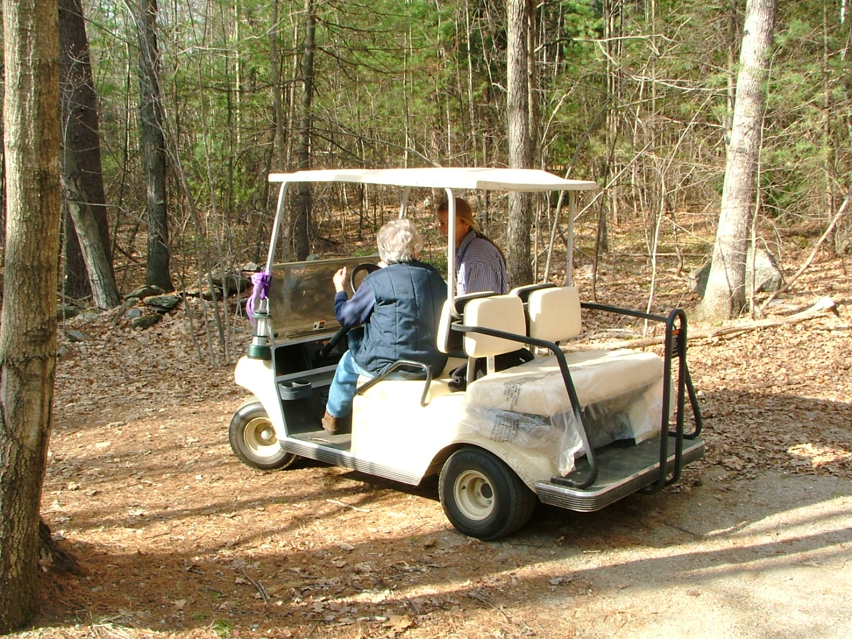

Marvel Family Conservation Area

getting there in style,

April 22, 2005

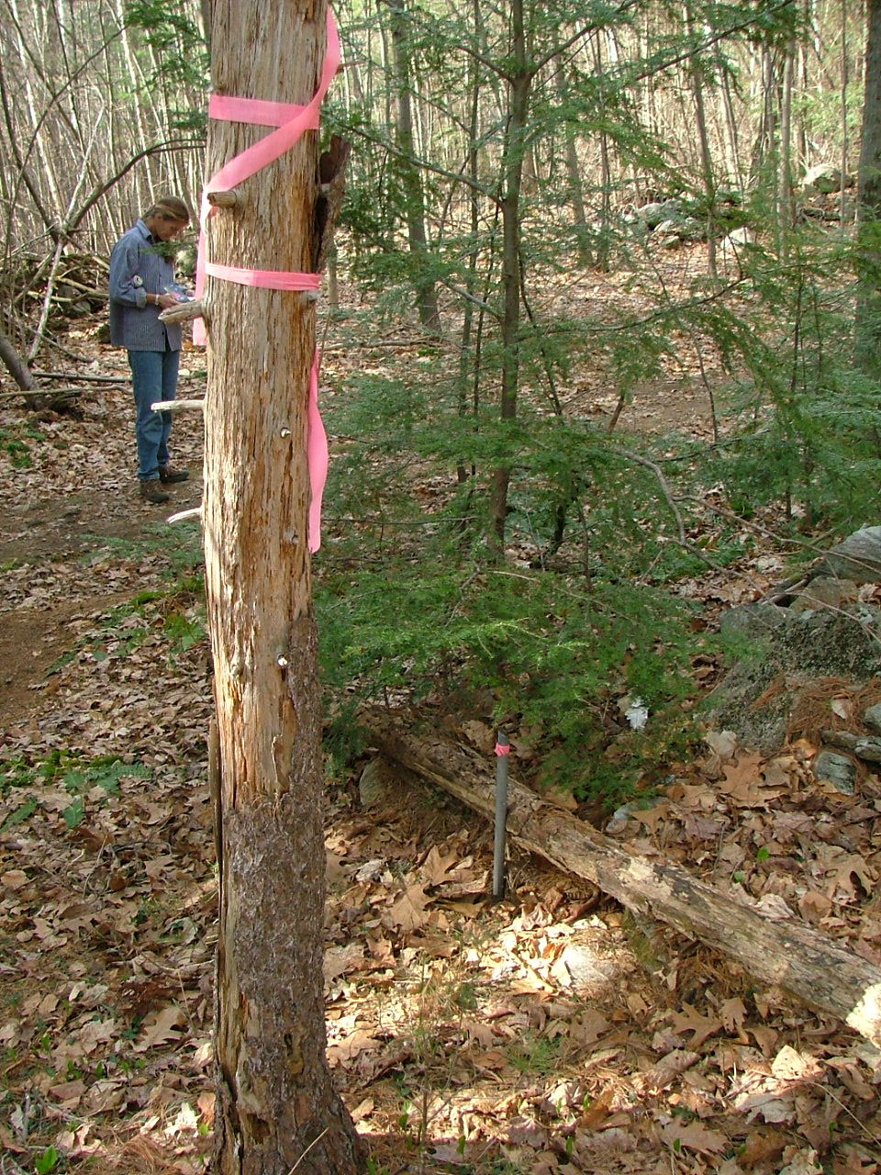

A. (NW corner) Corner stake and flagged tree on road,

Marvel/Richmond corner.

April 22, 2005

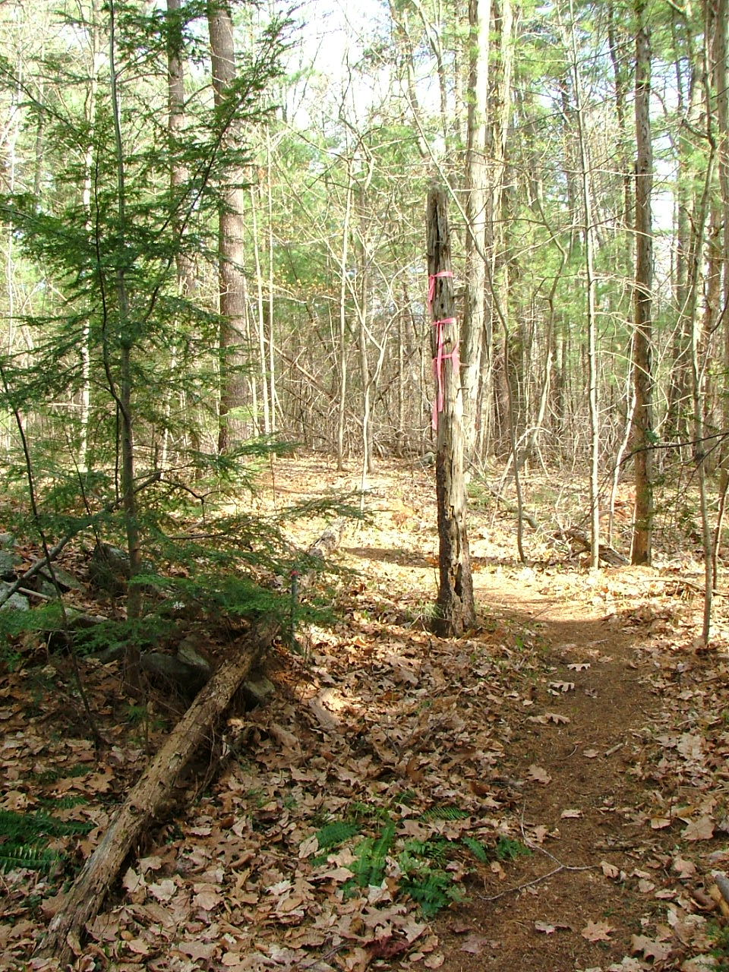

A. Same corner stake looking southeast along Marvel/Richmond line (trail does not follow line, is on Merritt land)

April 22, 2005

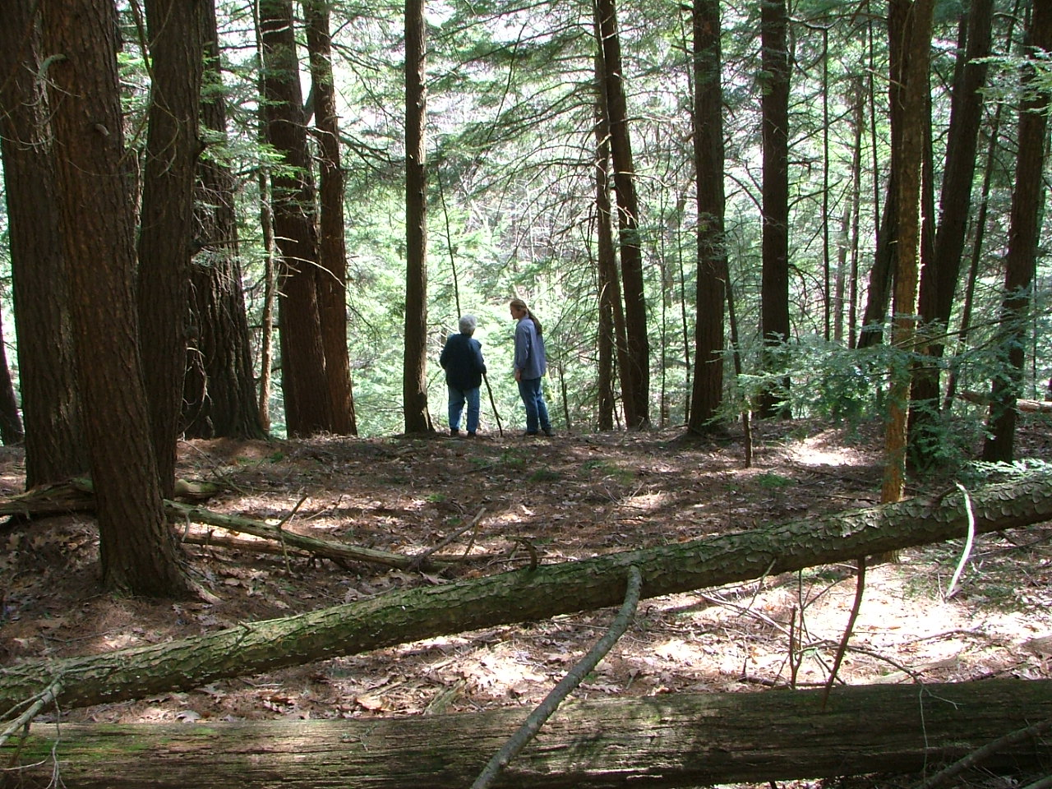

On Marvel, at edge of cliff above The Gutter

April 22, 2005

Note:

Marvel corners B and C (in the jog before SW corner) were found and tagged early in the monitoring process, but not photographed. When next reviewed, tagging was missing and has not been relocated. It is important to use the Marvel west-line survey done for Richmond (baseline). However, it does not appear to be a registered deed and the key for corners has been cut off. In revising the monitoring map, I assumed open circle = iron pin found; open square = stone bound found. (Traditionally filled in/black versions = "to be found")

Corner D (SW) or E (SE) have never been located exactly (or photographed). Problem in part is which line of cliffs forms the boundary. May be iron pin at E. (It is mentioned in the Glazier deed.)

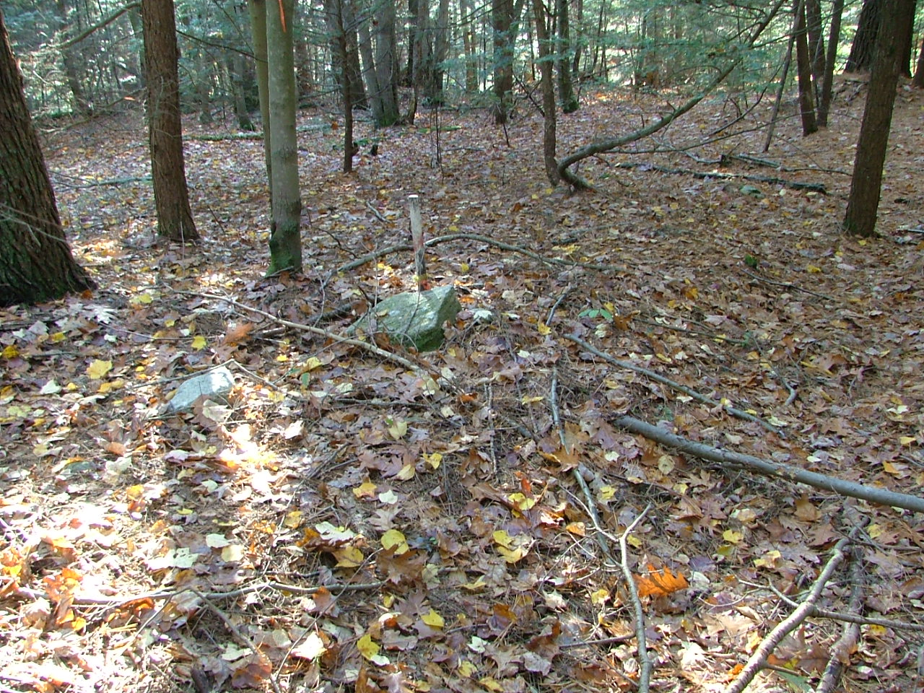

F. (NW corner) Whitney Road/Marvel Family CA/Glazier corner (stake)

10/21/2006

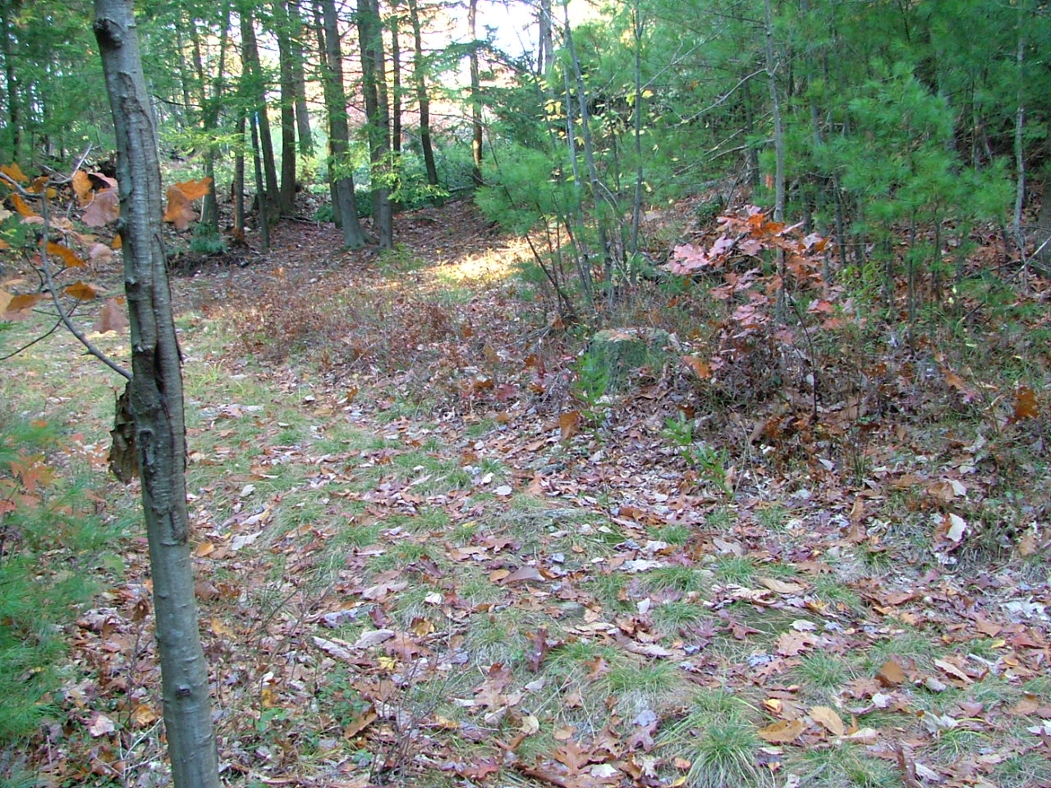Whitney Road Conservation Area

G. SW corner

At the crossroads: Whitney Road and Old Cave Hill Road (Driveway also at same corner

10/21/2006

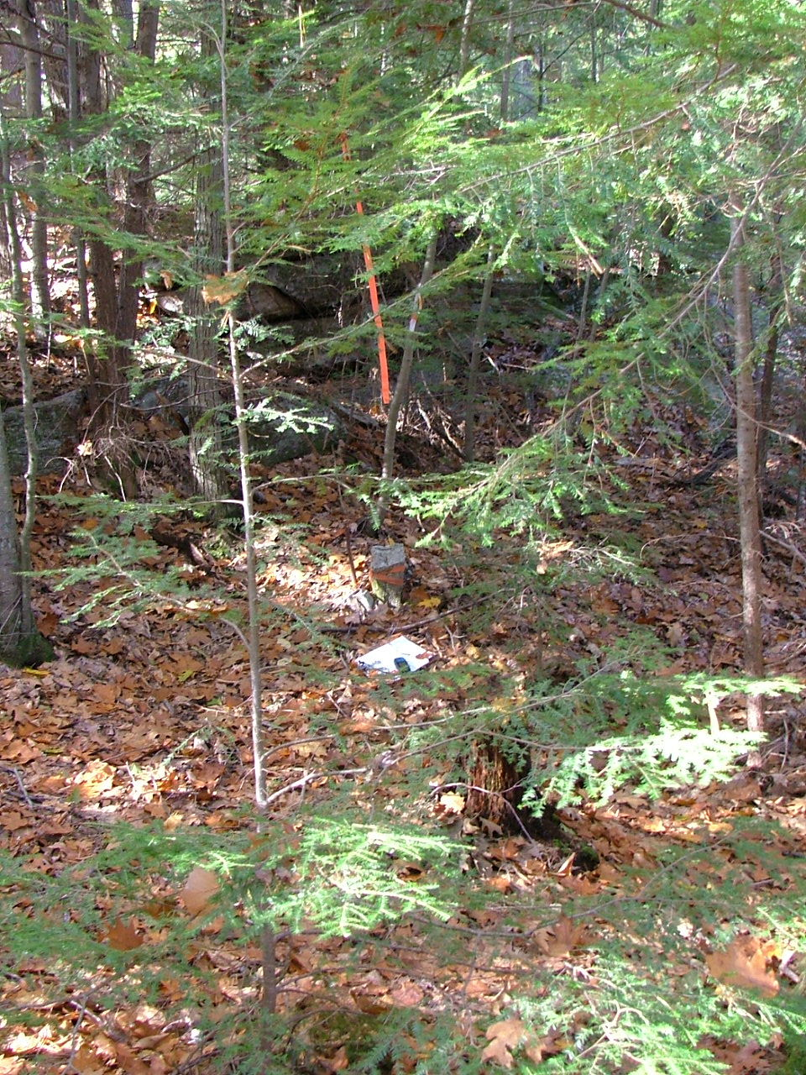

H. The NW corner is across the road (or technically half way across the discontinued road) from the NE corner of the Gibavic CR.

October 21, 2006

42.48442, -72.49471

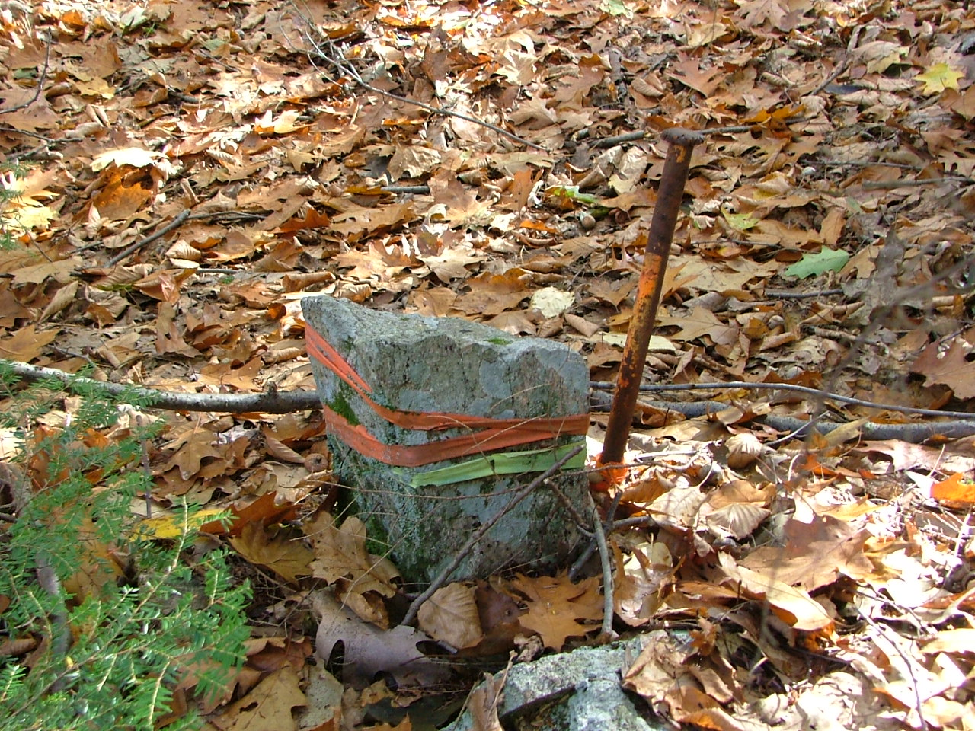

H. Same NW corner close up

Note: Corner I to L do not have photographs (along back line of Ryan's Hill Road residences. Do not have lat/long for these corners. Survey says "pins to be set."

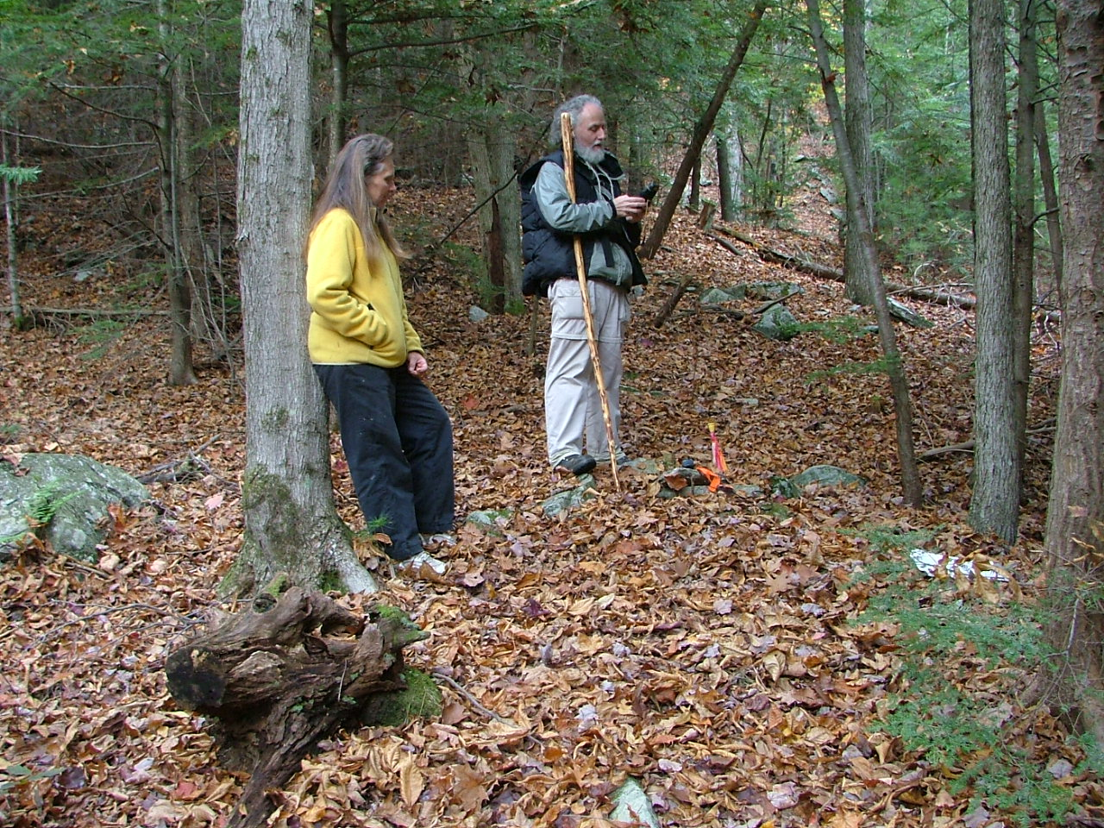M. NE corner with Blinn/Roberts

October 25, 2006

N. SE corner of Whitney Road CA with Blinn and Whitney Road

October 25, 2006

