RGT Monitoring Report

*\*\*\*\*\*\*\*\*\*\*\*\*\*\*\*\*\*\*\*\*\*\*\*\*\*\*\*\*\*\*\*\*\*\*\*\*\*\*\*\*\*\*\*\*\*\*\*\*\*\*\*\*\*\*\*\*\*\*\*\*\*\*\*\*\*\*\*\*\*\*\*\*\*\*\*\*\*\*\*\*\*\*\**

1. Name of Property and Year: Whitney Road/Marvel, 2014

2. Property owned by RGT? Yes

3. Date and recommendations from last year's monitoring:

No specific recommendations, property in good shape.

4. Date of this year's monitoring: 8/15/14

5. Participants: Eva Gibavic and Mobius (canine)

6. Describe the monitoring route briefly (also draw on map)*:*

See map.

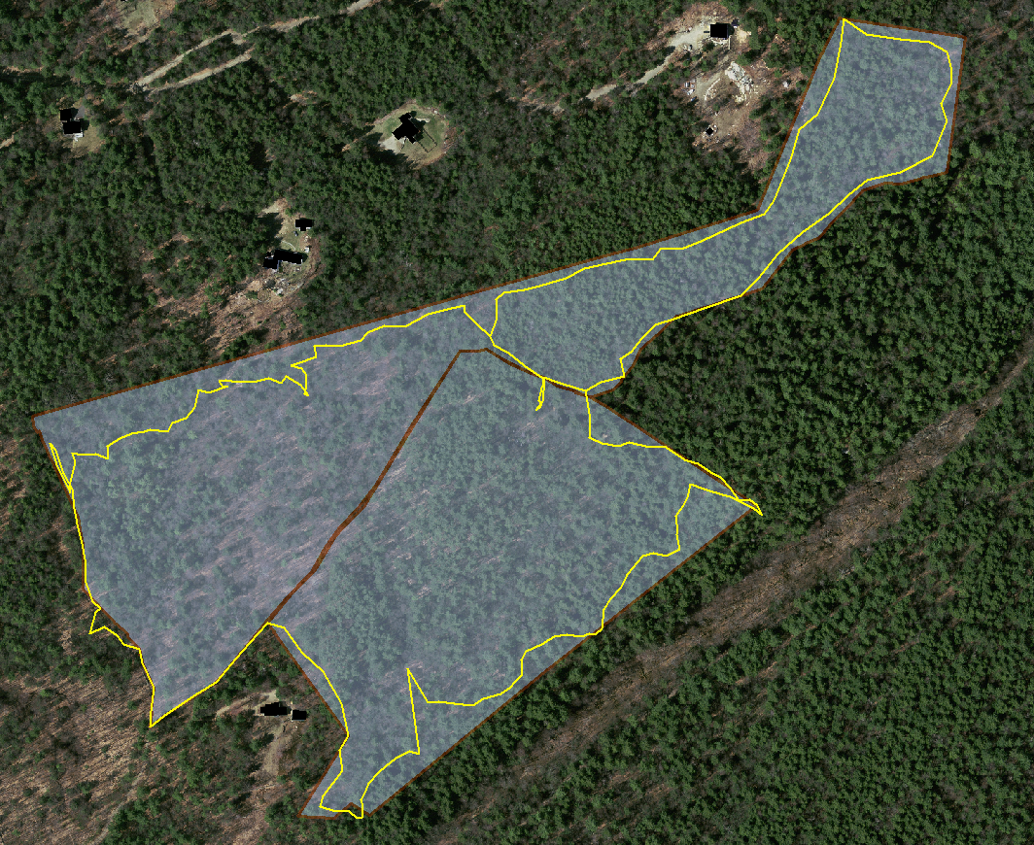

7. Describe any man-made alterations (draw on map/take photos. If no, write "none observed)

None noticed.

8. Describe any natural alternations:

Some storm damage, but essentially unchanged.

9. If CR, describe any interactions with landowner(s) during the monitoring or since the past monitoring: NA

10. Describe any changes in use being planned (ownership? land use?):

None.

11. List any observations comments, areas needing discussion or review:

None.

12. List any needed follow-up:

1) Mapping ceremonial features.

2) Consider marking the northern boundary.

13. Suggestions for next year's monitoring team? None.

Signed: ___________________________________________________________________________________

Date Signed:

AND

__x__I have asked to present this report at the next RGT Board Meeting.

__NA__ I have sent a copy of this report to the owner (if CR).

__x__ I have printed out a copy of this report and put it in the RGT green Field Notebook.

__x__ I have sent a copy to the person who puts reports in the RGT blue Archive Notebook.

__x__ I have sent an electronic copy of this report to the person who puts it on the Board-only section of the RGT website.