Tom and Portia and Shelburne Weiskel Conservation Restriction

Photos for Monitoring

(Tour of boundary starts in NE corner, goes south along road, then west and, finally, back north.)

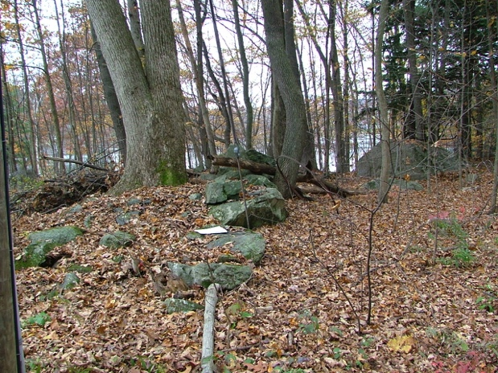

A. October 27, 2009

42.4544, -72.5025

Paper marks probable location of “drill hole in fast rock” marking NE corner. Stone wall is on the line.

(Eva found when monitoring 10/14/2010, do not have photo in that report. gps probably right.)

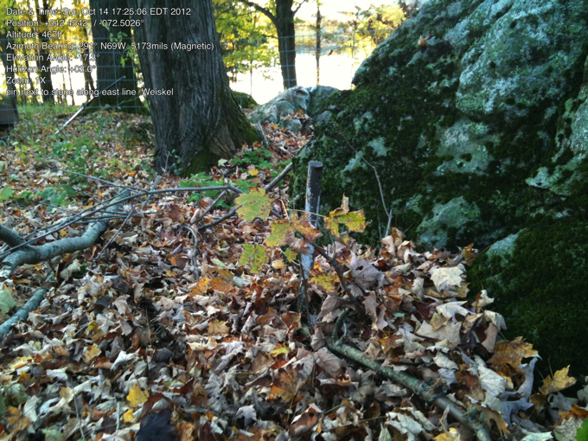

Line A - B, East Line

October 17, 2012

South of NE corner, along road.

Pin next to stone (this appears on the survey as drill hole in stone, but - after years of looking - the pin was right beside the rock we thought had the drill hole.

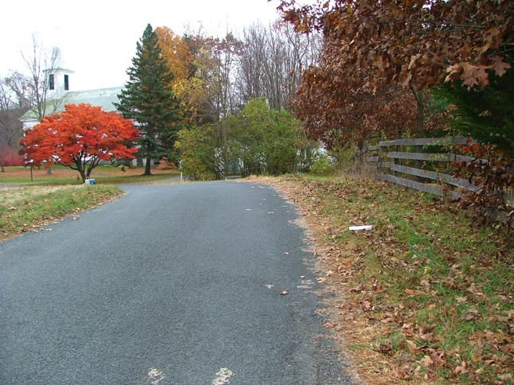

East line. October 27, 2009

42.4527, -72.5022

Paper marks approximate location of stone bound making old parcels D & E (Plan Book 13, p. 80). (Stone bound not found, but road is line.)

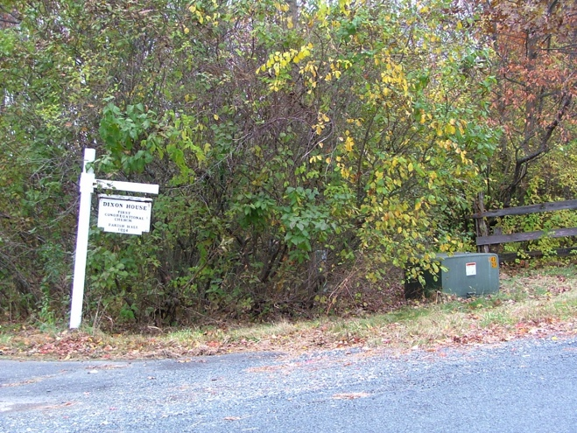

B. October 27, 2009

42.4526, -72.5020

Electric box at SE corner (iron pine not found). Looking west along fence line.

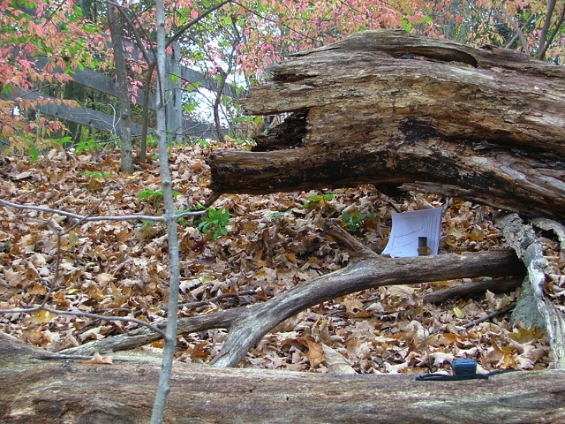

C. October 27, 2009

42.4525, -72.5026

Iron pin at SW corner, looking east (One of two survey monuments found on property. Other is stone monument half-way along north boundary (stone wall) marking two properties to the north.)

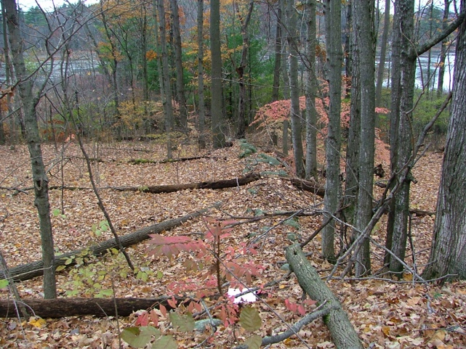C-D line (west/pond side), no change in property ownership on the pond side (Church owns all.)

October 27, 2009

42.4527, -72.5026

East end of stone wall on church property looking west to pond. Marks boundary of parcels D&E. Paper marks probable location of stone bound (not found).

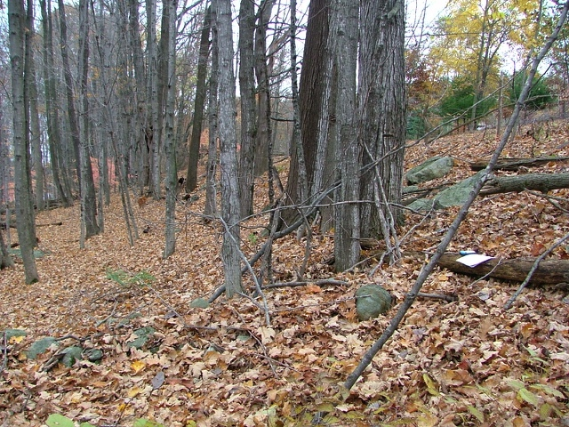

October 27, 2009

Same location as W6, but looking north along west line of “broken stone wall.”

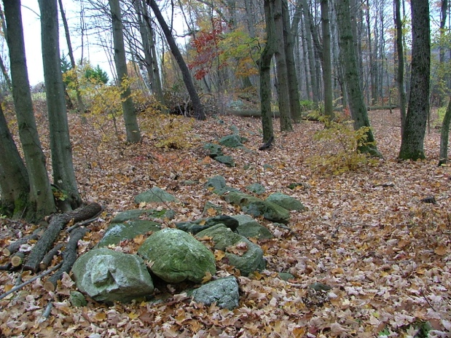

West line. October 27, 2009

42.4539, -72.5032

At western opening of church right-of-way looking south.

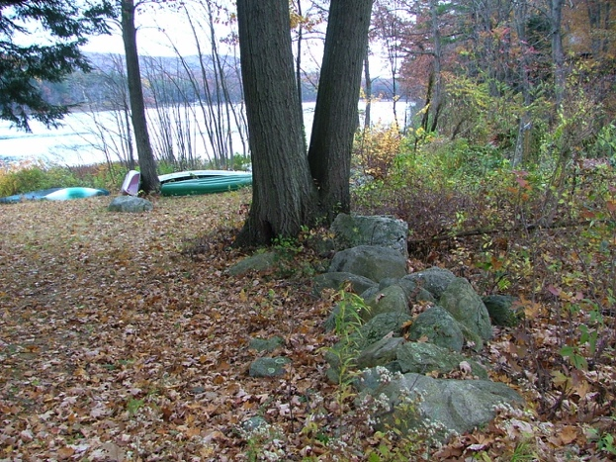

West line. October 27, 2009

Same location as W8, looking north to corner and pond.

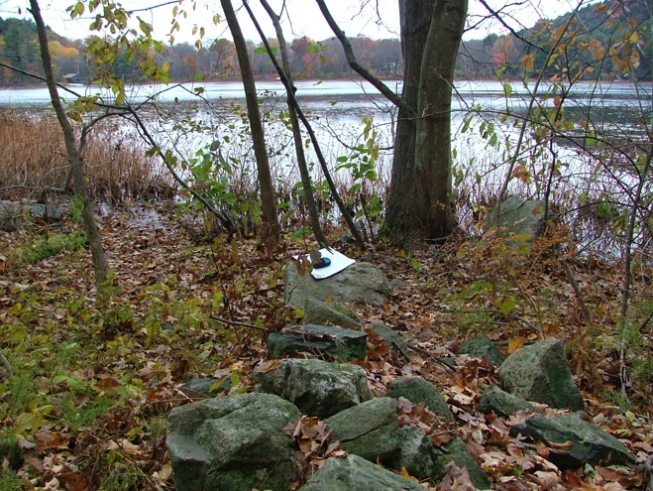

D. October 27, 2009

42.4543, -72.5034

NW corner, looking west to pond along stone wall. Paper marks probable location ofiron pin in intersection of stone walls. (iron pin not found, but there is gap in intersecting stone wall.)

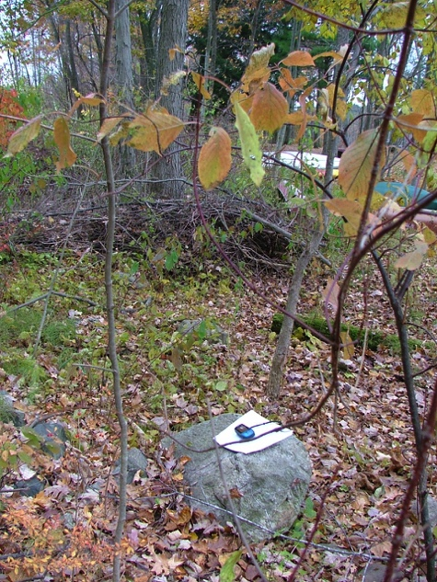

D. October 27, 2009

same location, looking west

Stone wall that marks most of western line has gap here – can barely be seen to right of tree.

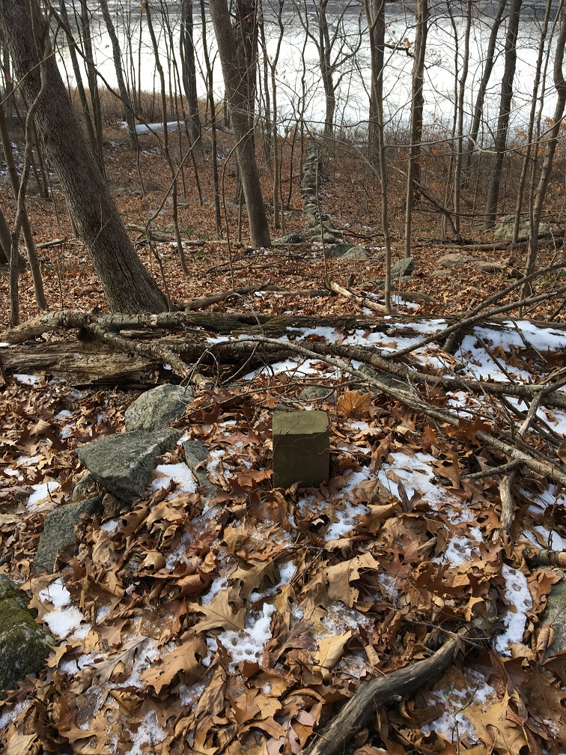

E. Stone bound in stone wall along the north line

December 11, 2016

Note: this stone/cement bound does mark change in ownership of the land to the north (pondside property and roadside property)