Tom and Portia and Shelburne Weiskel Conservation Restriction

(Tour of boundary starts in NE corner, goes south along road, then west and, finally, back north. With additional photos from eastern border/road.)

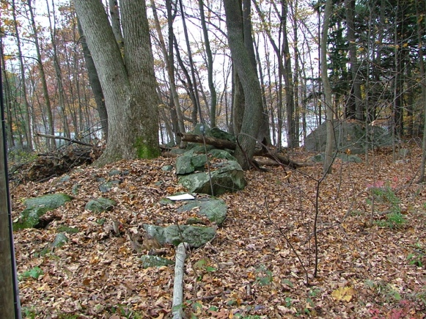

W1. October 27, 2009 011

42.4544, -72.5025

Paper marks probable location of

“drill hole in fast rock” marking NE corner

(stone wall is on the line)

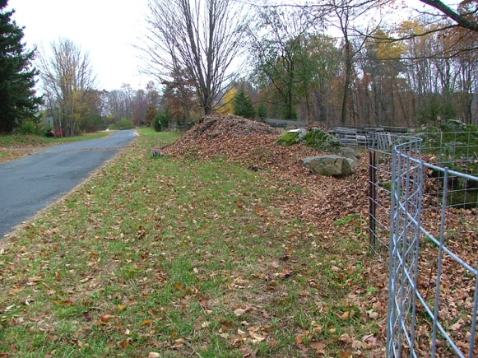

W2. October 27, 2009 013

South of NE corner, along road.

Paper marks approximate 2nd “fast stone

with drill hole.” (Road is line.)

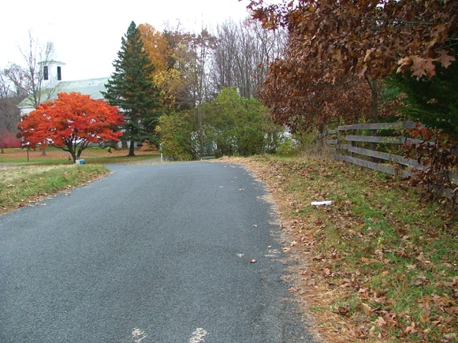

W3. October 27, 2009 021

42.4527, -72.5022

Paper marks approximate location of stone bound

making old parcels D & E (Plan Book 13, p. 80).

(Stone bound not found, but road is line.)

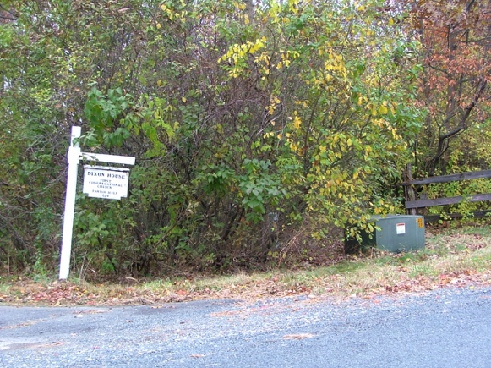

W4. October 27, 2009 001

42.4526, -72.5020

Electric box at SE corner (iron pine not

found). Looking west along fence line.

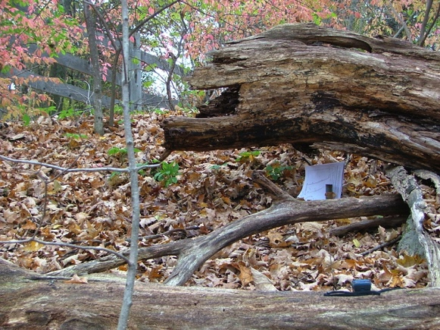

W5. October 27, 2009 002

42.4525, -72.5026

Iron pin at SW corner, looking east

(One of two survey monuments found on property.

Other is stone monument half-way along north

boundary (stone wall) marking two properties

to the north.)

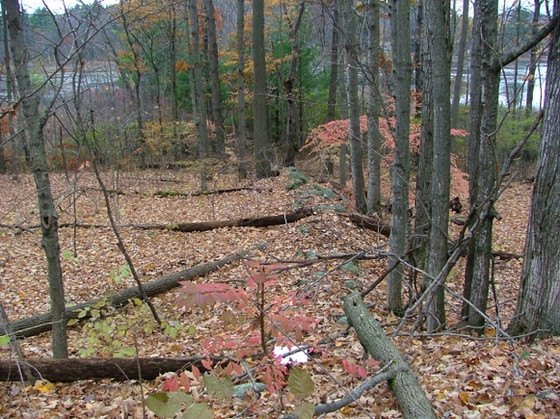

W6. October 27, 2009 003

42.4527, -72.5026

East end of stone wall on church property looking

west to pond. Marks boundary of parcels D&E.

Paper marks probable location of stone bound

(not found).

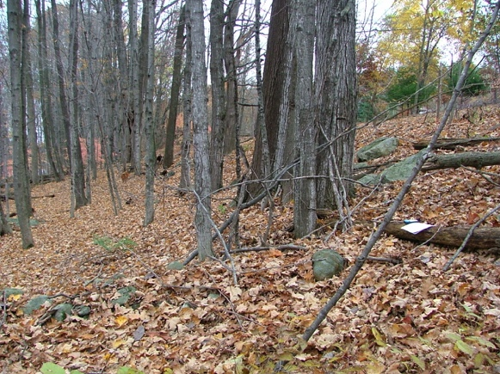

W7. October 27, 2009 005

Same location as W6, but looking

north along west line of “broken

stone wall.”

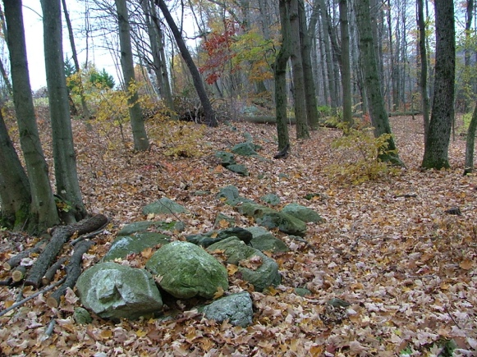

W8. October 27, 2009 006

42.4539, -72.5032

At western opening of church right-of-way

looking south.

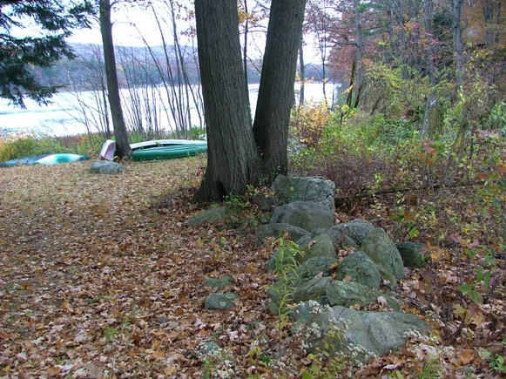

W9. October 27, 2009 007

Same location as W8, looking north to corner

and pond.

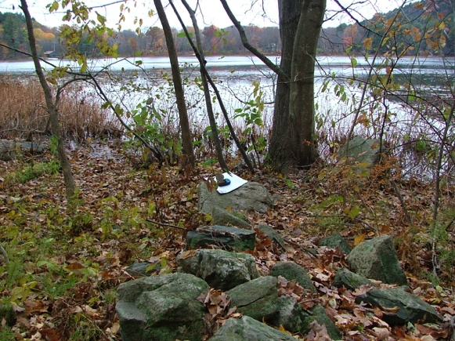

W10. October 27, 2009 008

42.4543, -72.5034

NW corner, looking west to pond along

stone wall. Paper marks probable location of

iron pin in intersection of stone walls.

(iron pin not found, but there is gap in

intersecting stone wall.)

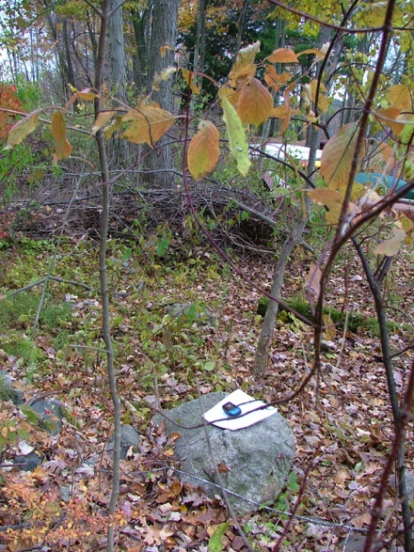

W11, October 27, 2009 009

same location, looking west

Stone wall that marks most of western line

has gap here – can barely be seen to right

of tree.

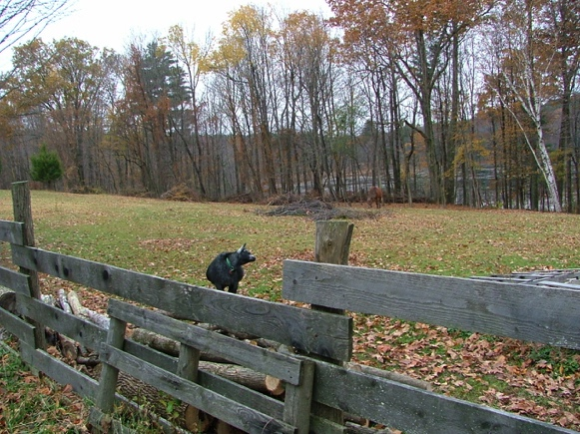

W12, October 27, 2009 015

Along road looking southwest into pasture

(with goat at front and horse at back).

Pasture has recently had major clearling of

scrub and vines.

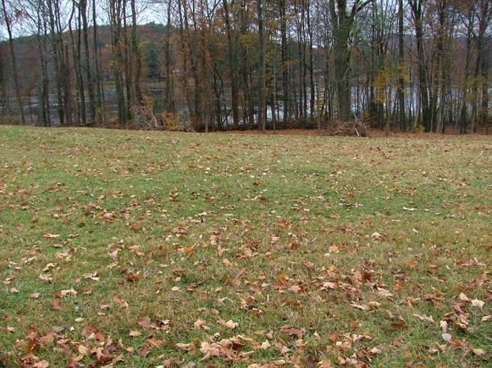

W13, October 27, 2009 017

Along road looking west over pasture with

recent clearing.

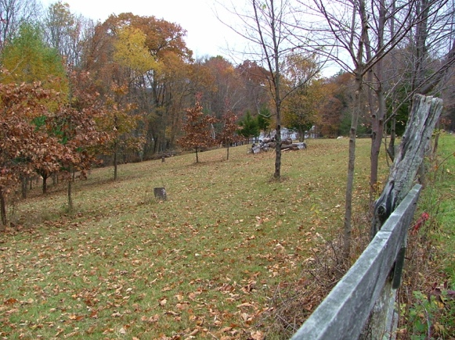

W14, October 27, 2009 020

Along road looking northwest into pasture

which has been recently cleared.

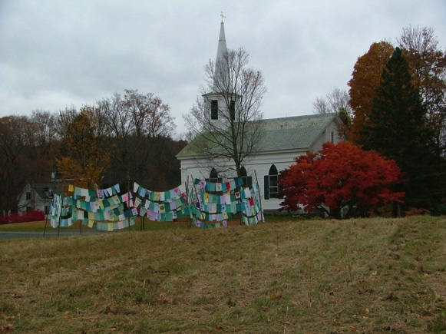

W15, October 27, 2009 018

View southeast to church and King Lot and

flags from the October 24th community

350 event. Photo taken in front on Annette

Gibavic memorial trees.

