Stetson Adams Memorial Woodland, photos for monitoring

(Letters for corners match letters used on stetson adams map for monitoring)

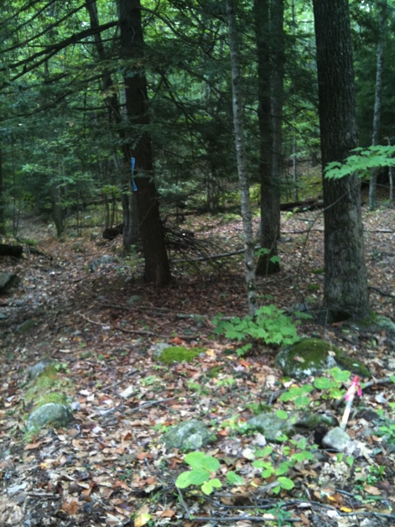

A. Northeast Corner

(stake mentioned in deed)

looking south along old Brushy Mt. Rd.

8/26/2010

42.45669228, -72.48273667

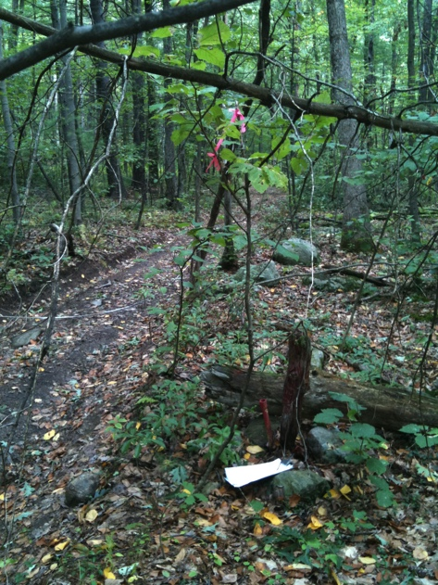

B. Southeast Corner

iron pin across (east side of) Old Brushy Mt Rd

photo taking at corner looking north

(Pin marks corner of Cowls/Downy lots. Line continues as Adams/Downy corner across the road.)

8/26/2010

42.45413404, -72.48357084

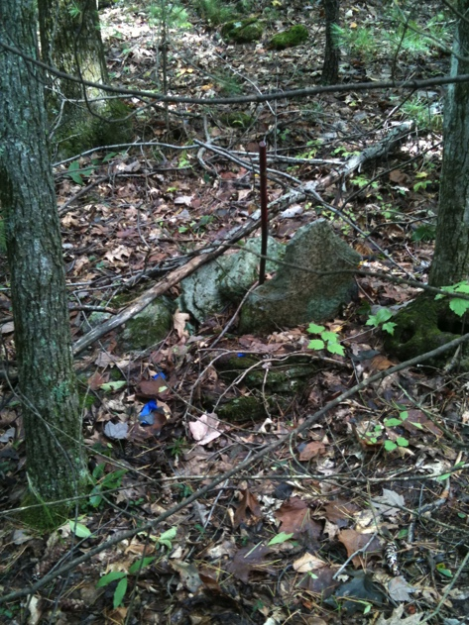C. SW corner

iron pin to west of old woods road (“west road”). Hidden among small pine trees.

This corner is about 10 feet west of where corner should be using 100-meter tape to measure from Old Brushy Mountain Road. Stake indicates angle change in Downy land (and is also in Adams deed as corner)

8/26/2010

42.45401829, -72.48579648

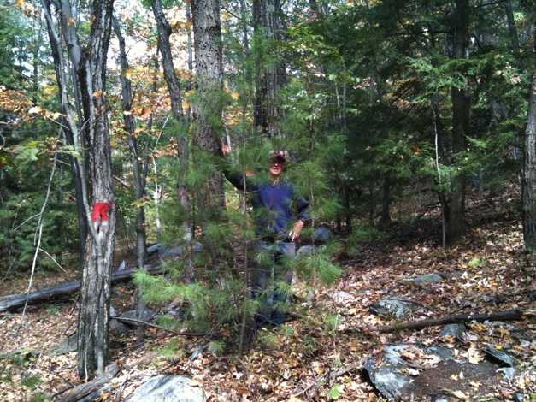

D. NW corner, red paint is north

line (Cowls)

This corner is on 12.5 degree line from iron pipe at SW corner. (degrees in deed) It is about 40 feet west of where corner should using 100-meter tape to measure from Old Brushy Mountain. (distance also in deed)

9/21/2010

42.45635709, -72.48599136

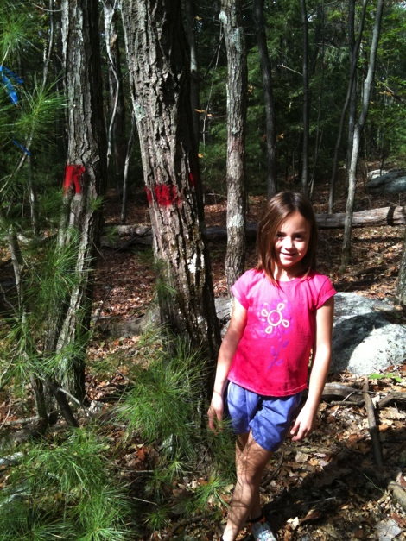

D. Same NW corner with the

final corner 3-dot paint (done

by Jayde Surette, age 9)

10/11/2010