Stetson Adams Sample of Stone Structures

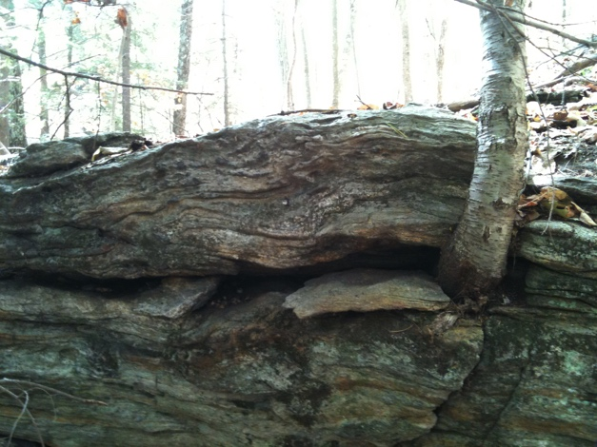

Example of ledges on east side

of ridge, looking west (foliated metamorphic)

9/21/2010

42.45643781, -72.48403025

On May 19, 2011, Eva Gibavic and Mary Alice Wilson walked the property again taking pictures and GPS readings of the stone configurations found on the property. Each took photographs and GPS data. The purpose of this visit was to document the presence of possible Native American ceremonial sites – but NOT to do an official inventory of sites on the property. The following pictures illustrate some of the types of stone configurations. We made no attempt to census all the stone groupings in the cluster on the northeast section.

Wilson took both digital camera and iphone pictures; it was a cloudy, almost raining, day. These pictures below are all from the digital camera. The full set of Wilson pictures can be found on the signed CD of all Adams CR photographs.

Pictures were taken in an approximately counter clockwise direction, beginning at the SE corner of the property.

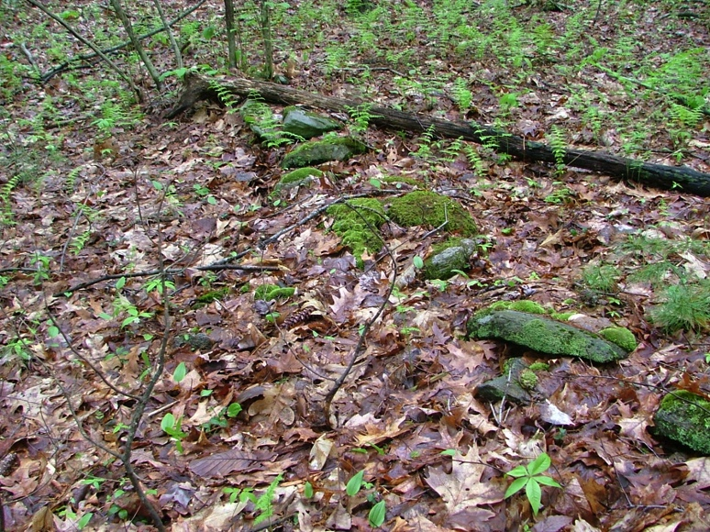

SA 1.Short stone wall

looking north

42.45422716 -72.48389756

5/19/2011

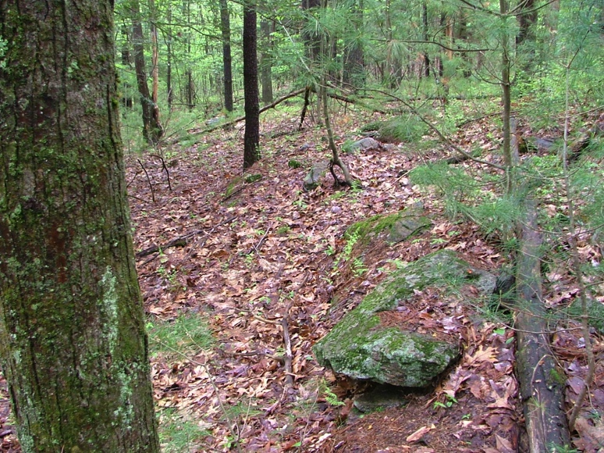

SA 6. One of many stone groupings

in NE part of the property. A second

stone group appears behind the first

looking south

42.45545553 -72.48396873

5/19/2011

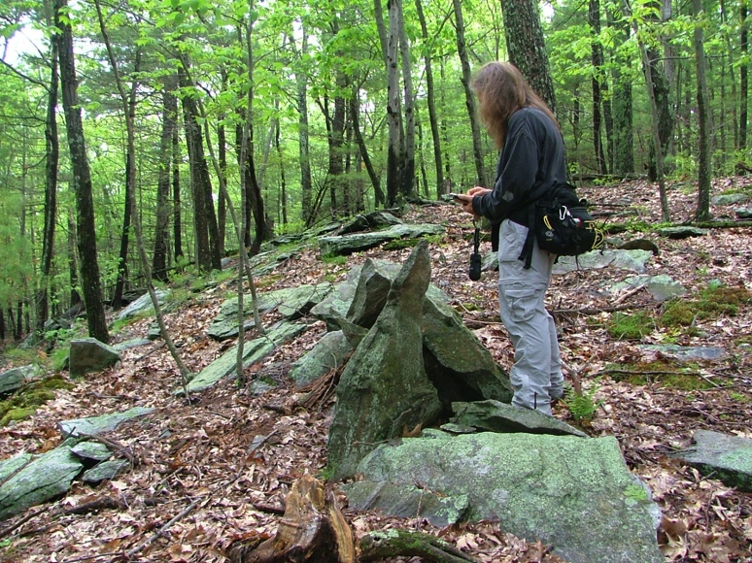

SA 11. Stone grouping west of ridge

looking NW

42.45604746 -72.48520665

5/19/2011

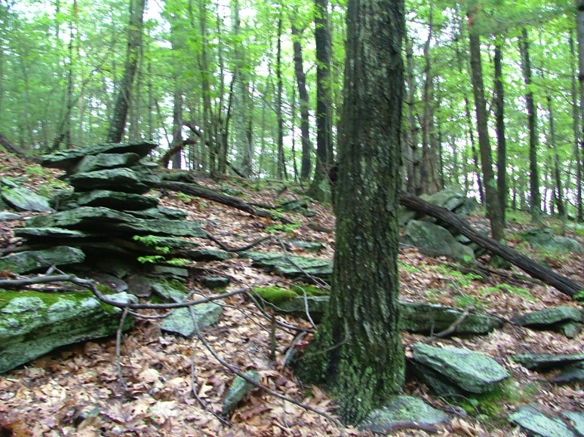

SA 12. pair of stone structures

looking NE near N line

42.45624620 -72.48567897

5/19/2011

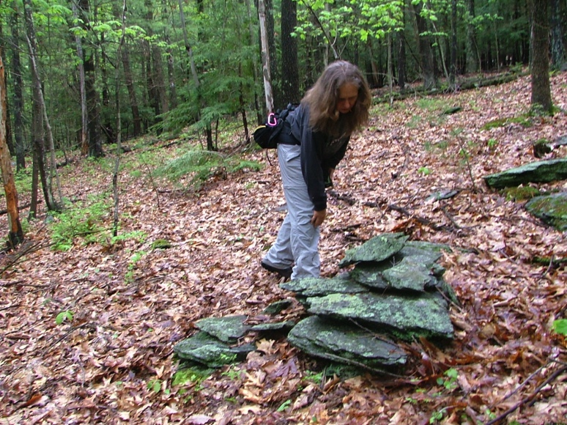

SA 13. pointed stone on left

aligns with 270 degrees

looking north

42.45487684 -72.48516717

5/19/2011

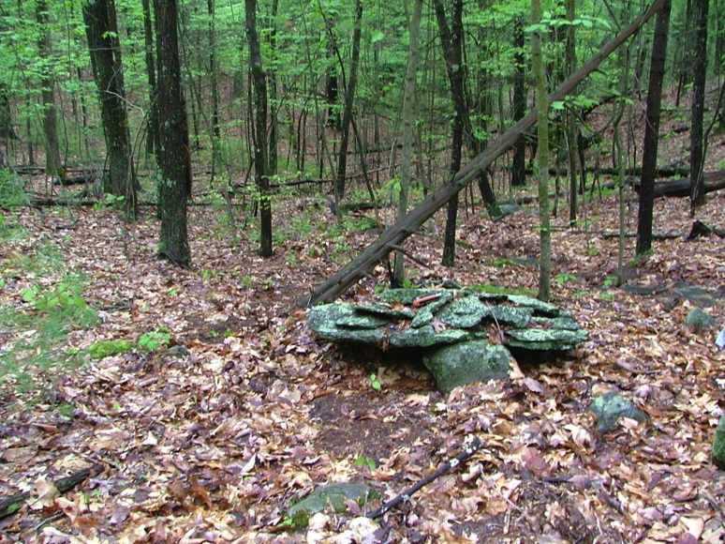

SA 14. almost table-like stone

configuration

looking south

42.45476427 -72.48557679

5/19/2011

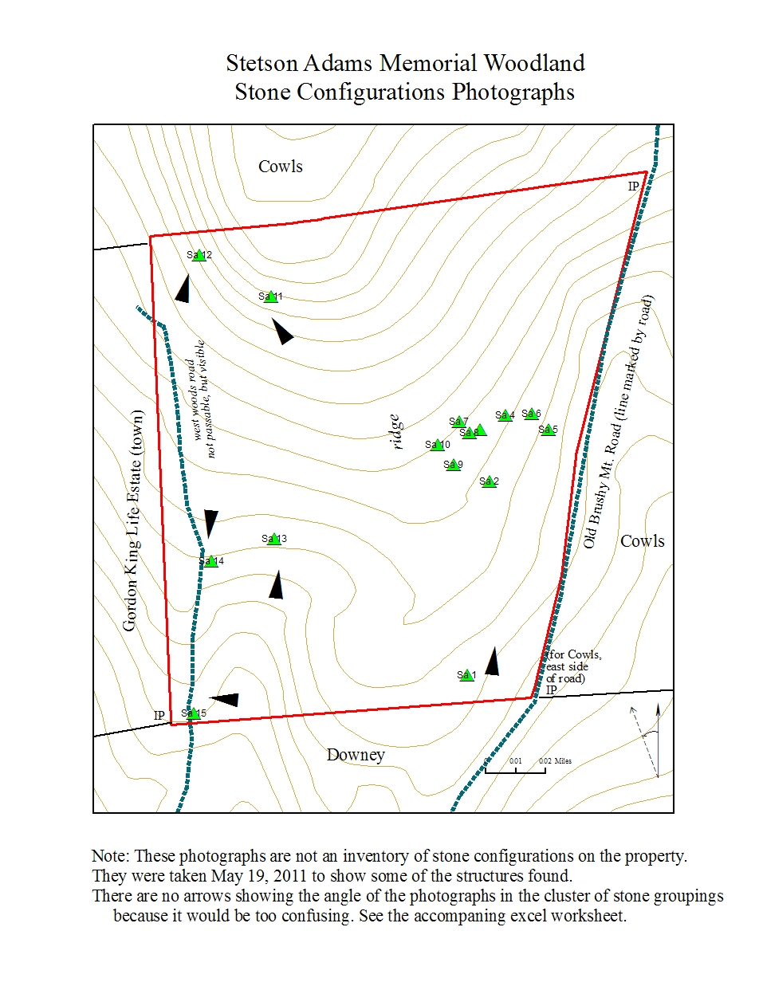

Stetson Adams Memorial Woodland, Sample of Stone Configurations

