Smith CRs photos for monitoring, part 2, east of power line

(Letters for corners correspond to letters added to smith map for monitoring)

(red indicates questions about photos: black used if photos missing)

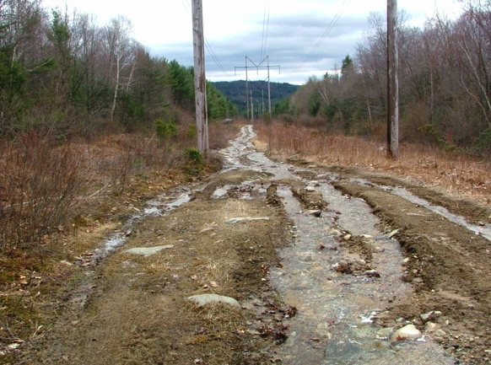Line T - U at power line

April 5, 2008

42.45283, -72.47401

Power line looking south

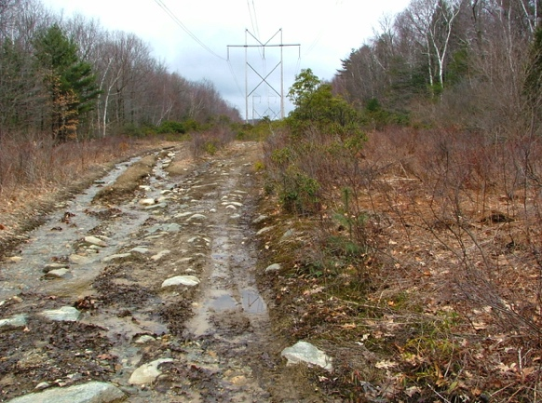

April 5, 2008

Power line looking north

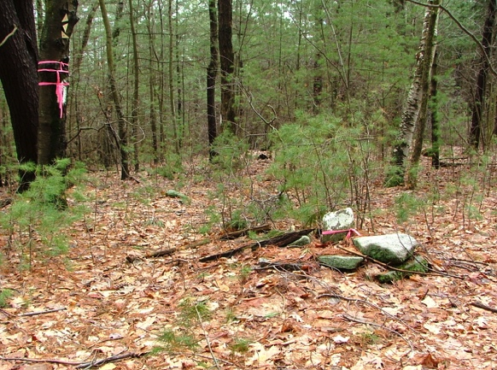

Note: no photo or gps of U. (unknown owner to the north)

V, April 5, 2008

42.45308, -72.47077

NE corner marking corner with W.D.Cowls

(3 triangles) looking southeast along line

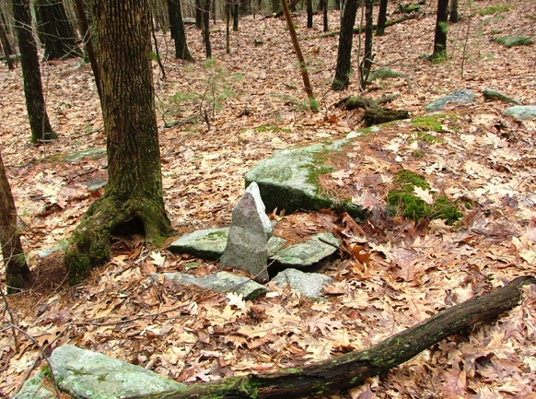

W???. April 5, 2008

Pointed stone marking change in eastern

line angle

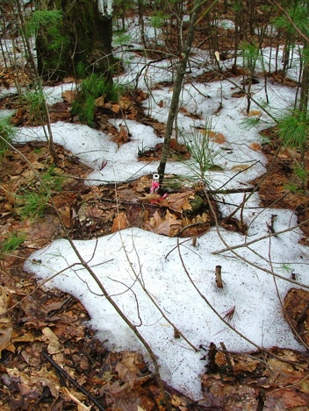

????. April 5, 2008

42.45173, -72.46875

Corner pipe just beside stream looking south along line

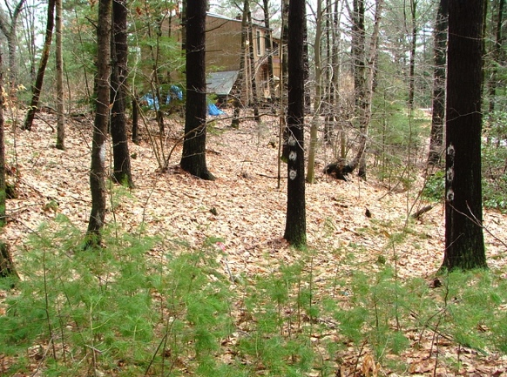

???. April 5, 2008

Corner post near house

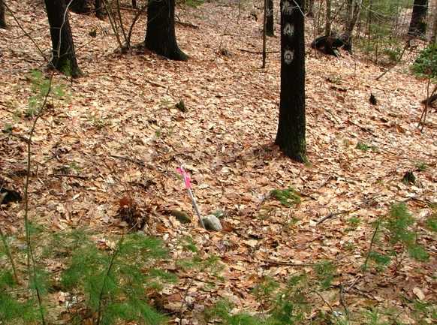

????. April 5, 2008

Close up of corner post

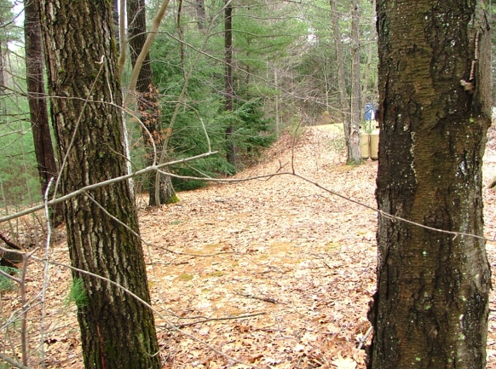

Line CC - BB

April 5, 2008

Apparent leach field, view (looking north

along line) includes marked tree on line,

next tree to the north in line but out of sight

behind white-blazed tree

CC. corner east of vernal pool, found on monitoring trip Nov 13, 2011

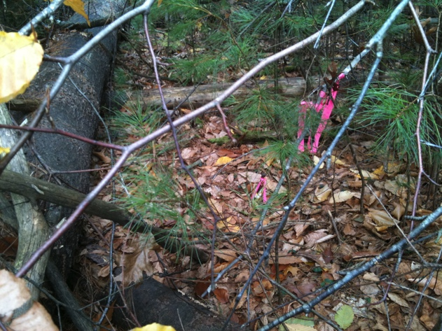

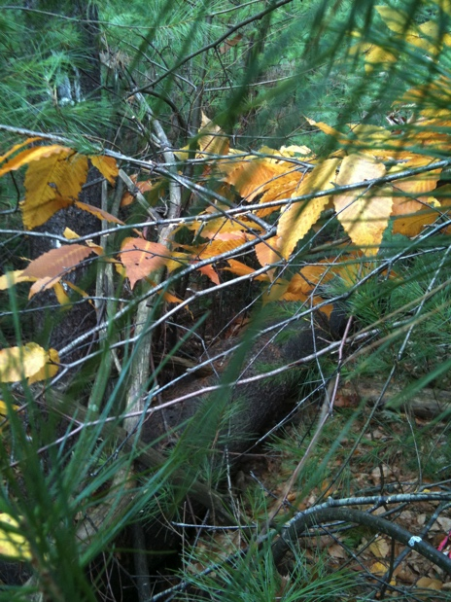

Above: Large pine tree trunk, pin and flag, looking north

Right: Tree with white corner markings, log, pin (right edge)

From same spot also looking north

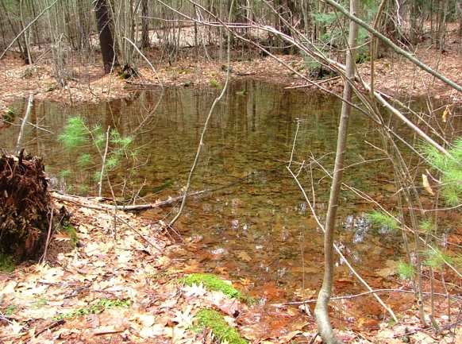

???. April 5, 2008

Wet area at corner (post of far left side)

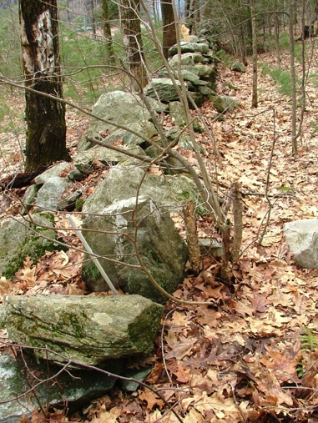

DD??. April 5, 2008

42.45015, -72.47155

Corner north of Rat Hollow??? looking south, stake in stone wall, brush-burning fire in distance

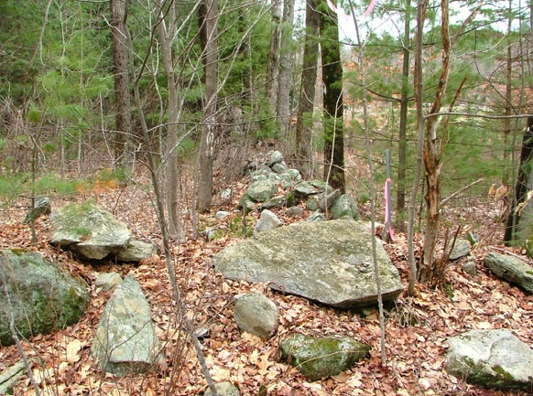

EE. April 5, 2008

42.44862, -72.47281

NE corner on Rat Hollow Road, looking north along stone wall

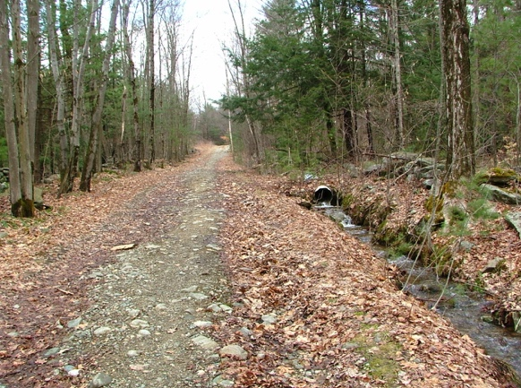

EE. April 5, 2008

On Rat Hollow Road, looking east to power line from previous corner

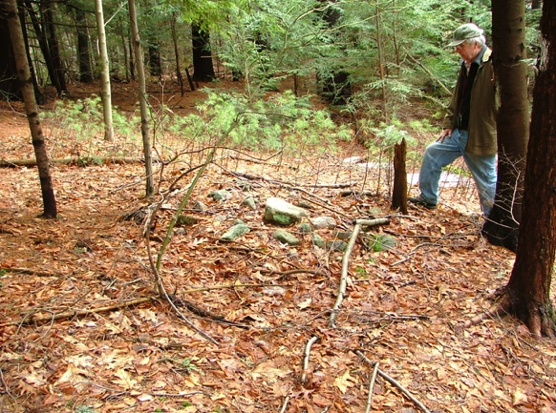

FF. April 5, 2008

42.44867, -72.4734

SE corner on Rat Hollow Road, looking east to corner marker on south edge

GG. No photo

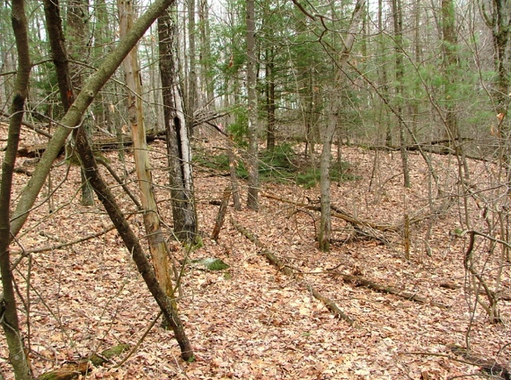

HH. April 5, 2008, 055

Small triangular indent in line, taken from

inside corner looking northeast along line

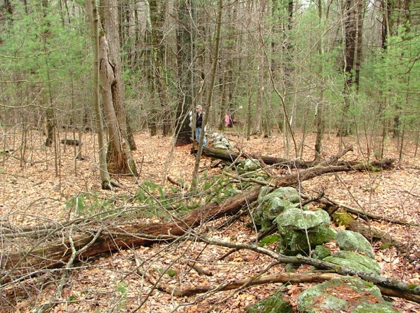

HH. April 5, 2008, 054

Small triangular indent in line, taken from

inside corner looking west along line/stone wall

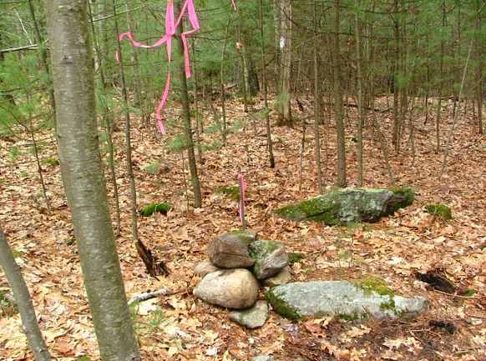II. No photo

JJ. April 5, 2008, 056

42.44658, -72.47346

Stake and stones at change of angle on east line,

looking south along line

And that brings us back to A. . . .