David Smith Conservation Restrictions (2), photos for monitoring, part 1, south-east-north sides

(Letters for corners correspond to letters added to smith map for monitoring)

(red indicates questions about photos: missing photos in black)

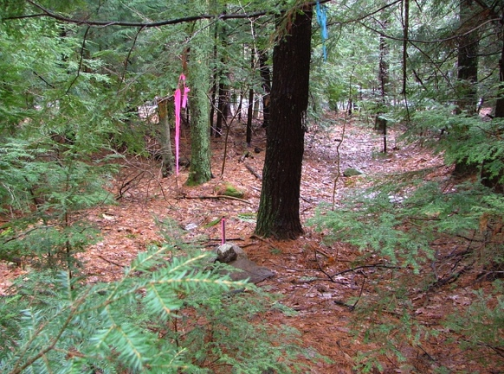

A. April 5, 2008,

42.44580, -72.47305

SE corner, east of power line, looking toward Shutesbury Road"

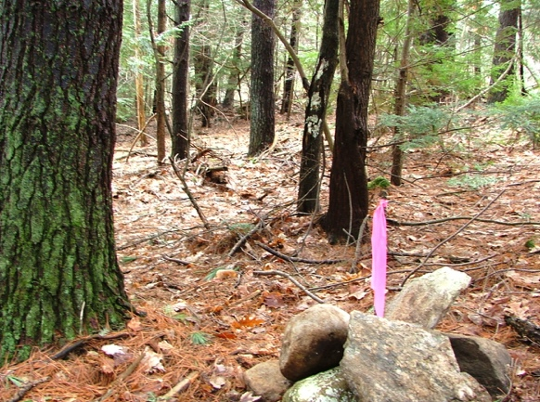

A. April 5, 2008,

SE corner, east of power line, looking along line to power line

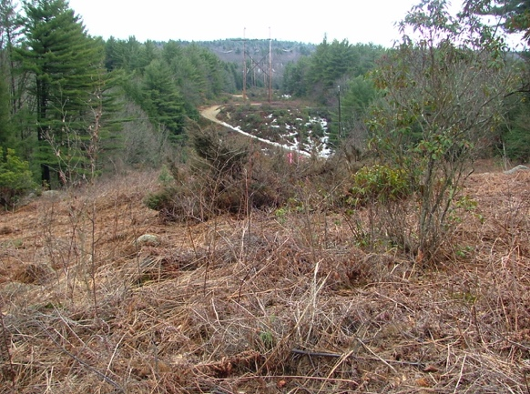

B. April 5, 2008

Post in center of power line (also in center of large juniper) looking south. Pin is marked in pink just next to large boulder.

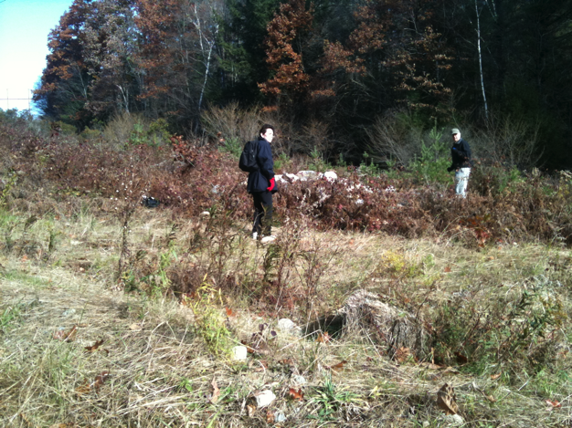

B. Same post in 2010 under pile of rock dumped by power company during major work on transmission lines. Looking north.

By 2014 vegetation made finding pin impossible.

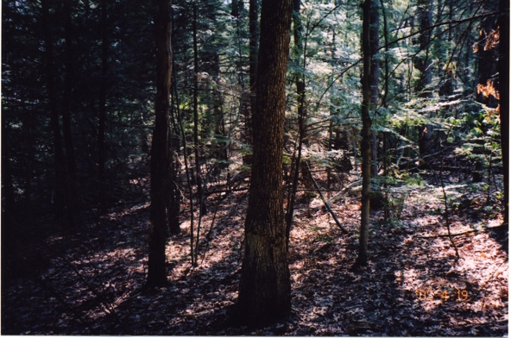

C. April 19, 2003

42.44548, -72.47457

NE Corner of 2-acre CER, along north edge, line not blazed (nor any need to walk it). To left (south) is older Smith CR; to right (north) is new Smith CR.

D and E. Photos are found are not useful. Retake corners on Shutesbury Road. (Retaking C and F would also be a good idea.)

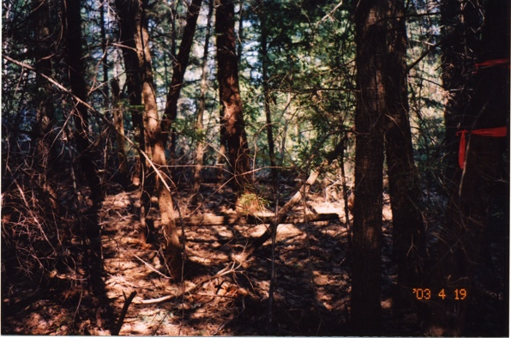

F. 19, 2003

42.44531, -72.47568

NW corner looking back along north line, not blazed. To right (south) is older Smith CR; to left (north) is new Smith CR.

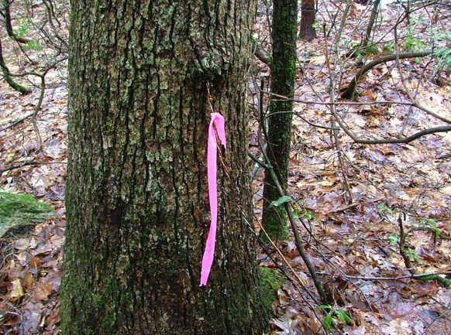

G. April 5, 2008

18 inch oak flagged on survey along south line, embedded barbed wire fence

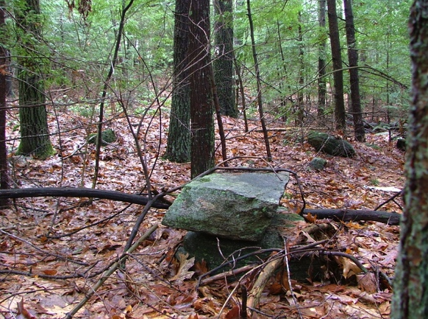

H. April 2008

Stone pile on survey, looking east along south line

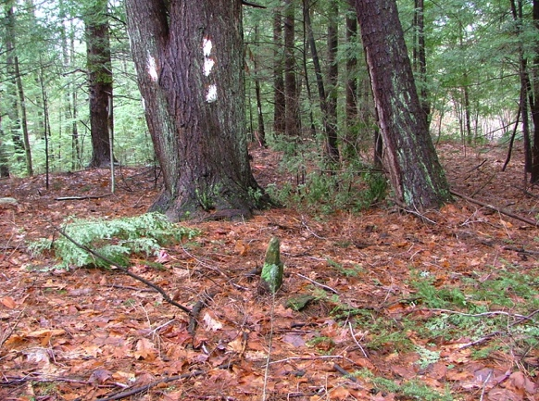

I. April 5, 2008

42.44484, -72.47869

Stone bound corner, looking east along south line

J. 24" oak. No photo

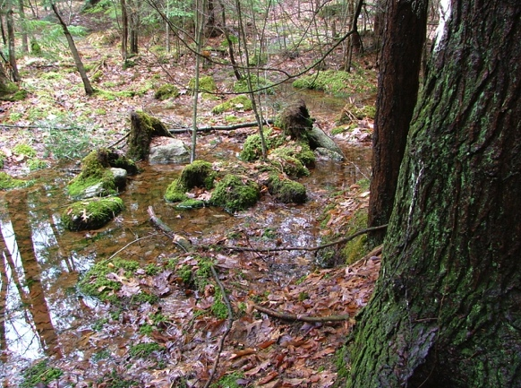

K. April 5, 2008

Wet area near surveyed 24" hemlock, west line (barbed wire in tree)

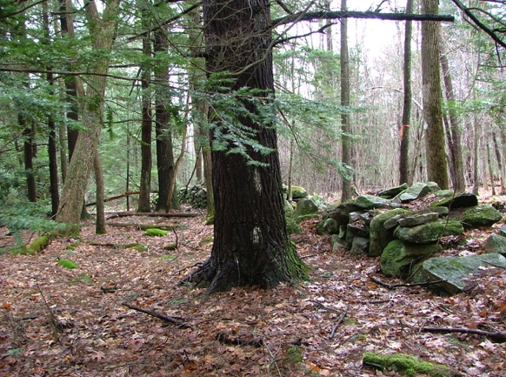

L. April 5, 2008

42.44744, -72.47819

Corner also at edge of stone wall rectangle. Looking west along line

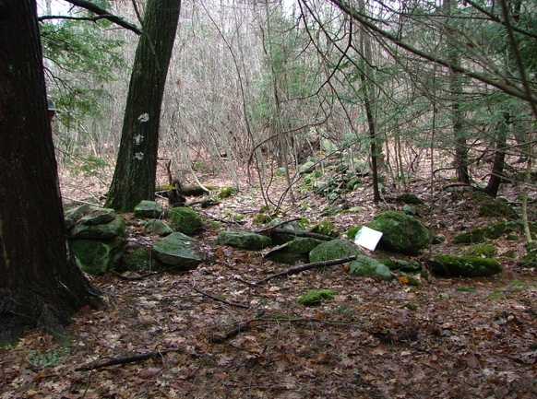

L. April 5, 2008

Same corner looking north (not a property line)

along stone wall

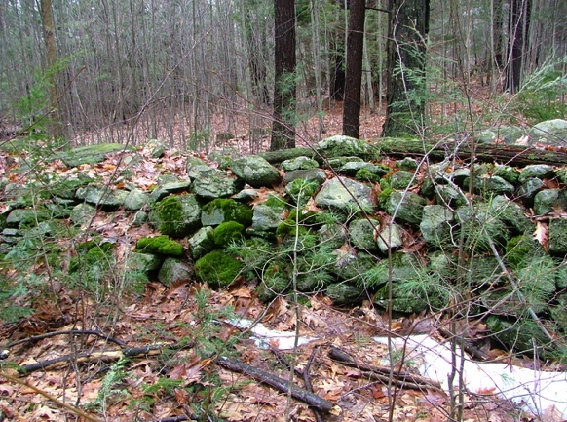

Line L to M. April 5, 2008

Stone all along south line

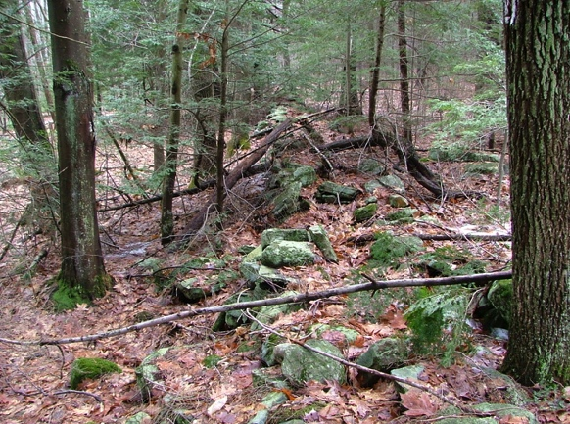

M. April 5, 2008

42.44731, -72.47899

Corner, stone wall looking north along line. (This part of stone wall not was elegant.)

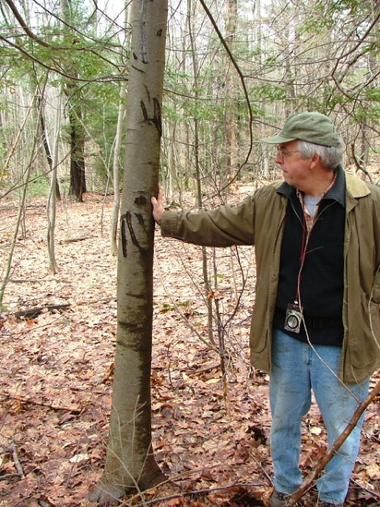

Line M to N

April 5, 2008

Along line near northeast corner of stone wall rectangle, Matt Kelty and possible bear claws.

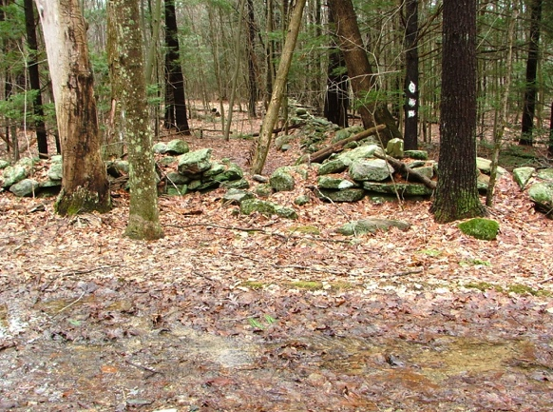

N. April 5, 2008

42.44989, -72.47851

Corner with Rat Hollow Road, looking south along line

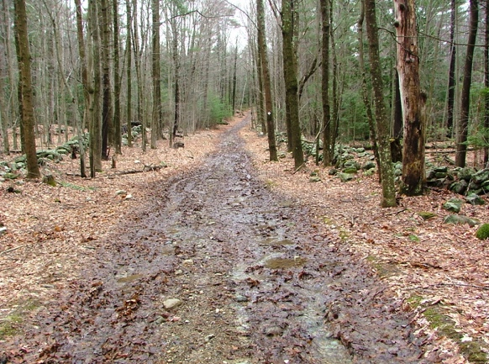

N. April 5, 2008, 024

At south corner of Rat Hollow Road, looking west

along road to north corner (O.)

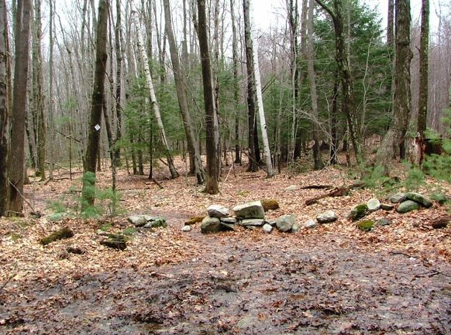

O. April 5, 2008

Looking north from Rat Hollow Road.

Moser CA (RGT) with M-M trail on left, Smith CR on right

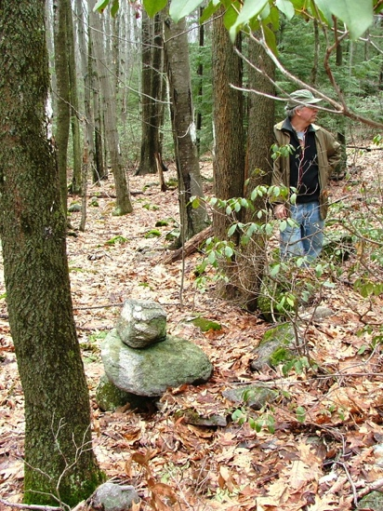

P. April 5, 2008, 026

Stone pile marking change in angle in east line, looking north, Matt Kelty

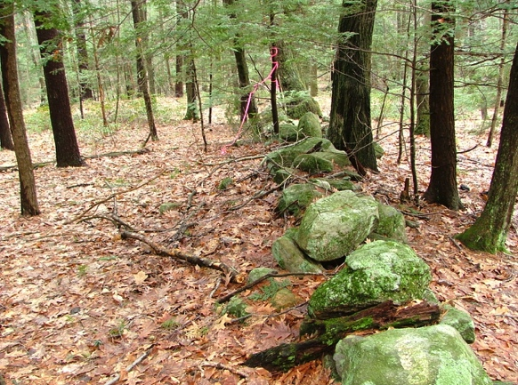

???. April 5, 2008, 027

42.45226, -72.47890

Post in stone wall marking NE corner

(Smith/Mosher), looking west

Q? R? S????? probably S