Schuyler Conservation Restriction
April-May 2012, new gps readings and new photographs
2014 corner letters added to monitoring map and this document

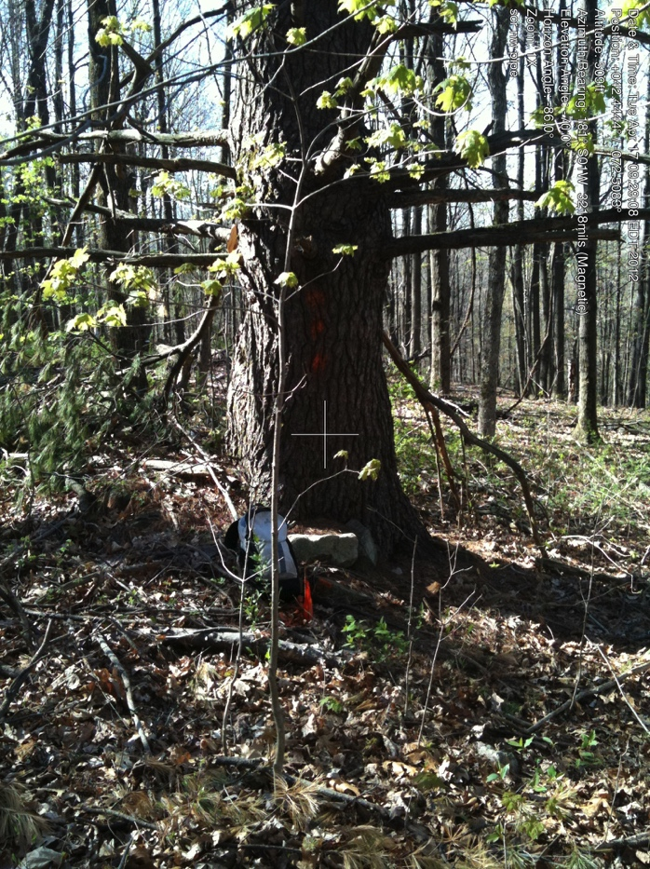

A. NW corner, pipe at tree and at N end of stone wall, Looking W into neighbor’s property.

Note: this is the second almost-parallel stone wall. It runs below/west of dug well which is somewhat farther south.

There is a second pin in the stone wall (“flush in wall”) that has never been found.

42.44456451 -72.50790660
April 17, 2012

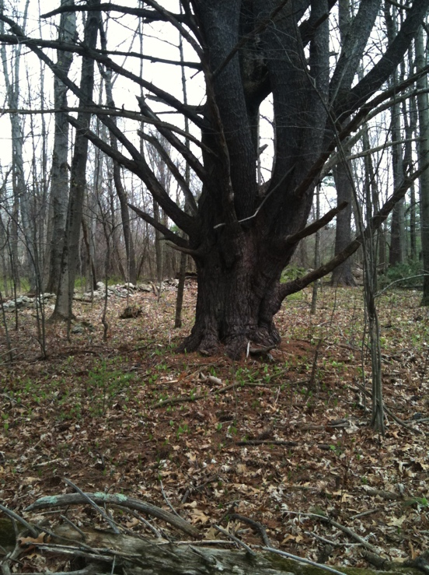

SCR 2012.2

Line A - B west line.
One of the many field-grown pines indicating the past history of the property. (There is a picture of the
same/similar tree in baseline 2003, #1.06).

42.44396939 -72.50726572
April15, 2012

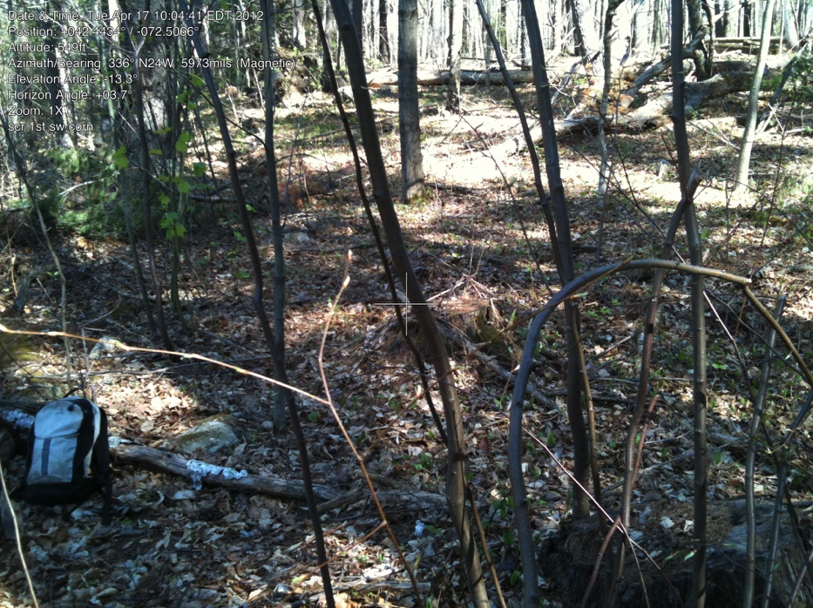
B. looking back more or less
along line.

Taken as close as possible to location of picture below. (Large fallen tree just behind the photographer.)

Backpack where stake probably is in picture below. No stake found (might be under tree)
Close. . . . (arrows to large tree, 2 stumps)

42.44337712 -72.50672693
April 17, 2012

(below) B. “first of double corner, (SW corner) looking back along line.”

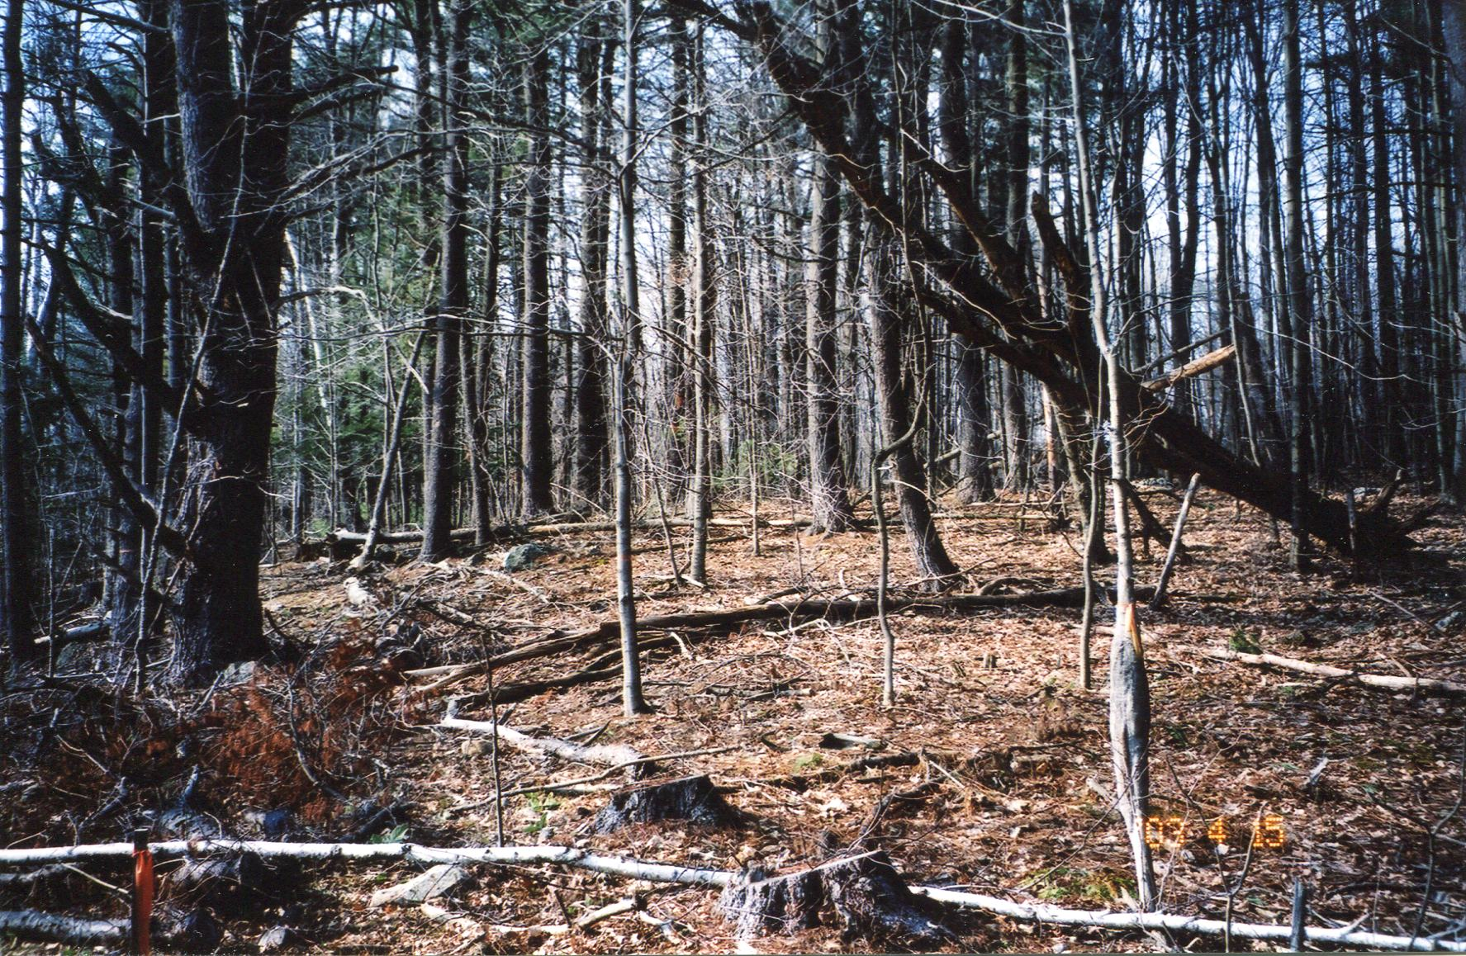

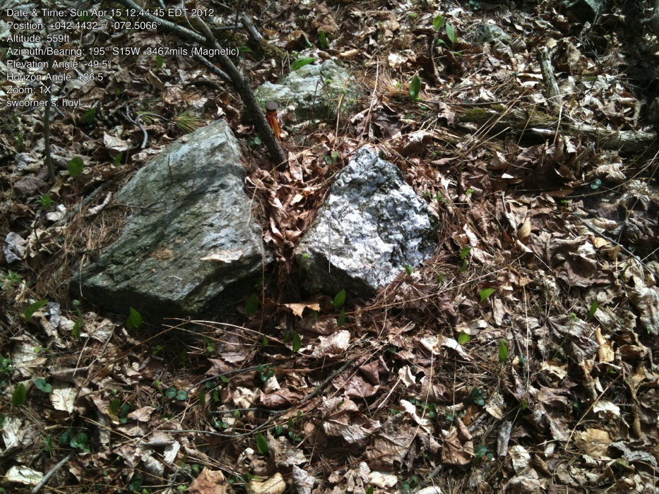

C. Second SW “double corner.” From here trail goes between “slot” with larger cliff-like rock on the right/south.

42.44326724 -72.50658151
April 15, 2012

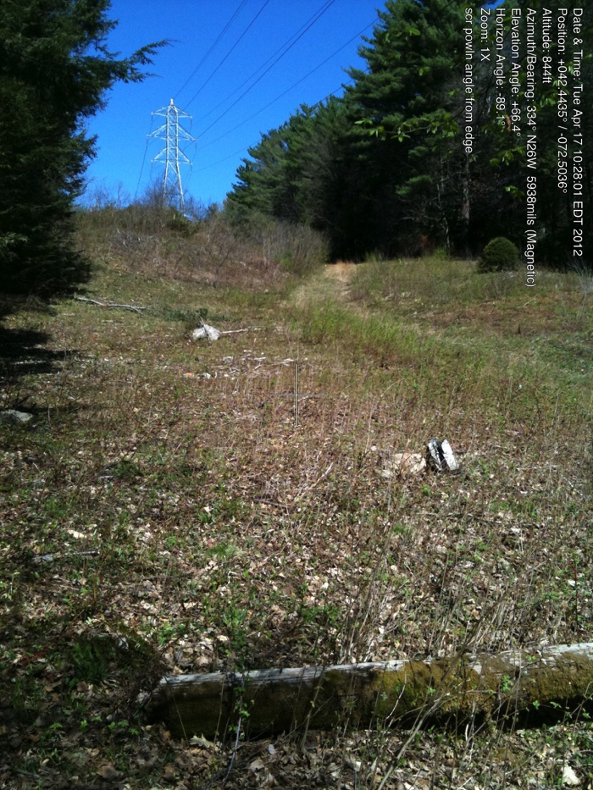
Note: before the powerline is the corner with Teawaddle Hill Farm (D. on map). Since these photos were taken, there was the CR survey for THF. Might provide additional pins and boundary markings.

Line C - E (south)

Photo from the power line looking north into CR. First stone (with orange X) is slightly south of line, Next stones are north of line.

When entering CR on east side of powerline, the woods road is slightly south of line (on Williams/Mitchell property).
Be careful to follow orange-marked line and NOT blue X line of trees to be logged.

April 17, 2012

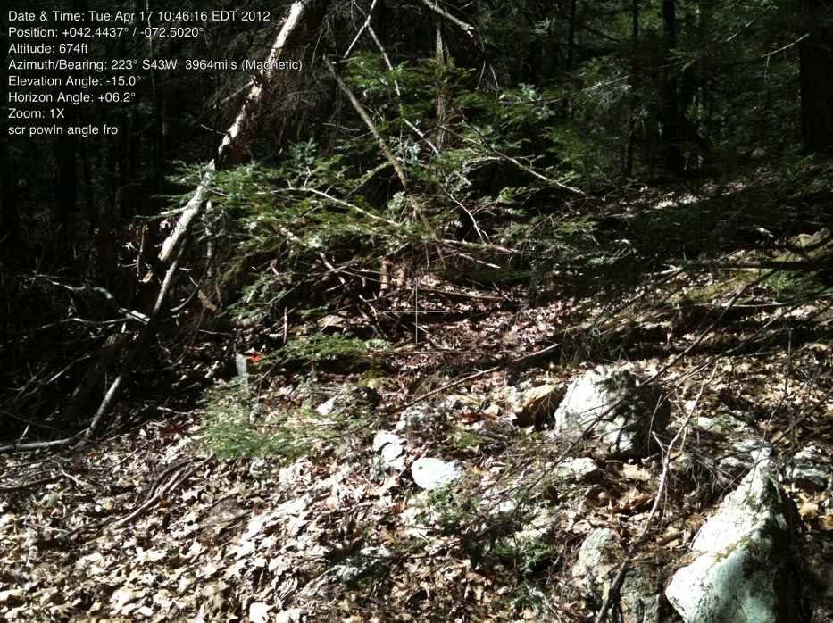

E. SE corner, at downhill end of small stone wall.

Note: label put on picture at time of photograph is incrorect. (Label is the same as previous picture.)

42.44387903 -72.50207280
April 17, 2012

See same corner in baseline 2003 #1.25

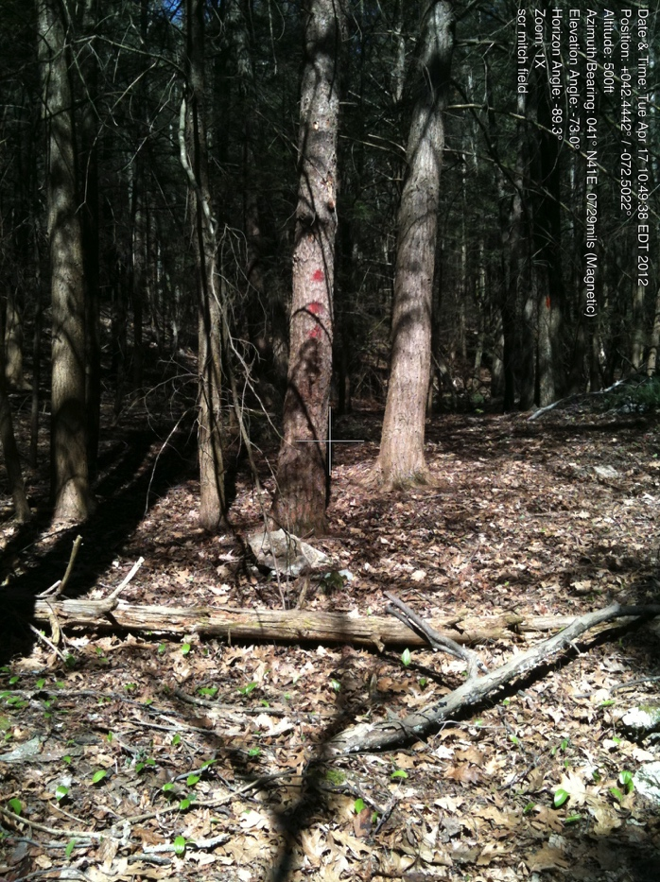

F. Corner along eastern line. This marks slight change in angle (180 to 185 degrees) and also the line between Williams/Mitchell land to the south and C & E Field land to the north.

42.44423468 -72.50224027
April 17, 2012

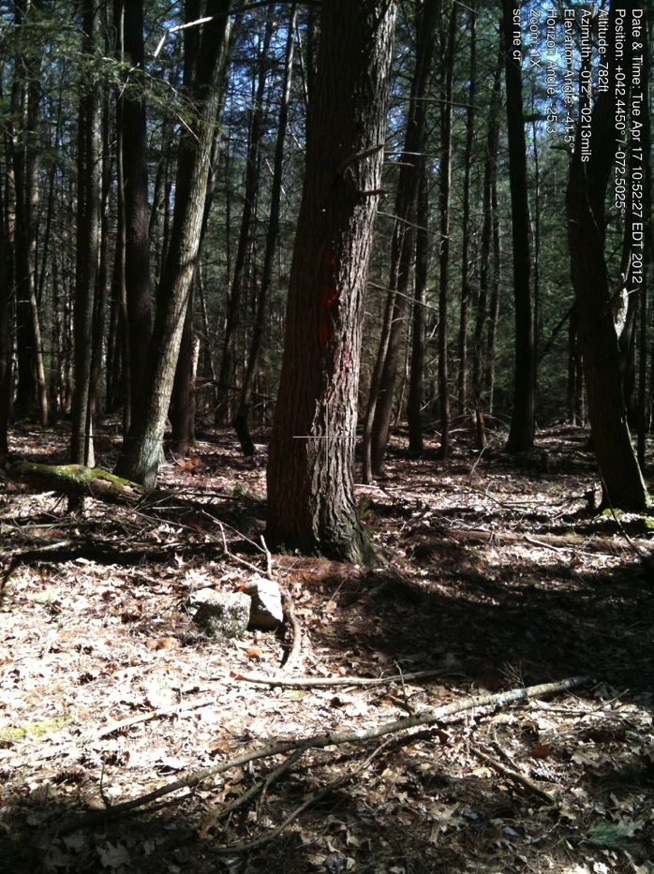

NE Corner
view of pipe in circle of stones

Note orange surveyor’s tape continued along line to north. DO NOT follow it.

42.44489232 -72.50228075
April 17, 2012

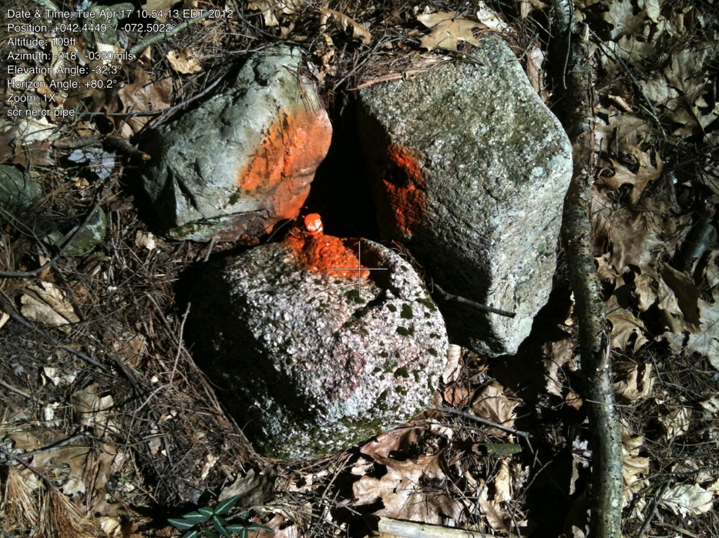

SCR 2012.9
April 17, 2012

pipe up close

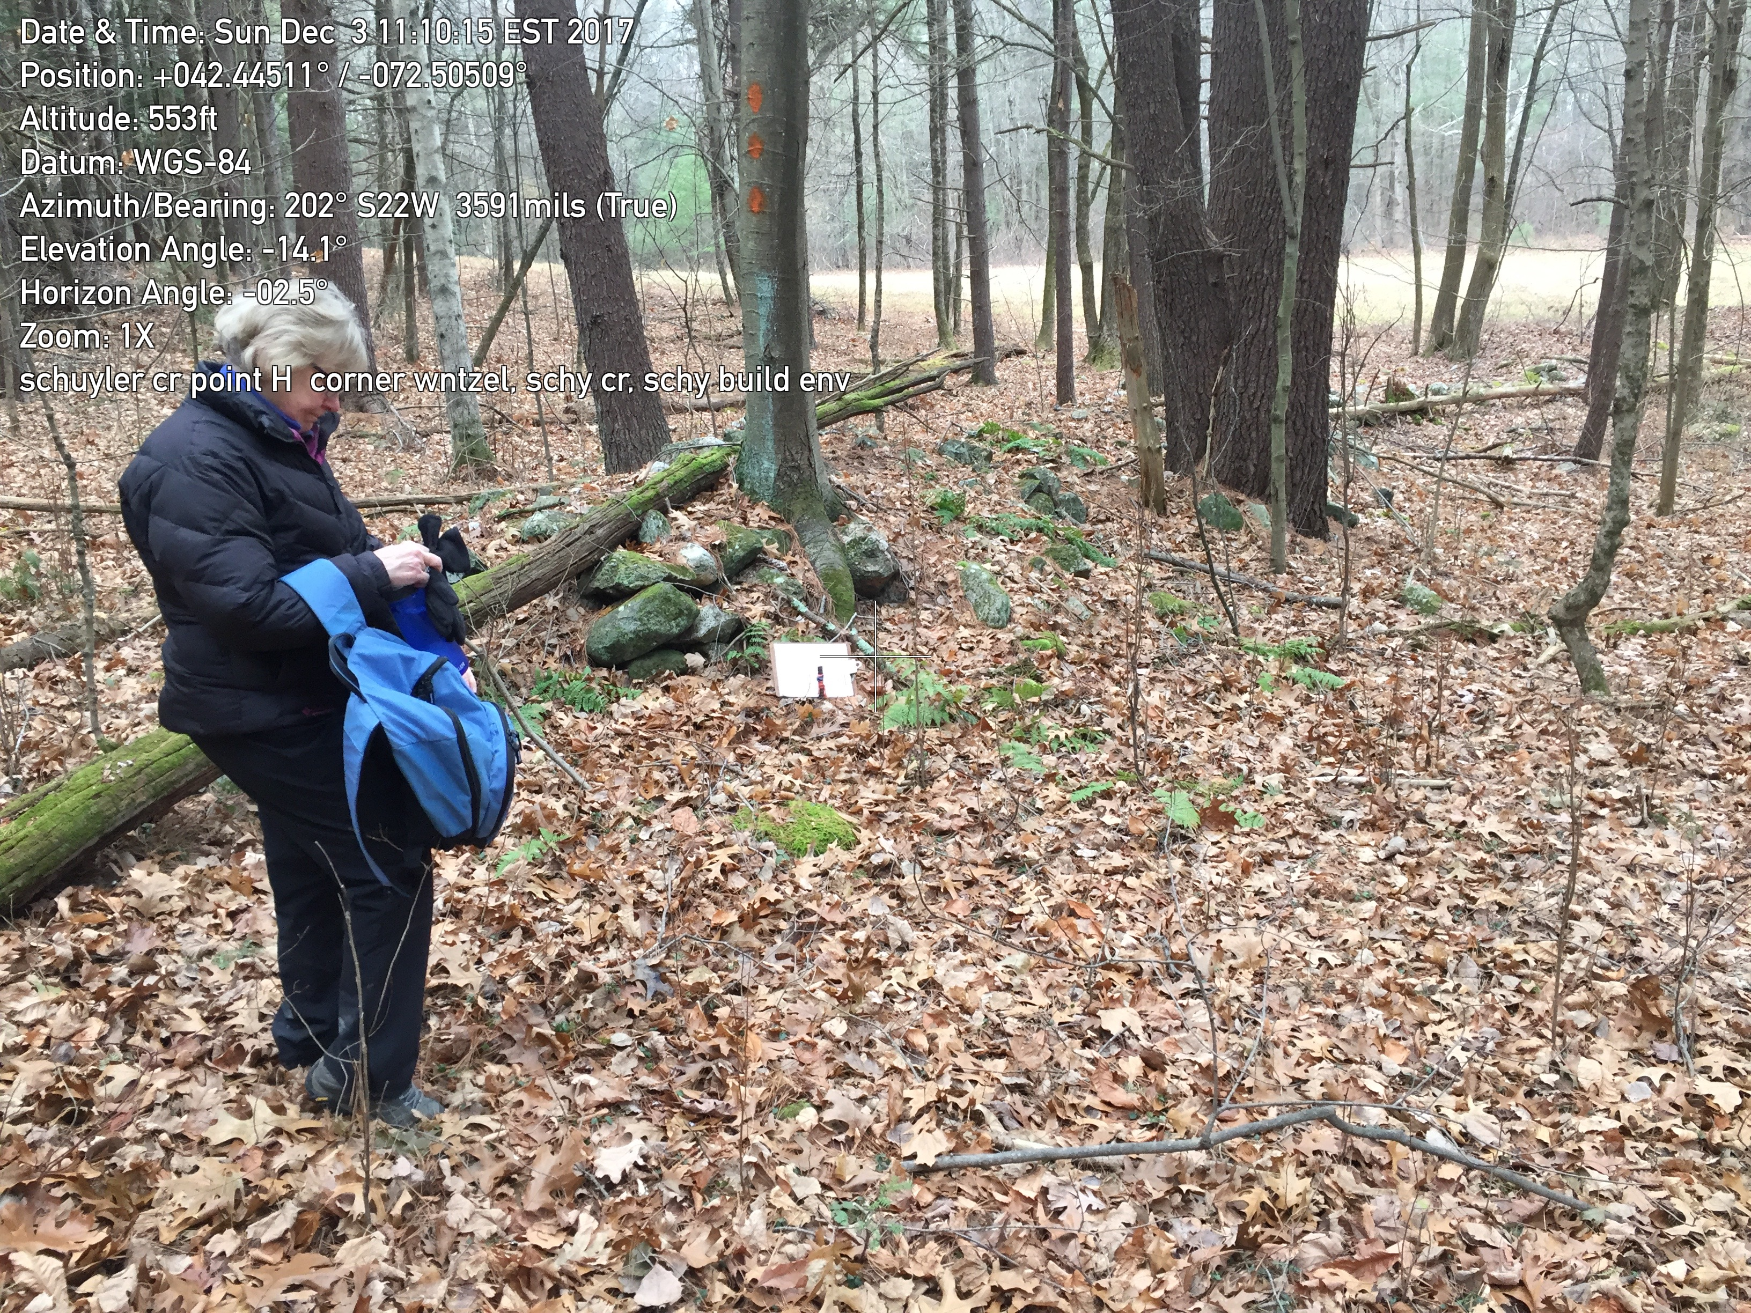
H. pipe at east end of short stone wall
(on north edge, east of powerline

Also see 2003, #2.08

At this point, CR goes west
and the Schuyler line for the land
outside the CR (building envelope
goes north.

Do not follow this stone wall
(which becomes line of rubble,
presumably where power company
equipment flattened the wall).
This stone wall (before the powerline)
angles slightly to the south.

42.44503473 -72.50512783

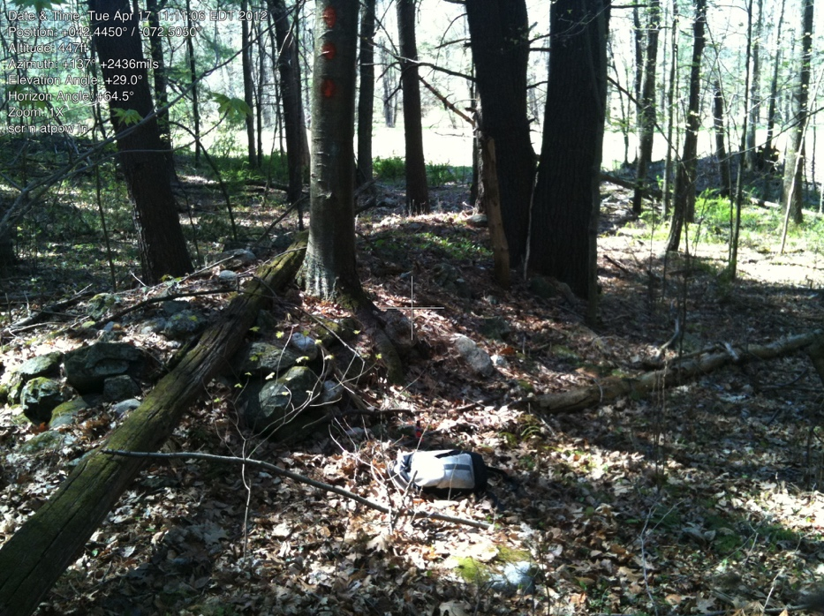

H-A line west of powerline

Looking back/east to power line. along line.
Note: CR line does NOT follow stone wall, but cross the wall. The stone wall goes slightly to the north of the line.

April 17, 2012 (revision
Dec 2, 2017)

