Scheffey photos for monitoring

(Letters used for the corners match letters on the monitoring map.)

Most pictures taken on November 1, 2009

Sequence begins beside Roaring Brook at the Shutebury/Leverett line. It then follows the south line to the west line and back to the Shutesbury Road.

The baseline photographs also include two trips down to the road to follow the old property lines between the three properties that were combined into the Sheffey Conservation Restriction. They are not included in this version

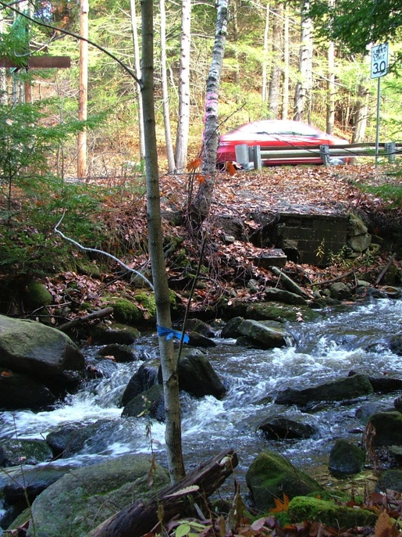

A. East corner

East corner, south side of Roaring Brook.

Town line sign on left

42.4497 -72.4511

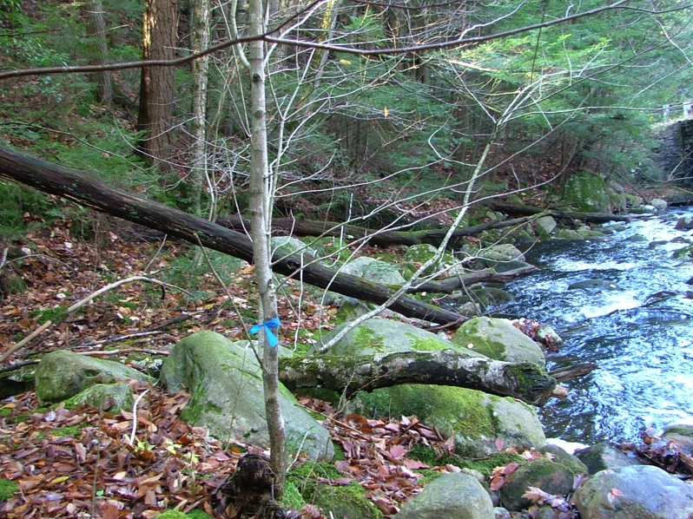

At the east corner looking along line (white tape) to southwest (268 degrees)

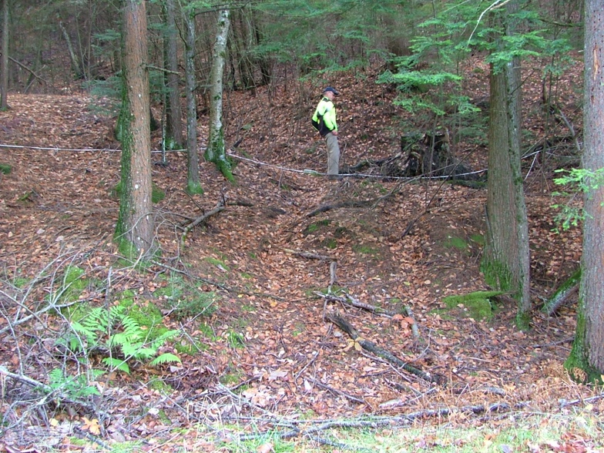

Line A to B

Along eastern section of South line

Short path, dumped stump

looking from the road

white tape (line) in front of stump

42.4494 -72.4519

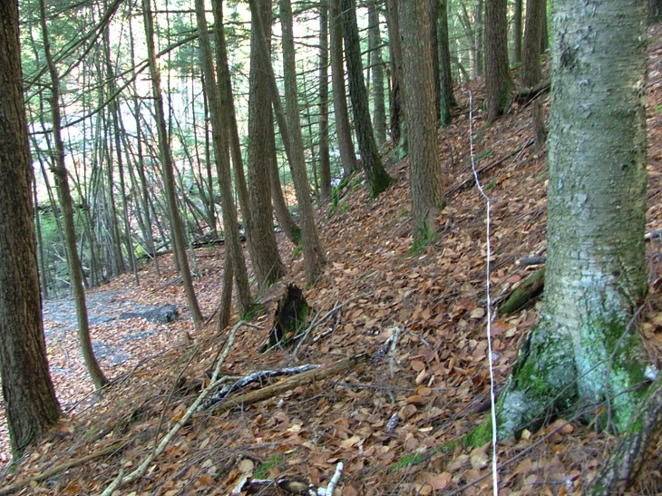

Along east section of South line

Looking back to East corner

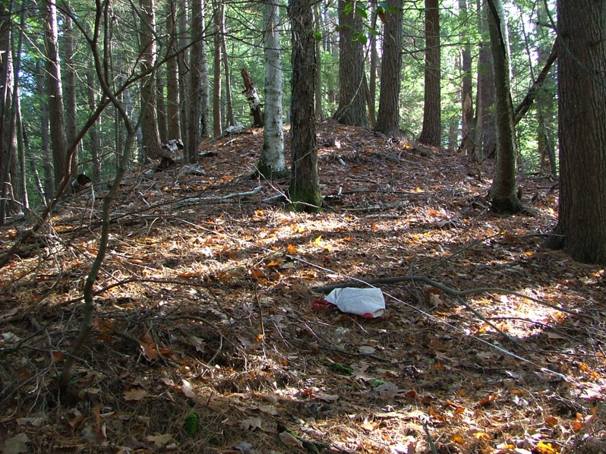

Closer to B, looking northwest from the line to a hillock.

Tape (line) crossing in front.

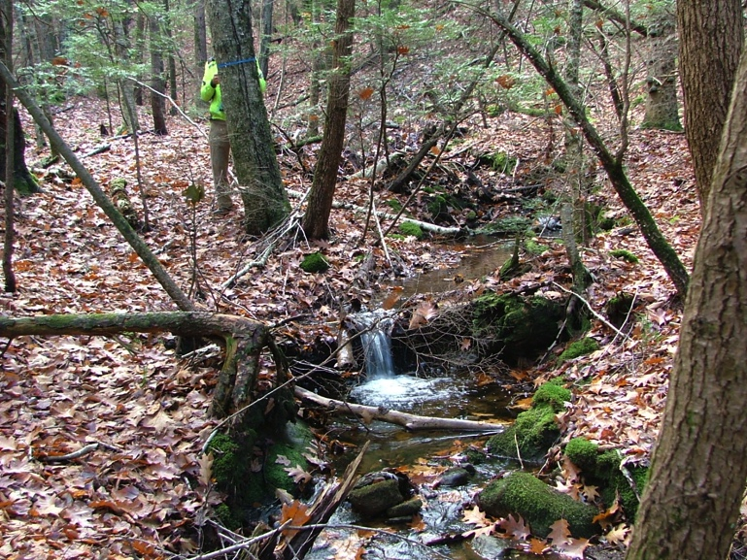

B. Corner between Rodolphus Turner section and the land he mortgaged to Lucy Fitts.

(More photos in baseline and history of ownership in Appendix to Baseline)

angle changes (no pins on north line)

42.4488 -72.4548

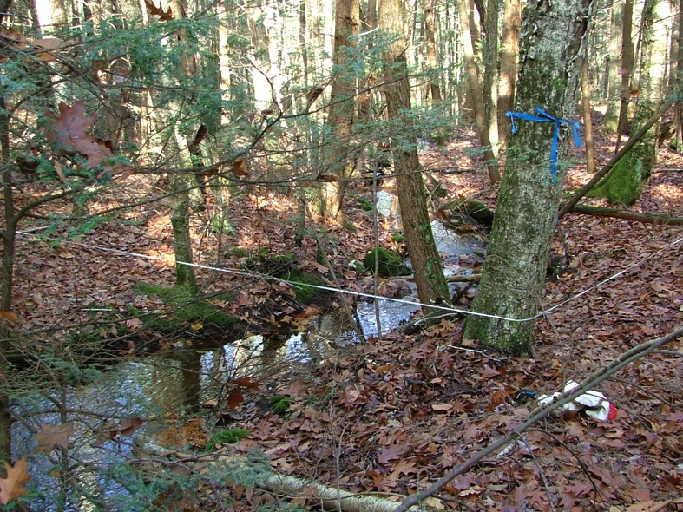

Same corner, looking north, downstream

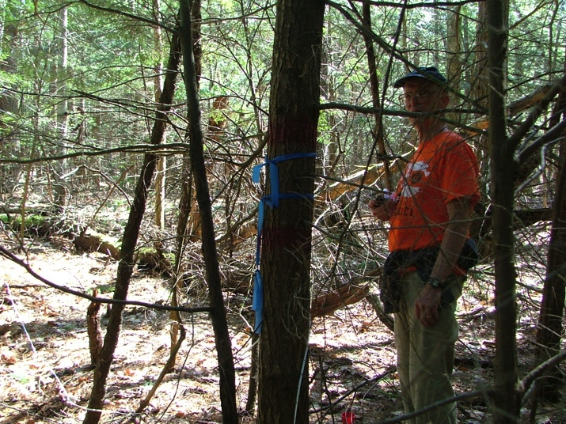

C. Corner of James Fitts and Lucy Fitts (held mortgage on w. half of Turner parcel, see baseline photos and Appendix of old deeds)

Angle change in line.

Corner just painted red, 4/2/2010

42.4491 -72.4587

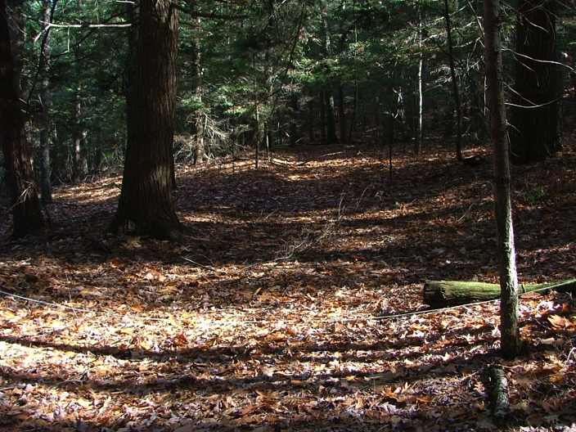

East -West Woods Road

Parallel and north of south line 22 meter

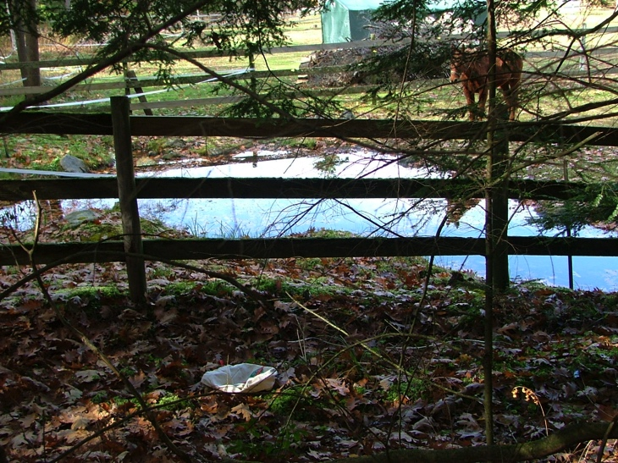

D. SW Corner

Looking west to farm pond

42.4496 -72.4604

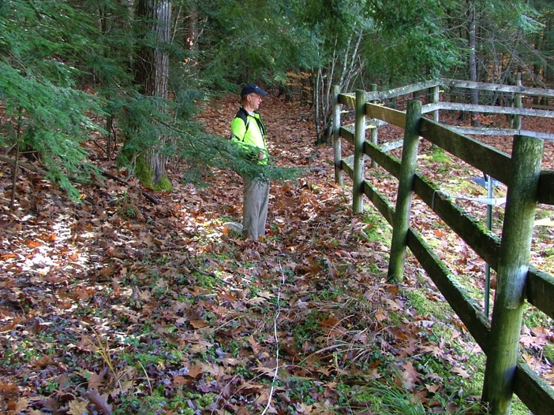

D. looking south

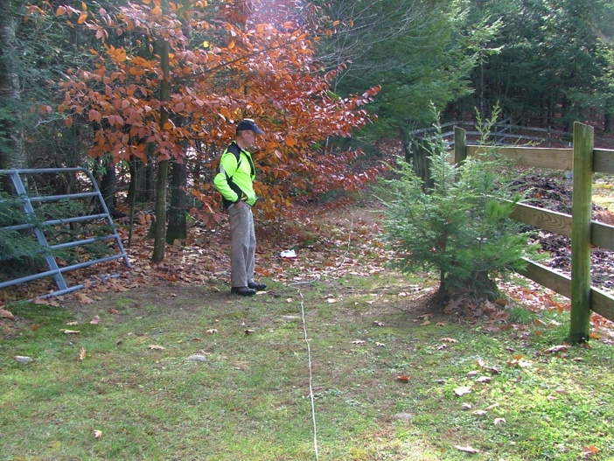

E. corner along west line

Small turn in fence

42.4497 -72.4602

F. NW Corner along road 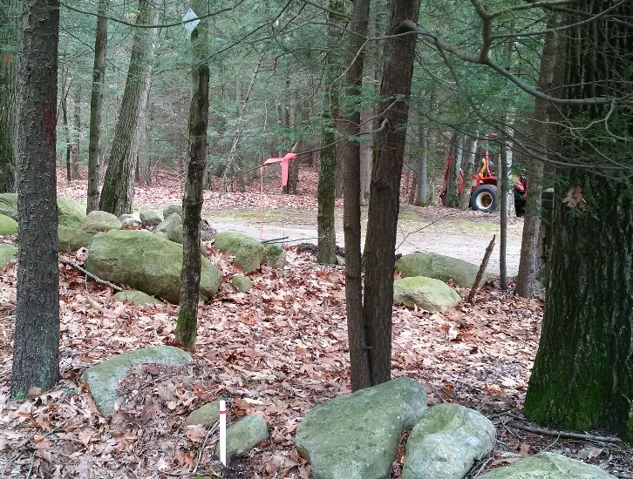

plastic post (deed says iron pin)

looking southeast

42.4503 -72.4600

(photo taken DEC2015)

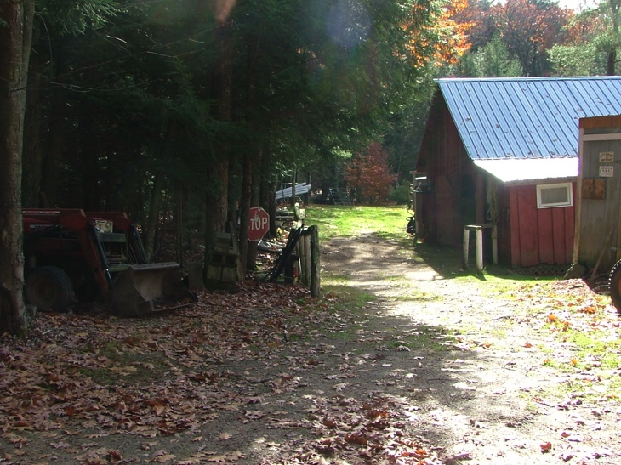Just south of F, looking south

line goes just beside the barn. (Right of way

for neighbors to have farm access.)

(north line follows Shutesbury Road)