Rattlesnake Hill CR Photos for Monitoring, part 2, H to K

(letters used for corners match those used on the monitoring map)

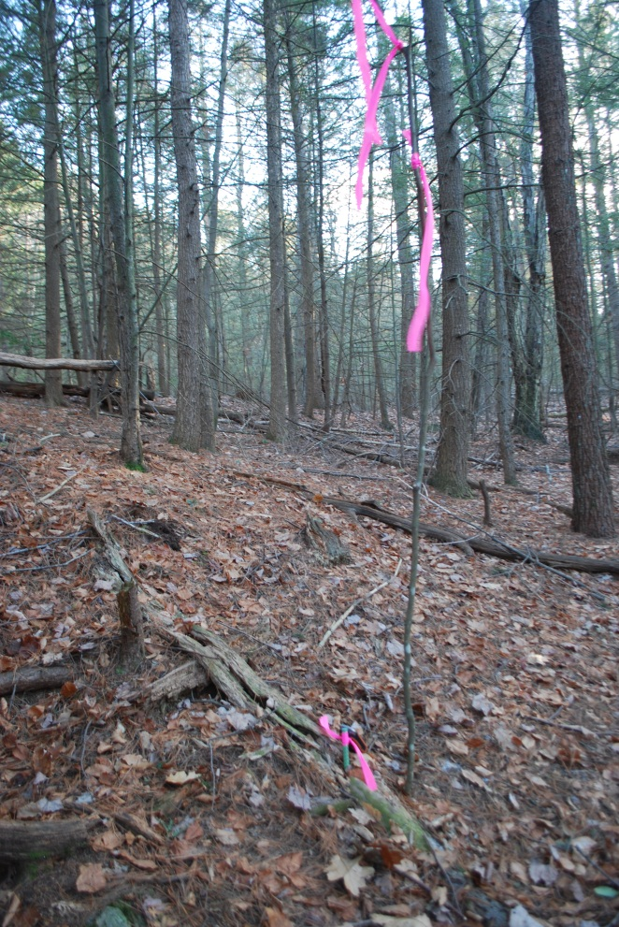

H. Survey pin H, NW corner

42.491033, -72.484433

Pin looking back along the line (south)

12/8/2010

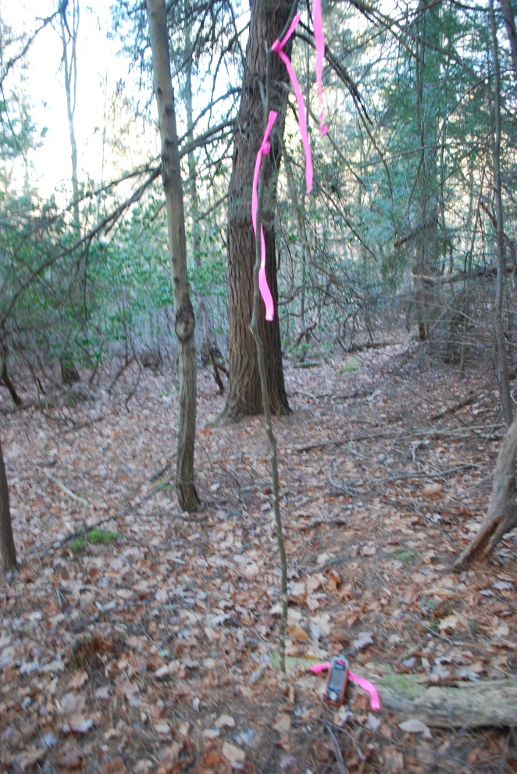

H. View from survey pin looking east along the line toward the next pin (I) 12/8/2010

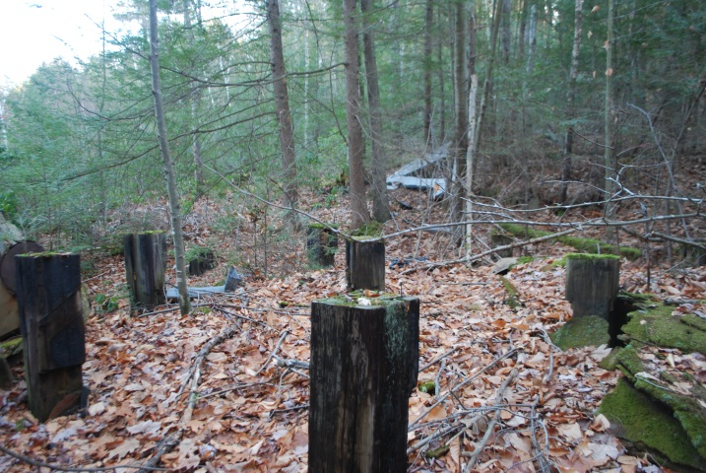Near H -I line. Remains of building (see Baseline: Land History).

42.49100268, -72.48407518

Looking east, property line to the left.

12/4/2010

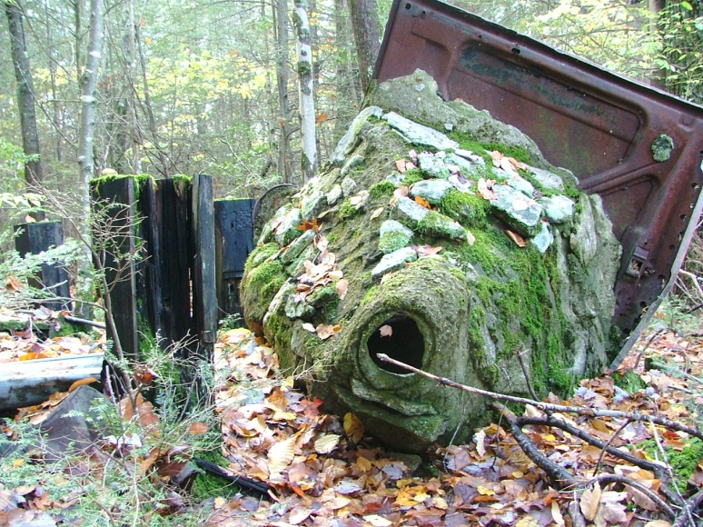

Same area, looking west

10/20/2011

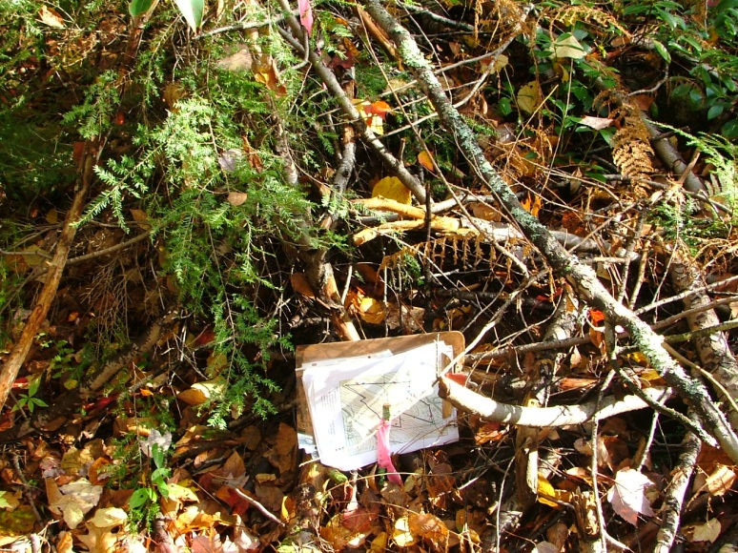

I. Point at back of Berry house/yard. Below view to the west, in the area cut to maintain that view.

42.49091567, -72.48363362

Pin, 10/20/2011

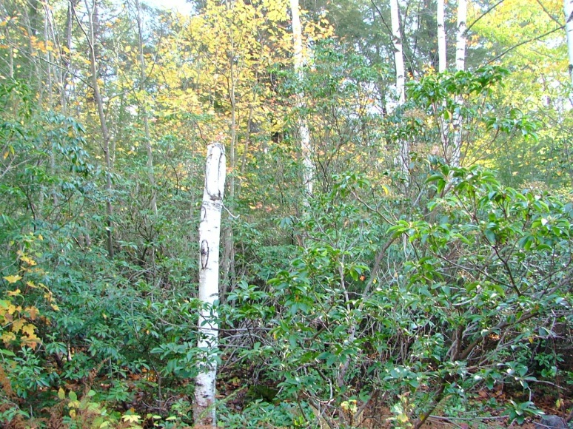

I. Looking west along line from pin.

Recent growth makes finding pin (and walking) difficult.

10/20/2011

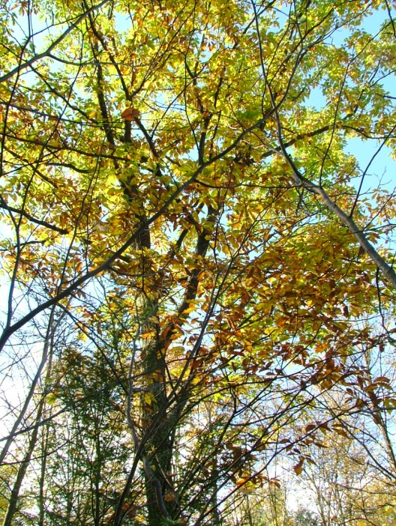

I. On the line (south of point) is a 12 inch diameter oak that is included in the survey. Photograph is taken looking west.

10/20/2011

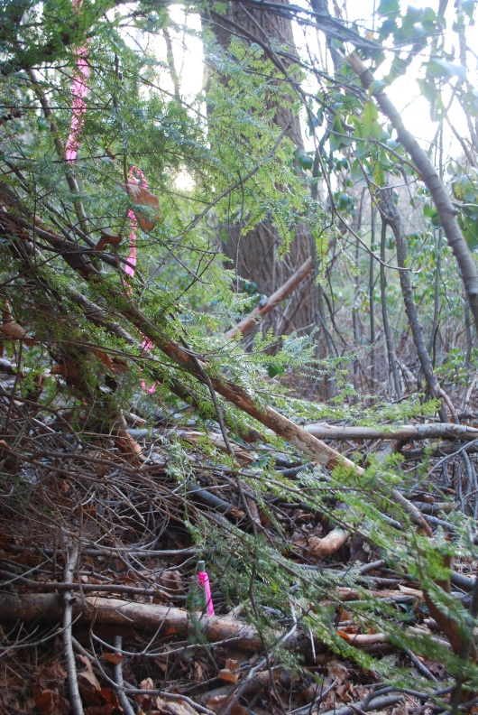

J. Survey point J, also behind Berry house/yard and also in area cut to maintain the view from the ledge above.

42.491100, -72.483350

Pin in new growth area. Finding the pin

is difficult. Looking southwest to large tree on

the line. 12/08/2010

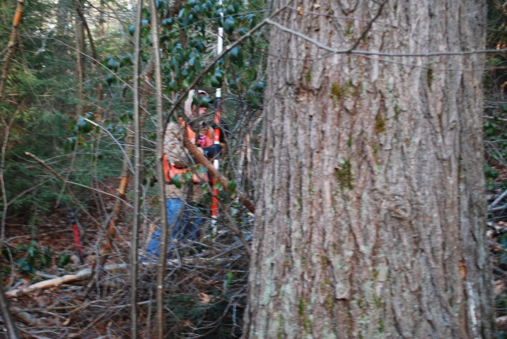

J. Surveyor at pin. Looking east from other side of the same tree. 12/08/2010

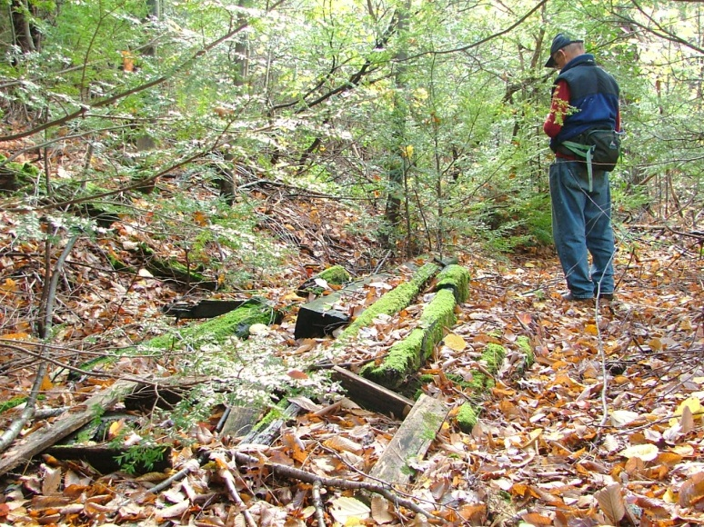

J-K line

Pile of railroad ties. Looking southwest along line. The line goes just to west/right of the stack of ties.

42.49126771, -72.48326423

10/20/2011

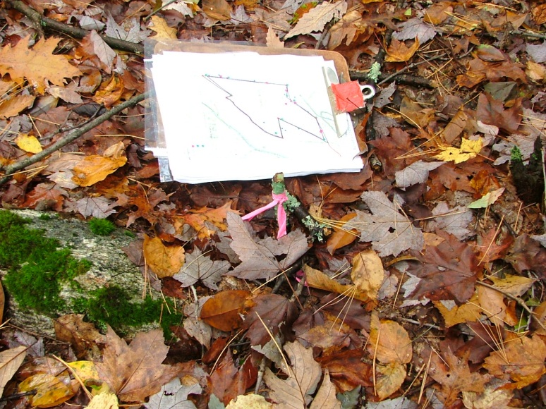

K. Survey point K, west corner of north line.

42.491983, -72.482300

10/20/2011

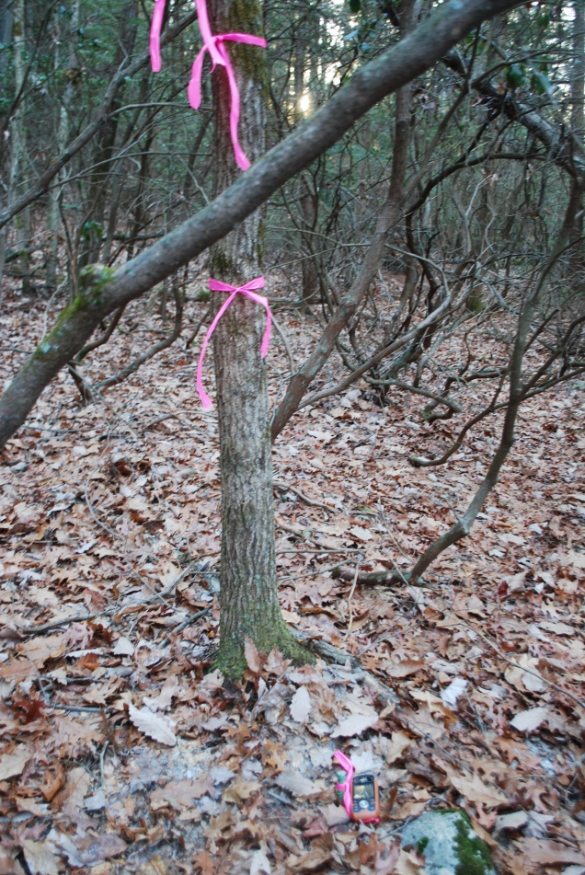

K. Pin just behind gps unit.

Looking back along line toward

Point J (southwest)

12/08/2011

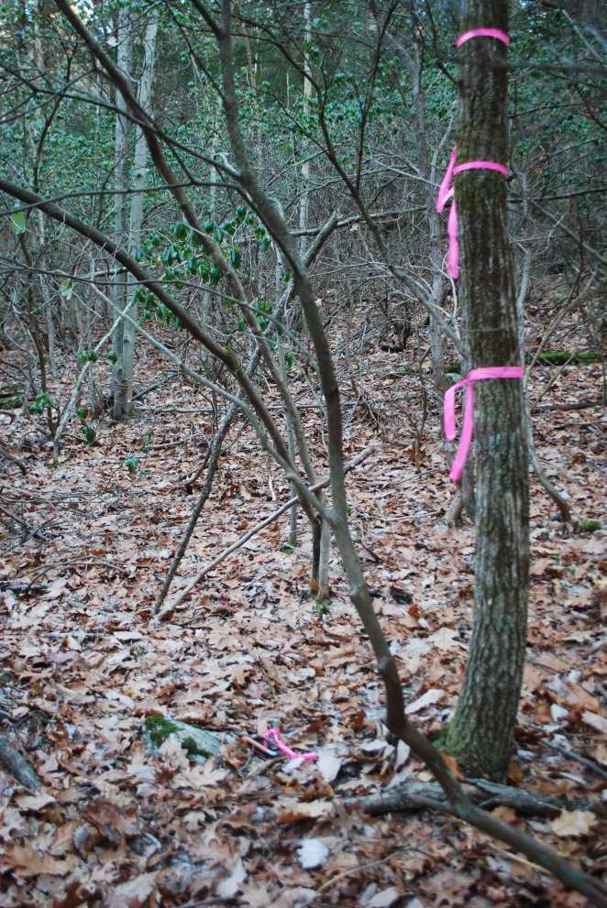K. Pin is just to left of tree with

corner ribbons. Looking east, uphill

from corner toward dump 12/08/2011

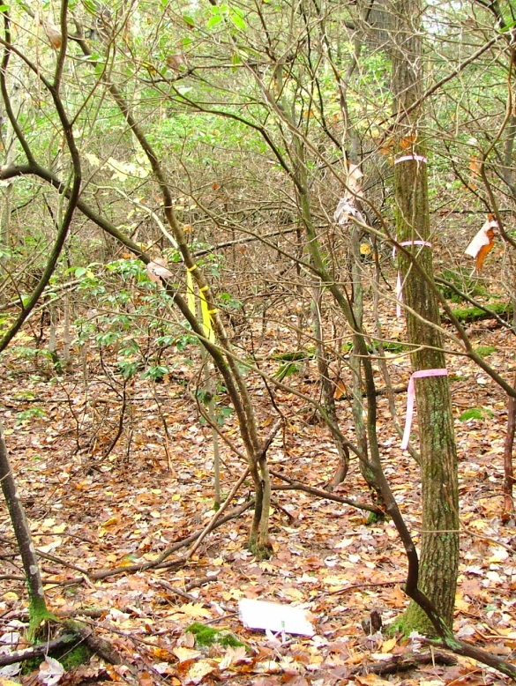

K. Same view with faded pink ribbons and haze of green leaves (illustrating the importance of painted corners and boundary line).

10/20/2011

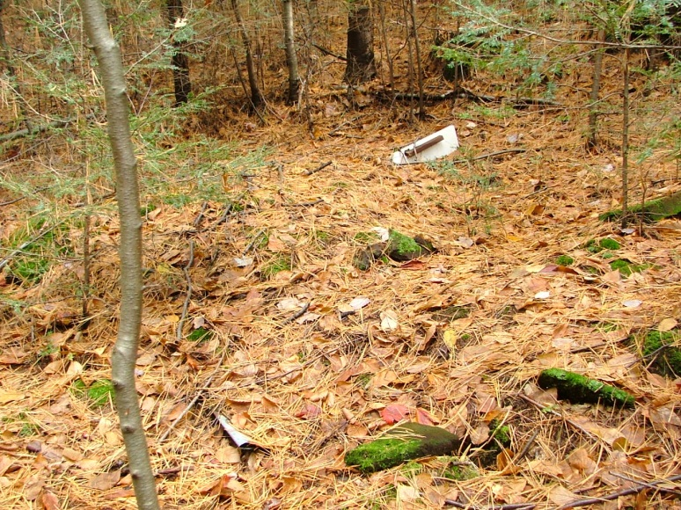

K5. Household dump

42.49208227,-72.481474.

Looking east. Some materials are on Rattlesnake Hill, most is to the left/north of the line on Berry property.

10/20/2011

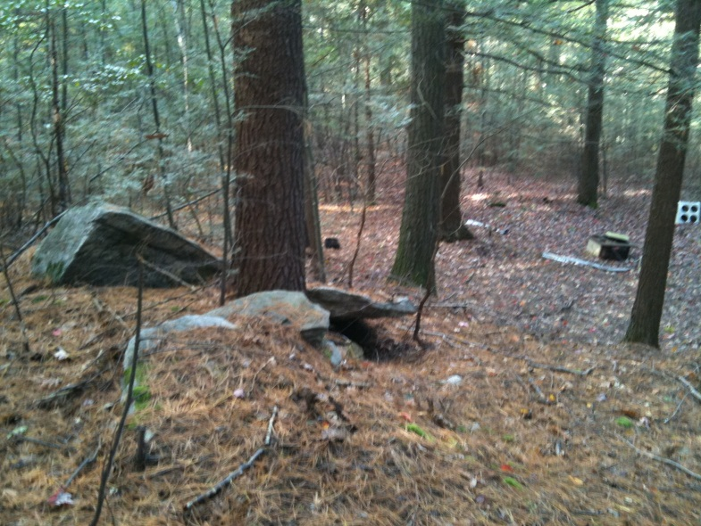

K6. Same area looking west

The property line (pins A to K) is just south/left of the triangular rock. Again, most of the materials are on the Berry

property. There are additional abandon materials on the CR (see baseline for some photos). 10/16/2011