Mosher photos for monitoring, part 2 south side

(Letters used for corners correspond to letter shown on monitoring map)

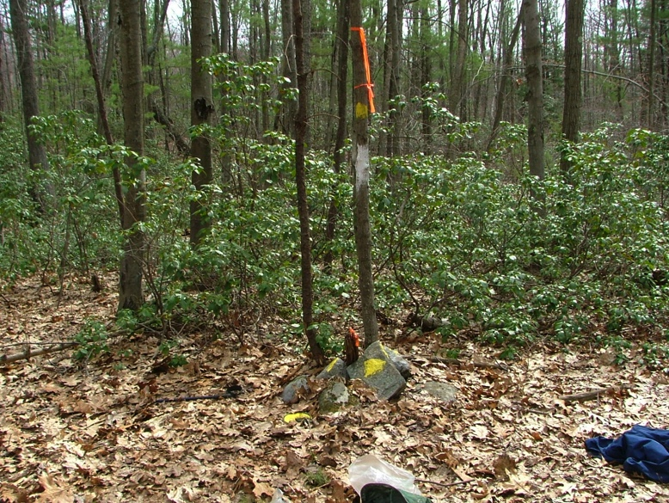Mosher: D-F

D. Mosher southwest corner

Smith/Mosher/Kosloski corner

stake and stones 4/21/2005

Note: Eva's 2014 photo looks different

check on the ground.

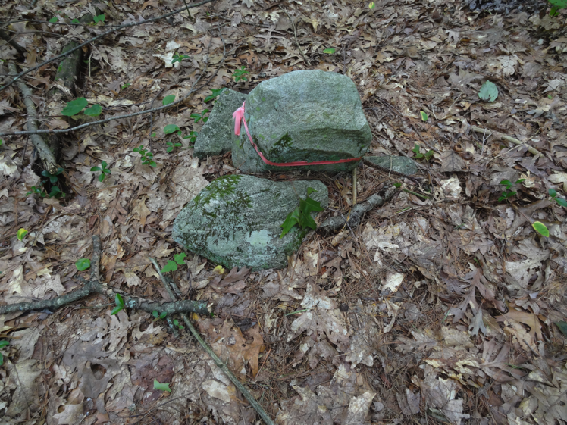

Eva: 2014 - see above

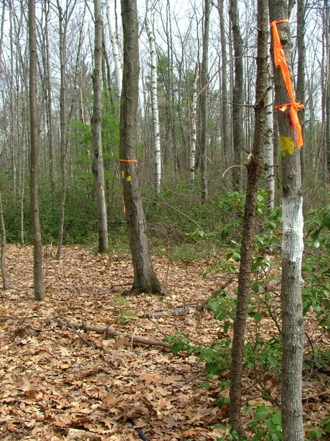

D. Smith/Mosher/Kosloski corner

looking north

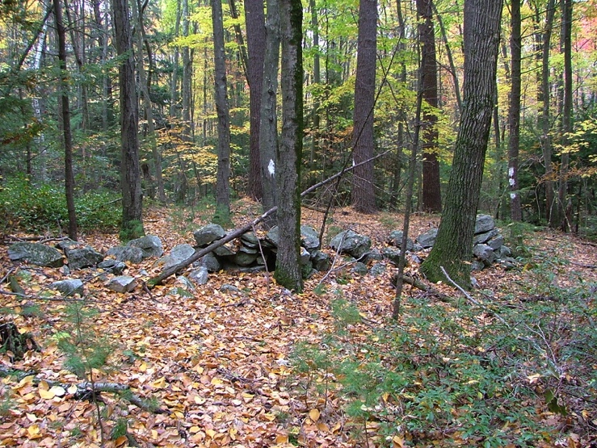

E. Mosher/Smith “inside corner

10/22/04

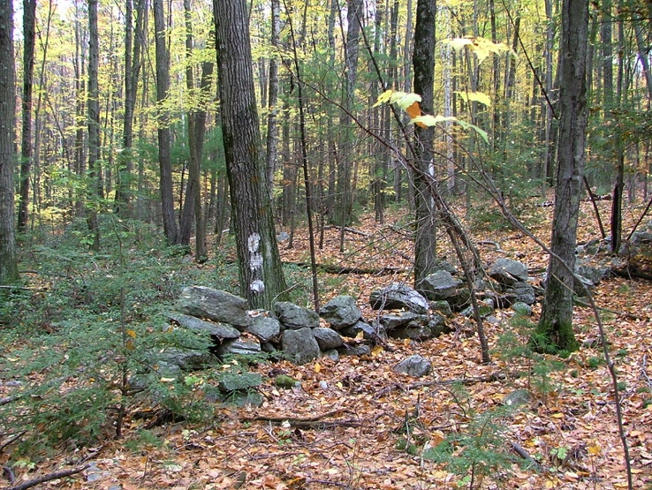

Looking north at same “inside corner”

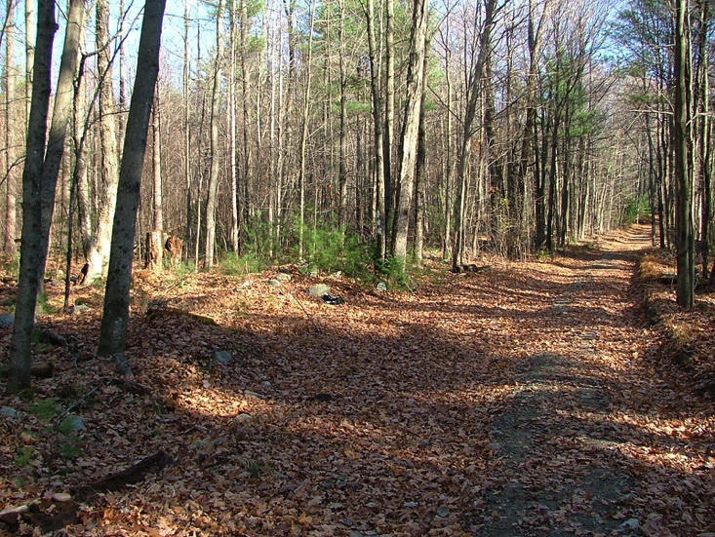

F. Mosher southeast corner

smith/mosher/rat hollow road corner, looking east

11/07/2004

42.44972, -72.4787

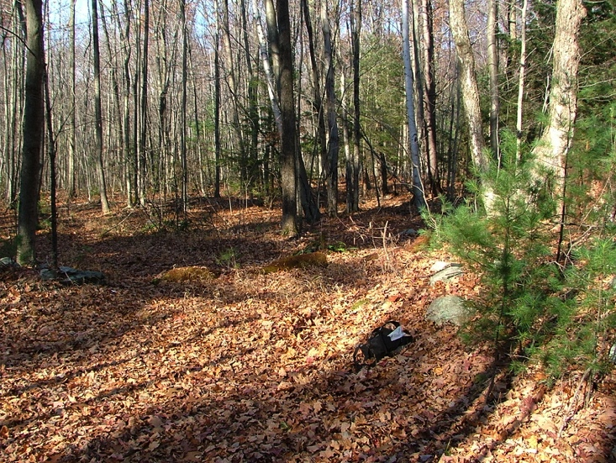

F. Smith/mosher/rat hollow road corner, looking north

11/07/2004

Can see opening in the stone wall