Mosher Conservation Area: Photos for Monitoring, part I (west, north, east sides)

Note: There are excellent photos in the 2010 and 2011 monitoring reports, but they are not labeled. Need to match on the ground or take new ones.

A. No photograph found. Corner is right at edge of Cowl's woods road. Road work may have destroyed pin - has never been found.

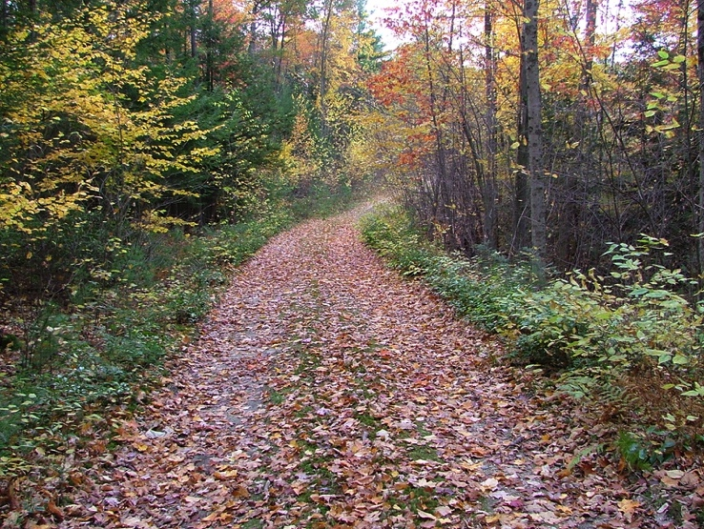Mosher: B to A (and lines east, north, west)

Looking south from B

Along Cowls Road

10/22/04

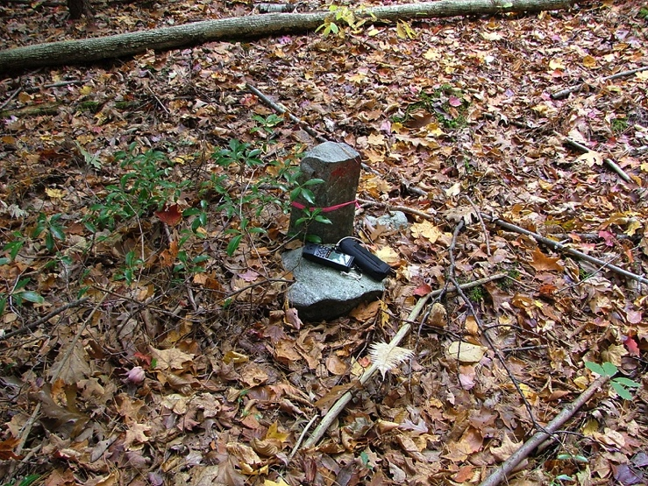

B. Cowls line Stake and Stone

10/22/04

stake is just beyond culvert.

42.45315, -72.48013

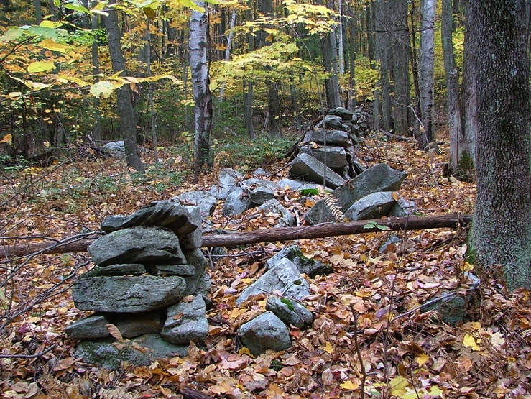

B to C: North Line

Cowls/Mosher line, stone wall

10/33/04

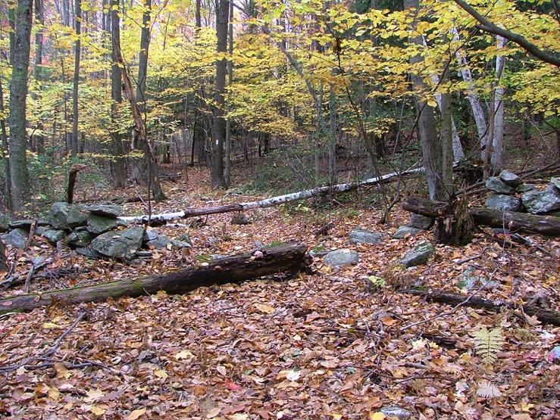

Opening in stone wall

(M-M Trail used to go north into Cowls property)

10/22/04

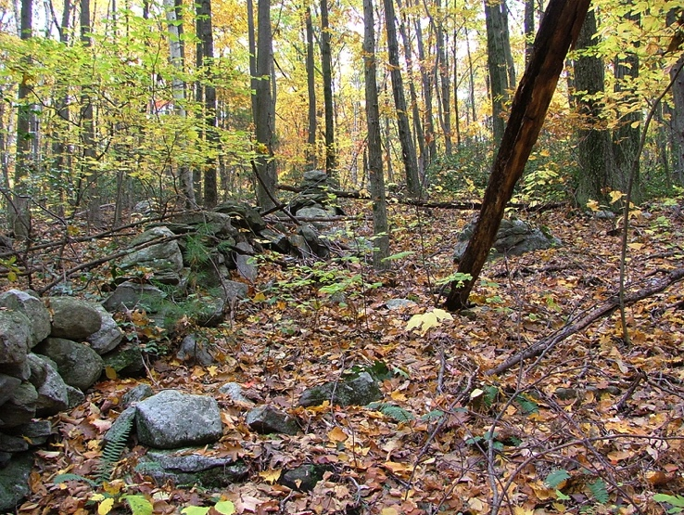

Stone wall along Mosher/Cowls north line

10/22/04

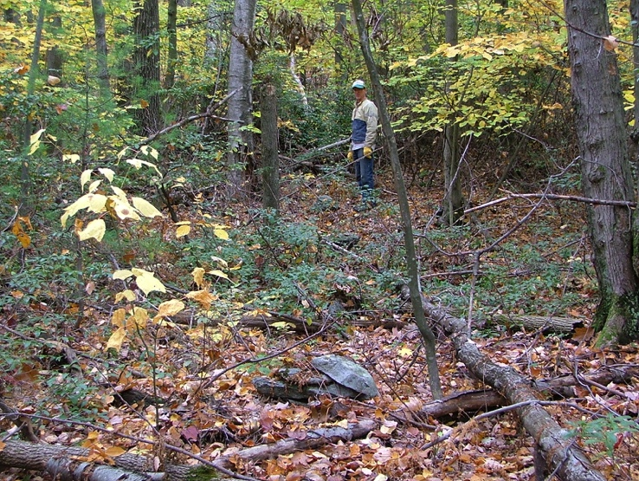

Cowls/Mosher north line

Stones for Virginia rail fence

10/24/04

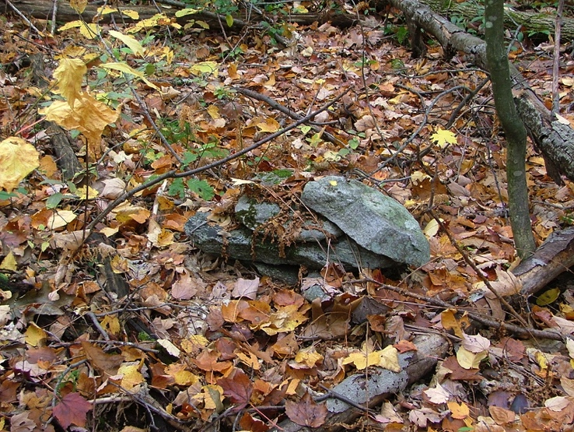

Example of stones used as base for Virginia Rail Fence

10/22/04

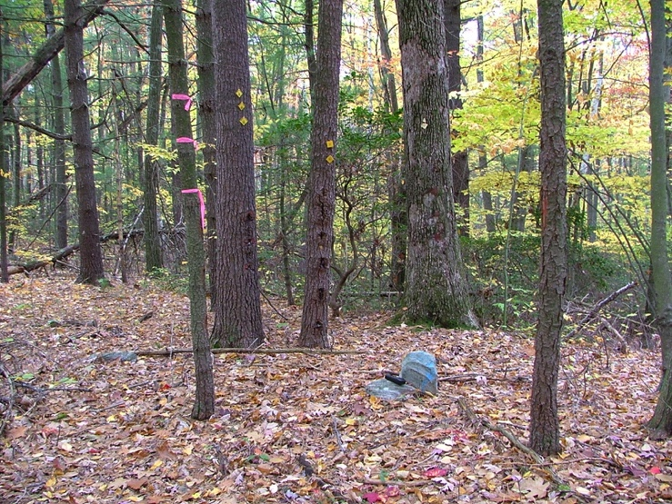

C. Mosher NW corner with Cowls/Kosloski

10/22/04

42.45366, -72.47515

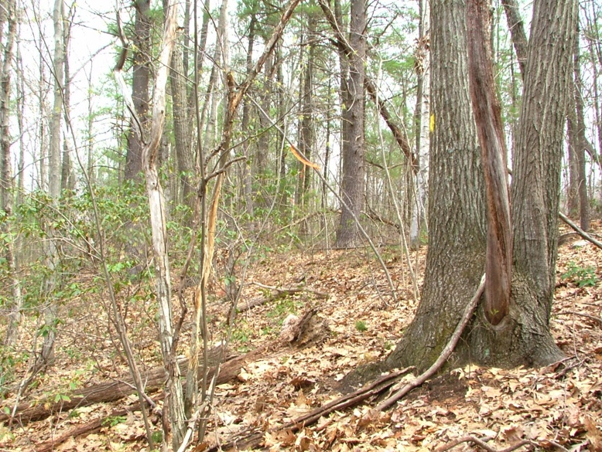East Line: C to D

On Kosloski/Mosher line (Mosher east line) northern part, looking north

4/21/2005

line (195 deg) marked by yellow paint

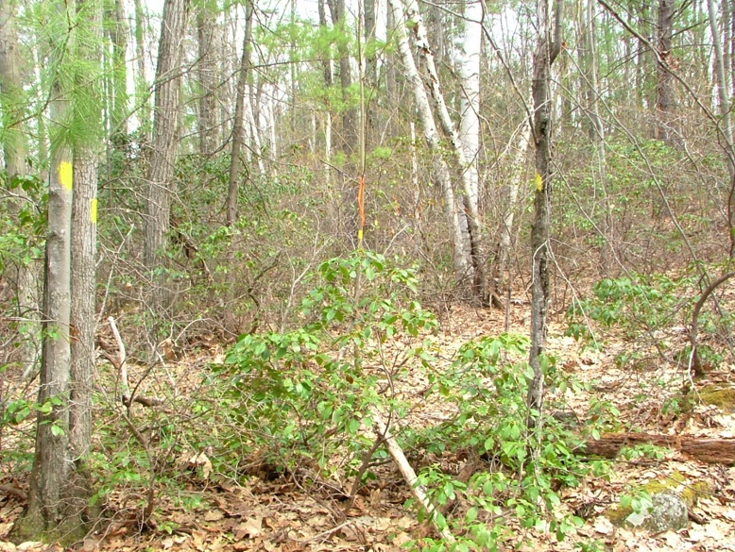

On Kosloski/Mosher line

(Mosher east line)

southern part, looking north

4/21/2005