Long Hill Natural Area photos for monitoring, part 3, east side, W-GG

(Letters used for corners match those used in the monitoring map)

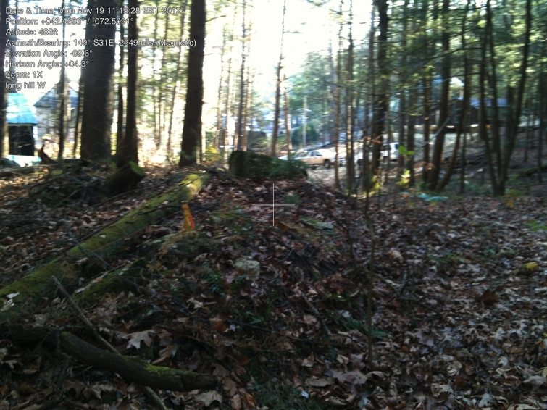

Long Hill: W to GG

W. Iron pin at edge of road/corridor leading to Camp Road. NW corner of Camp Rd tongue.

42.45954347 -72.50931485

gps: 11/19/2012

photo: 11/21/2012

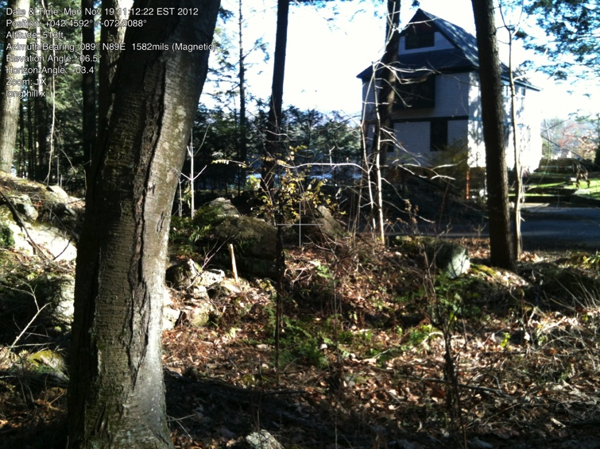Note: there is an iron pin between W and X. Not seen recently and does not need to be.

X. Iron pin (in lowers rocks)

Near (not on) Camp Road.

NE corner of Camp Rd tongue.

42.45928321, -72.50877438

gps: 4/20/2012

photo: 11/19/2012

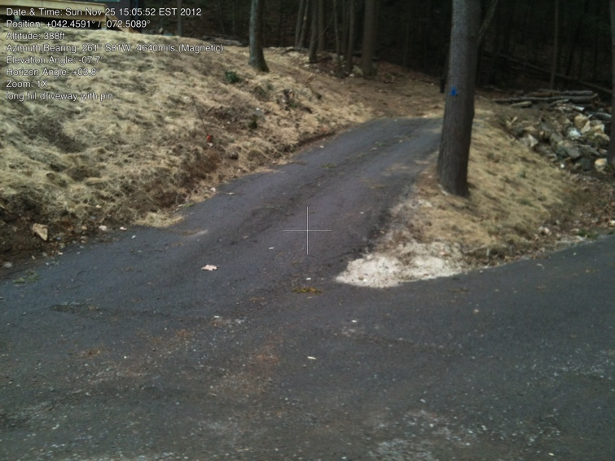

Y. Iron pin along left bank just above new driveway/lawn. (This pin is much farther to the left/south than one would expect (the woods road is visible on the right). However it does line up with the ip between Y and Z (see next photo). And they both line up with Z. This is SE corner of Camp Rd tongue.

42.45913141, -72.50878017

gps: 11/25/2012

photo: 11/04/2012

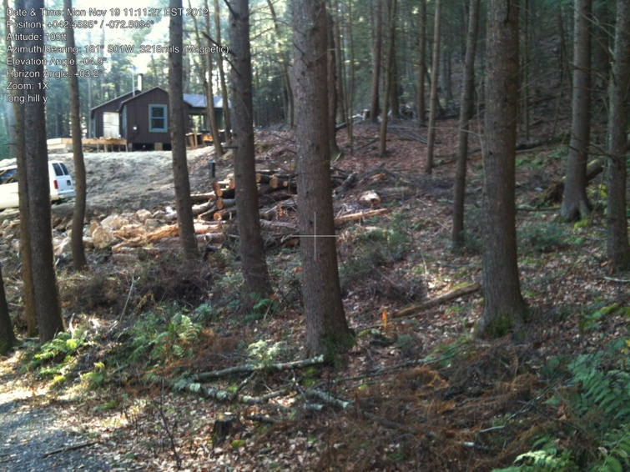

IP between Y and Z (between first two trees).

photo: 11/19/2012

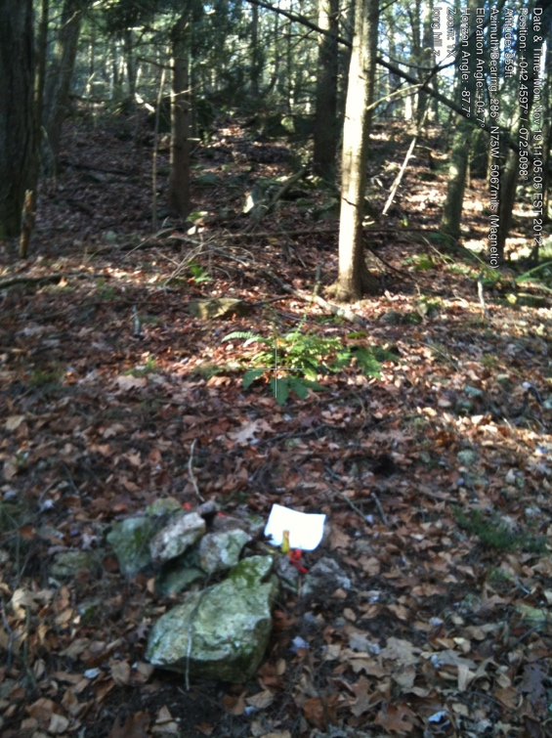

Z. Iron pin at the SW corner of the Camp Rd tongue.

Note: this pin is set north and west (uphill) of the wood road. The hiking trail that goes behind the houses on Camp Road is on the neighbor’s property at this point.

42.45951866, -72.50964325

gps and photo: 11/19/2012

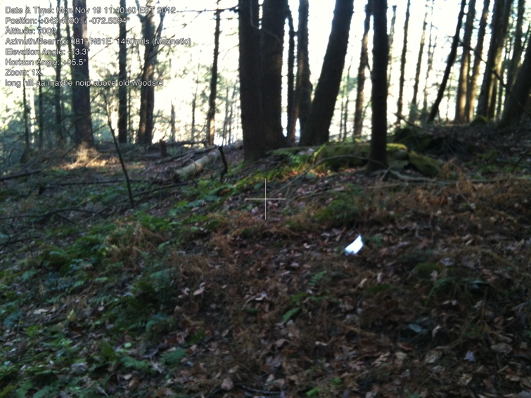

AA. This is near BUT IS NOT the iron pin. Photo taken from the trail. (Memory says we found once, but memory may be wrong.)

42.45887300, -72.50948718

gps and photo: 11/19/2012

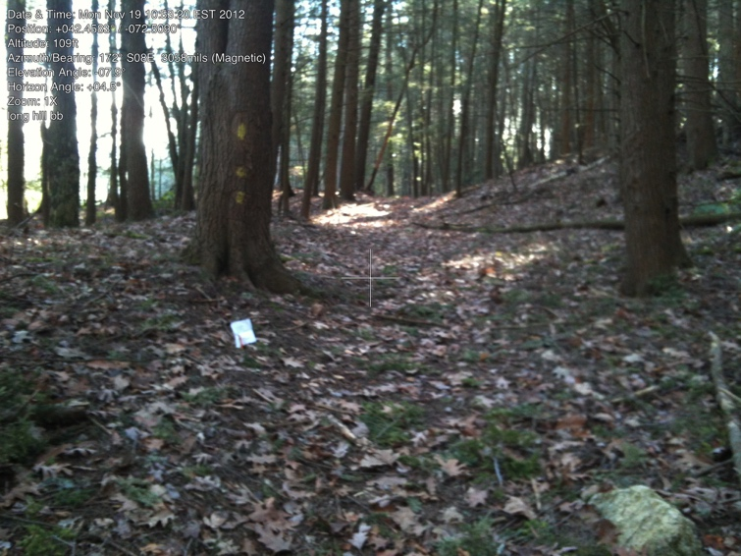

BB. Iron pin just beside (to east of) trail. Pin in front of white paper. Photo looking south along trail.

42.45842809 -72.50921837

gps: 11/4/2012

photo: 11/19/2012

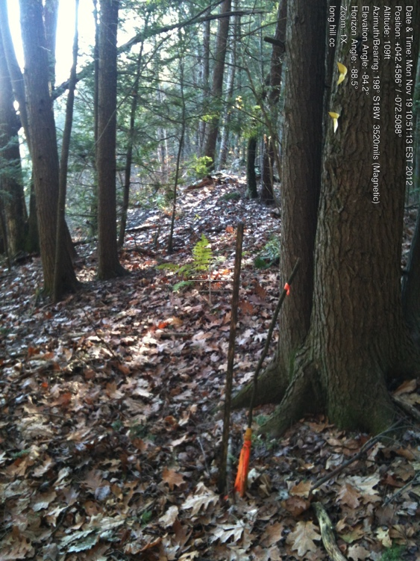

CC. Iron pin well to east of trail. Open land (only foundation left from earlier house) below to southeast.

42.45814277, -72.50883138

gps and photo: 11/19/2012

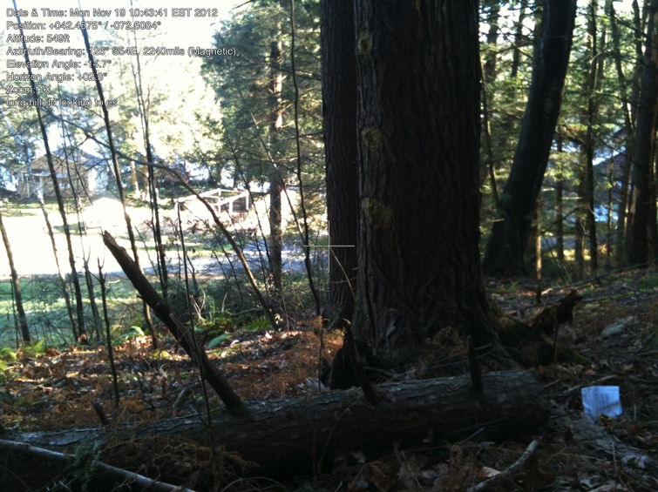

DD. Iron pin just above/uphill/west of CC. Just near/east of trail

42.45760054, -72.50838622

gps: 11/20/2012

photo: 11/19/2012

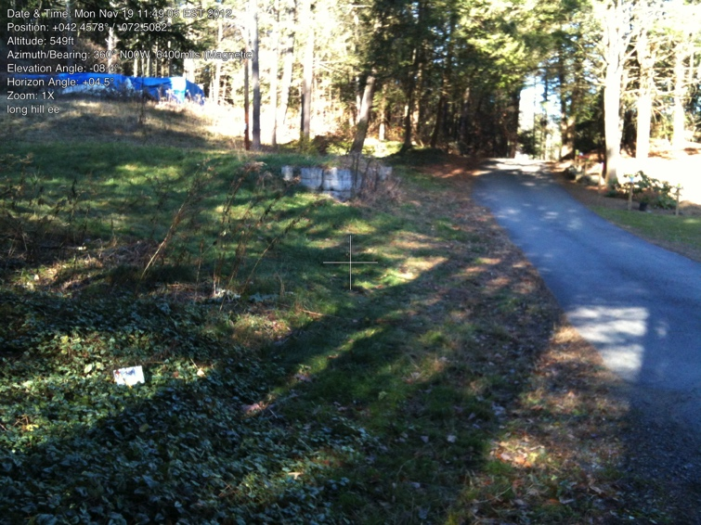

EE. Iron pin to west of Camp Road. (Pin just in front of paper). Blue plastic covers foundation of earlier house.

42.45762913, -72.50809025

gps: 11/4/2012

photo: 11/19/2012

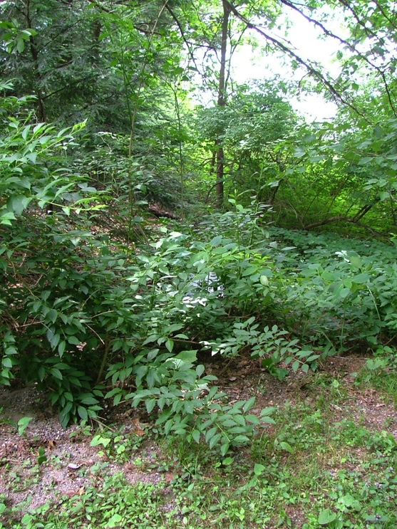

FF. North corner of pond-side section.

Looking southeast to pond. Pipe is just in front of white paper. Poison ivy in front AND back. Taken June 8, 2010, 001

42.45642389 -72.50795379

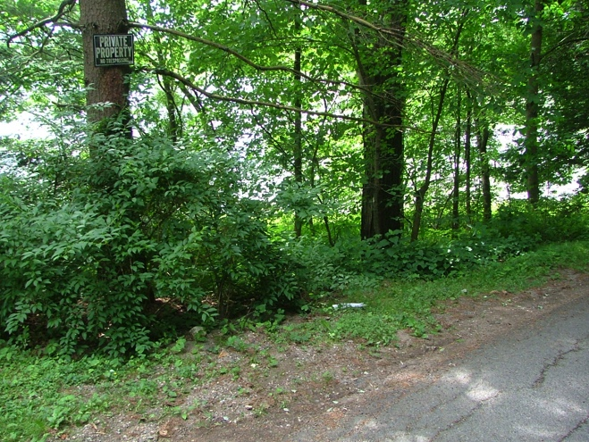

FF. Same pipe, paper in front of pipe, looking south to pond. Taken June 6, 2010, 002

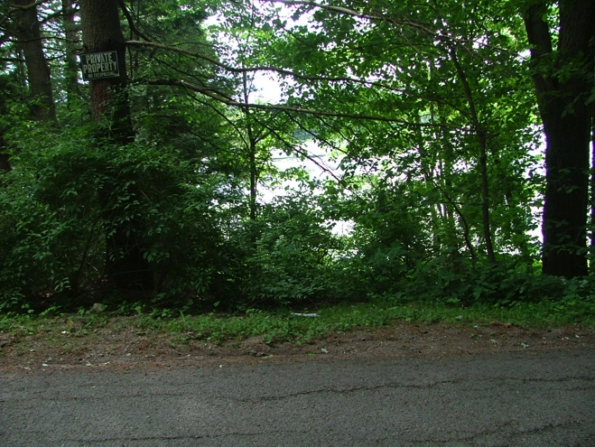

FF. Same pipe from across the road looking southeast to pond. Paper in front of pipe. Taken June 8, 2010, 003

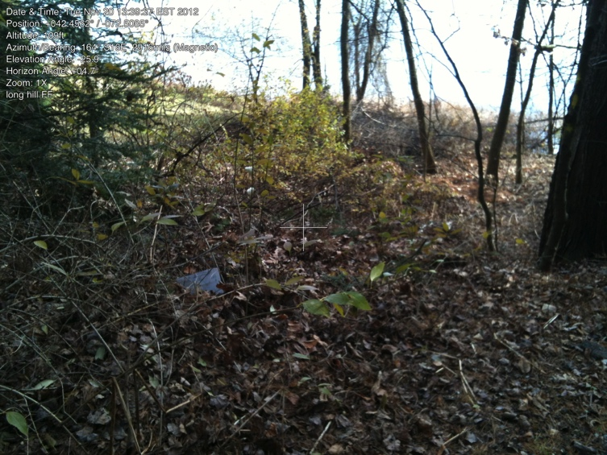

One more FF. Paper in front of pipe.

photo: 11/20/2012

Note, line between FF and the shore has rarely (if ever) been walked. It goes along the hedge (mowed area is RGT’s). Owner received a letter thanking him for his help and noting where the line was. Survey indicates there is iron pin at the shoreline.

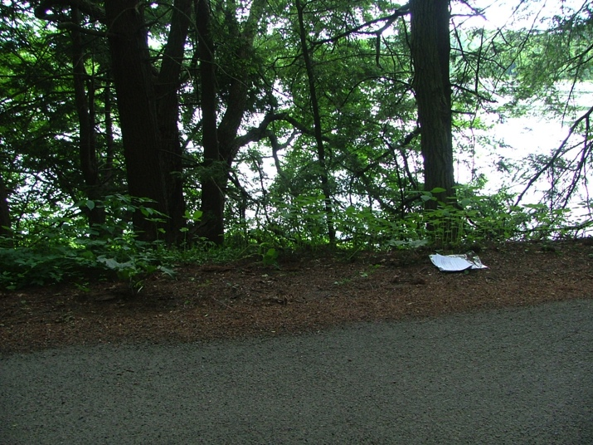

FF-GG. Paper directly above old well, looking

south to pond.

Taken June 8, 2010, 004

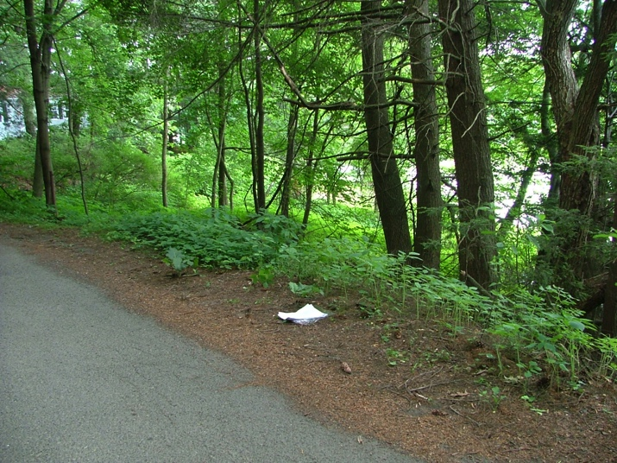

FF-GG. Same paper-above-well. Looking northeast to northern part of property. Taken June 8, 2010, 005

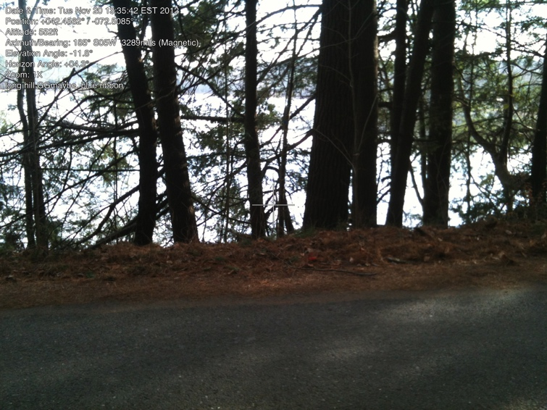

GG.

maybe

photo: 11/20/2012

Note neither pin at roadside nor (if there is

one) at shoreline has been found recently.

2014 Brooke and Ken may have found pin. Need photo and gps.

Note, there is a pin near the upper part of the trail that might be part of the division line between the two portions of the property. However, it seems to be too far north to be part of that line.

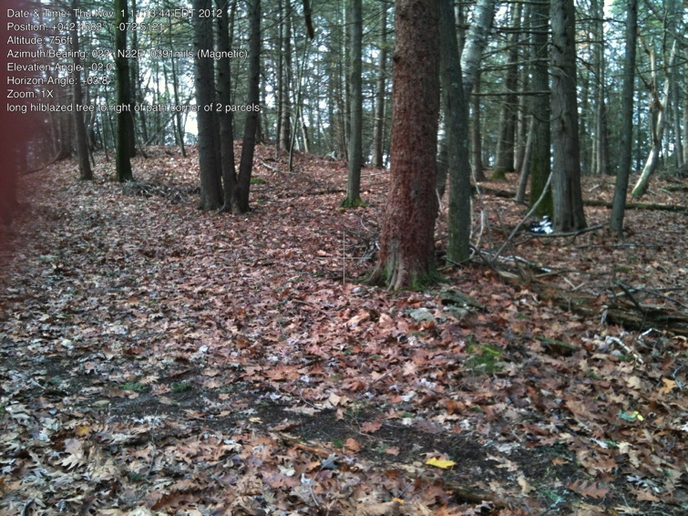

Iron pin in front of white papers.

(Camera label indicates more confidence than later work with map justified.)

42.45806046, -72.51218766

Photo and gps, 11/1/2012

This pin is included so pin-finders will not be confused. It is not an outside property line.