Long Hill Natural Area photos for monitoring, part 2, west and north sides

(Corners use letters that match the Long Hill monitoring map)

Long Hill: K to V

K. Iron pin along western line.

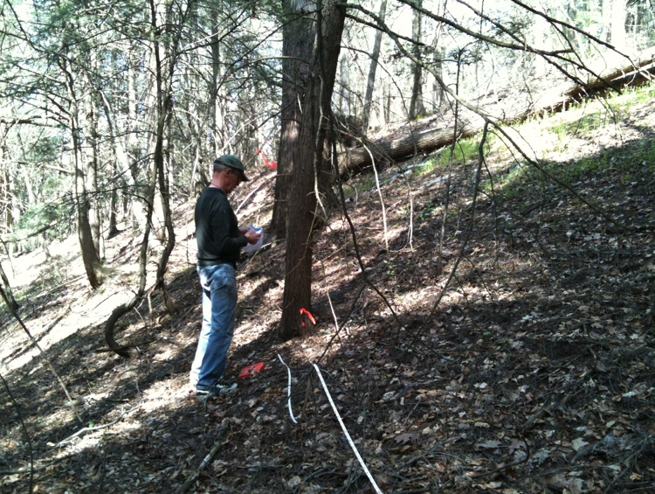The line is steep at I, but slope lessens (not flat)

42.45867410, -72.51402908

photo; 4/23/2010

gps: 11/01/2012

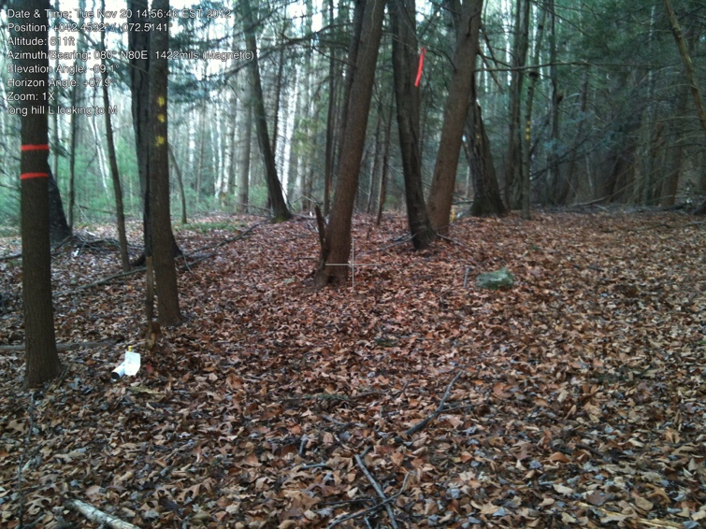

L. (looking to M) Iron pin for L in front of white paper. Iron pin for M to left of red ribbon.(pins only 36 feet apart)

42.45925966, -72.51417895

gps and photo: 11/20/2012

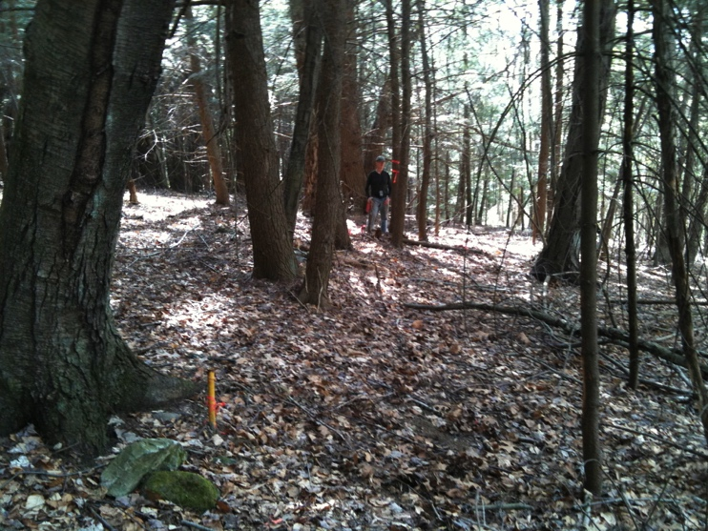

M. At M looking 36 feet west to L where Bill Wilson is standing. Taken April 23, 2010, looking west along line.

42.45924876, -72.51411273

gps: 11/20/2012

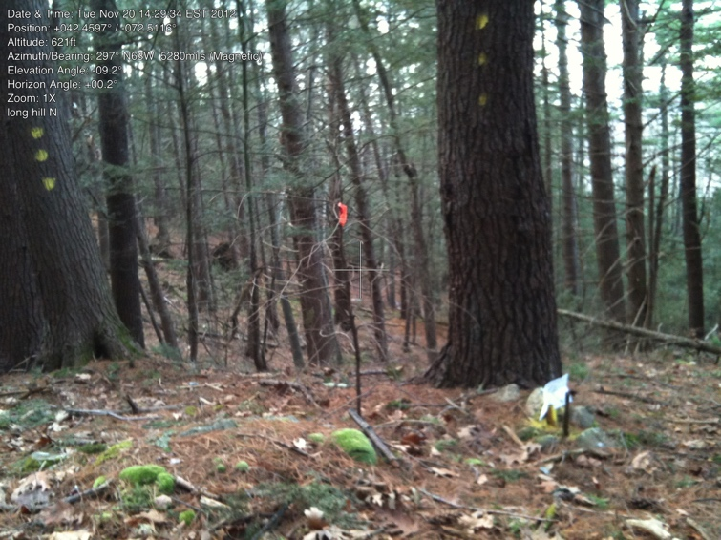

N. Iron pin (in front of white paper)

42.45955906, -72.51166798

gps: 11/1/2012

photo: 11/20/2012

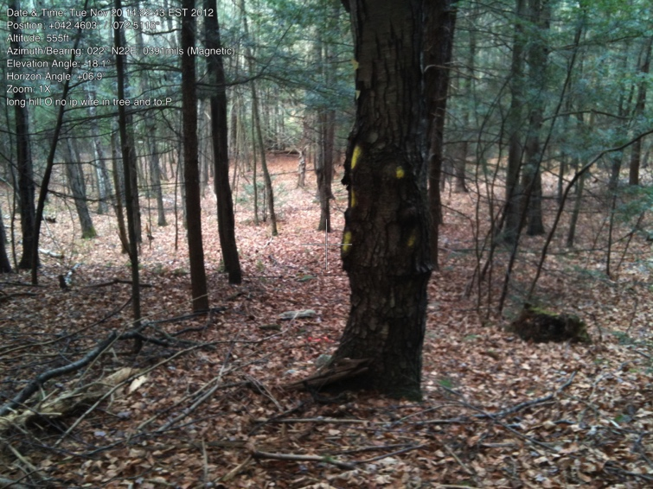

O. This is the beginning of NW “bump.” All of this area along shared line with Cowls.

O-P-Q has wire fence (first part only wire, second barbed wire. No iron pins found in this “bump” area (O through U).

O and Q have corner wires deeply embedded in the corner trees.

Cowls blazes and red paint used as boundary line.

42.46015392, -72.51164074

gps: 11/4/2012

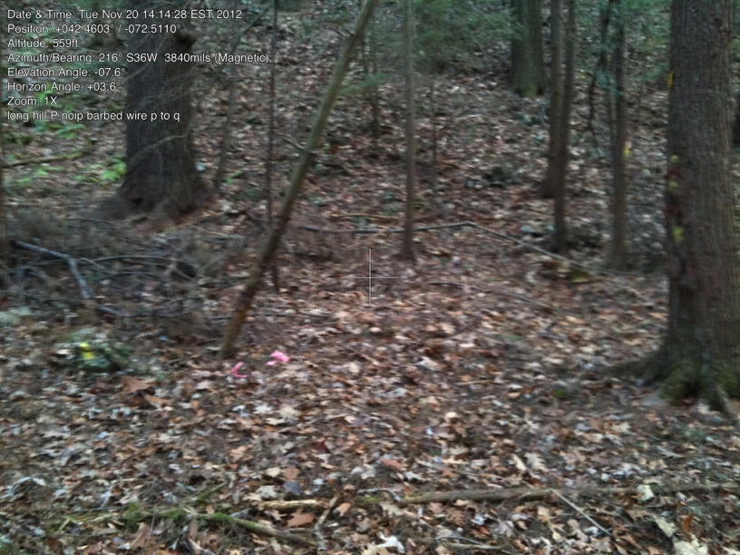photo:11/20/2012

P. Stone pile, blazed trees (Cowls). Wire fencing continues through trees to Q.

42.46013272, -72.51092291

gps: 11/1/2012

photo: 11/20/2012

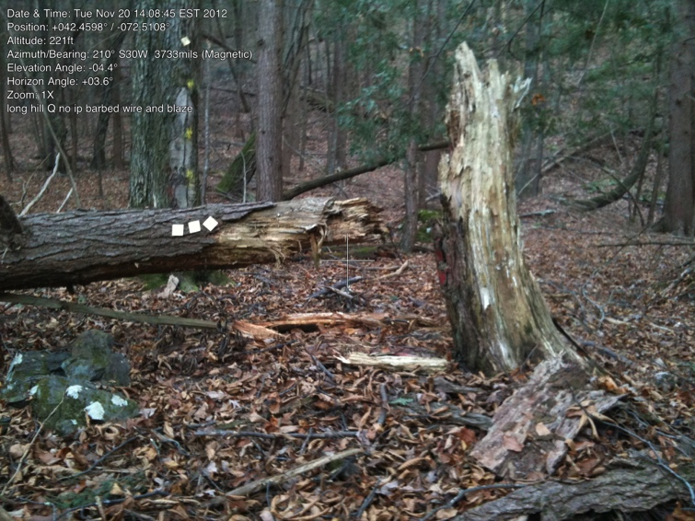

Q. Iron pin not found, stones were painted. End of wire fencing. Just uphill from Cowls’ woods road.

42.46012006 -72.51046518

gps: 11/4/2012

photo:11/20/2012

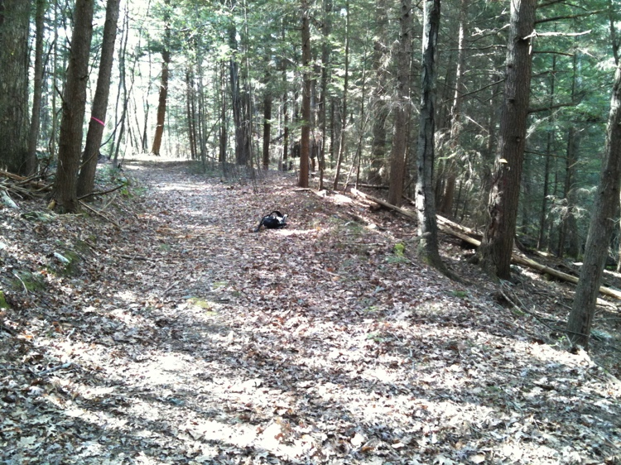

R. Photo taken just SW of R. Backpack placed where line crosses Cowls’ woods road. Looking NW along road.Taken April 23, 2010

42.46037554, -72.51040466

gps: 11/1/2012

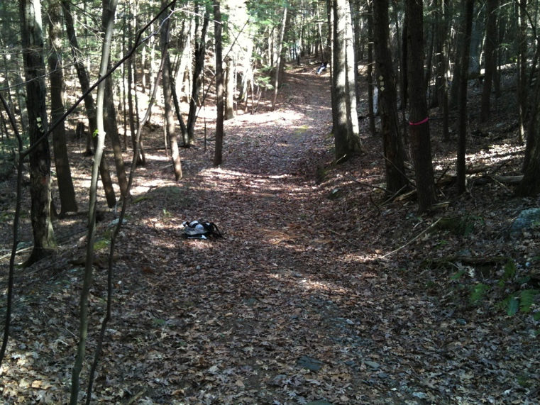R. Backpack in same location, looking SW along road into Long Hill Natural Area. Taken April 23, 2010

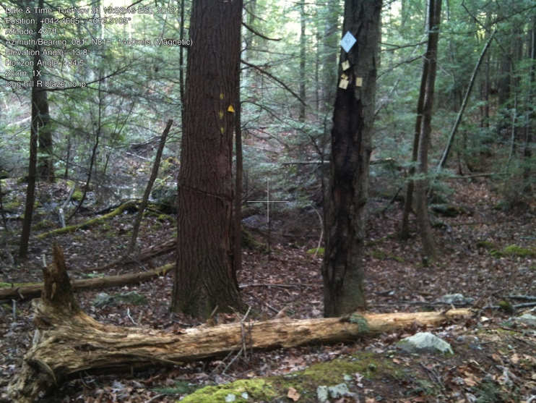R. Close-up of blazes, note how close swampy area is. Taken from road.

photo: 11/20/2012

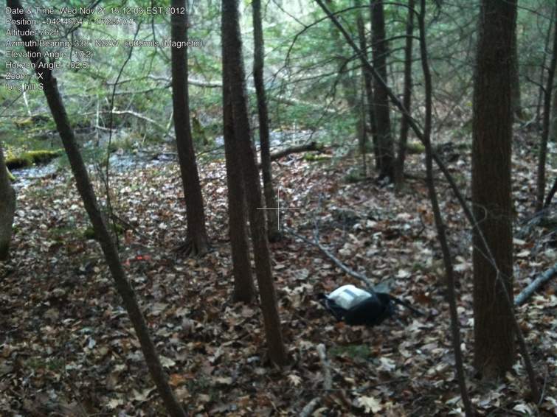

S. Blaze, very slight change in angle.

Very near swamp edge.

42.46043530, -72.51009185

gps and photo: 11/21/2012

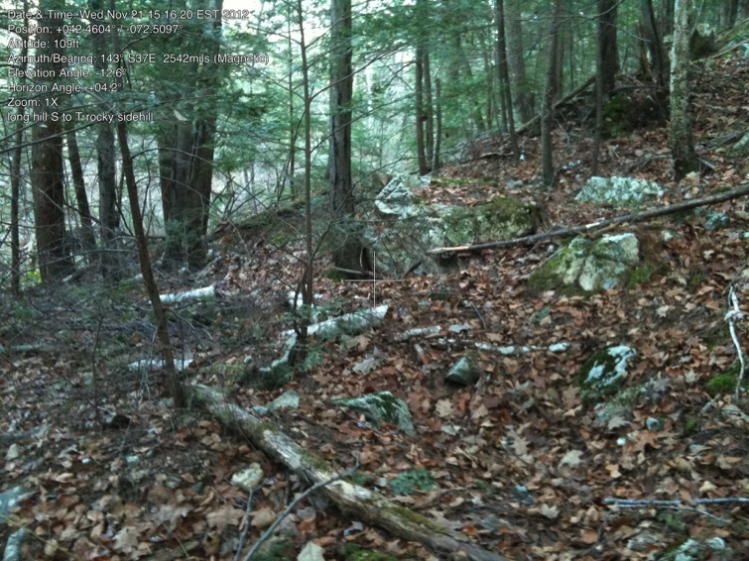

Line from S to T is along side of very rocky slope.

photo: 11/21/2012

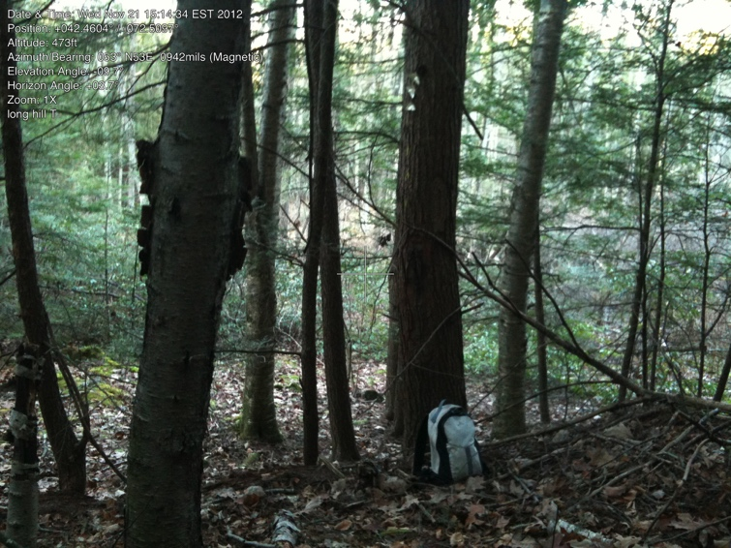

T. Blaze along edge of swamp

42.46045056, -72.50970561

gps: 11/25/2012

photo: 11/21/2012

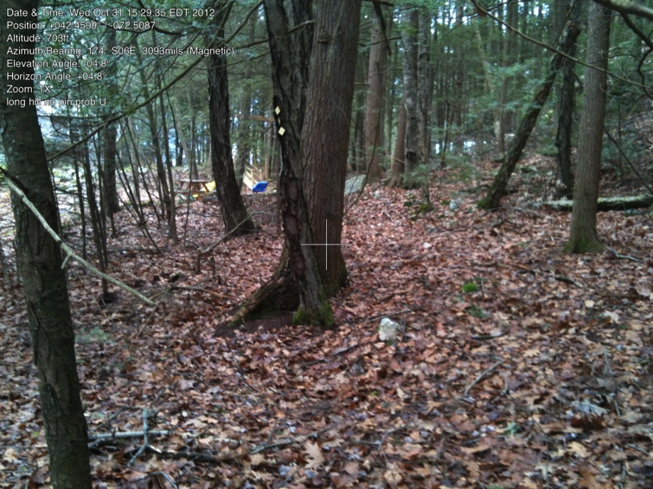

U. No corner post. Bounded by Cowls to north and house to east. (They have never found IP either.)

42.46017278, -72.50926053

gps and photo:10/31/2012

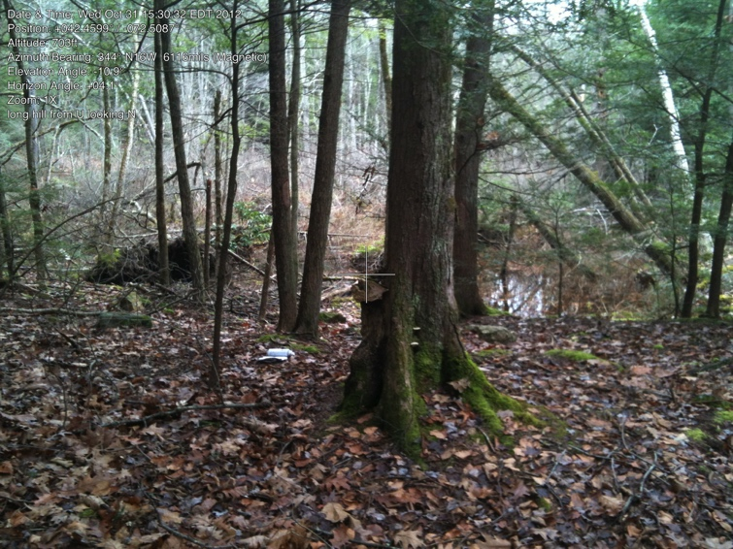

U. Looking north.

photo: 10/31/2012

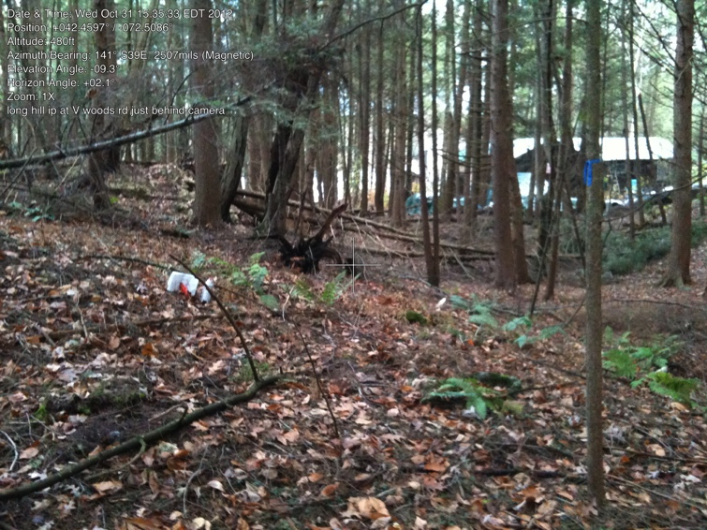

V. First iron pin since M! On hillside just north of Cowls woods road (unclear whether owned by RGT or just right of way). Pin in front of white paper.

42.45983139, -72.50945114

gps: 11/4/2012

photo: 11/21/2012