Long Hill Boundary Photographs, November 2012, photos for monitoring, part 1 (south side)

(Letters used for corners match letters on Long Hill monitoring map)

Note: When using this set of photographs, use the monitoring map, if you want to use survey, use the east and west surveys which carry 2012 corner annotations. (Earlier version of surveys and deeds use a different lettering system – which can be very confusing!).

Lines are marked with yellow paint (not done for E-F, H-I, or FF-GG as of 11/23/2012)

Corners are marked with 3 yellow dots (except AA and GG)

Except for the North line, boundary lines to not match any change of land use – either present or past (as observed in differences in vegetation). Nor do lines follow contours.

Long Hill: A to J

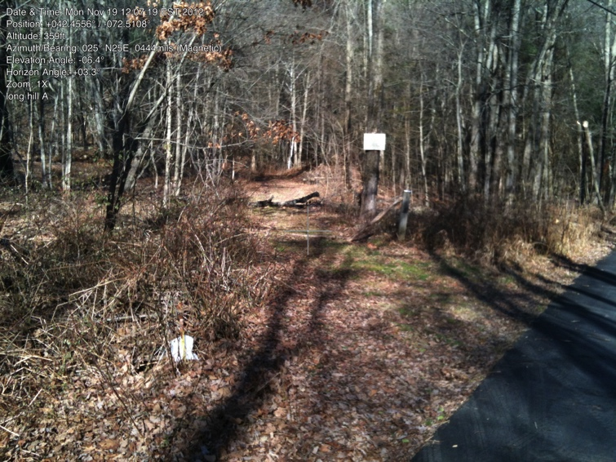

A. Corner post at entrance to Long Hill Trail from Camp Road.

Iron Pin on left (by road, next to culvert. Trail and sign just to left. Line follows stone wall to left of trail.

42.45564094, -72.51070817

gps: 11/20/2012

photo: 11/19/2012

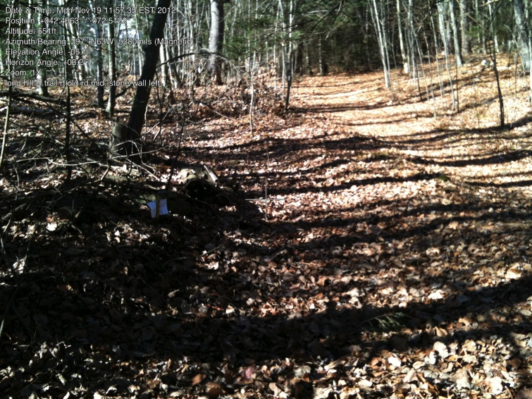

B. Iron pin (white paper) at corner of stone wall

On the right is hiking trail up Long Hill.

To the left of that is old woods road.

And to the left of that is stone wall which marks the boundary

42.45613153, -72.51082619

gps: 11/18/2012

photo: 11/19/2012

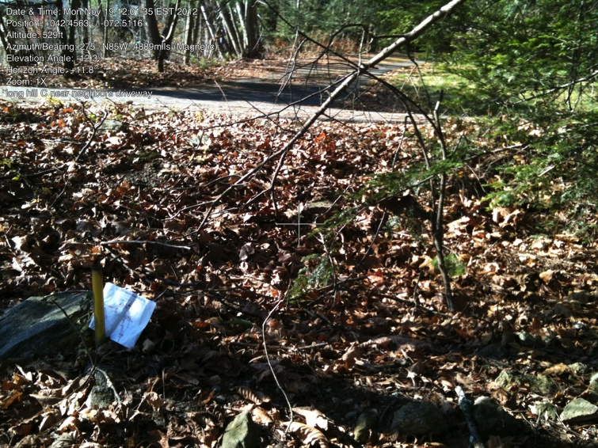

C. Iron pin at west end of stone wall.

Neighbor’s driveway clearly visible.

Note: there is an opening/gap in the stone wall east of the pin. Keep going along wall to where the wall really ends to find the pin.

(It is just north of this pin that the neighbor’s shed is built slightly over the line. He has received a letter to that effect.)

42.45618015, -72.51155642

gps: 11/18/2012

photo: 11/19/2012

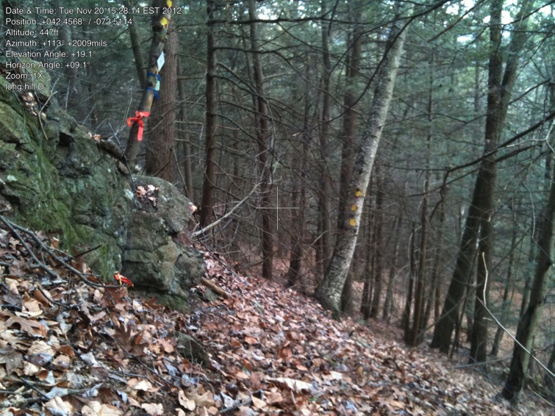

D. Iron pin at edge of small cliff.

Line from C to D is very steep

42.45698347, -72.51125258

gps: 11/18/2012

photo: 11/20/2012

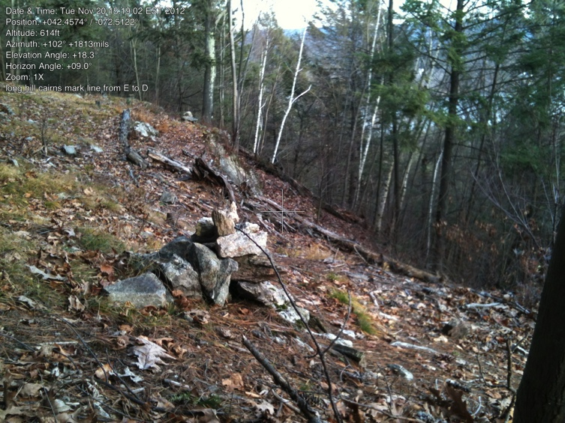

D-E line (photo on cliff toward D)

Very steep area, line is marked by a series of cairns (although walkers build additional cairns regularly).

Almost impossible to walk line, very steep and angles up to flat behind cliff (west of bench)

photo: 11/20/2012

Note: part of line C-D, all of line D-E and part of line E-F are common lines with the Cave Hill View CR.

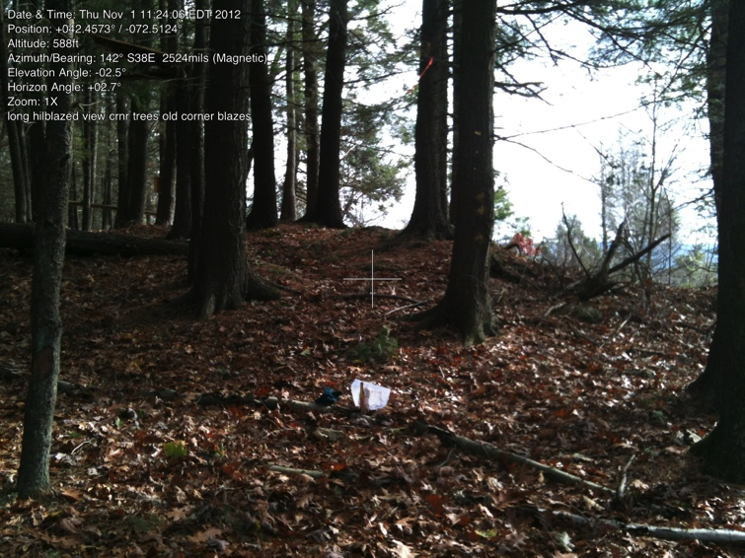

E. Iron pin west of bench, behind cliff.

This is also NE corner of “tongue” that drops down to Long Hill Rd.

(This is also edge of one of the two properties that make up Long Hill Natural Area (see survey) the line between E and BB is a bit unclear, but also irrelevant.

42.45720860, -72.51262737

gps: 11/21/2012

Photo: 11/01/2012

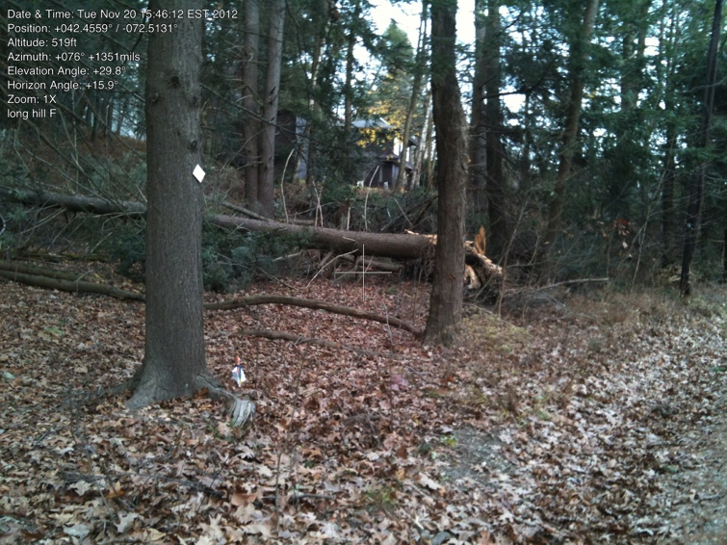F. Iron pin along Long Hill Road SE corner of “tongue.”

Pin is just below tree with RGT metal tag. (Paper behind pin.)

Note: There is another pin to the east, closer to the house, which is not associated with this property

42.45588494, -72.51316977

gps: 11/1/2012

photo: 11/20/2012

Note: G is not an iron pin, just a bend in the road on the survey map. Location not important.

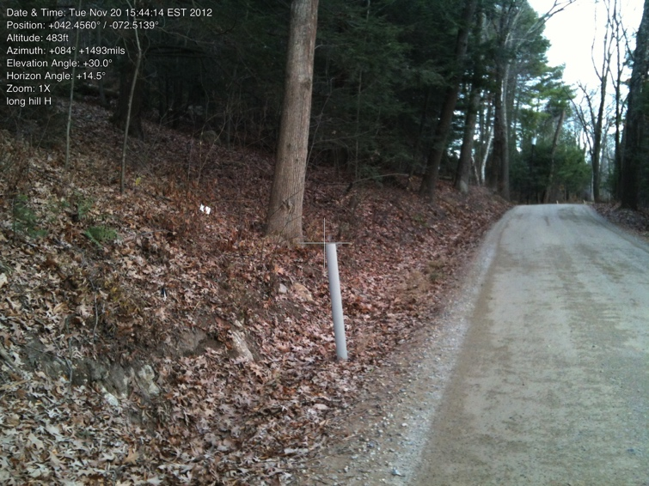

H. Iron pin, SW corner of tongue.

Note this pin seems to be just below the home above. However, it angles to right/east of the house.

(Pin is behind tree, in front of white paper. Long Hill Road to right.)

42.45596079, -72.51391928

gps: 11/1/2012

photo: 11/20/2012

Note: As of 11/25/2012, the lines from E to F and from H to I have not been marked - may never even have been walked (well, crawled). Needs to be done. (Note December 2014. The west line has been walked (and discussed with owner of home). The east line has been walked, but flagging may not be complete and it has not been walked with home owners (2 houses on this side).

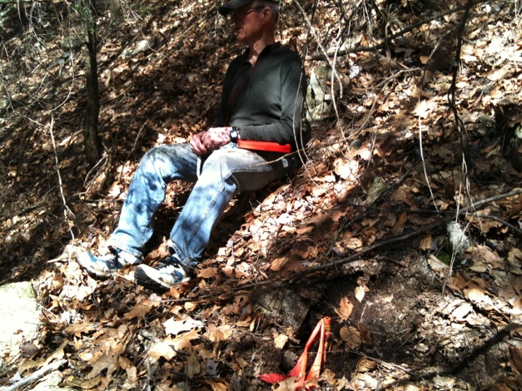

I. Iron pin, NW corner of “tongue.”

Monitors usually go from E to I, skipping the trip down the “tongue.”

From E, this ip was found after steep descent from top at about 300 deg. Photo April 23, 2010, (Yellow post covered with leaves, remember to dig out occasionally.)

42.45731179, -72.51339507

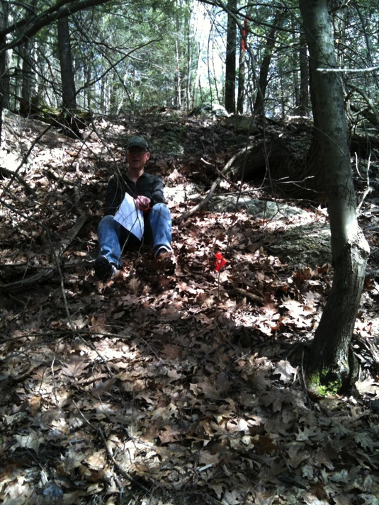gps: 11/4/2011

I. Also at I, looking uphill toward view

Taken April 23, 2010, Bill Wilson by yellow post.

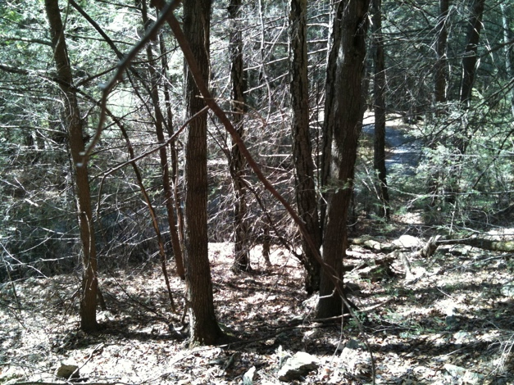

I to J. Looking downhill (west) from I.

Driveway clearly visible below.

(taken same day)

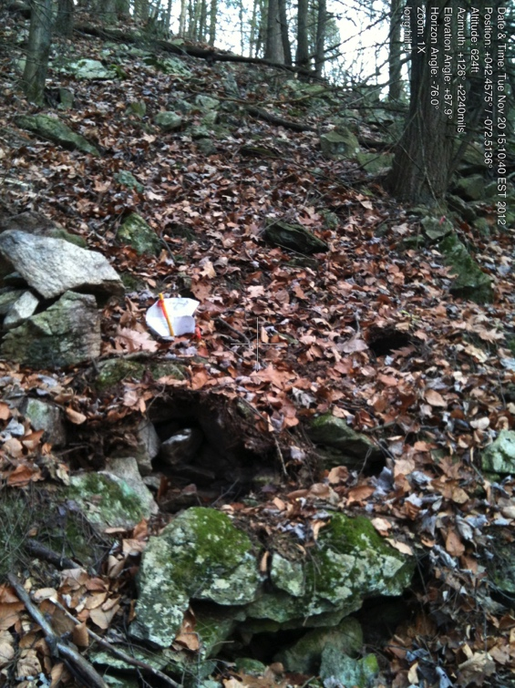

J. IP, on steep slope, below I. Driveway is just downhill (west) of pin.

Pins (older/shorter and newer/taller) are near newly constructed pile of rocks.

42.45743106, -72.51378760

gps: 11/4/2012

photo: 11/20/2012

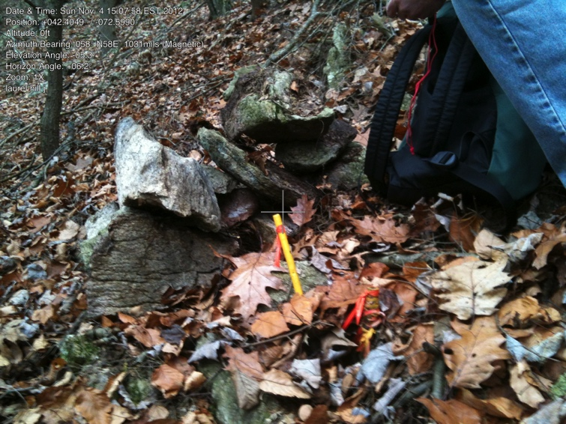

J. Iron pins, close up

photo: 11/04/2012