Laurel Hill photos for monitoring, part 6, Common Land G, north side G15 - G19

(Note: the letter designating each of the common lands and the number of the corner match those used on the Laurel Hill monitoring map)

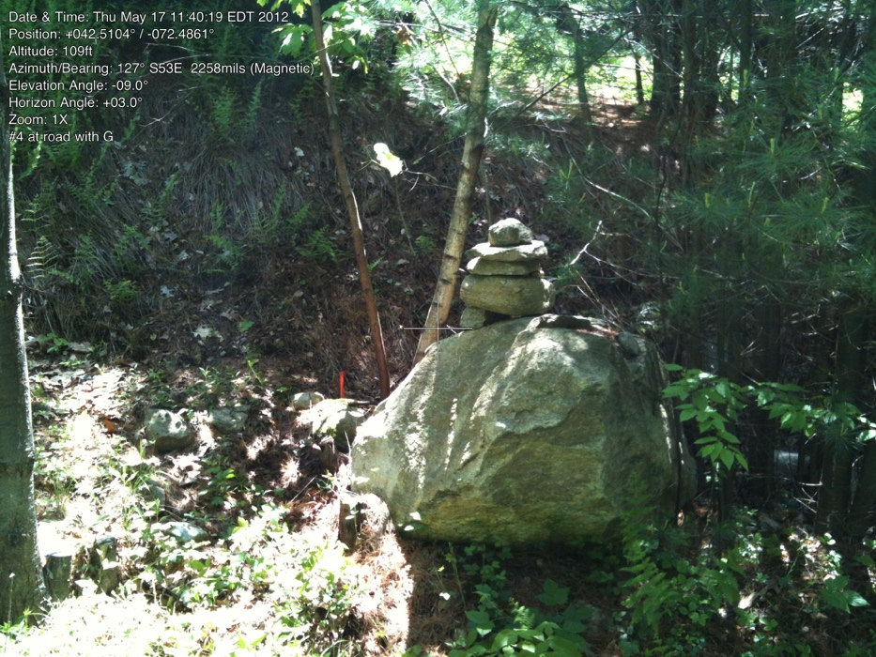Common Land G15-G19

G15. corner G and #4

42.51050402 -72.48628003

May 17, 2012

Iron Pipe beside road (large rock in front of it).

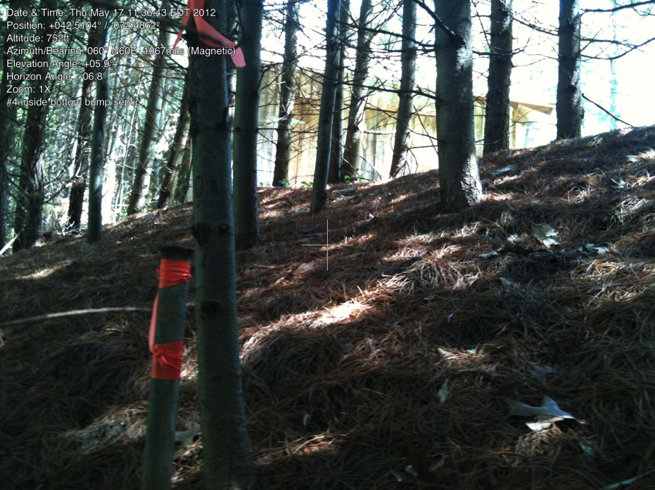

G15A. NW corner of leach field

42.51052500 -72.48613000

May 17, 2012

Plan Book 116, page70 shows new shape of north and south lines for lot #4, with a leach field bump on south corner near road.

This is the first corner of this rectangl

G15B. SW corner of leach field pin not found, probably in the woods behind cleared area

(no photo)

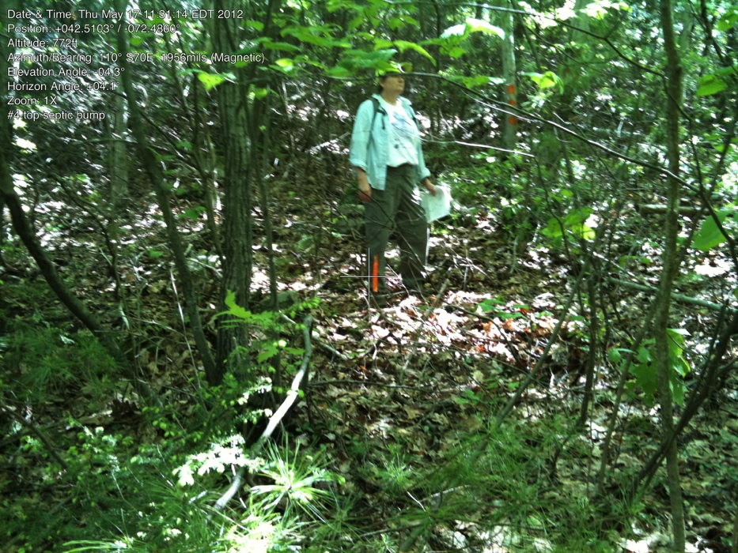

G15C. SE corner of leach field for lot #4

42.51034000 -72.48591000

May 17, 2012

Very near trail (to west about 5 feet).

G15D. NE corner of leach field. Pin not found, uphill near area cleared for view. (no photo)

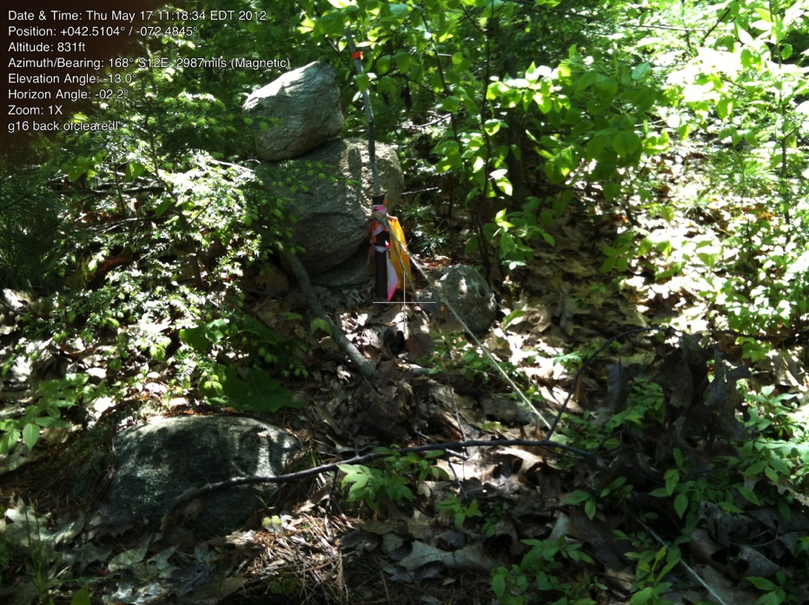

G16

42.51034853 -72.48456434

May 17, 2012

IP marked with stones.

Previous owner had cleared into Lot G, so pipe is inside cleared area.

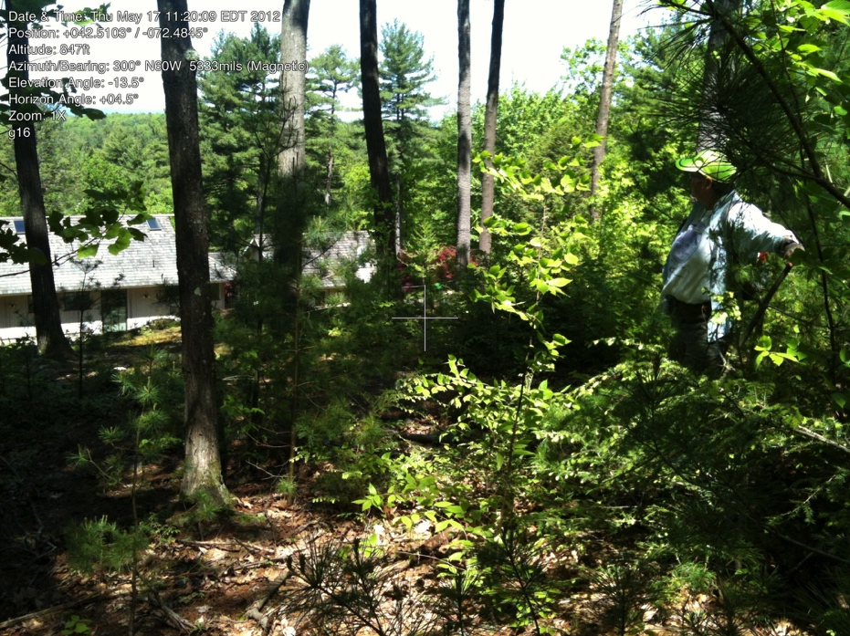

G16

Looking the other way from stone toward house (nw)

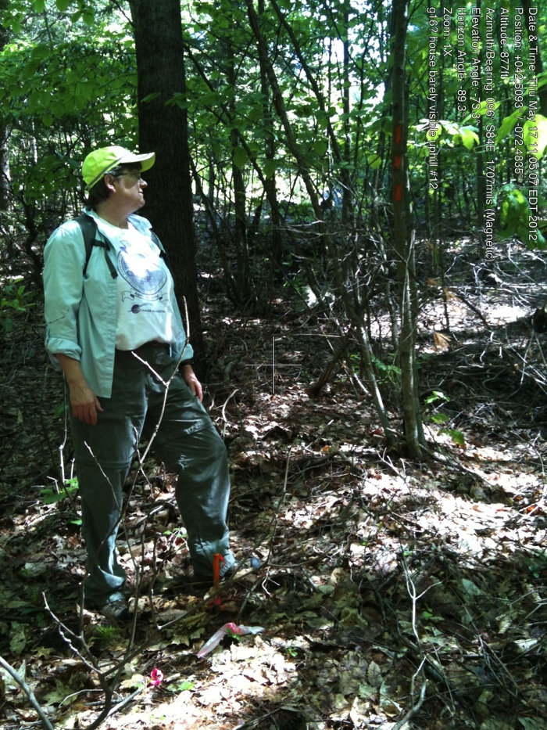

G17.

42.50943482 -72.48344930

May 17, 2012

House for lot #12 barely visible. It was below (sw) of this corner that some view-cutting was done on lot G.

(Over a period of about 5 years and originally with S. Poritz permission.)

Owner understands that cutting must have permission of Association.

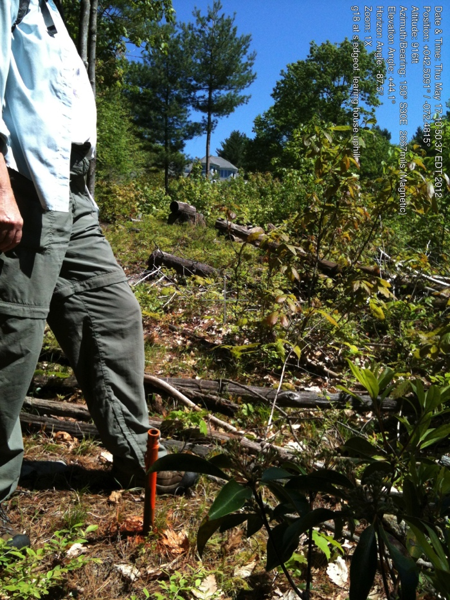

G18.

42.50907742 -72.48160268

May 17, 2012

Iron pin is just at the edge of clearing below house #14 (visible in picture).

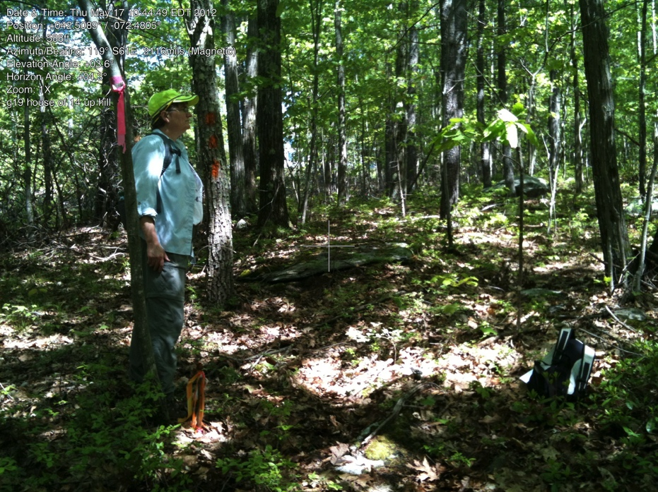

G19.

42.50903567 -72.48055587

May 17, 2012

Corner of 13, 14, and G

Can see house uphill.