Laurel Hill photos for monitoring, part 5, Common Land G, south side G9 - G14

(Note: the letter designating each of the common lands and the number of the corner match those used on the Laurel Hill monitoring map)

Common Land G9-G14

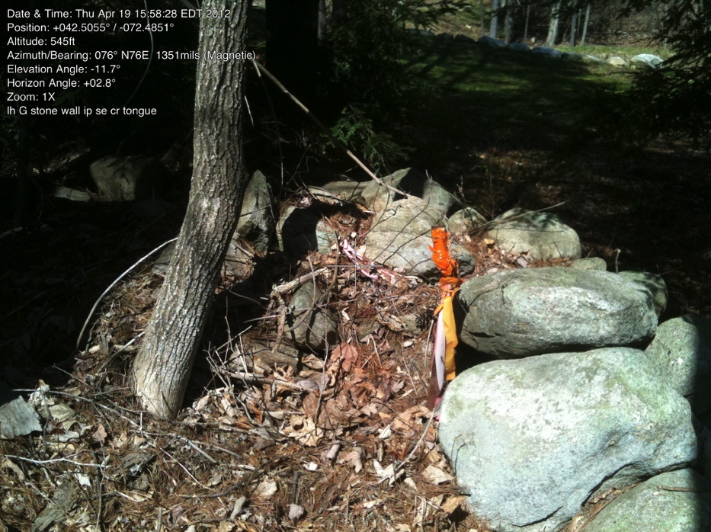

G9.

42.50555098 -72.48510196

IP SE corner of “tongue” at North Leverett Road

April 19, 2012

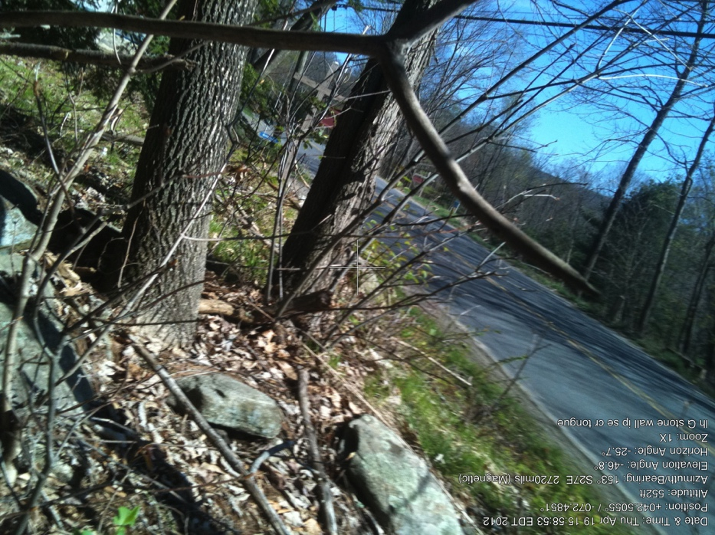

G9

same SE corner, view to road

April 19, 2012

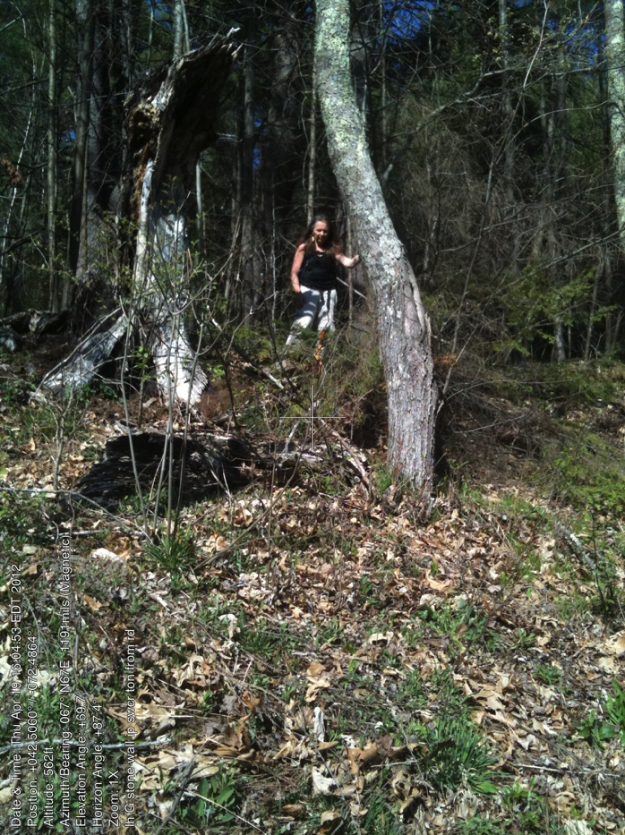G10.

42.50609857 -72.48628557

IP SW corner of “tongue”

April 19, 2012

IP in front of Eva, taken from road.

The “access road” shown on the survey but not maintained is just to the right/east.

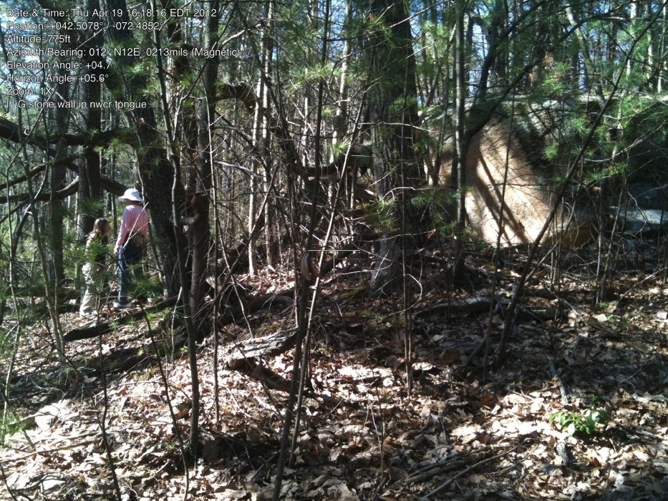

G11.

42.50777470 -72.48538326

IP NW corner of tongue

Pin is just below dramatic stone/cliff and just to left/west of access road.

Sandy and Eva are standing at the pin.

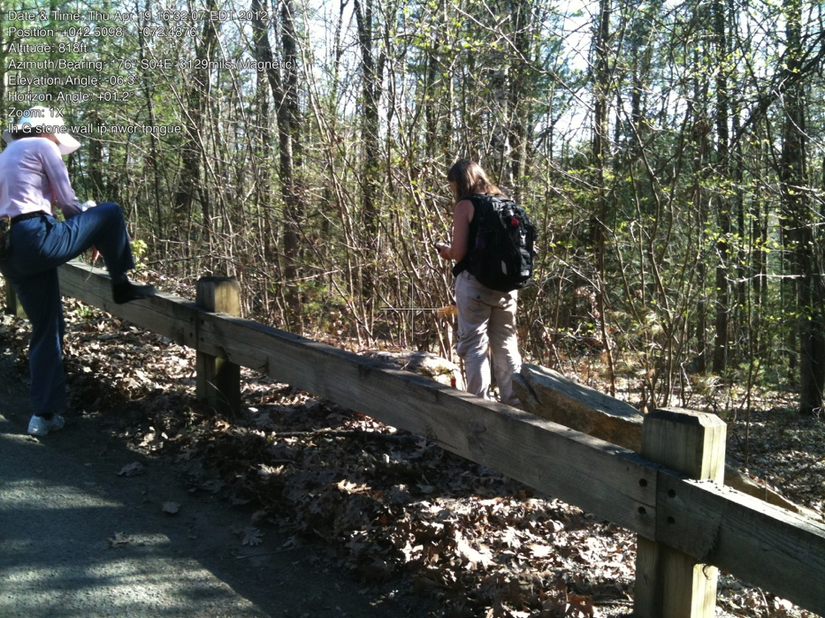

G12.

42.50979616 -72.48745434

IP of G and road (across from C)

Pin is by Eva’s foot.

Note: label on picture is the same as on previous picture, i.e.incorrect.

G13.a

take when leaves are off

Note there are 3 pins close together. Only the eastern pin touches CommonLand G; the other two are part of the line shared between lot #3 (now part of lot #2) and private property to the south

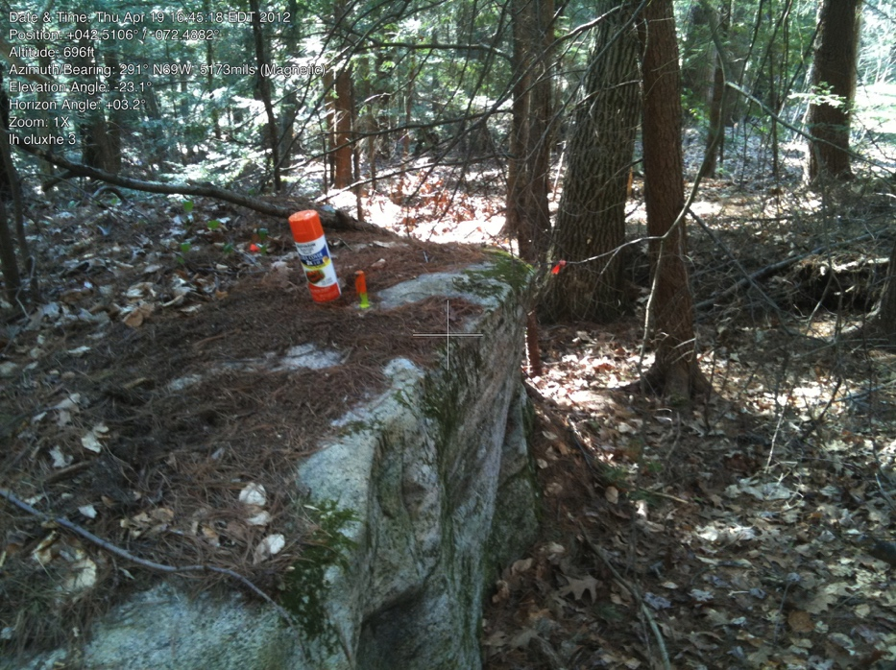

(Not a Common Land IP)

IP in boulder, very near G 3 corner

April 19, 2012

This is line of #3 (now joined with lot #2) and neighbor, but what a great place for pin

G.14

There is NO PIN where this little triangle meets road. (Probably lost during road work.)

(Nor is there a photo)