Laurel Hill photos for monitoring, part 4, Common Land G east side

(Note: the letter designating each of the common lands and the number of the corner match those used on the Laurel Hill monitoring map)

Common Lands: G1 - G8

Lot G has 21 corners. It touches the Laurel Hill Road at its northern tip and on the west. A rectangle goes down to North Leverett Road (referred to in this document as the “tongue.” The numbering begins at the north where the Indian Rock Trail begins.

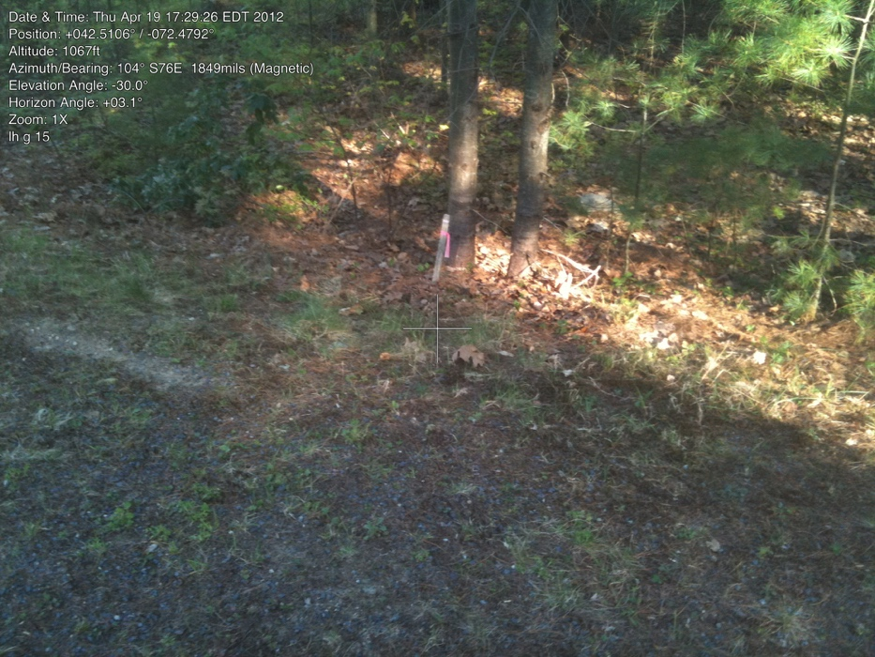

G1. Corner with #15 and G at F

42.51070501 -72.47952070

April 19, 2012

IP removed in construction, only wood post. Trail slightly to west

Cleared land on Lot #15 is slightly to the east.

while plastic short post added in 2013

Eva/Mary photo?

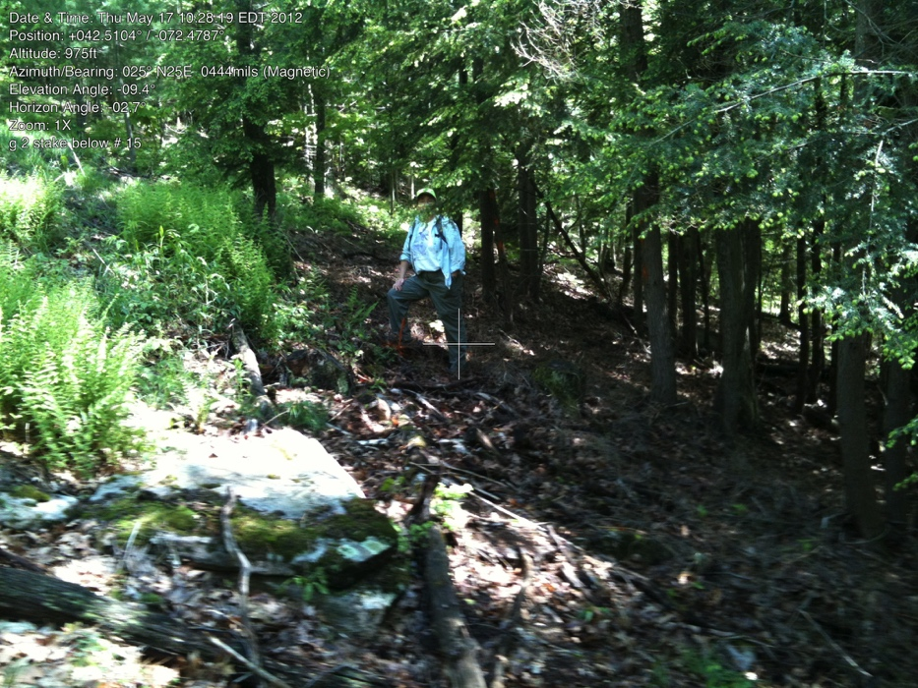

G2. Corner of #15 and G south

42.51009213 -72.47863390

5/17/2012

Iron pipe just below (Southeast) of #15 clearing. It is somewhat inside the cleared south line of #15 – i.e. some of G has been cleared.

G3. at beginning of jog

Have not found pin yet, no picture

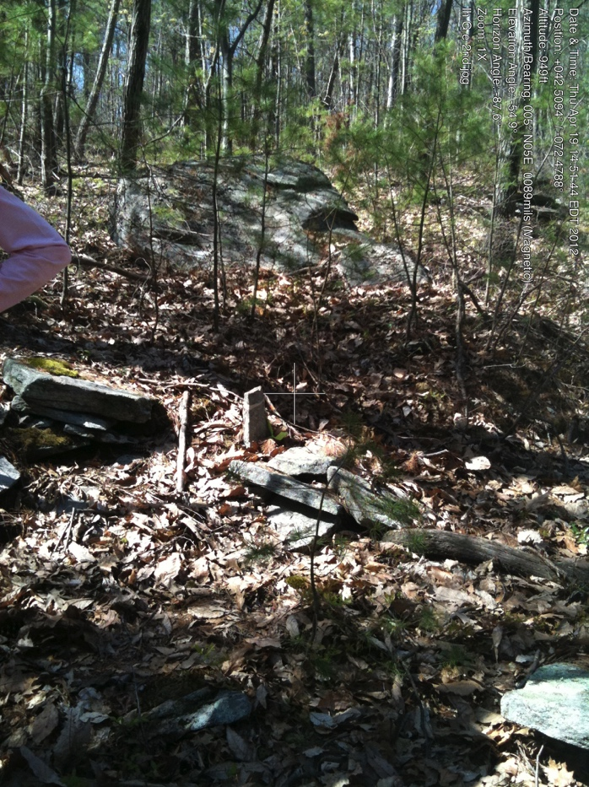

G4.

42.50944647 -72.47884571

Stone Bound at jog in east line

April 19, 2012

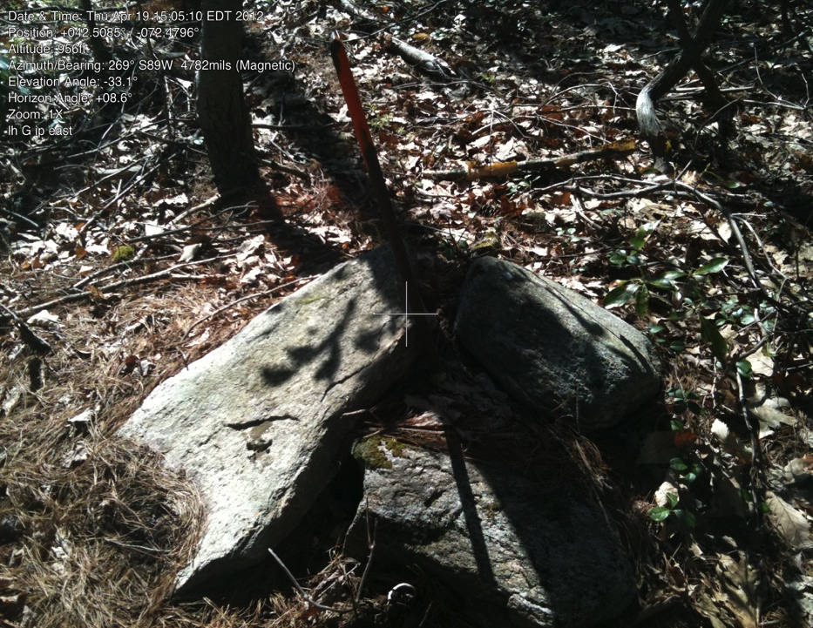

G5.

42.50831056 -72.47956052

IP along east line

April 19, 2012

Line fairly easy to follow because of barbed wire and recent flagging/no hunting signs

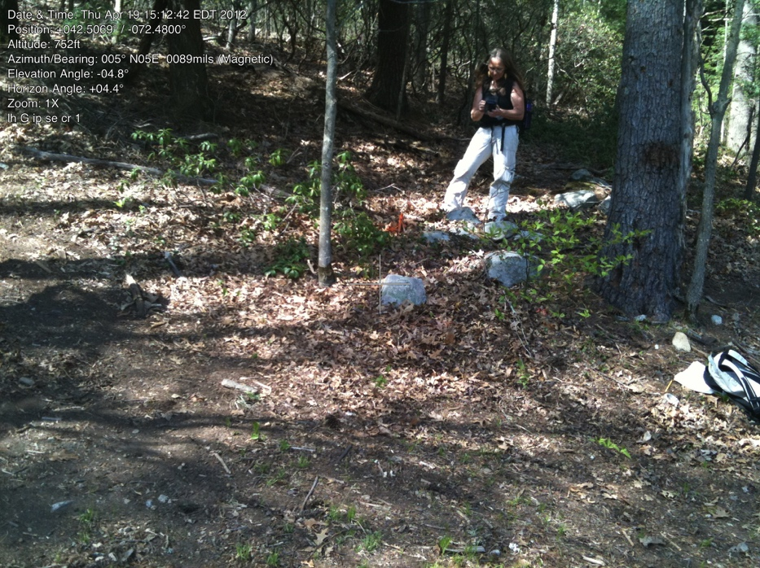

G6

42.50704992 -72.48008329

IP G first SE corner

April 19, 2012

At edge of trail.

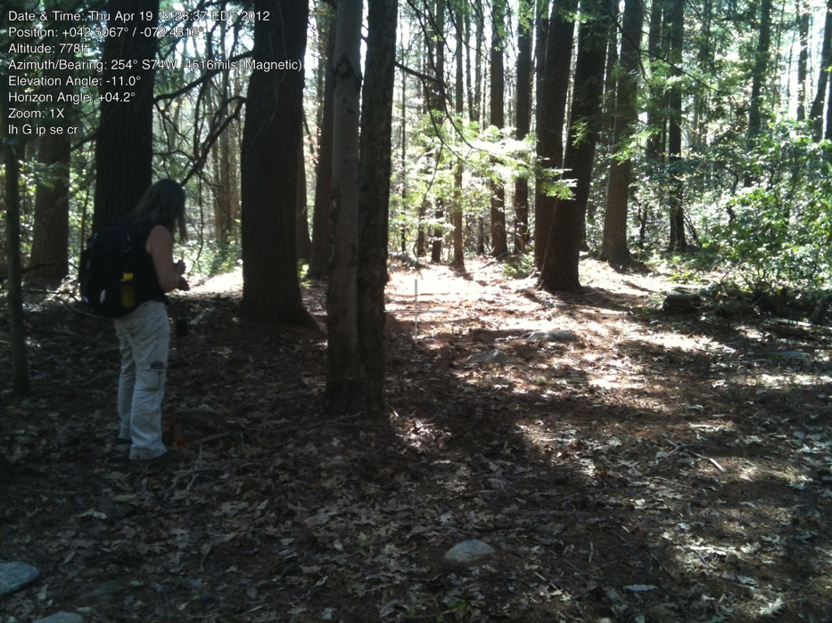

G6.

same corner, longer view of trail

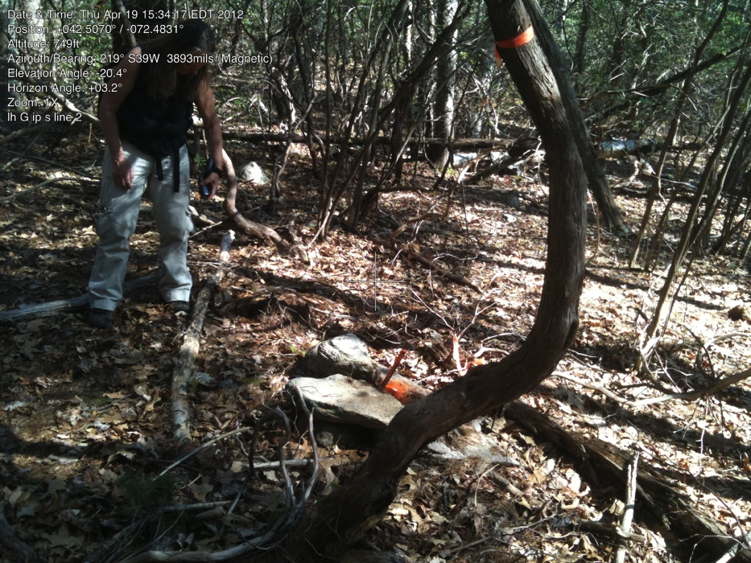

G7.

42.50689292 -72.48150772

IP midline S line

April 19,2012

(might be Virginia Rail fence stones along this line.)

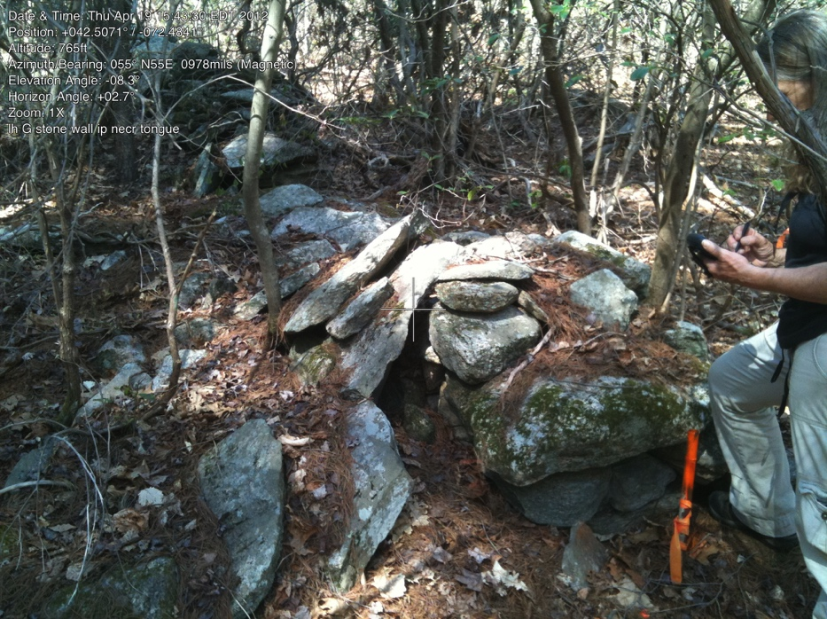G8.

42.50707950 -72.48410694

IP NE corner of “tongue”

April 19, 2012

Stone walls intermittent along this line. First stone wall is north of corner.