Laurel Hill photos for monitoring, part 3, Common Land E and F

(Note: the letter designating each of the common lands and the number of the corner match those used on the Laurel Hill monitoring map)

Common Land E

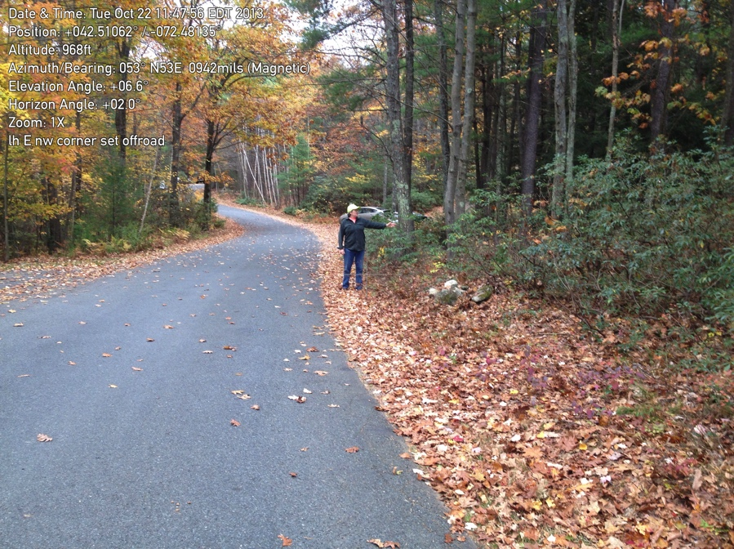

E1. NW corner along the road. (The NE corner, E2, is farther along the road at the next turn.

October 22, 2013

42.51064600 -72.48115200

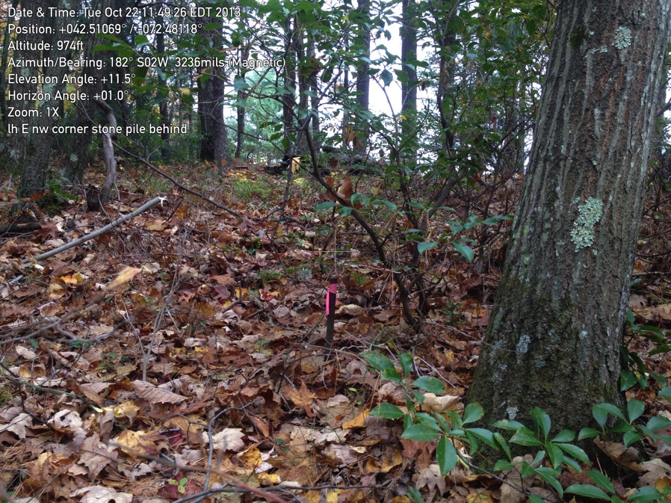

E1. Close up of iron pin looking toward E4.

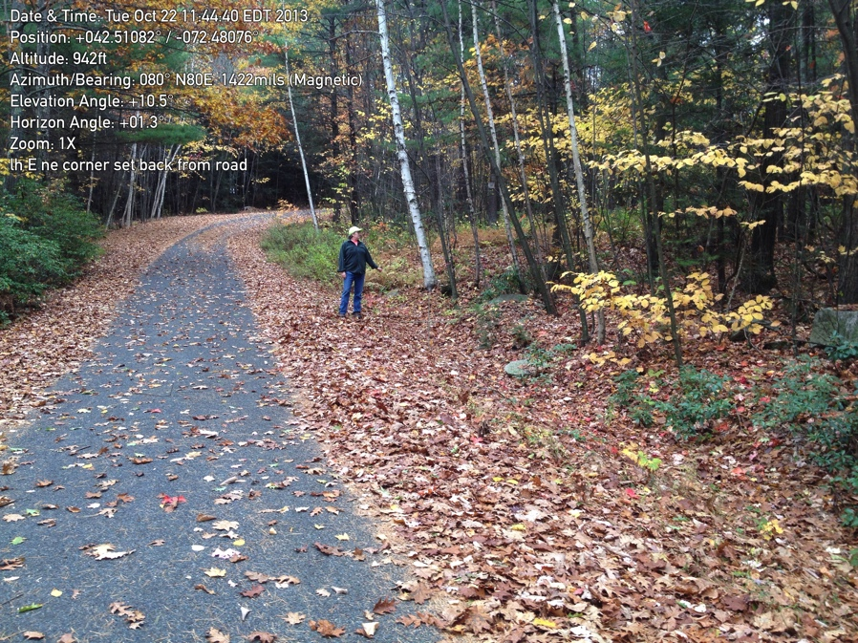

E2. NE corner along the road

October 22, 2013

42.51078400 -72.48064100

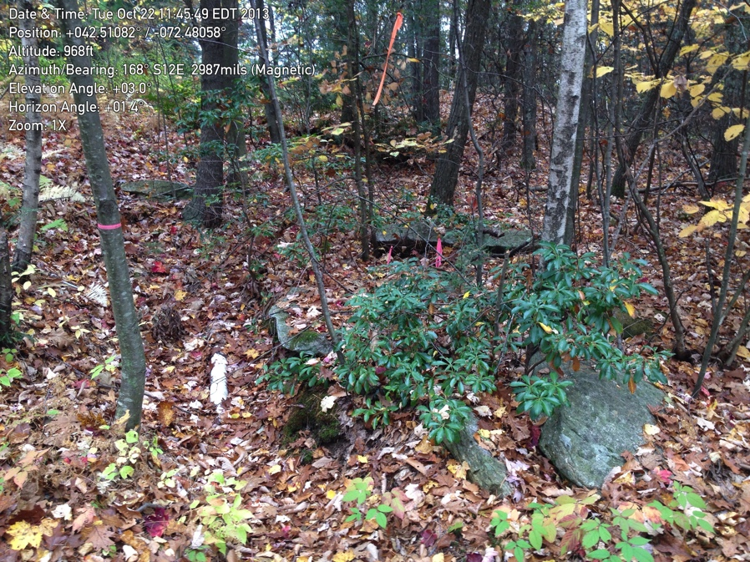

E2. Close up

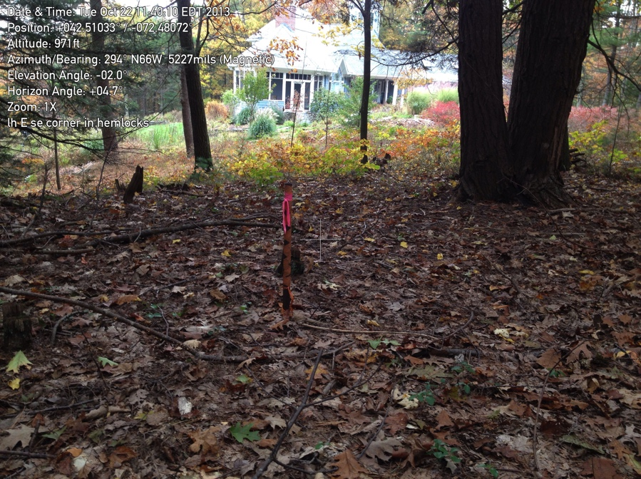

E3. Northeast corner in open woodland. Looking back toward the house.

(E4 at the left side of the photo)

October 22, 2013

42.51030800 -72.48058600

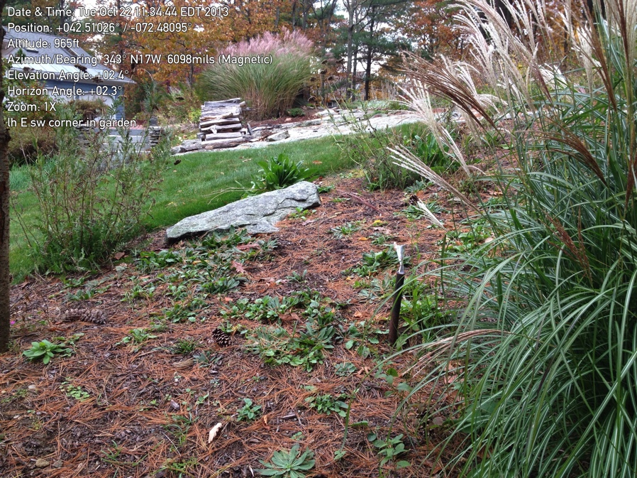

E4. Southeast corner in landscaped area. Looking toward the house

October 22, 2013

42.51018100 -72.48096600

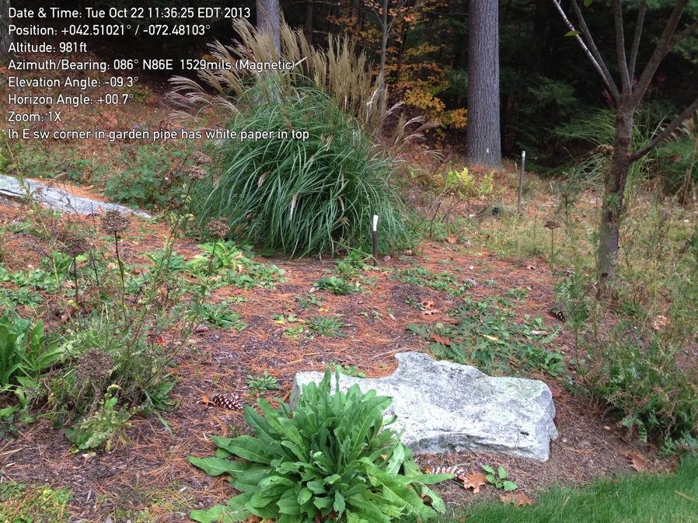

E4. Same corner looking east toward E2.

Common Land F

Lot F is completely surrounded by road so pictures and gps points are unnecessary.

However, for mapping purposes, it helpful to realize how wide the road is where the circle begins. (Common Lot E is just to the right of this view.)

May 17, 2012

