Laurel Hill photos for monitoring, part 2, Common Land B, C, and D

(Note: the letter designating each of the common lands and the number of the corner match those used on the Laurel Hill monitoring map)

Common Land B

North end loop follows edge of road. The south line is shared with Lot #6.

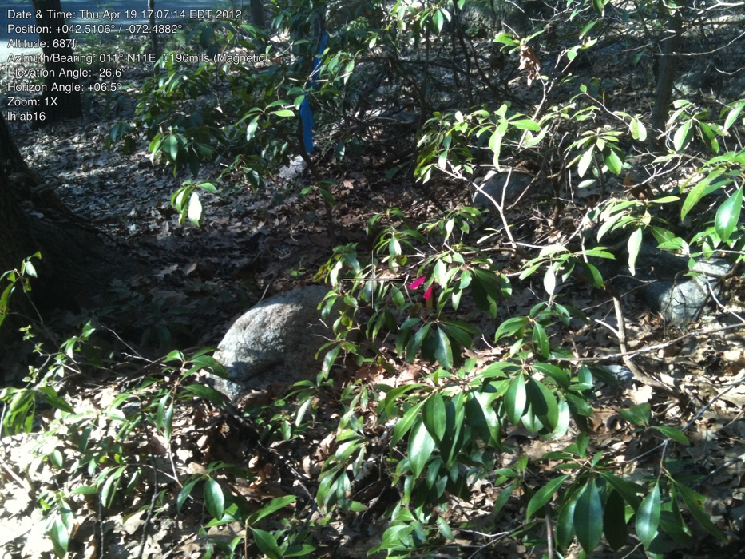

B.1

42.51329854 -72.48421834

IP A, B,6

April 19, 2012

Note there is flagging in front of tree, but post in behind (road barely visible in picture)

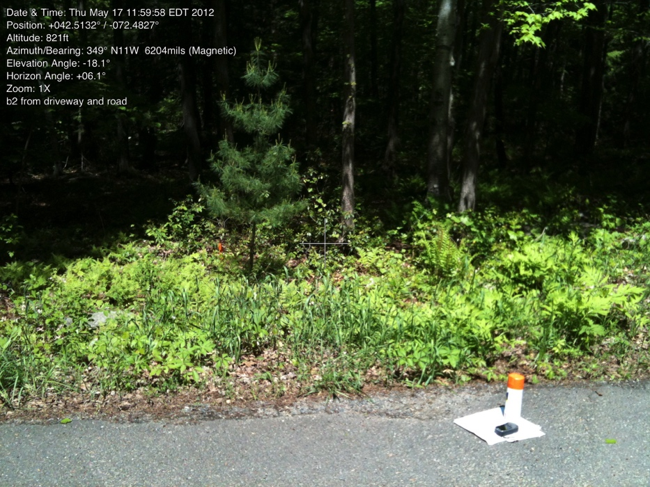

B.2

42.51318488 -72.48271605

May 17, 2012

IP is down off the road. Photo taken from intersection of road and driveway to house on lot #6,

Common Land C

The southern part of Common Lot C is a loop formed by the road. The northern border is shared with Lot #1. There is a Split Rock Trail that crosses Lot C east-west.

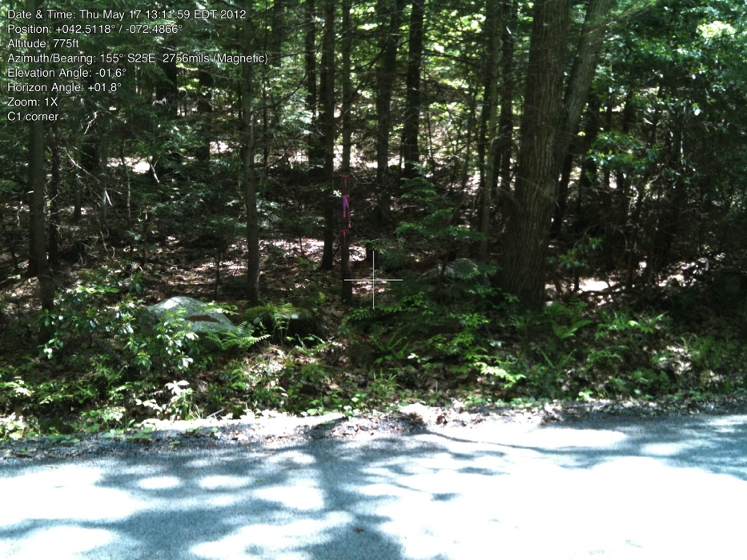

C1.

42.51197900 -72.48670100

May 17, 2012

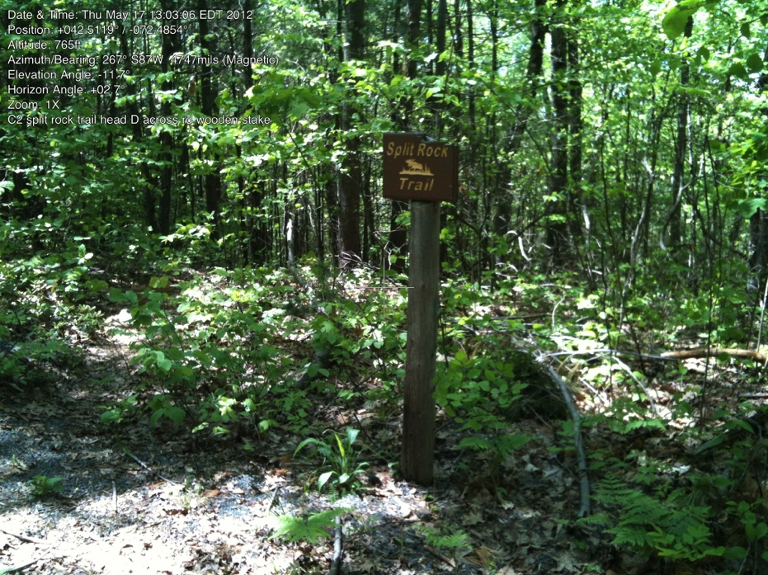

C2. did not find corner except that it is across from D8, might be at the “Split Rock Trail” sign.

# Common Land D

Major changes in this lot. Be sure to use Plan Book 82, page 79 and for shared line with #4, use PB 116, p. 70.

Note: did not find photos of the septic system trade (D1/D2/D3) or the corners of the meadow (D4, D5) although we have visited them, and know approximately where they are.

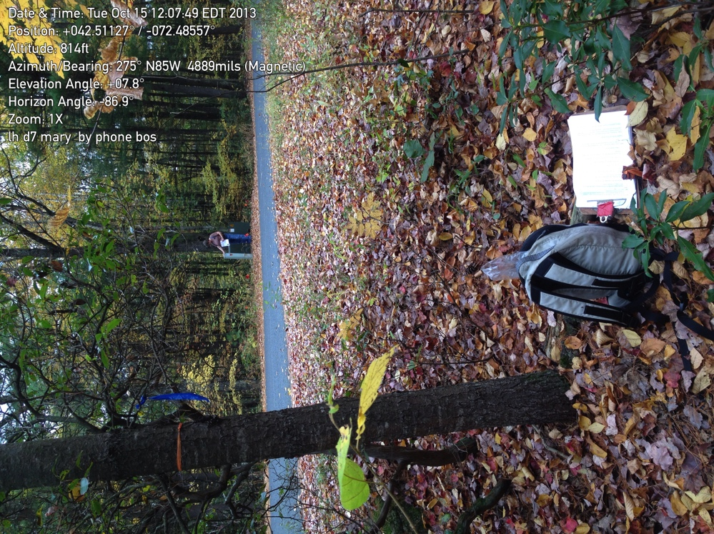D7. Corner post well back in the woods. Mary across the road at telephone distribution box.

10/15/2013

42.511261 -72.48581