Laurel Hill photos for monitoring, part 1, Common Land A

(Note: the letter designating each of the common lands and the number of the corner match those used on the Laurel Hill monitoring map)

Common Land A

The north line is to Leverett/Montague town line. The west corner is from the town line to the entrance road. Lot A then borders lot #1 until it meets the road on the eastern edge.

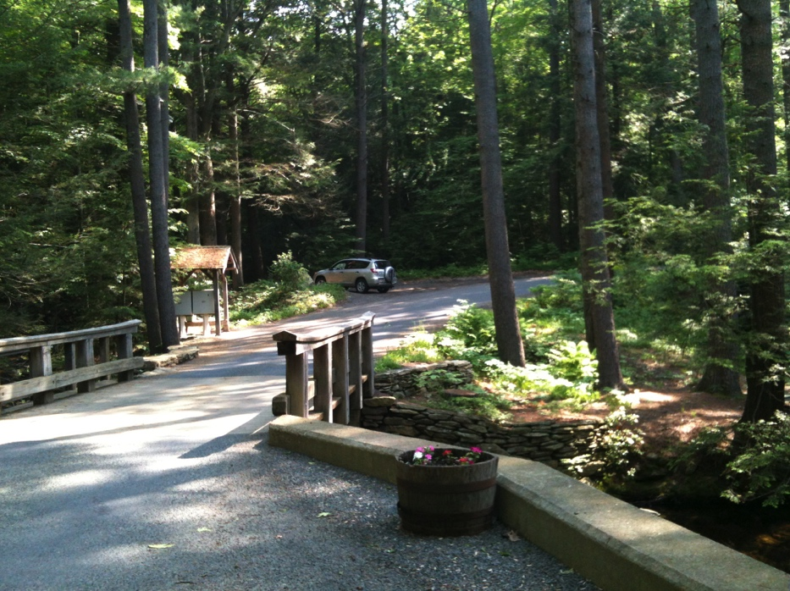

42.51334500 -72.48701000

May 17, 2012

Bridge across stream looking west

A is on the right/upstream/north side

H is on the left.

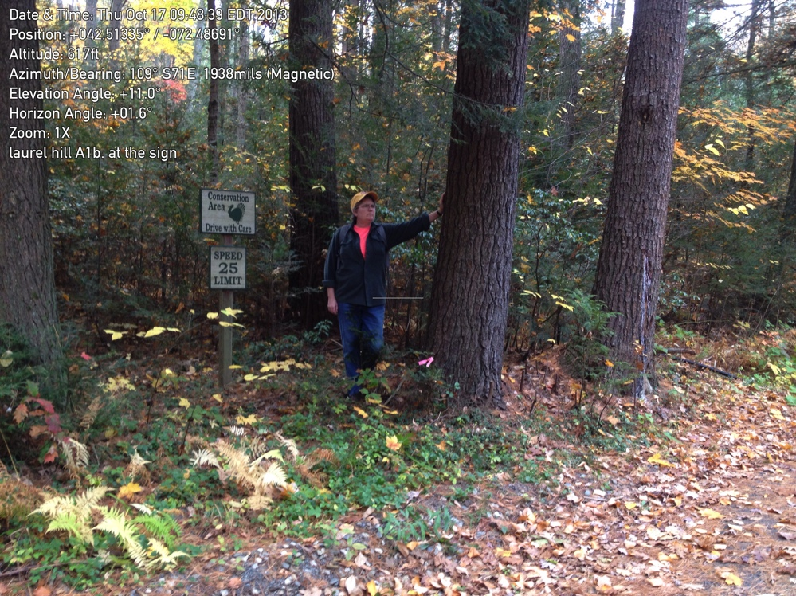

A1 Approximate location.

Using this as the SW corner of Common Land A, the survey angles seem to comeout right at the SE corner. Metal detector did not find post.

October 17, 2013

42.513288 -72.48674100

3-dot corner marking painted on back of tree

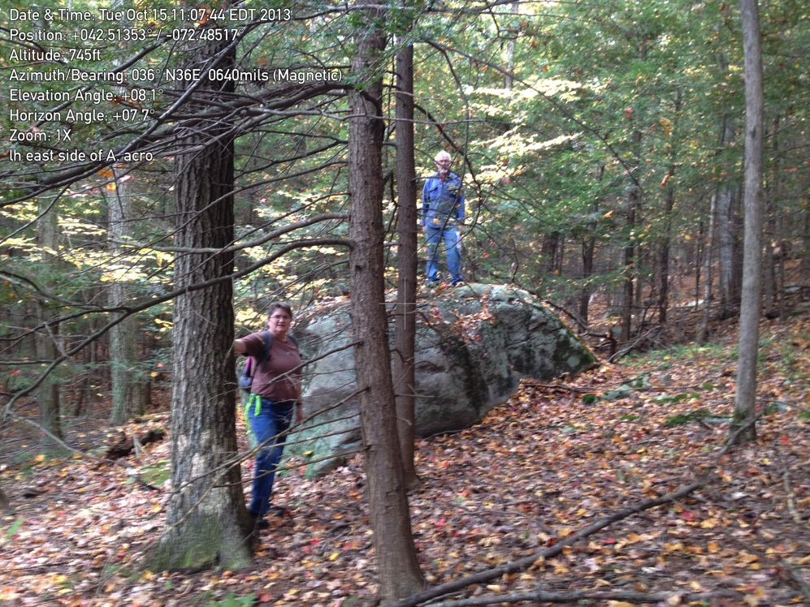

A2. Survey says "unmarked corner" but a huge stone serves as well. Mary at tree, Richard on the huge stone.

10/15/2013

42.513555 -72.485246

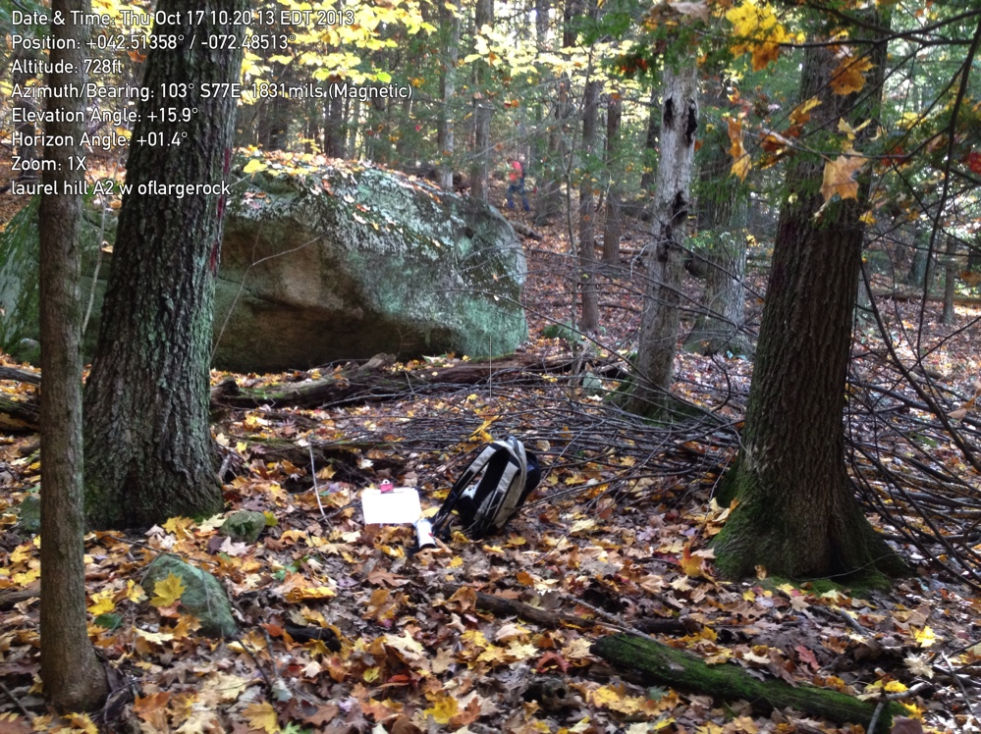

A2 Coming from the other direction (east). Again huge rock serves as the center corner.

October 17, 2013

The approximate line between Common Land A and Lot 1 was painted. Should the need arise, a surveyor would need to locate the theoretical IPs at the road corners.

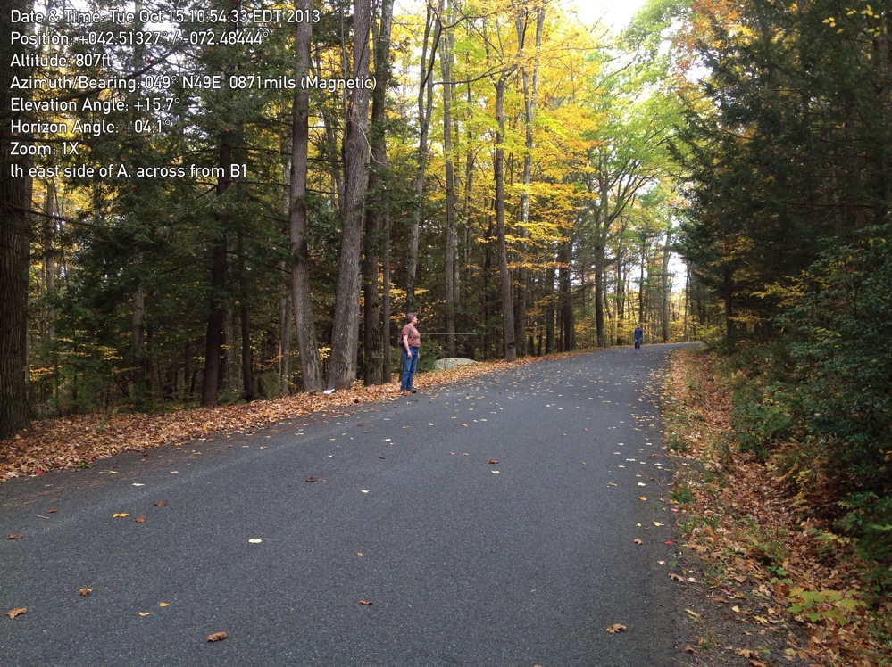A3.

Mary standing across from B1, i.e. SE corner of Common Land A.

10/15/2013

A.3

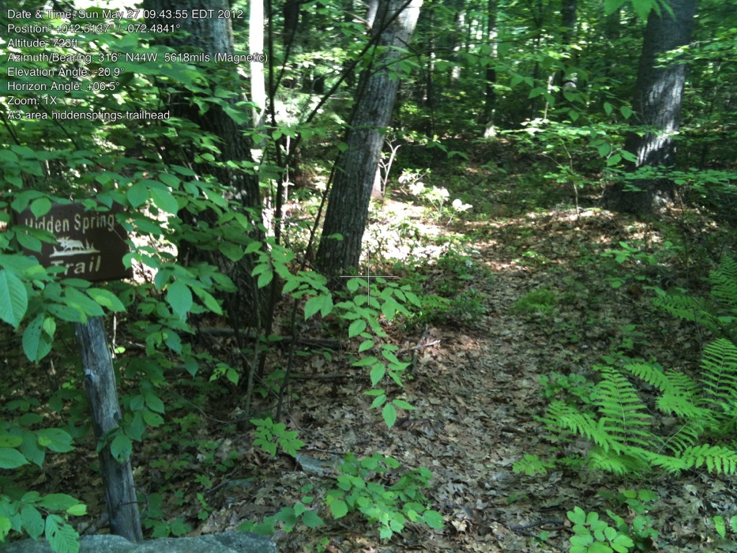

42.51380700 -72.48390000

May 27, 2012

Trail Head for Hidden Springs Trail.

(Note this lovely trail may cross the line into Montague. Town lines provided by the state seem to align with boundary stones on Chestnut Hill and Richardson Roads.)