While the Rattlesnake Gutter Trust is responsible for protecting the conservation values of the Common Land, the management of the Common Land is the responsibility of the Board of Directors of the Laurel Hill Association.

What does this mean for you as an owner or renter in the Laurel Hill community?

- The Common Lands will never be developed – they will be available to you and future residents in perpetuity.
- You can walk the trails or engage in any passive (non-motorized, no hunting) recreation that is not environmentally damaging on the Common Lands.
- If you need to do any tree trimming or cutting on Common Land, you must first seek permission from the managers of the Common Land (the Board of Directors of the Laurel Hill Association).
- Because there are stone structures on the Common Land that have been recognized as features of a Native American ceremonial stone landscape by Tribal Historical Preservation Officers, as well as a few stone walls of 19th century origin, you are asked to respect all stone configurations and to not disassemble, alter, or remove them.
- You, along with all present and future residents of Laurel Hill, are the stewards of your Common Land.

Questions?

Contact a member of the Board of Directors of the Laurel Hill Association.

If it is a question that needs input from both the Laurel Hill Association and the Rattlesnake Gutter Trust, it can be referred to the LHA/RGT Common Lands Committee made up of representatives from both Boards. For more information on RGT, go to:
www.rattlesnakeguttertrust.org

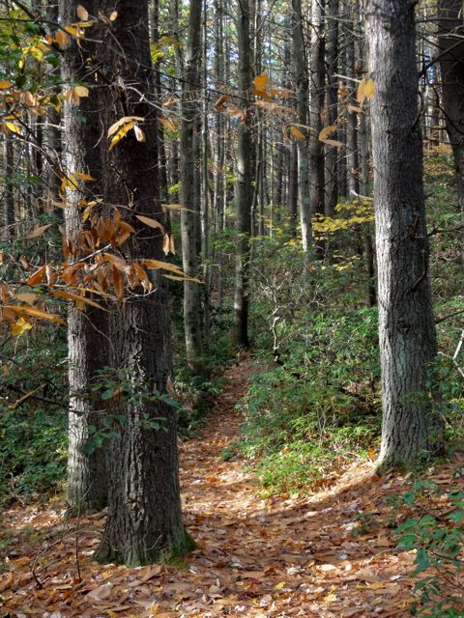

Trail on the Common Lands
(photo by Mary Barnett)

Suggestions for ways to make this flier more useful? Contact info@rattlesnakeguttertrust.org

updated: 1/10/2015
Laurel Hill Common Lands

A brief history

When Leverett was still part of Sunderland in the early 1700’s, records indicate that the land now known as Laurel Hill was owned by Ezekiel Wales. Ethan Howard, a life-long resident of North Leverett whose family owned portions of Laurel Hill in the past, relates that his grandfather as a young boy remembered the Wales family who lived on Laurel Hill. Remains of the Wales cellar hole can be found nearby. By 1850 Laurel Hill was cleared and farmed. Stone walls marking the edges of four pastures reaching north to the Montague town line are partly on Laurel Hill land. Ethan Howard remembered the last major timber harvest on the hill in 1935. The hill then returned to forest until the development in the 1990’s.

In 1991, Sidney Poritz, purchased adjoining properties on Laurel Hill to develop a community of homes that would forever be bordered by conservation land that could be enjoyed by residents but could never be developed as house lots. Eight parcels were set aside, varying in size from 1 to 44 acres as Common Land. The Common Land was to be protected in perpetuity. As each of the original homeowners purchased their property and their share of the Common Land, they transferred their share of the Common Land to the Rattlesnake Gutter Trust, a private non-profit land trust serving the Leverett community. The Board of Trustees of the Rattlesnake Gutter Trust agreed to accept ownership of the Common Land to assure that its conservation value was maintained.

