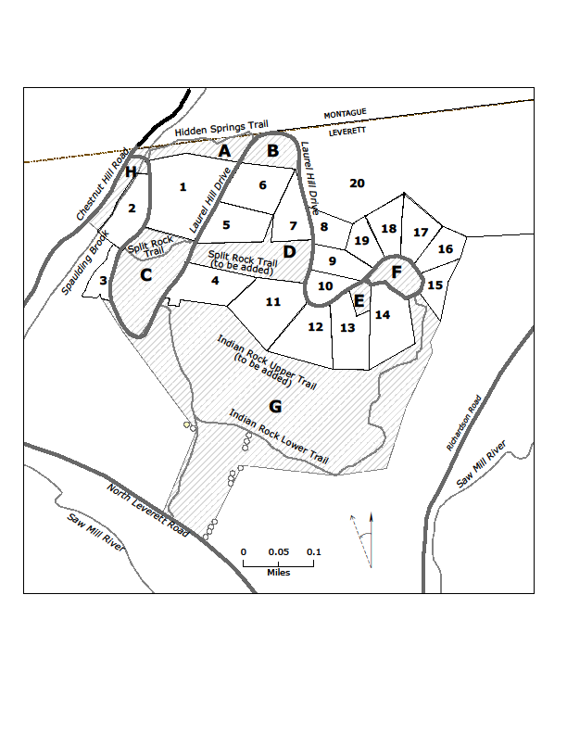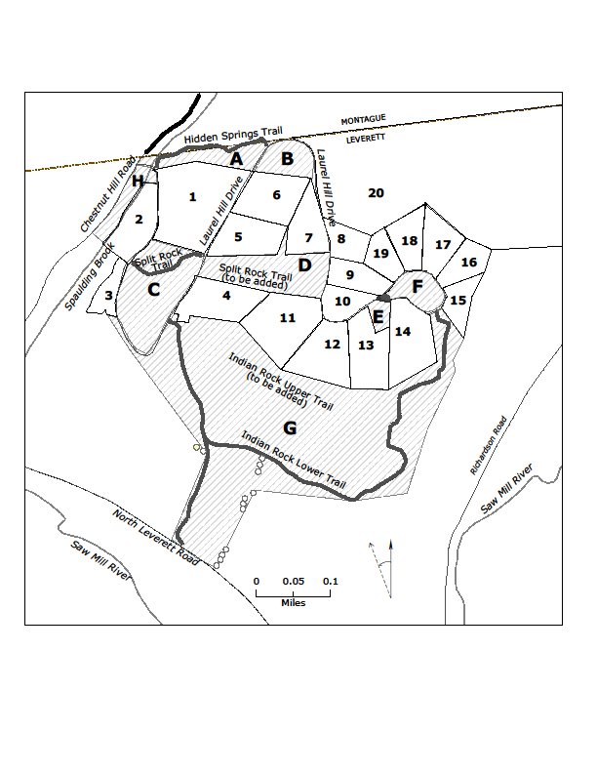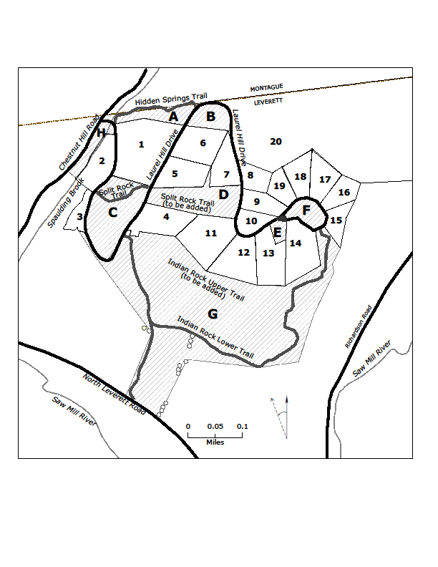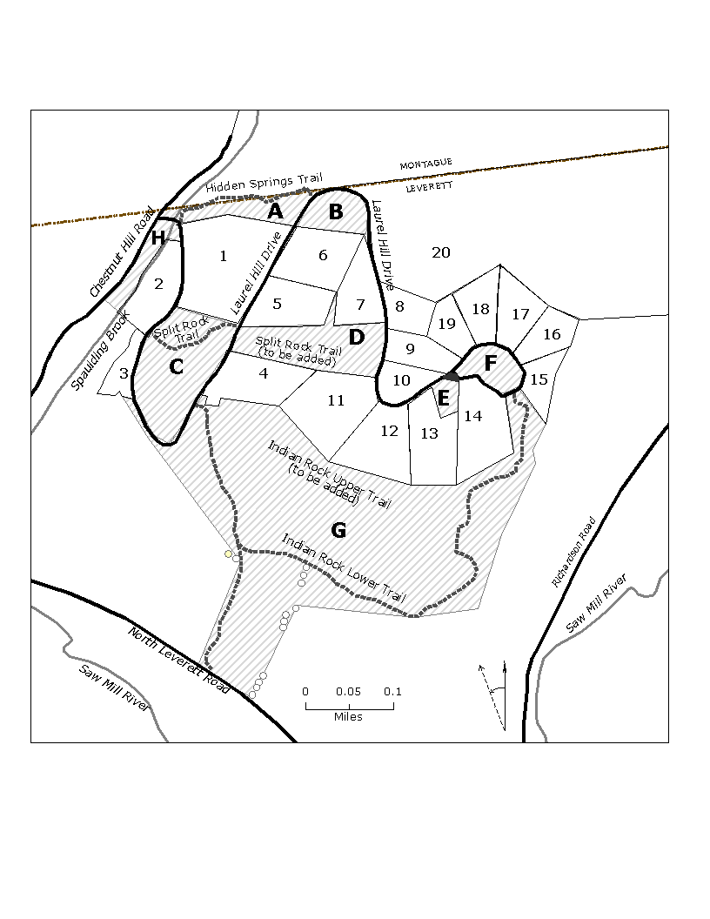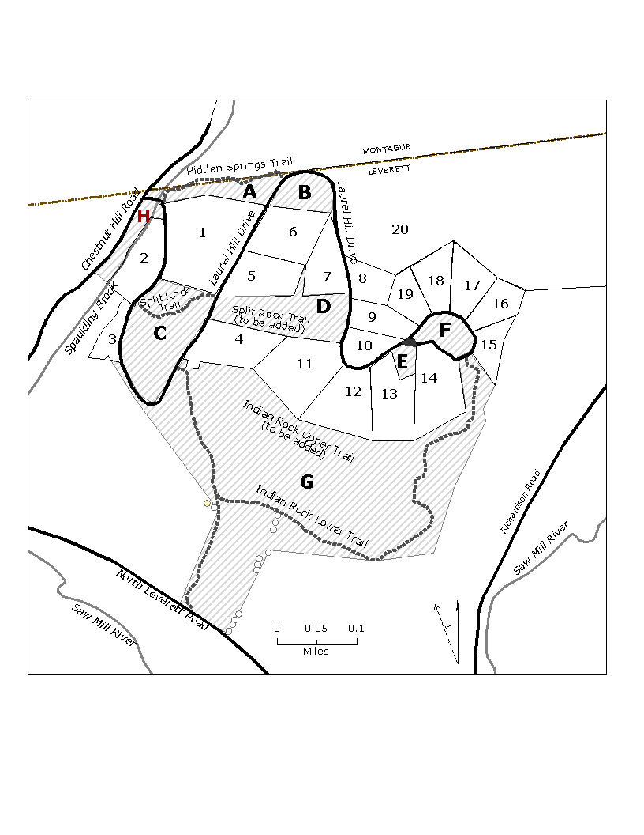Laurel Hill Common Lands

*Please note: This map is a schematic representation of Laurel Hill. It is not*

*intended to be used as a legal boundary definition*.

*Photo (postcard) on the right: North Leverett 1890. Photo from the Forrest Briggs Collection,*

*courtesy of the Leverett Historical Society and the Rattlesnake Gutter Trust. (Laurel Hill is*

*the hill on the right.)*

Laurel Hill Common Lands

There are 8 parcels of Common Land within Laurel Hill. They are labeled the same way on the map as they are on the official surveys of Laurel Hill, as lots A through H. The parcels range in size from 1 acre to 44 acres.

The 20 private properties in Laurel Hill are labeled on the map, as they are on the official surveys, as house lots 1-20 (not by their street address).

Three trails on the Common Land are shown:

Hidden Springs (Common Land A)

Split Rock (Common Land C & D)

Indian Rock: Upper and Lower Trails

(Common Land G)

(There are additional trails on private land that not shown on this map)

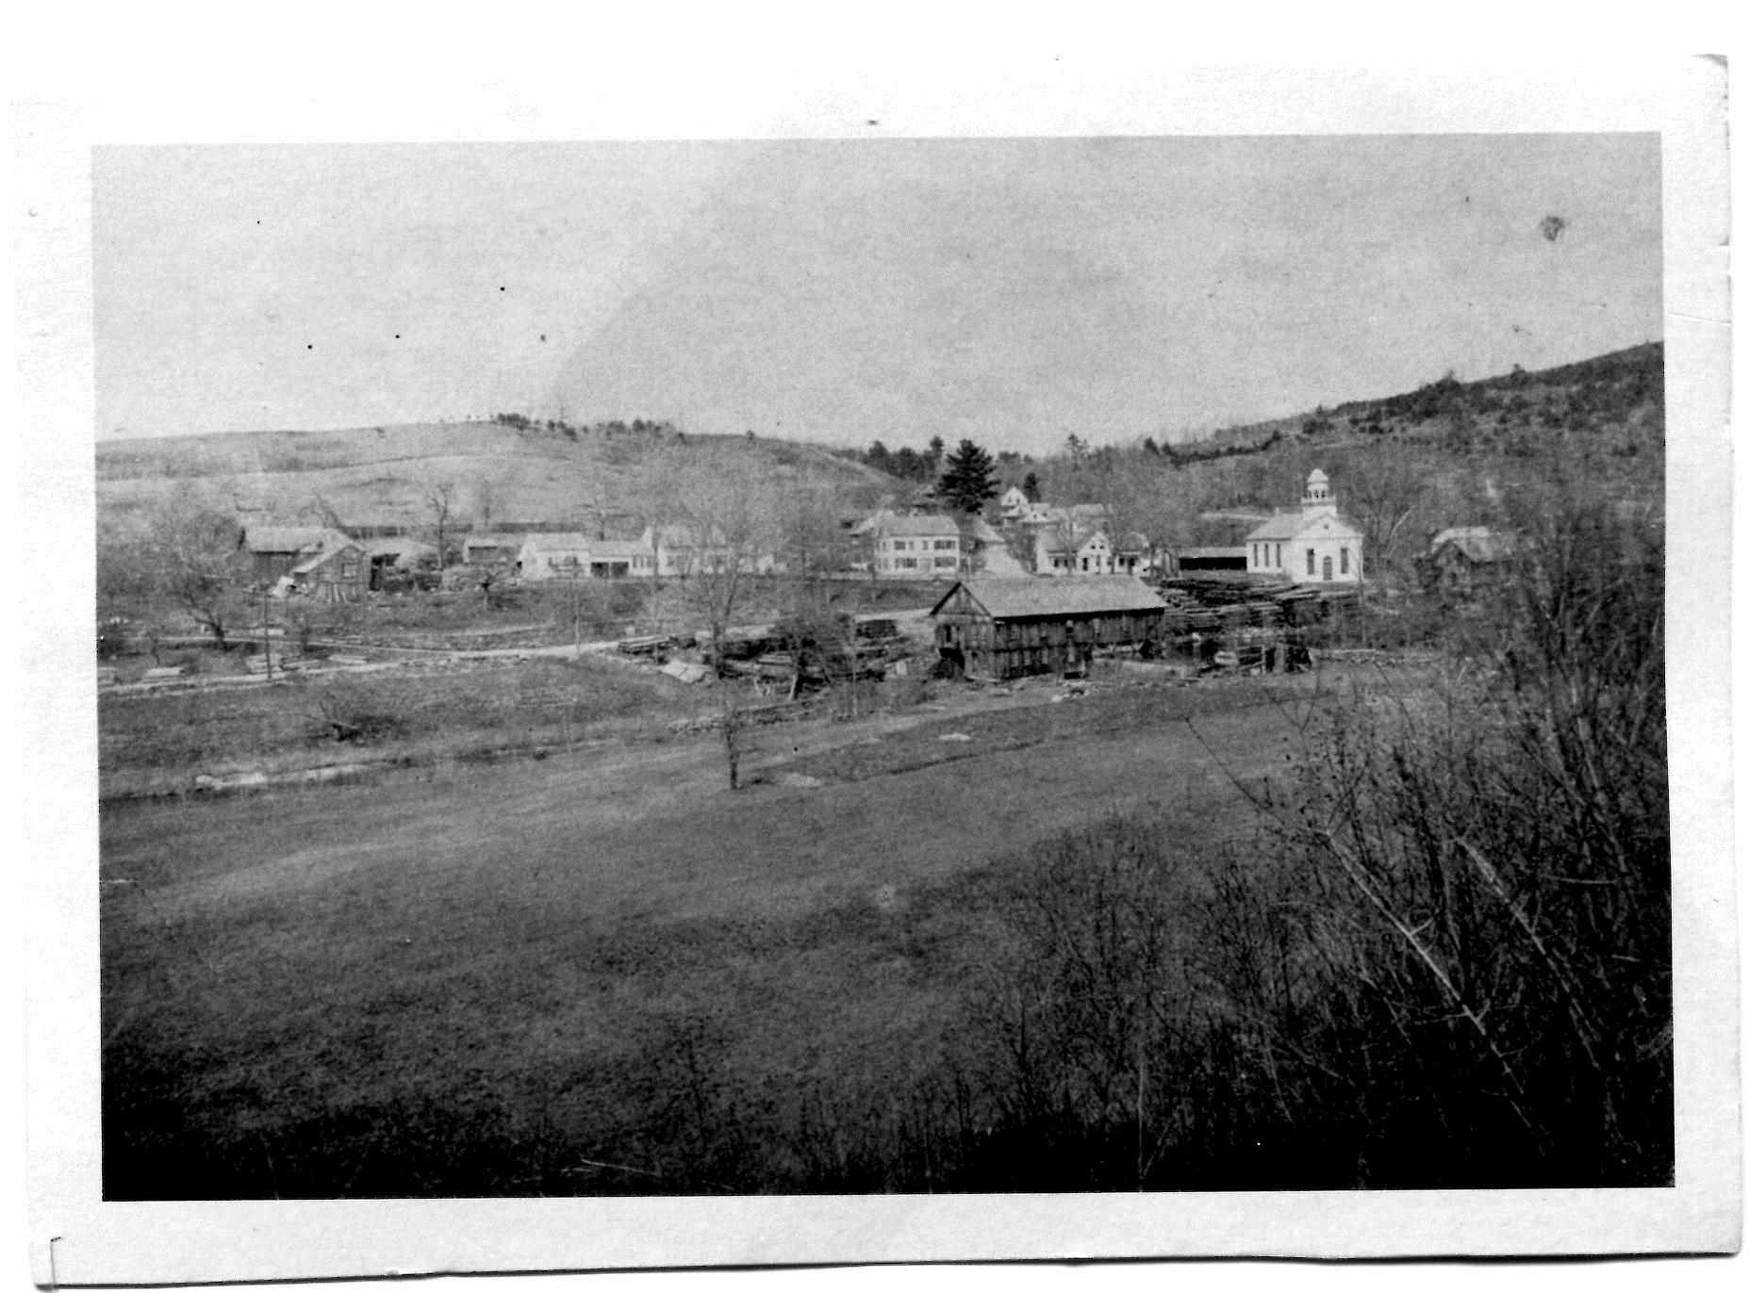Mapping of the stone structures is ongoing