Kuzmeski CR photos for monitoring, part 3 (west side)

(Letters designating corners match those on Kuzmeski monitoring map)

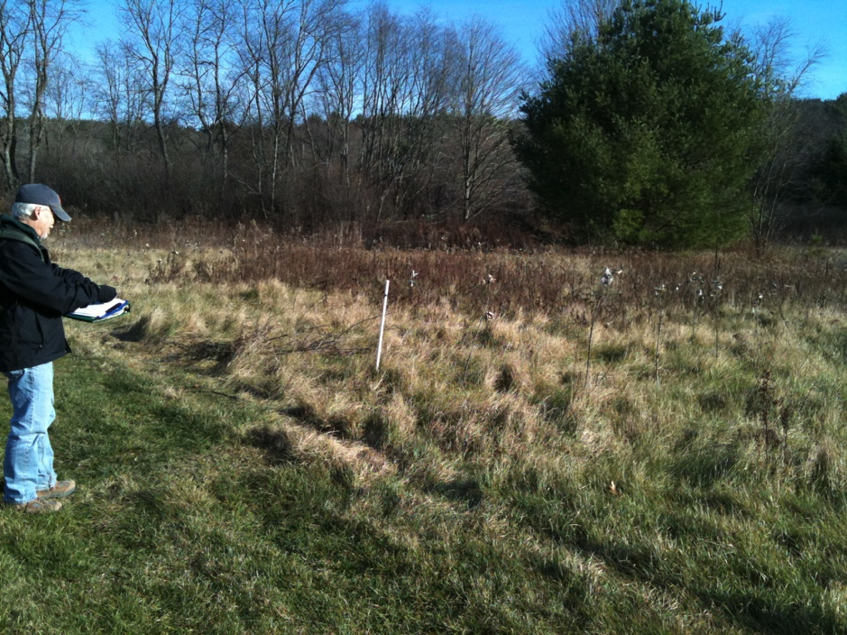

C. NW corner post

corner of Kuzmeski/ELM

Nov 21, 2010

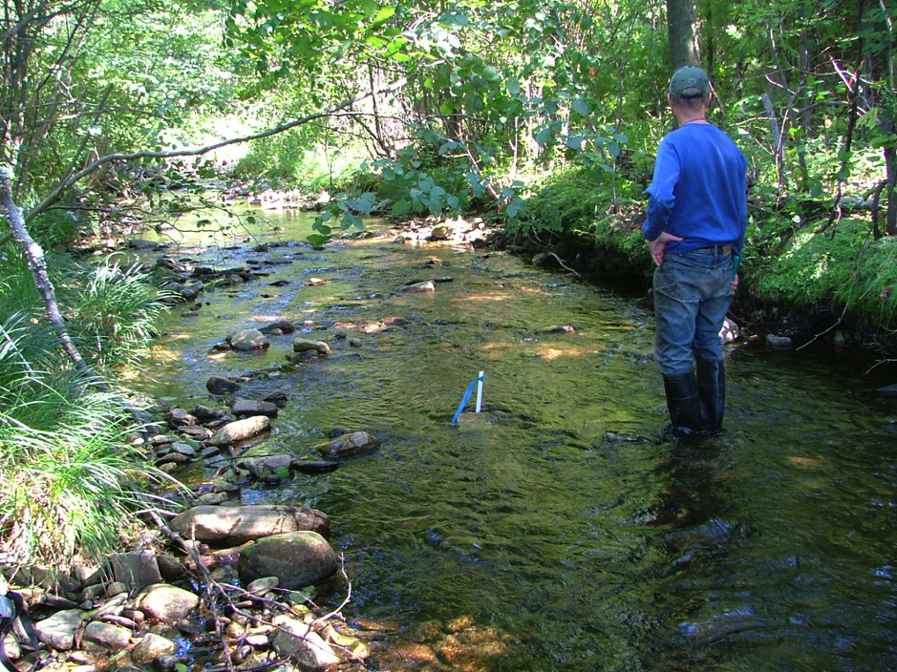

C to D

Along west line. IP has never been found. Temporary plastic approximate

Sept 10, 2006

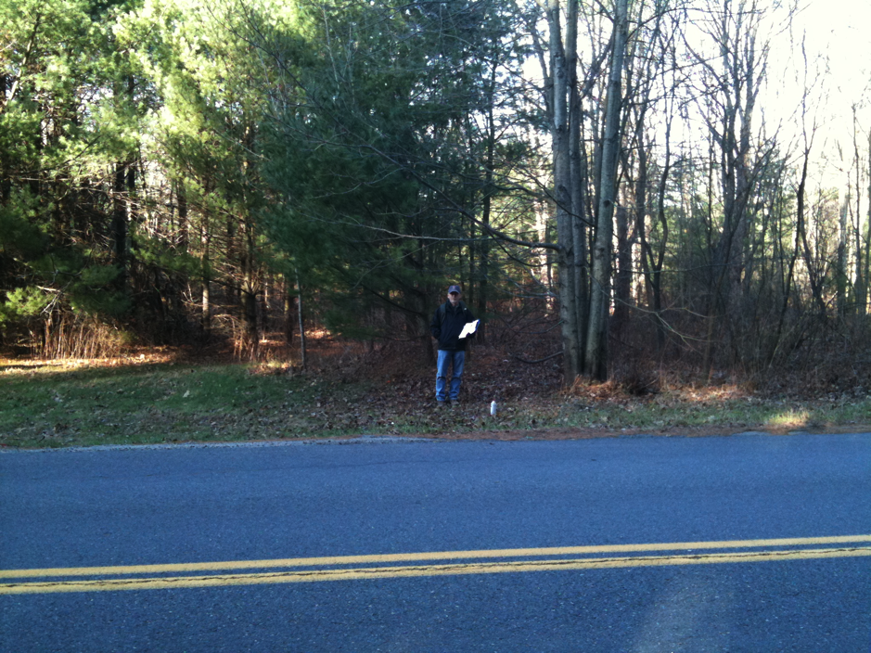

D. SW corner stone

Nov 21, 2010

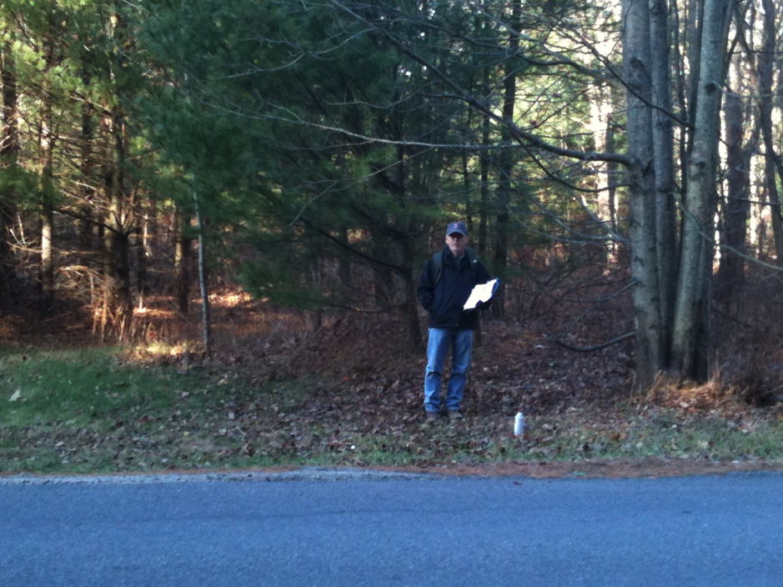

D. SW corner stone close-up

Nov 21, 2010

Parking area and entrance

just to the left side of photo.

(South line follows edge

of Cushman Road.)