Kuzmeski CR photos for monitoring, part 2 (east side)

(letters designating corners match letters on Kuzmeski monitoring map)

A. to B.

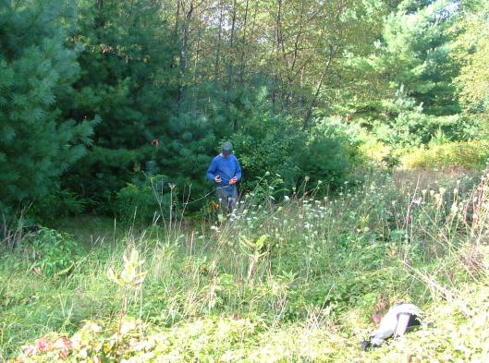

Along west line with Seaman-Williams line. Just north of Roaring Brook and bordering pines. Looking south.

Sept 7, 2006

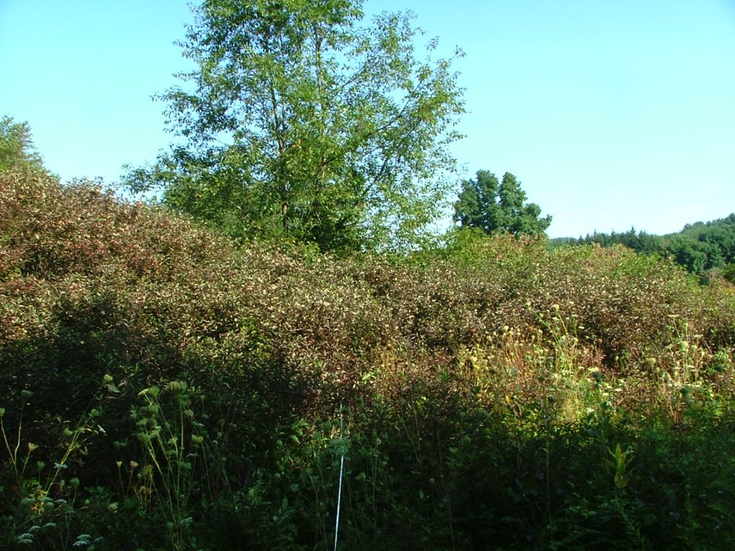

On eastern line looking south into brush north of Roaring Brook

September 7, 2006

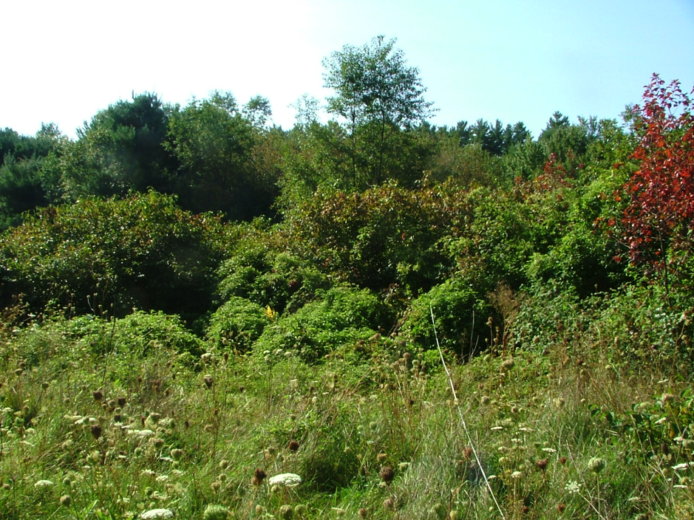Along eastern line closer to

the meadow (north of previous photo)

September 7, 2006

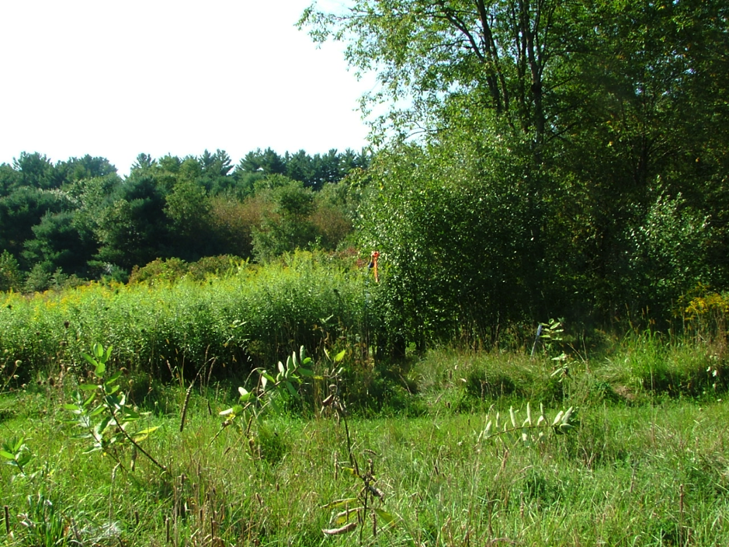

B. NE corner

Red flag a post.

Seaman-Williams, KCR, ELM corner

Sept 7, 2008

(North line is along edge of mowed field)