Kuzmeski Conservation Restriction Photos for Monitoring, part 1 (south east corner)

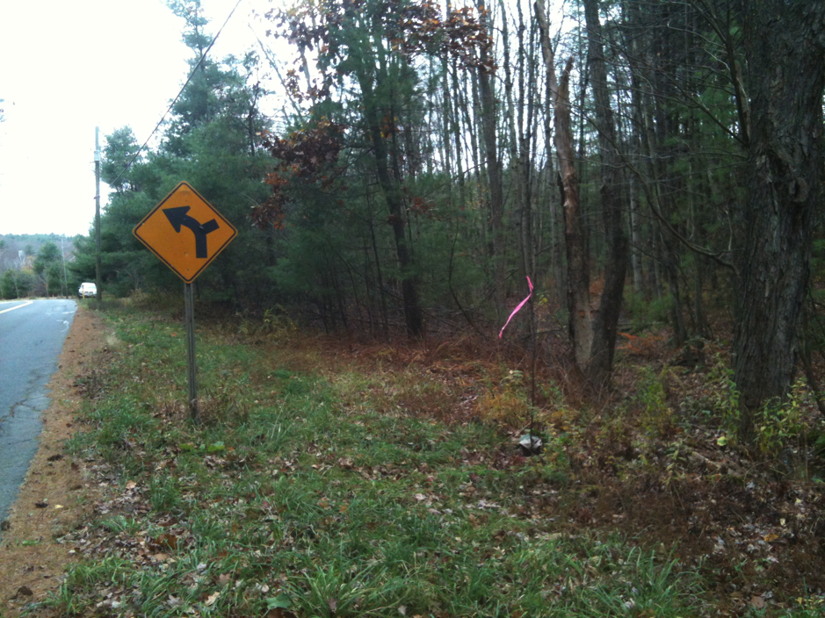

A. SE corner bordering Seaman/Williams

Iron pipe and stone bound

October 28, 2012

Note: there is another IP and stone bound that 50 feet east of the real corner (just east of the yellow sign). Ignore.

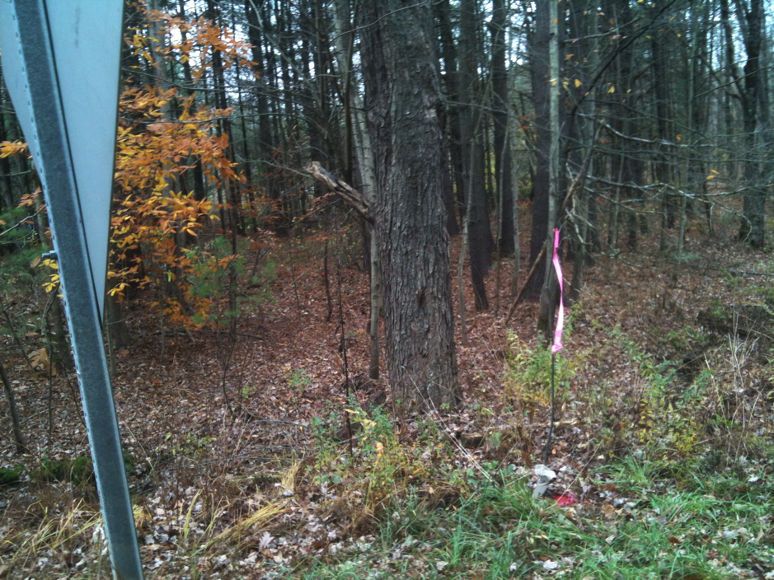

A. SE corner, taken from road next to yellow sign

October 28, 2012

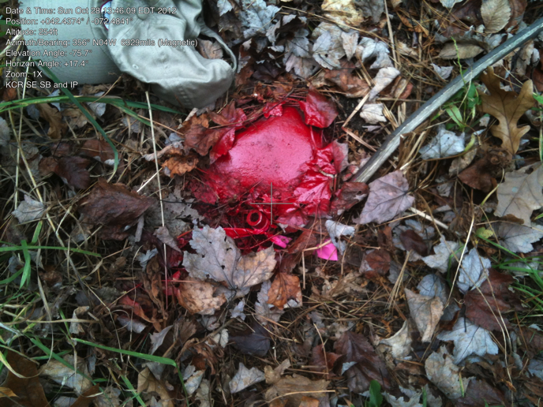

A. Close-up of SE bent iron pin.

October 28, 2012