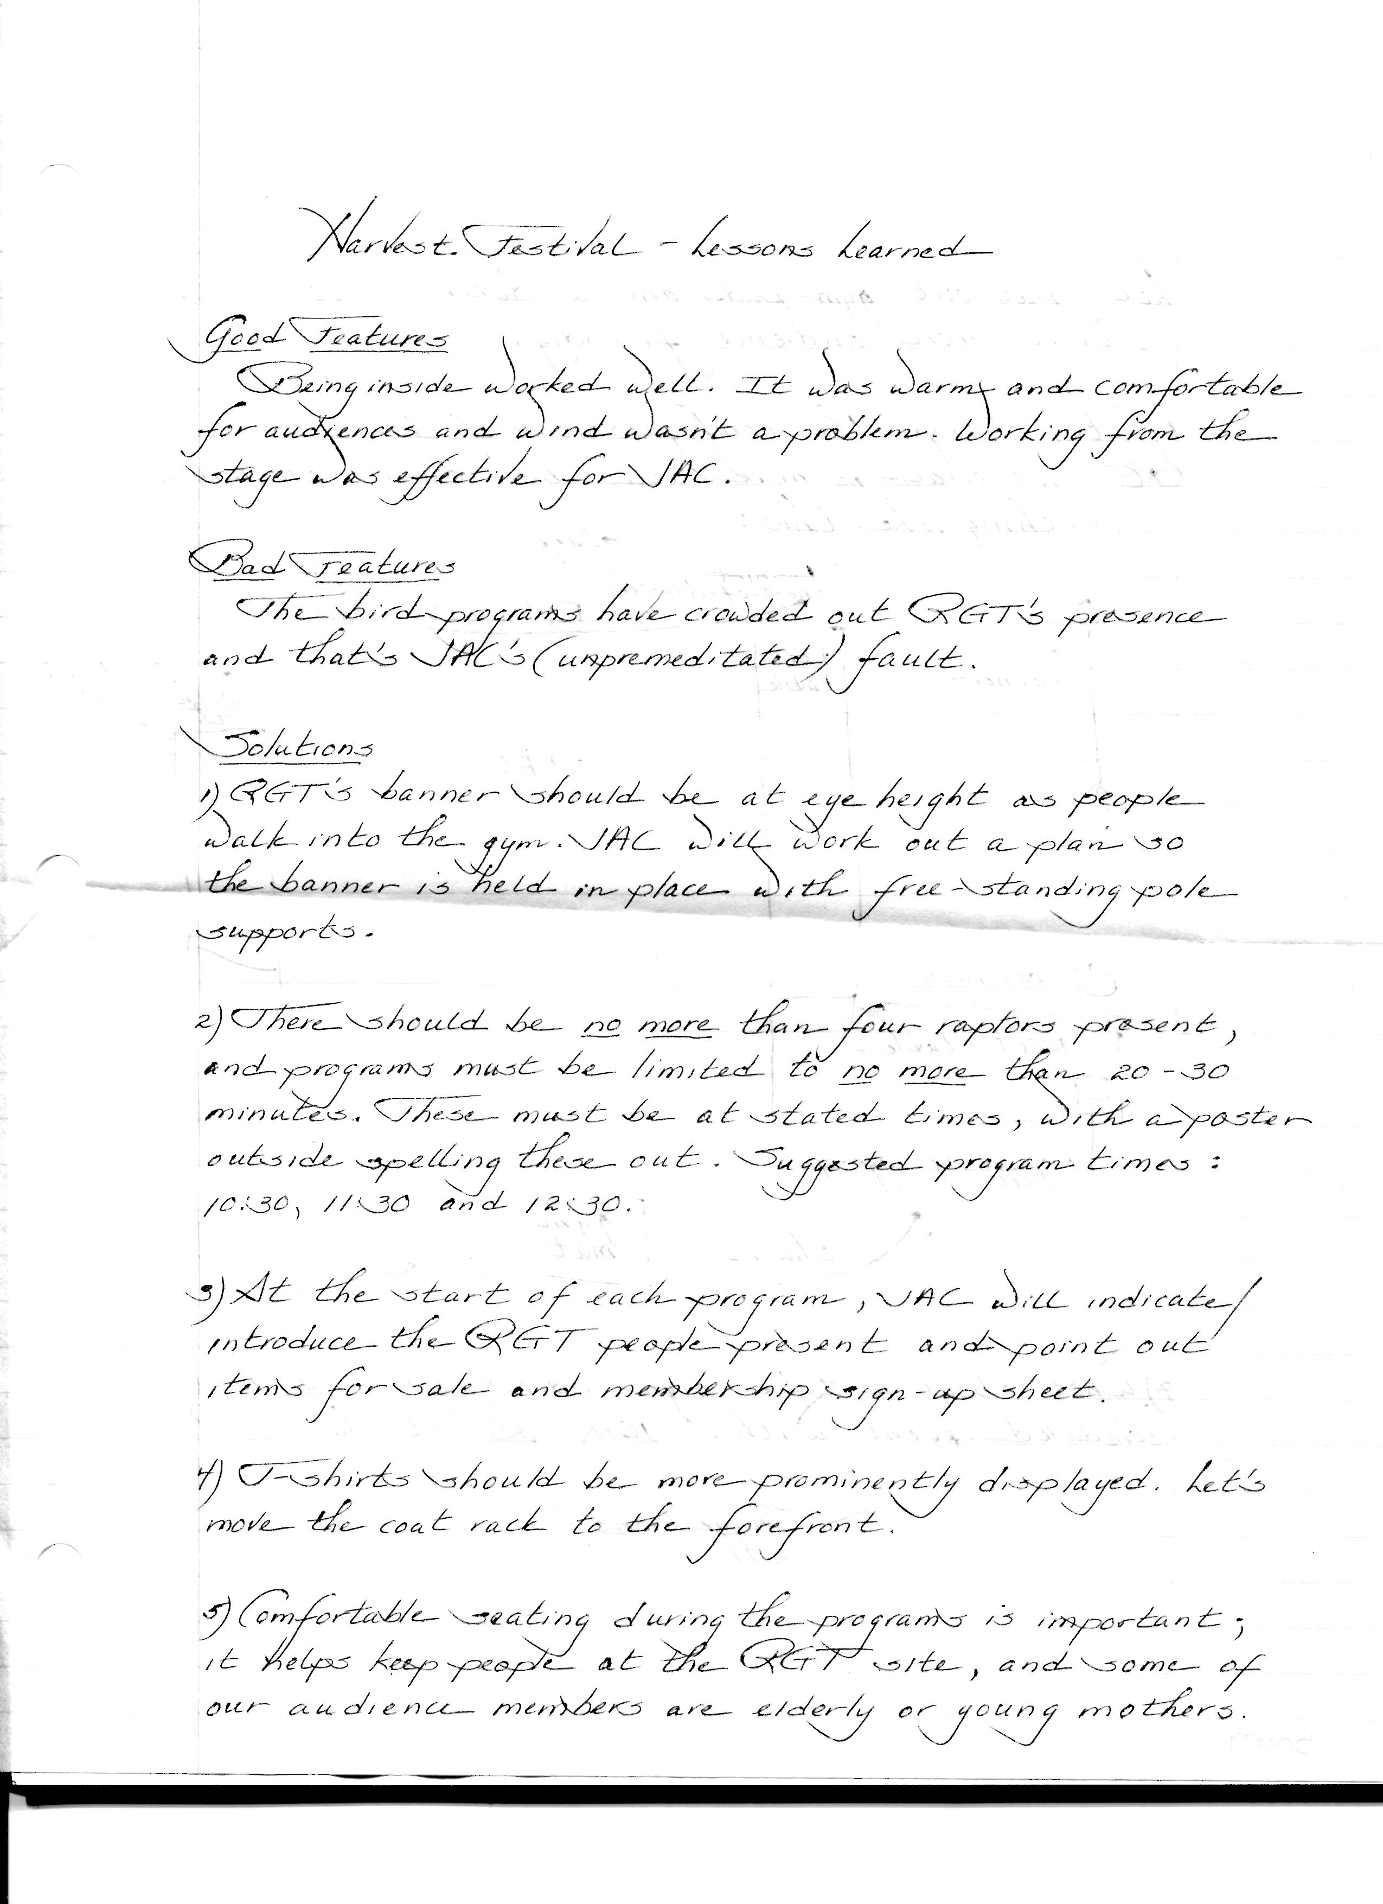

Notes after the 2012 Harvest Festival from Julie Collier and Mary Alice Wilson
(written to help us plan for 2013 and added to in 2014)

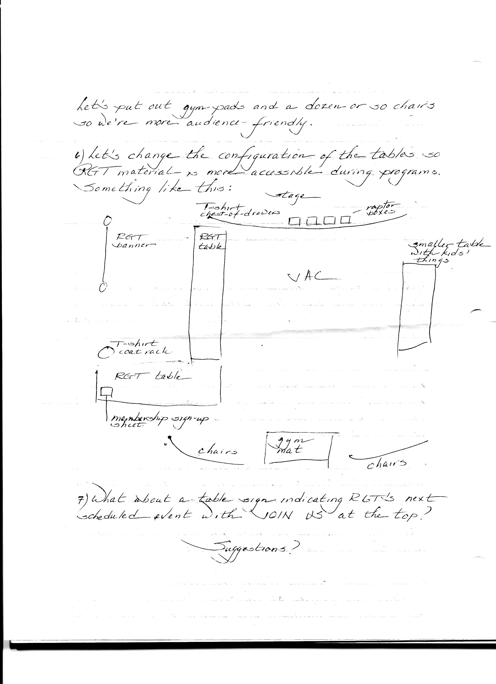

Julie Ann Collier

In early September, Before Harvest Festival

Find out who is organizing the whole event for this year. Get form, fill it out for both RGT and LTC. Julie will need to provide insurance form.

Get information about anything special we are doing in flier that the committee is putting out, in Leverett newsletter, website, any other place

Note about planning afternoon trail walks. In 2014 with the Cave Hill Trails open, we offered both Saturday and Sunday walks. Saturday was OK; Sunday was not - almost no people. Lesson? Offer only Saturday and maybe only 2 trips with different folks leading (so leaders don't have to rush back).

Be on the organizing committees list so you are updated on changes

Harvest Festival supply list and comments

Note: this is a generic list, Julie’s notes above refer to the managing of presentation and tables. No matter what we do, however, the list below is basic stuff. (Julie’s description assumes nice day with most of the tables outside. We would need to modify our use of space if everyone was crowded in the gym. Still her suggestions and the list below would apply. In 2013, birds +RGT inside and LTC outside. In 2014 LTC moved in and out with the weather.

Get from museum:

Cashbox
Cards ($1.00 each)
Snakes (10 and 25 cents) top of filing cabinet (many given to greenhouse)
Banner
Eva's photo string - I don't think used 2013
2 plexiglass stands
Brochures (top of filing cabinet)
Membership cards – DO NOT USE small ones, use left overs from last year’s funding mailing (in one of lower drawers)

To get elsewhere

Cash ($207 - $5 in quarters, $2 dimes; $20 in $1’s, $30 in $5’s, rest in $10) I usually bring some $20s also – sometimes there are large bills. I don’t put all of this in the box, but I make a note of what is in there at the beginning so the numbers come out right later.
List to write down what is sold. (hasn't happened last 2 years) This is useful and we usually forget to do it, leaving treasurer with some variation on “miscellaneous” Changing the price of hats to $15 with T-shirts at $20 will make life easier - perhaps.
Tables – at least 2 bridge tables and cloth that covers, might need more (Julie’s tables better). Julie also has easel that is great (remember to pick it up/pack it. I had to come back for it in 2014)
Updated map of Protected Lands in Leverett in plexiglass stand
Trail maps - enough for both inside and outside
Second plexiglass stand either for RGT or LTC table
Any sign-up sheets needed for projects
Masking tape, scotch tape, stapler, some serious way to tie stuff – bungee cord?
for outside table bring rocks, bathtub feet, whatever works to hold papers against wind.
The Celebrate the Trails waterproof poster looks great on the front of the outside table. (bring tape)

People needed:

RGT two people, Julie cannot be left alone since shows/birds take all her time.

LTC two people, this is just good logistics. allows one person to walk around handing out maps etc.

Set-up - can be the three folks listed above, but help great.

Putting away - additional person. Julie especially needs help from one strong person to get everything back in her van. LTC and RGT archive stuff can be packed in whichever car got that stuff there. (And then, of course, it has to be put away.)

Mary Alice, June 2015

