Gibavic Family Conservation Restriction Photos for Monitoring, Part 2.

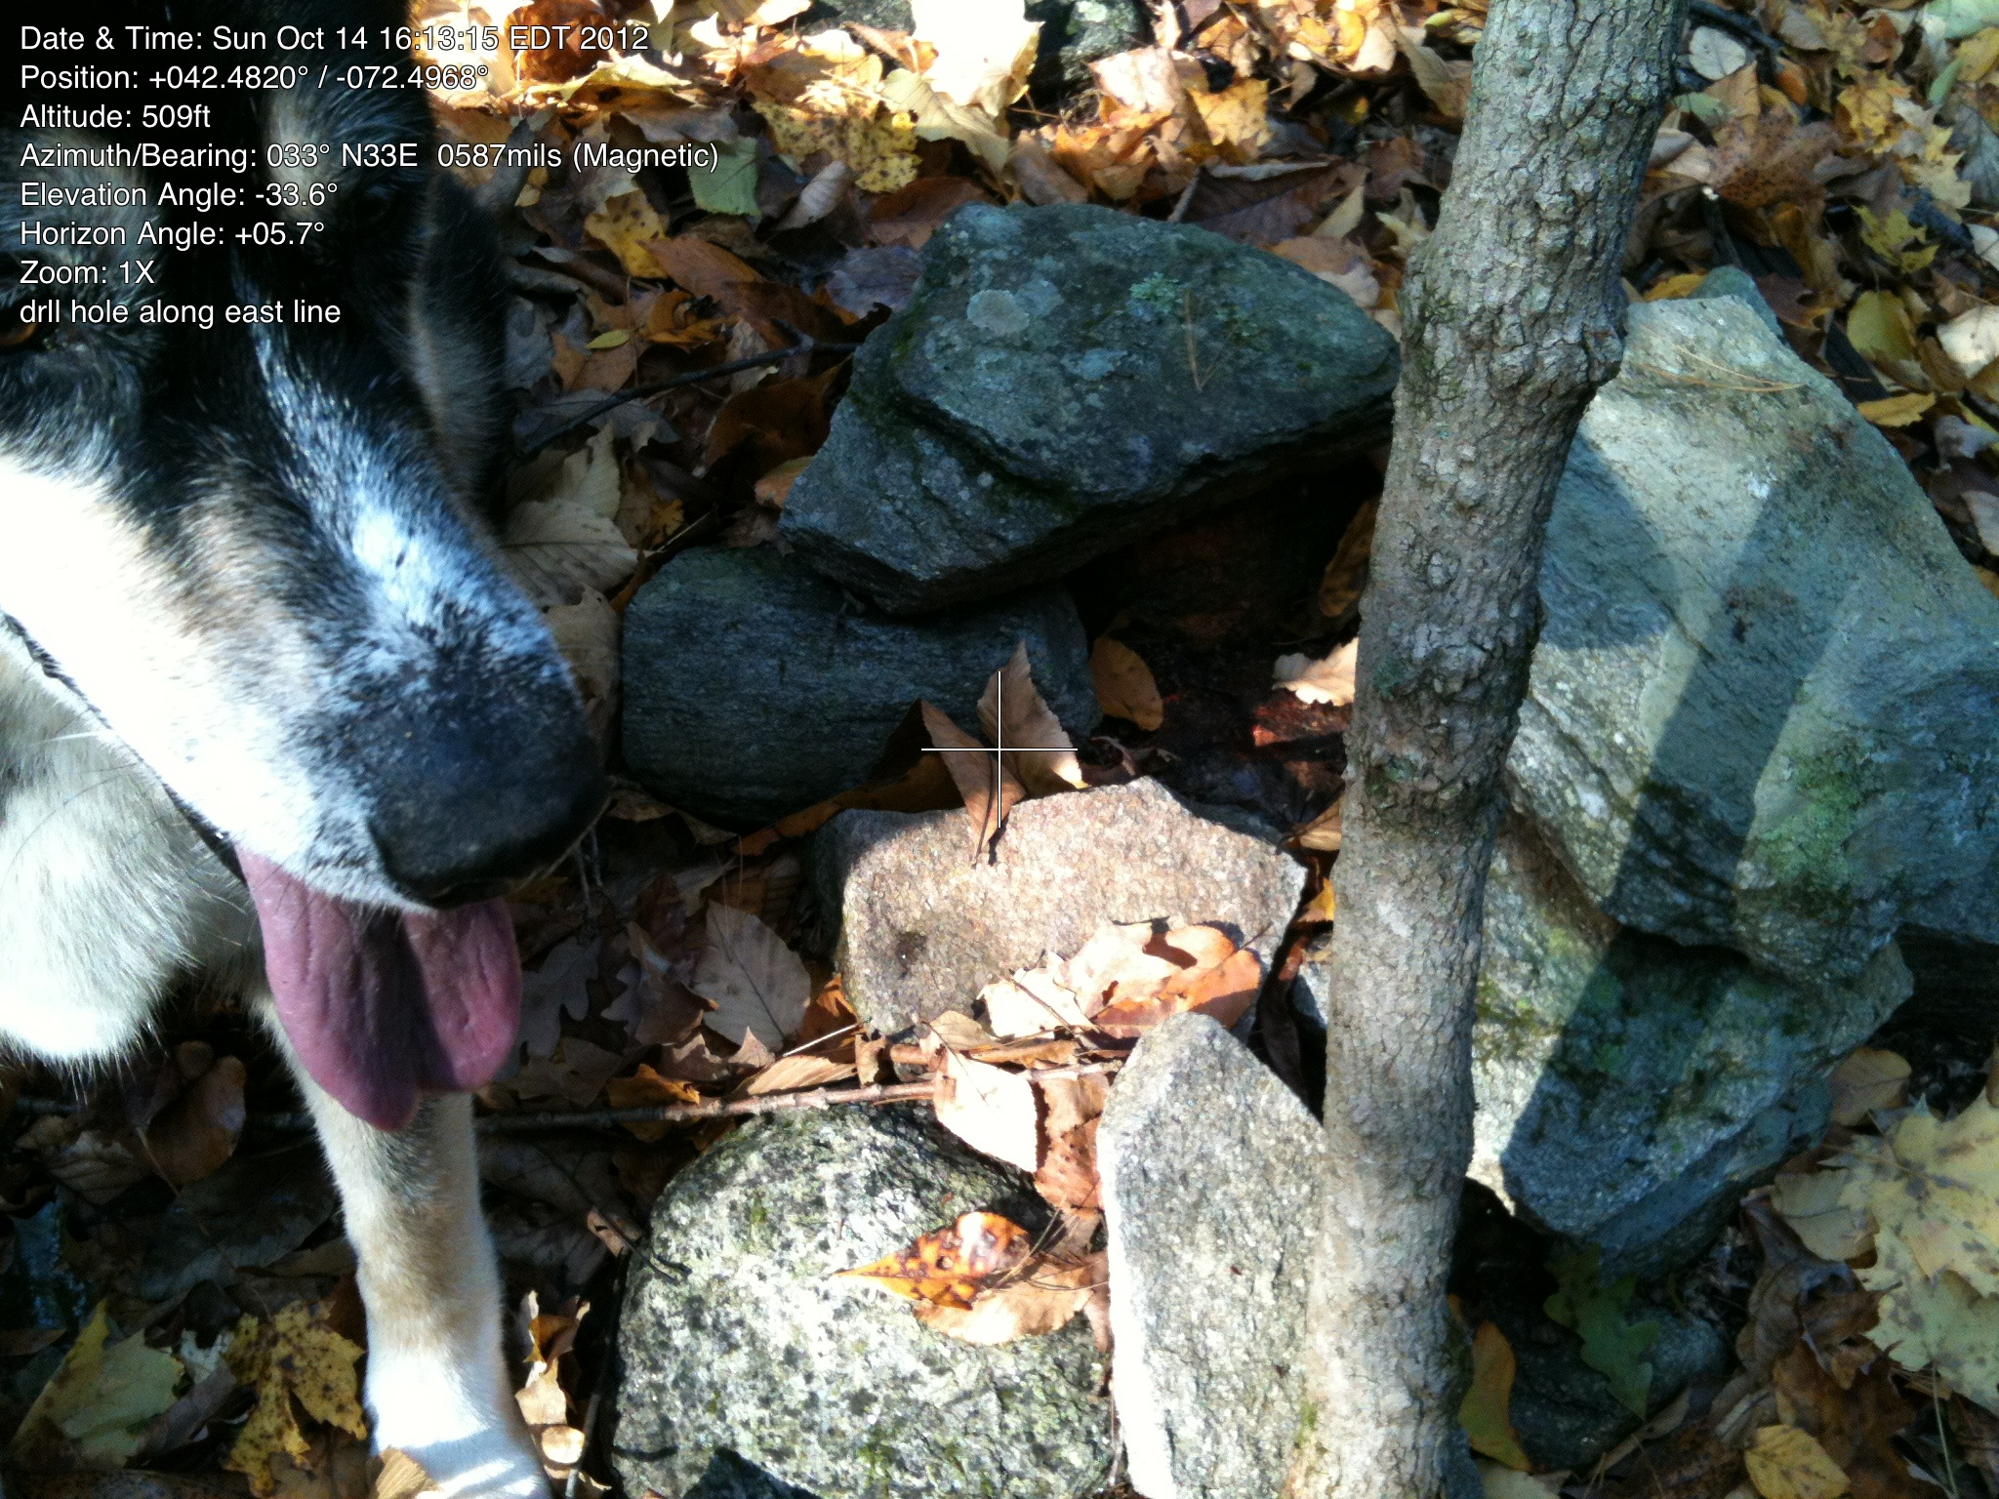
F. Drill hole (and Sadie)

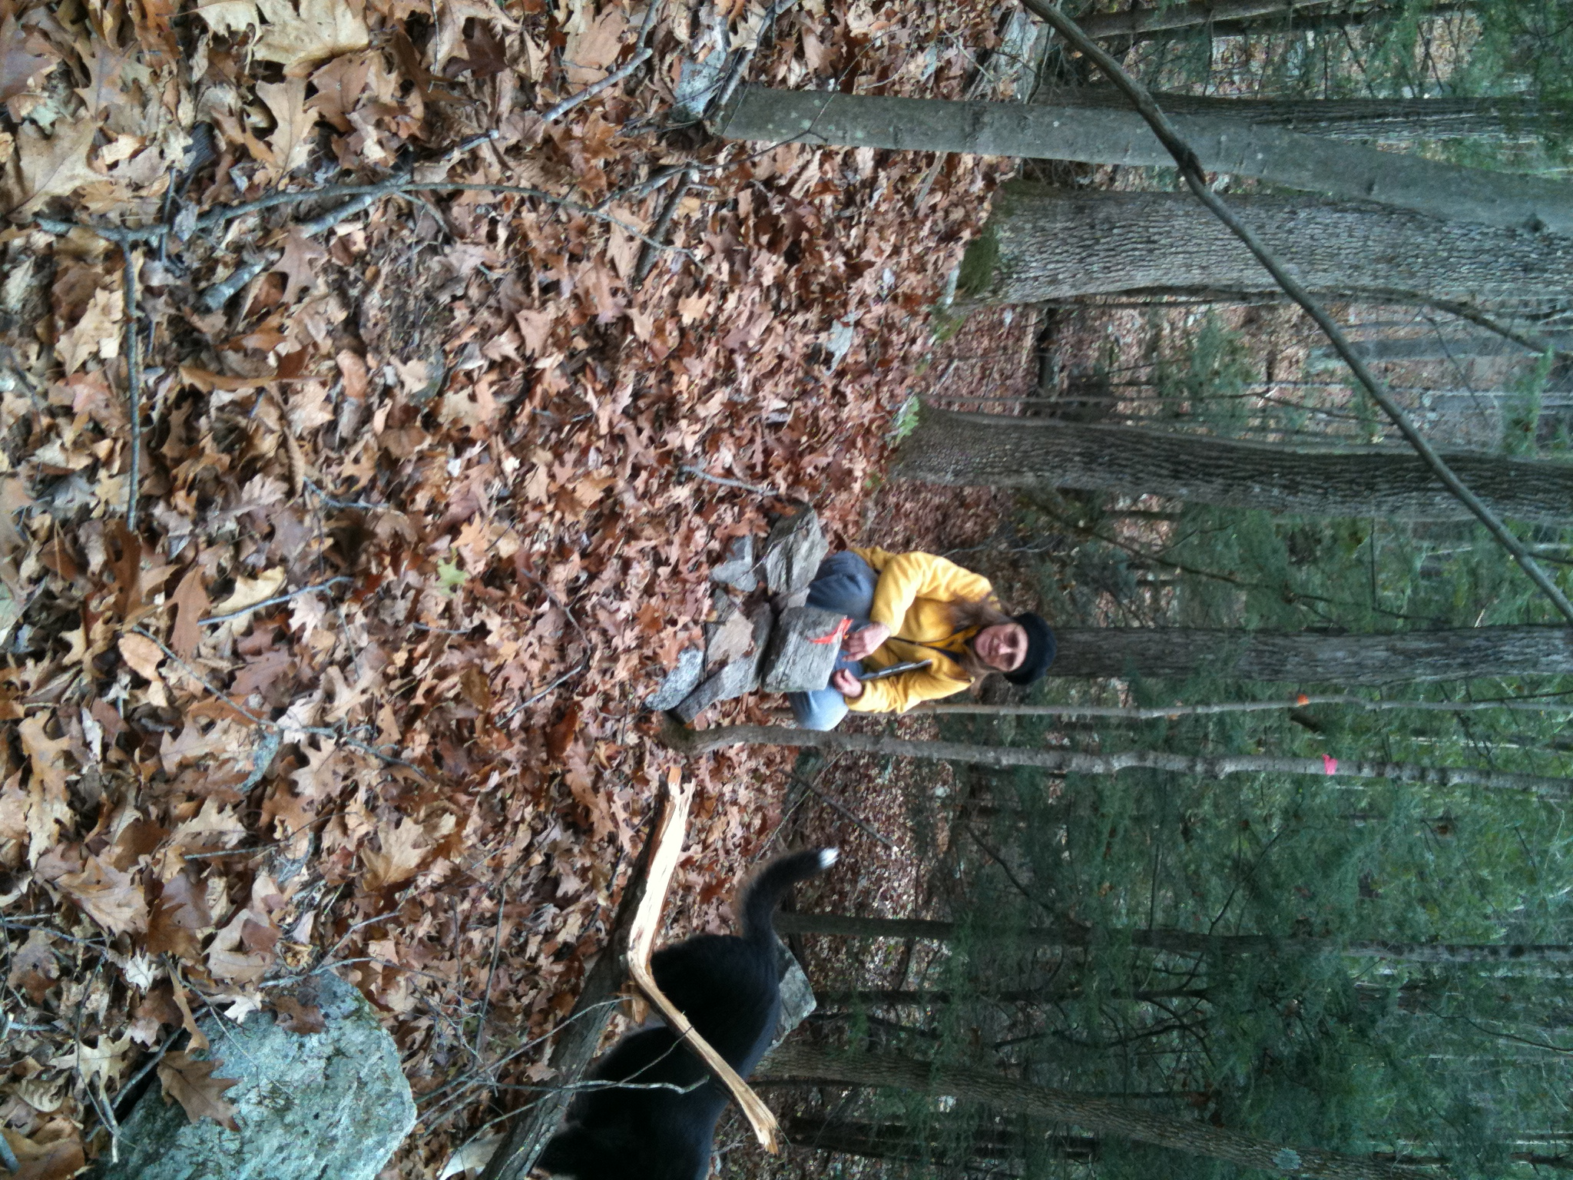

Corner post F
11/20/2011

G. This point is mid-stream in Doolittle Brook. The location used to be marked by a collapsed foot bridge. It floated away. There was never an ip midstream. Need to take new photo and mark probable corner.

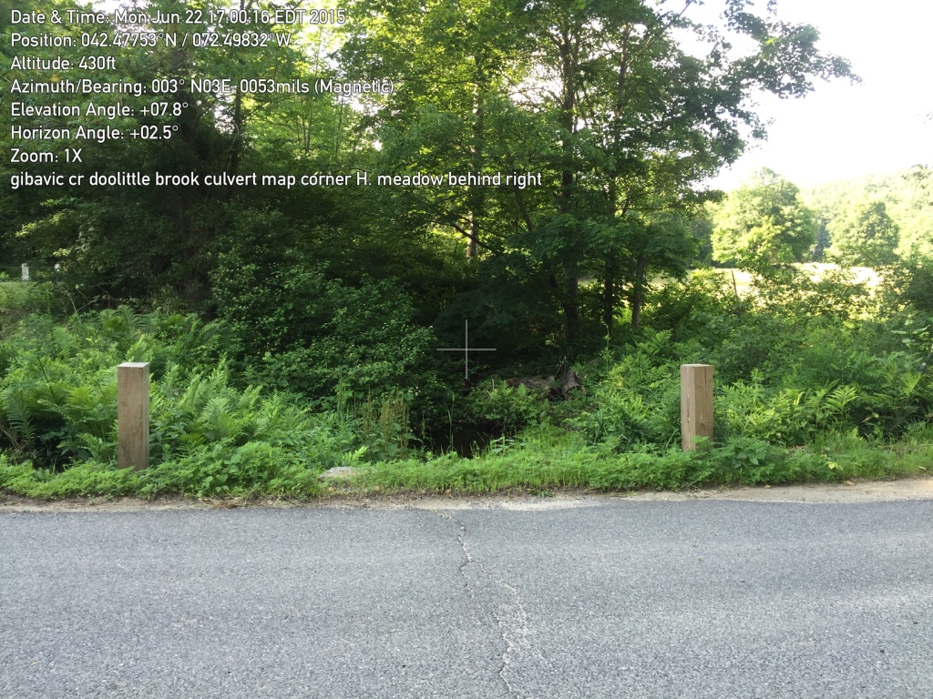

H. Where Doolittle Brook crosses under Rattlesnake Gutter Road. In the summertime, it is not possible to see upstream, but the meadow can clearly be seen to the east.

June 22, 2015

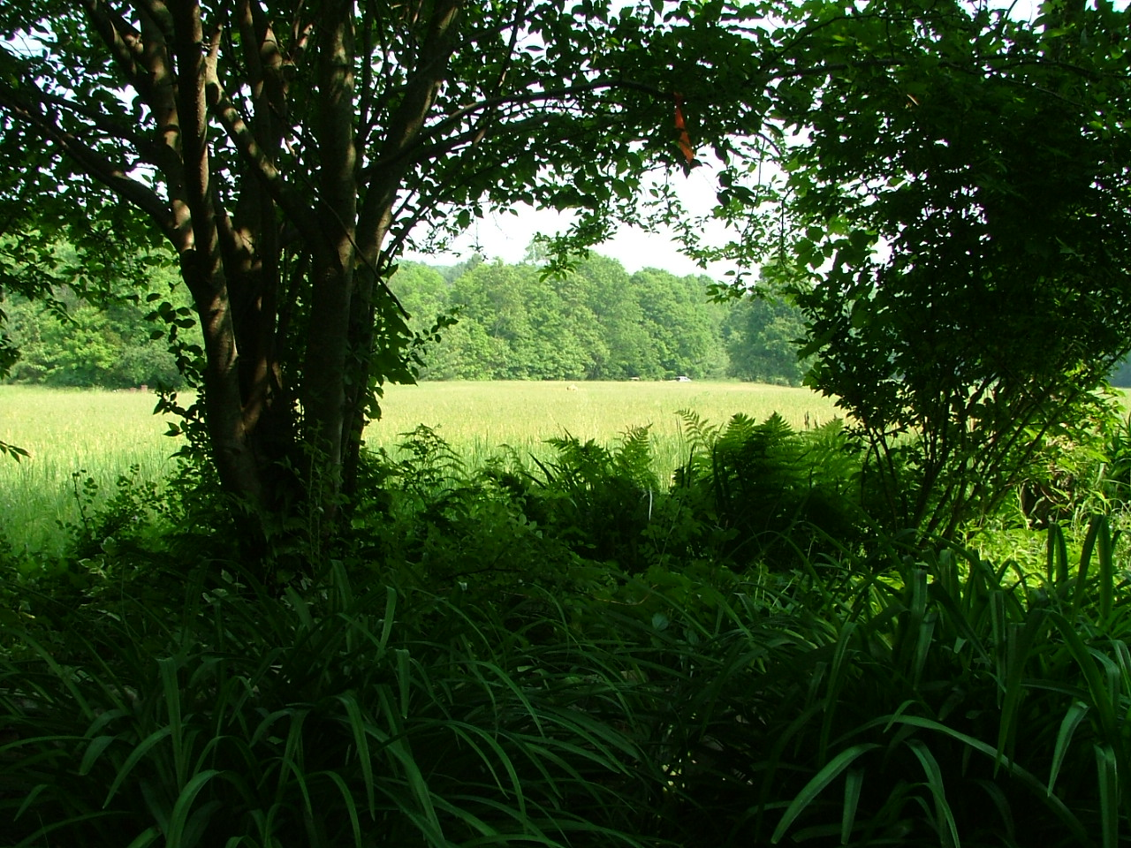
I. June 2, 2007
42.47787, -72.49690
Looking north from Rattlesnake Gutter Road along line separating CR (on left/west) from building envelope (on right/east)

Permanent corner markers will be place in the stone wall and in the meadow. (Piece of red tape on branch of cherry tree temporarily marks the beginning of the line.)

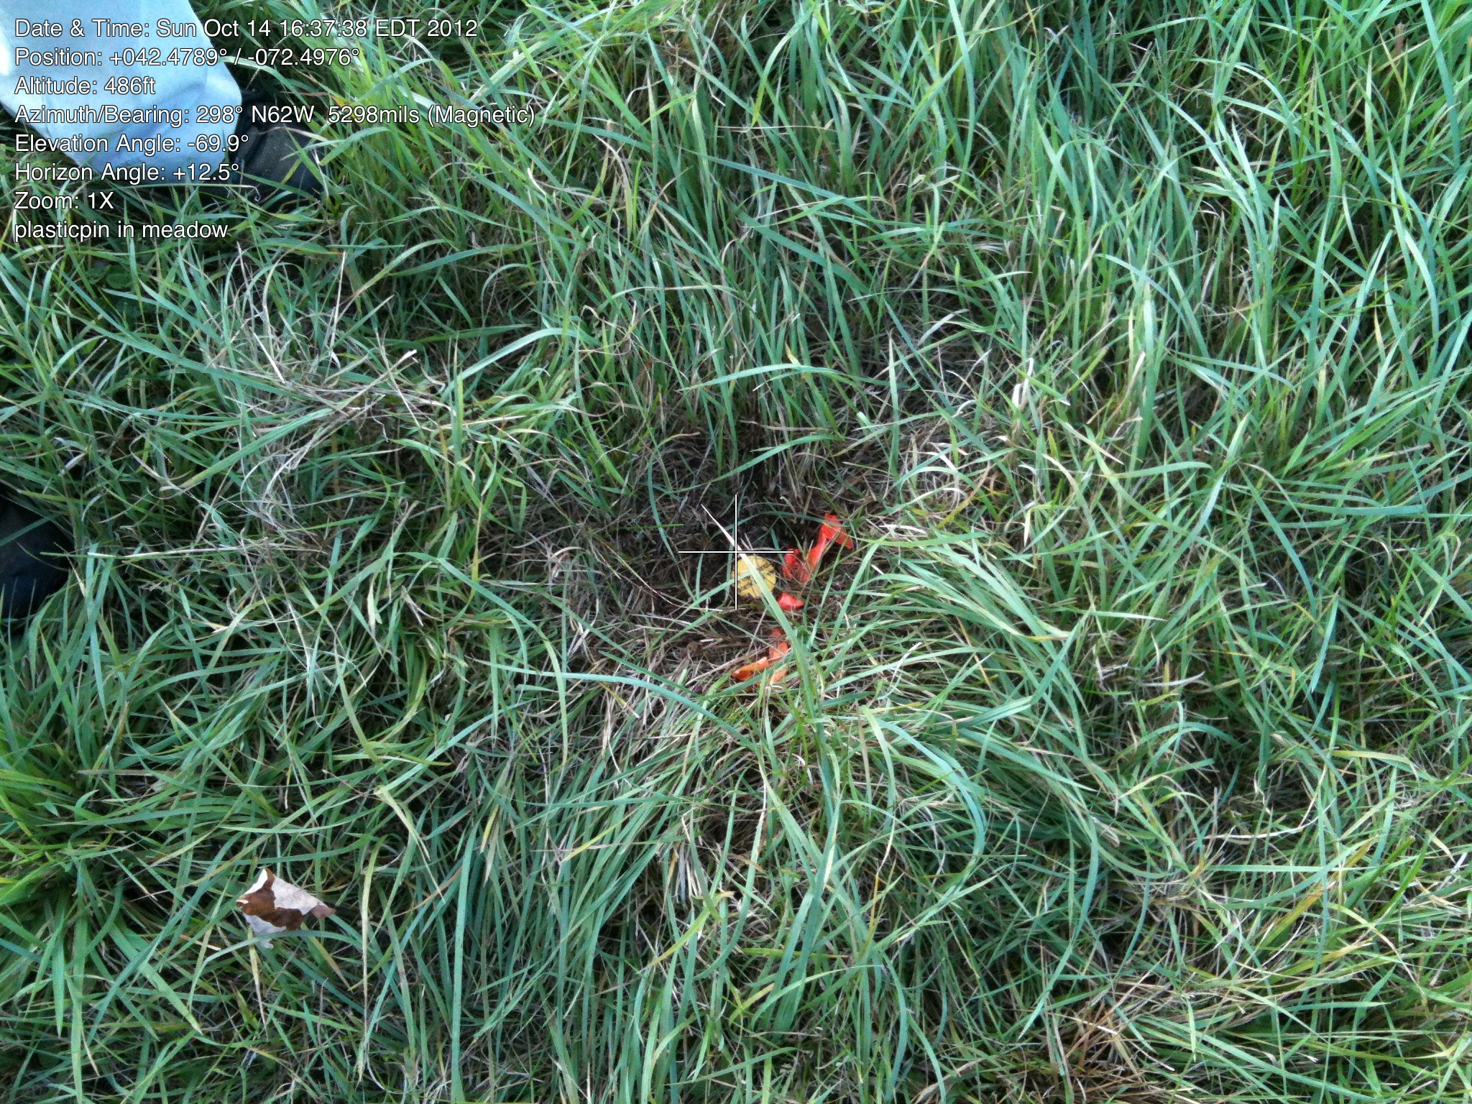
J. Yellow plastic post in meadow (usually knocked off in mowing)

(Photo October 2012 monitoring)

It is possible to come quite close to the corner by lining up the cherry tree (I) with the white stone in the stone wall (K). (And a lovely reason to stand out in the meadow.)

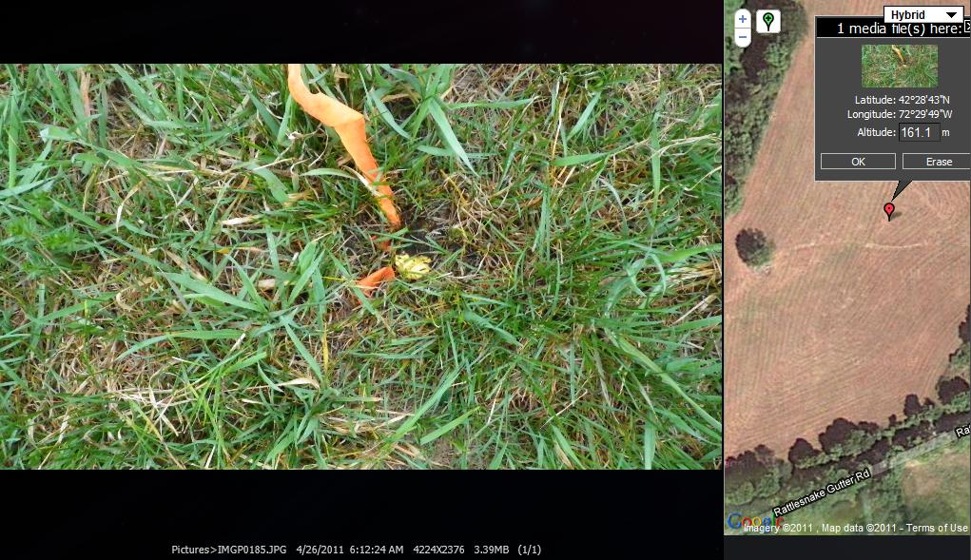

Pin in meadow, point J (Photo November 2011 monitoring)

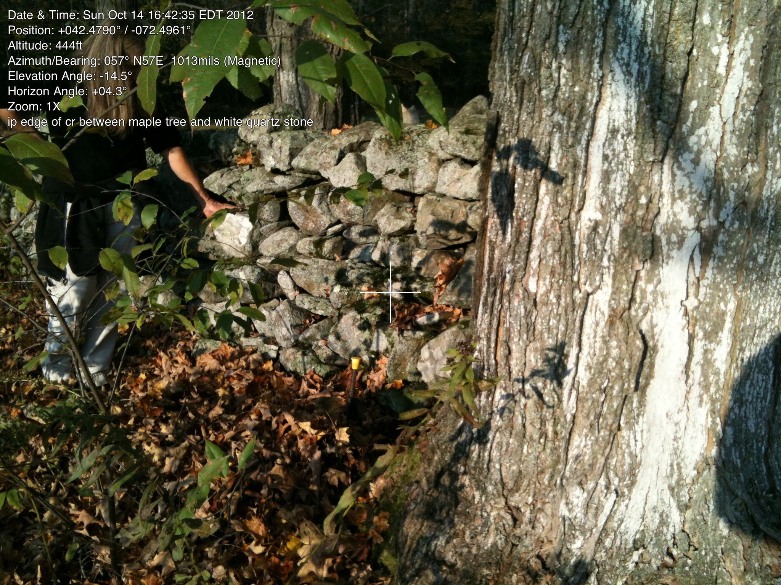

K. IP (yellow top) between white quartz
stone and maple tree. White quartz stone is visible from the meadow.

(Photo, October 2012 monitoring)

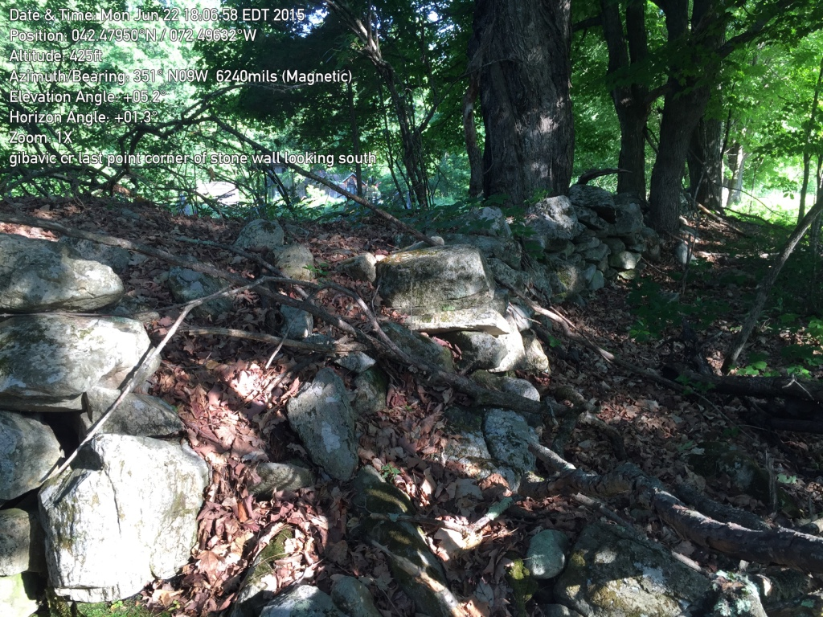
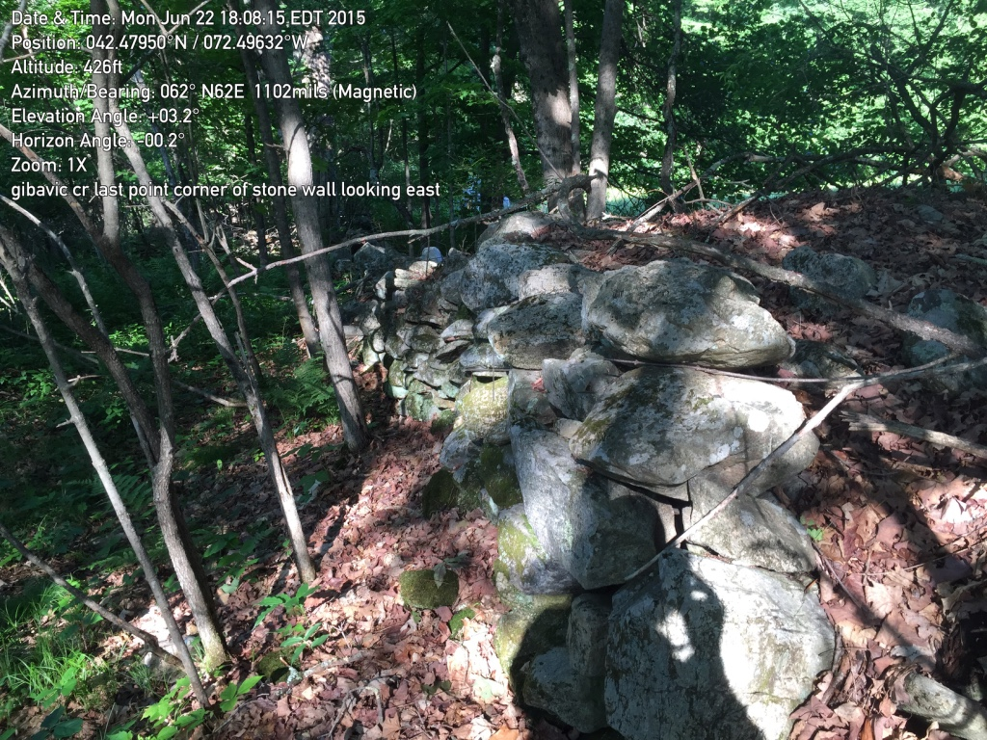
L. Corner of the stone wall north of K. This photo looks south to Rattlesnake Gutter road.

June 22, 2015

L. Same corner looking east to point A on Old Cave Hill Road.

