Gibavic Family Conservation Restriction
Letters match letters on the monitoring map

Note to future monitors: While there is some confusion (at least in my mind) of the location of the NW corner, the rest of the boundary is very clear. However, because the family would prefer not to have paint sprayed all along the north and west boundary (the east and south are along roadways), there are no marks between pins. This means you need either a compass (and the skill to use it and ideally the ability pace distances) or a gps unit into which you have loaded the shape file (and the skill to use your unit or app). It is a lovely place to spend time. In fact, I keep going back trying to figure out the totally-unimportant problem of the nw corner (C) just to spend time on the property.
Mary Alice Wilson, June 2015

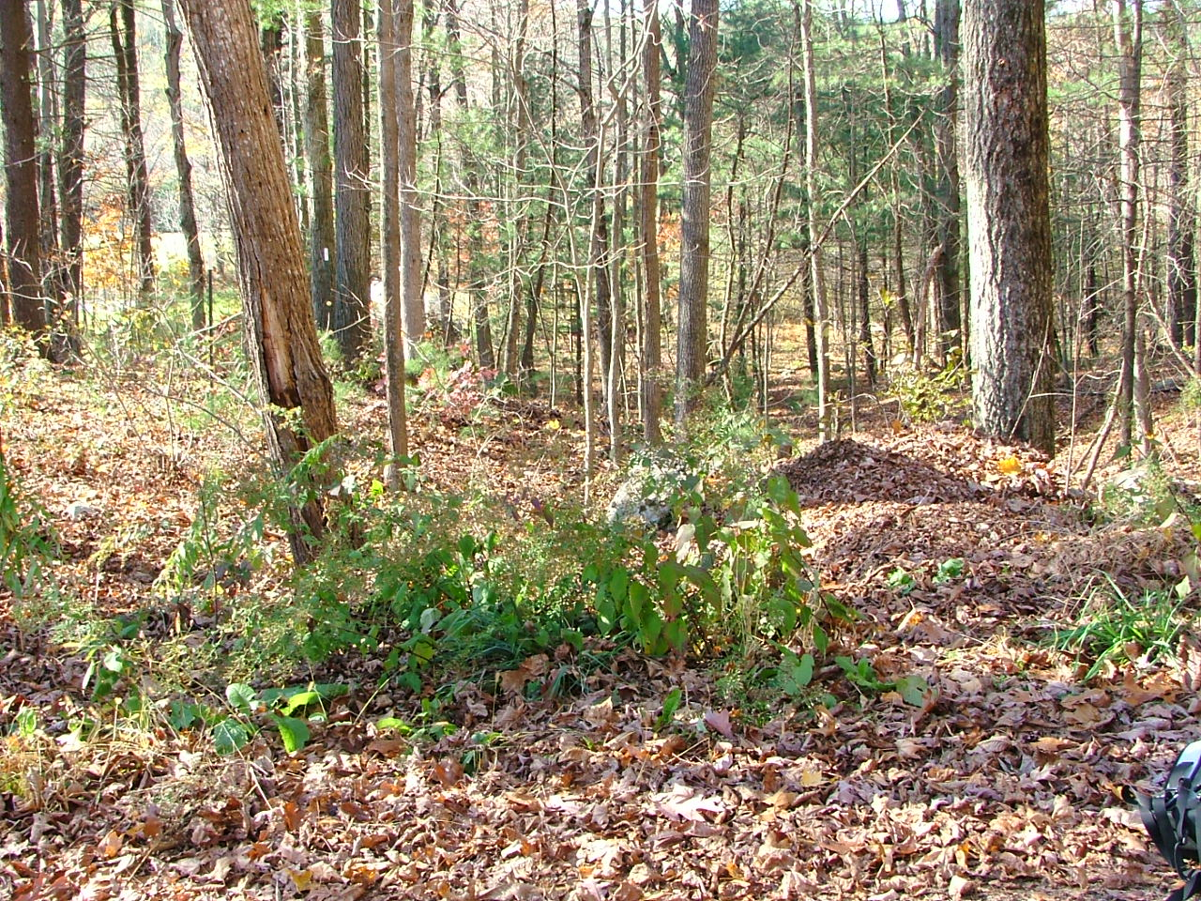
A. October 21, 2006
42.47937, -72.49482
Looking west along Eva Beth Gibavic line at corner with Gibavic Family CR and Old Cave Hill Road

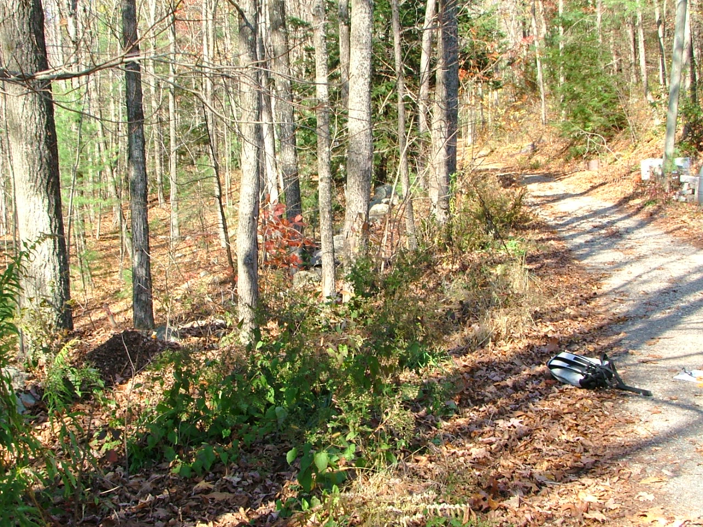
A. October 21, 2006
(same place as above)
Looking north along Old Cave Hill Road at same corner (stone wall ends).

Note: iron pin apparently buried in work on Old Cave Hill Road.

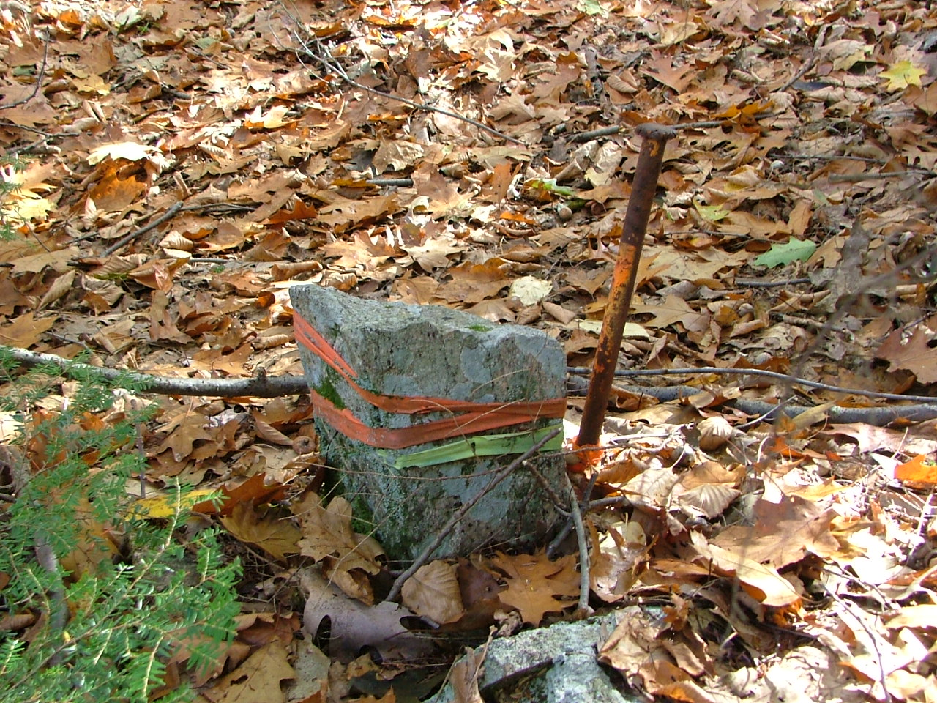

B. October 21, 2006
42.48442, -72.49471
stone post marking NE corner

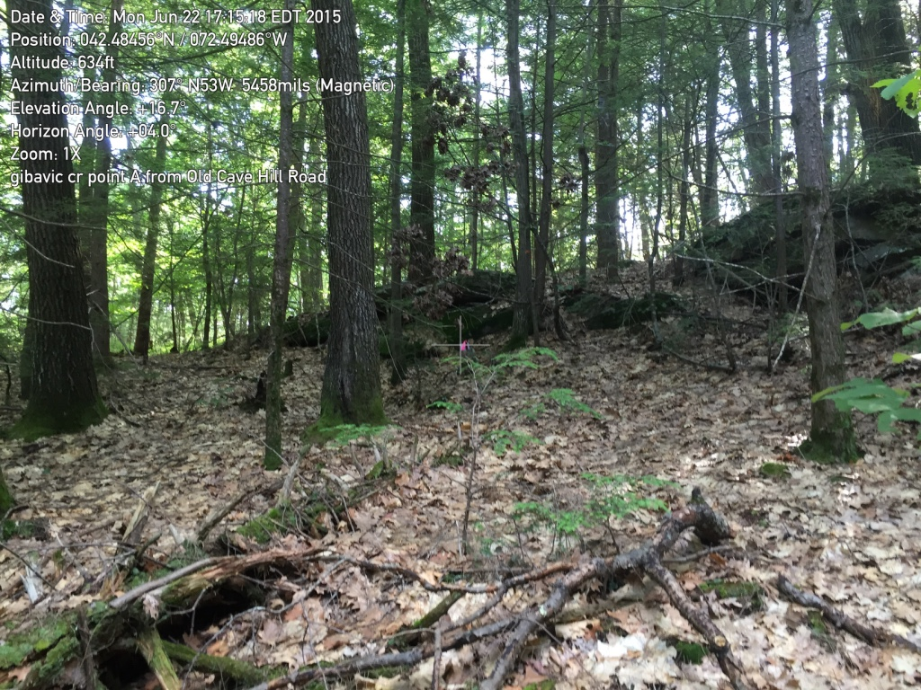
B. June 22, 2015
same stone post taken from Old Cave Hill Road. Stone Bound and iron pin in center of photo (red) showing outcrop behind.

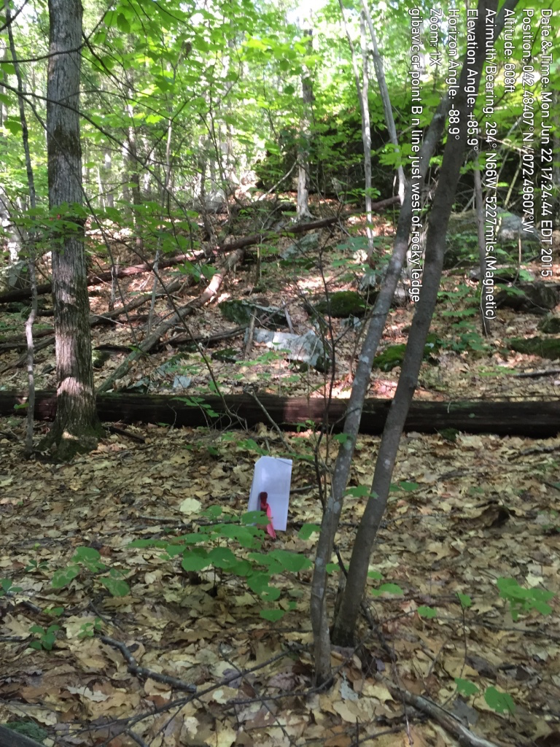

B1. Pin along N line
(Photo June 22, 2015)

Photo shows pin in front of white paper, looking east along line and outcropping. There is another line of outcroppings to the north - pin is in the valley between them.

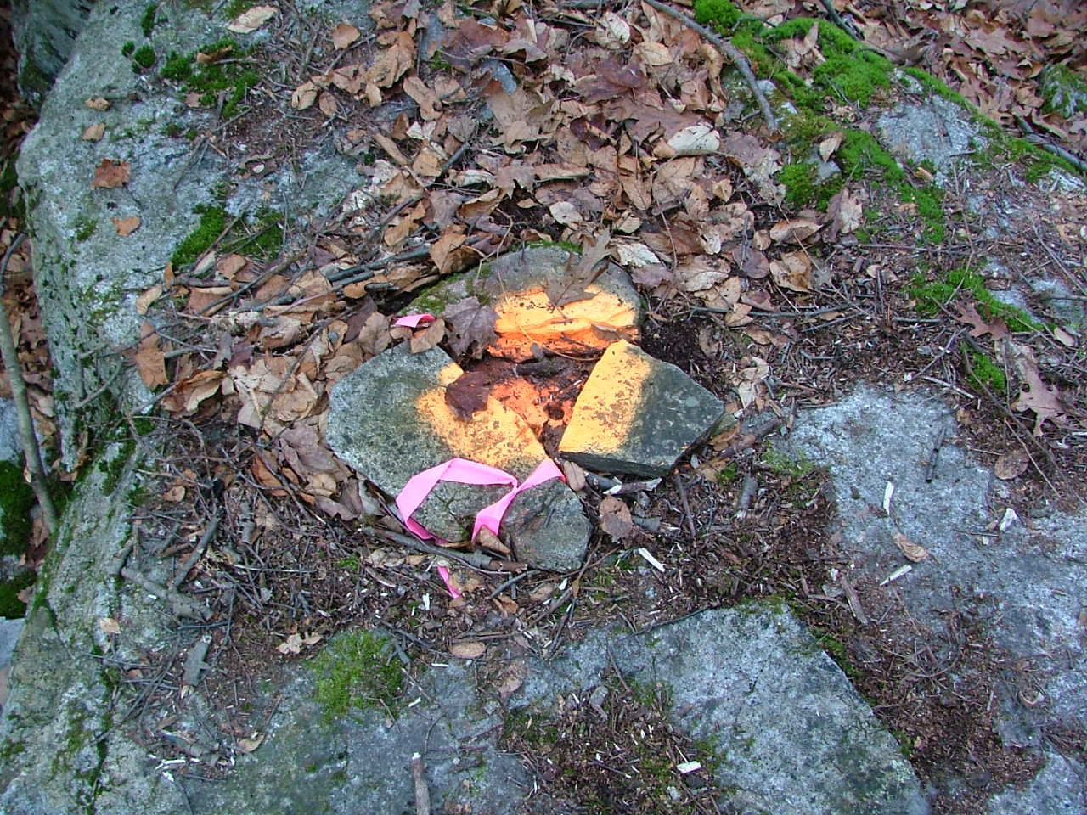
B2. (which might or might not be C)

12/3/2006
42.48375, -72.49774
Northwest corner, drill hole
(from baseline report)

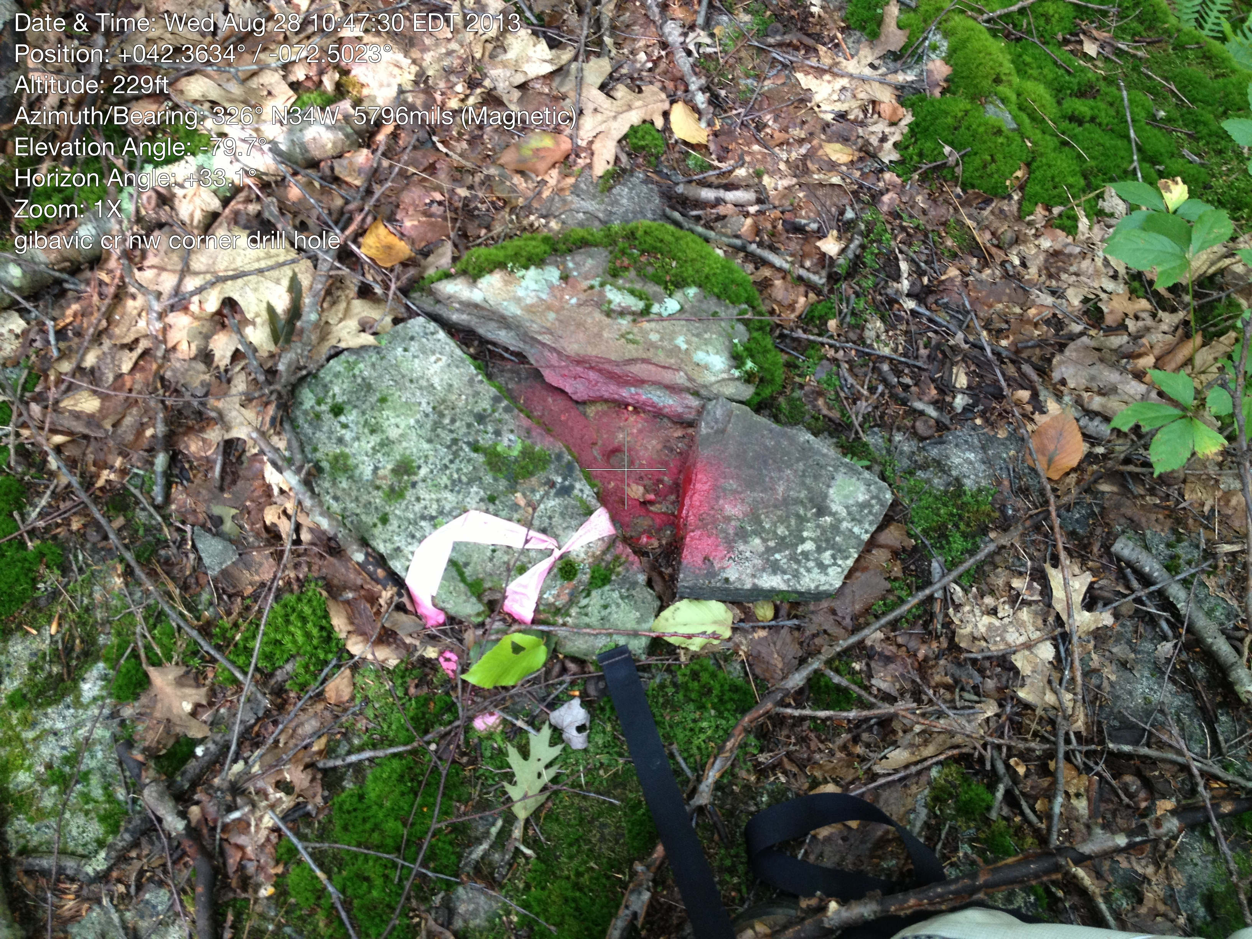

Is this the same place?
August 28, 2013

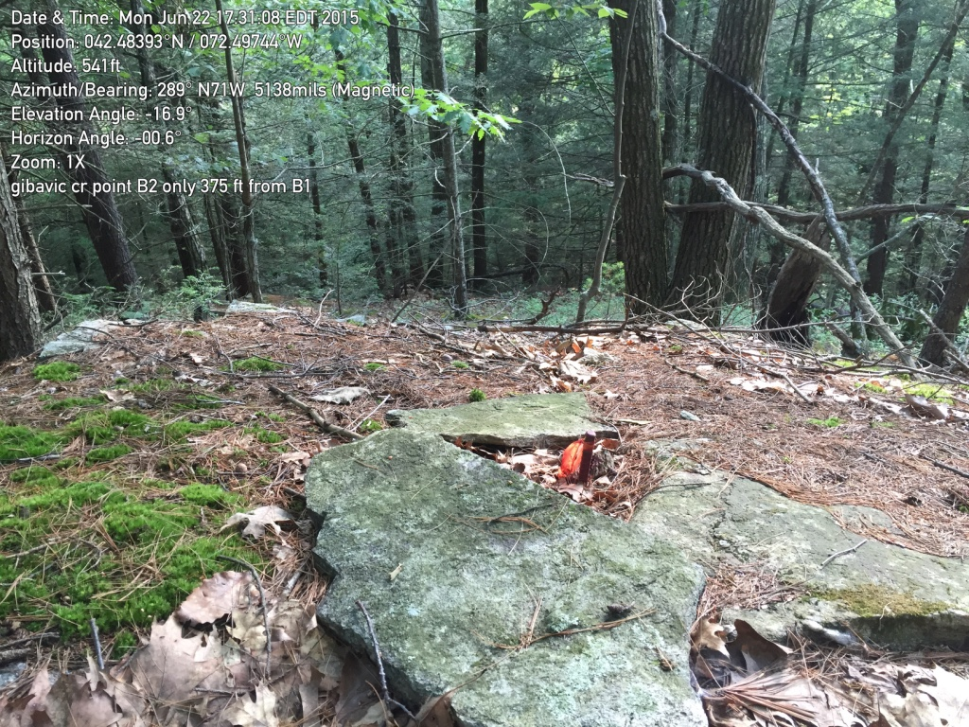
June 22, 2015
At some point maybe. An ip was placed by someone in the drill hole.

The location of this pin is NOT the location shown in the CR sketch plan. Nor does it match the survey prepared for the Lee family to the north (PB 54, page 27). An annotated copy of the survey on the Board-only website with this document and the monitoring map. The location of C is unknown (unless it is B2)

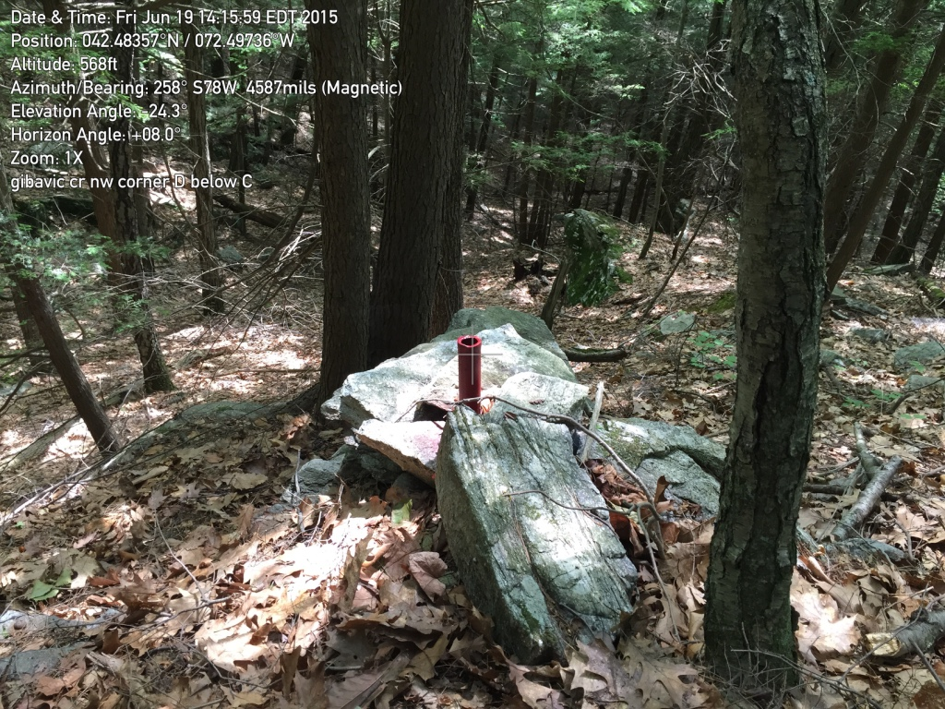
D. 6/19/2015
42,483578, -72, 497287
This iron pipe is just below B2 on the cliff.

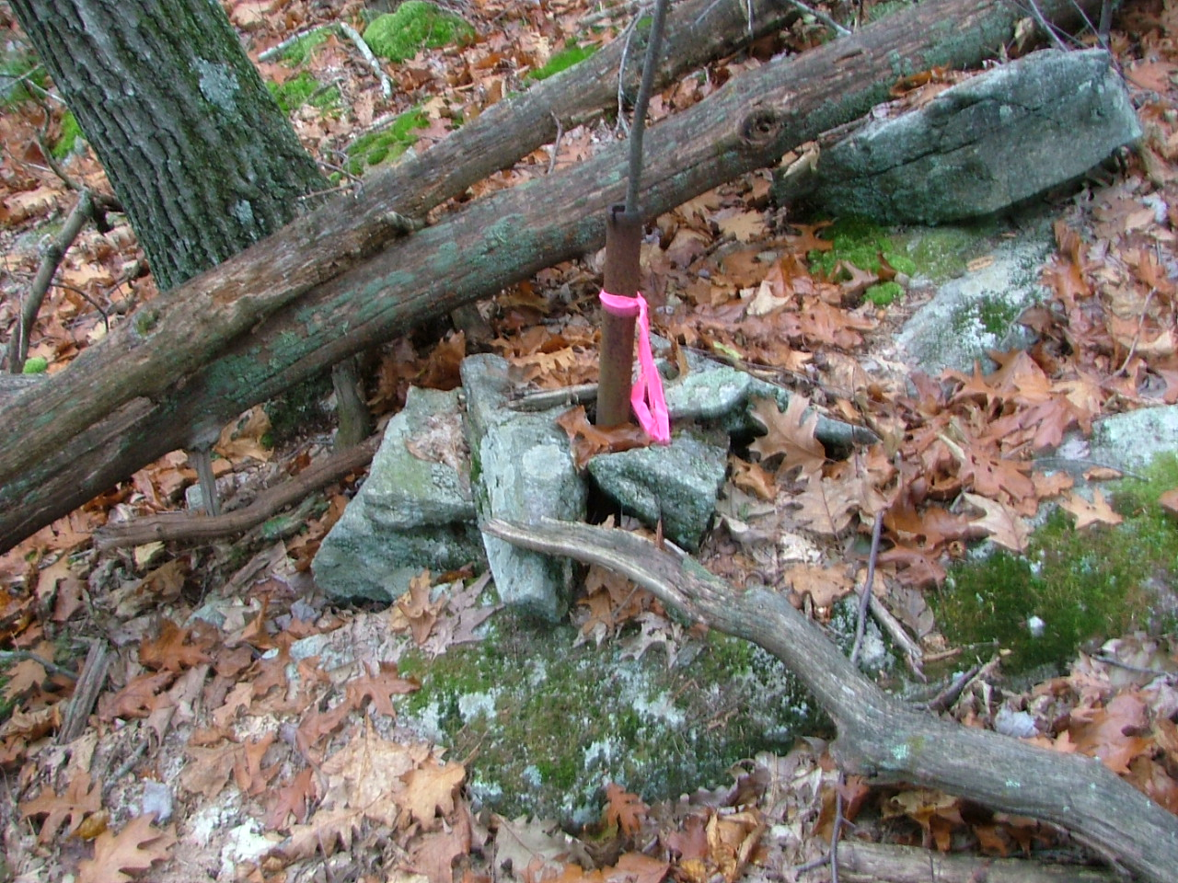

E. October 25, 2006
42.48275, -72.49625
Stake on side hill marking slight change in angle.

Note: gps reading 6/19/2015
42.482642, -72.496842

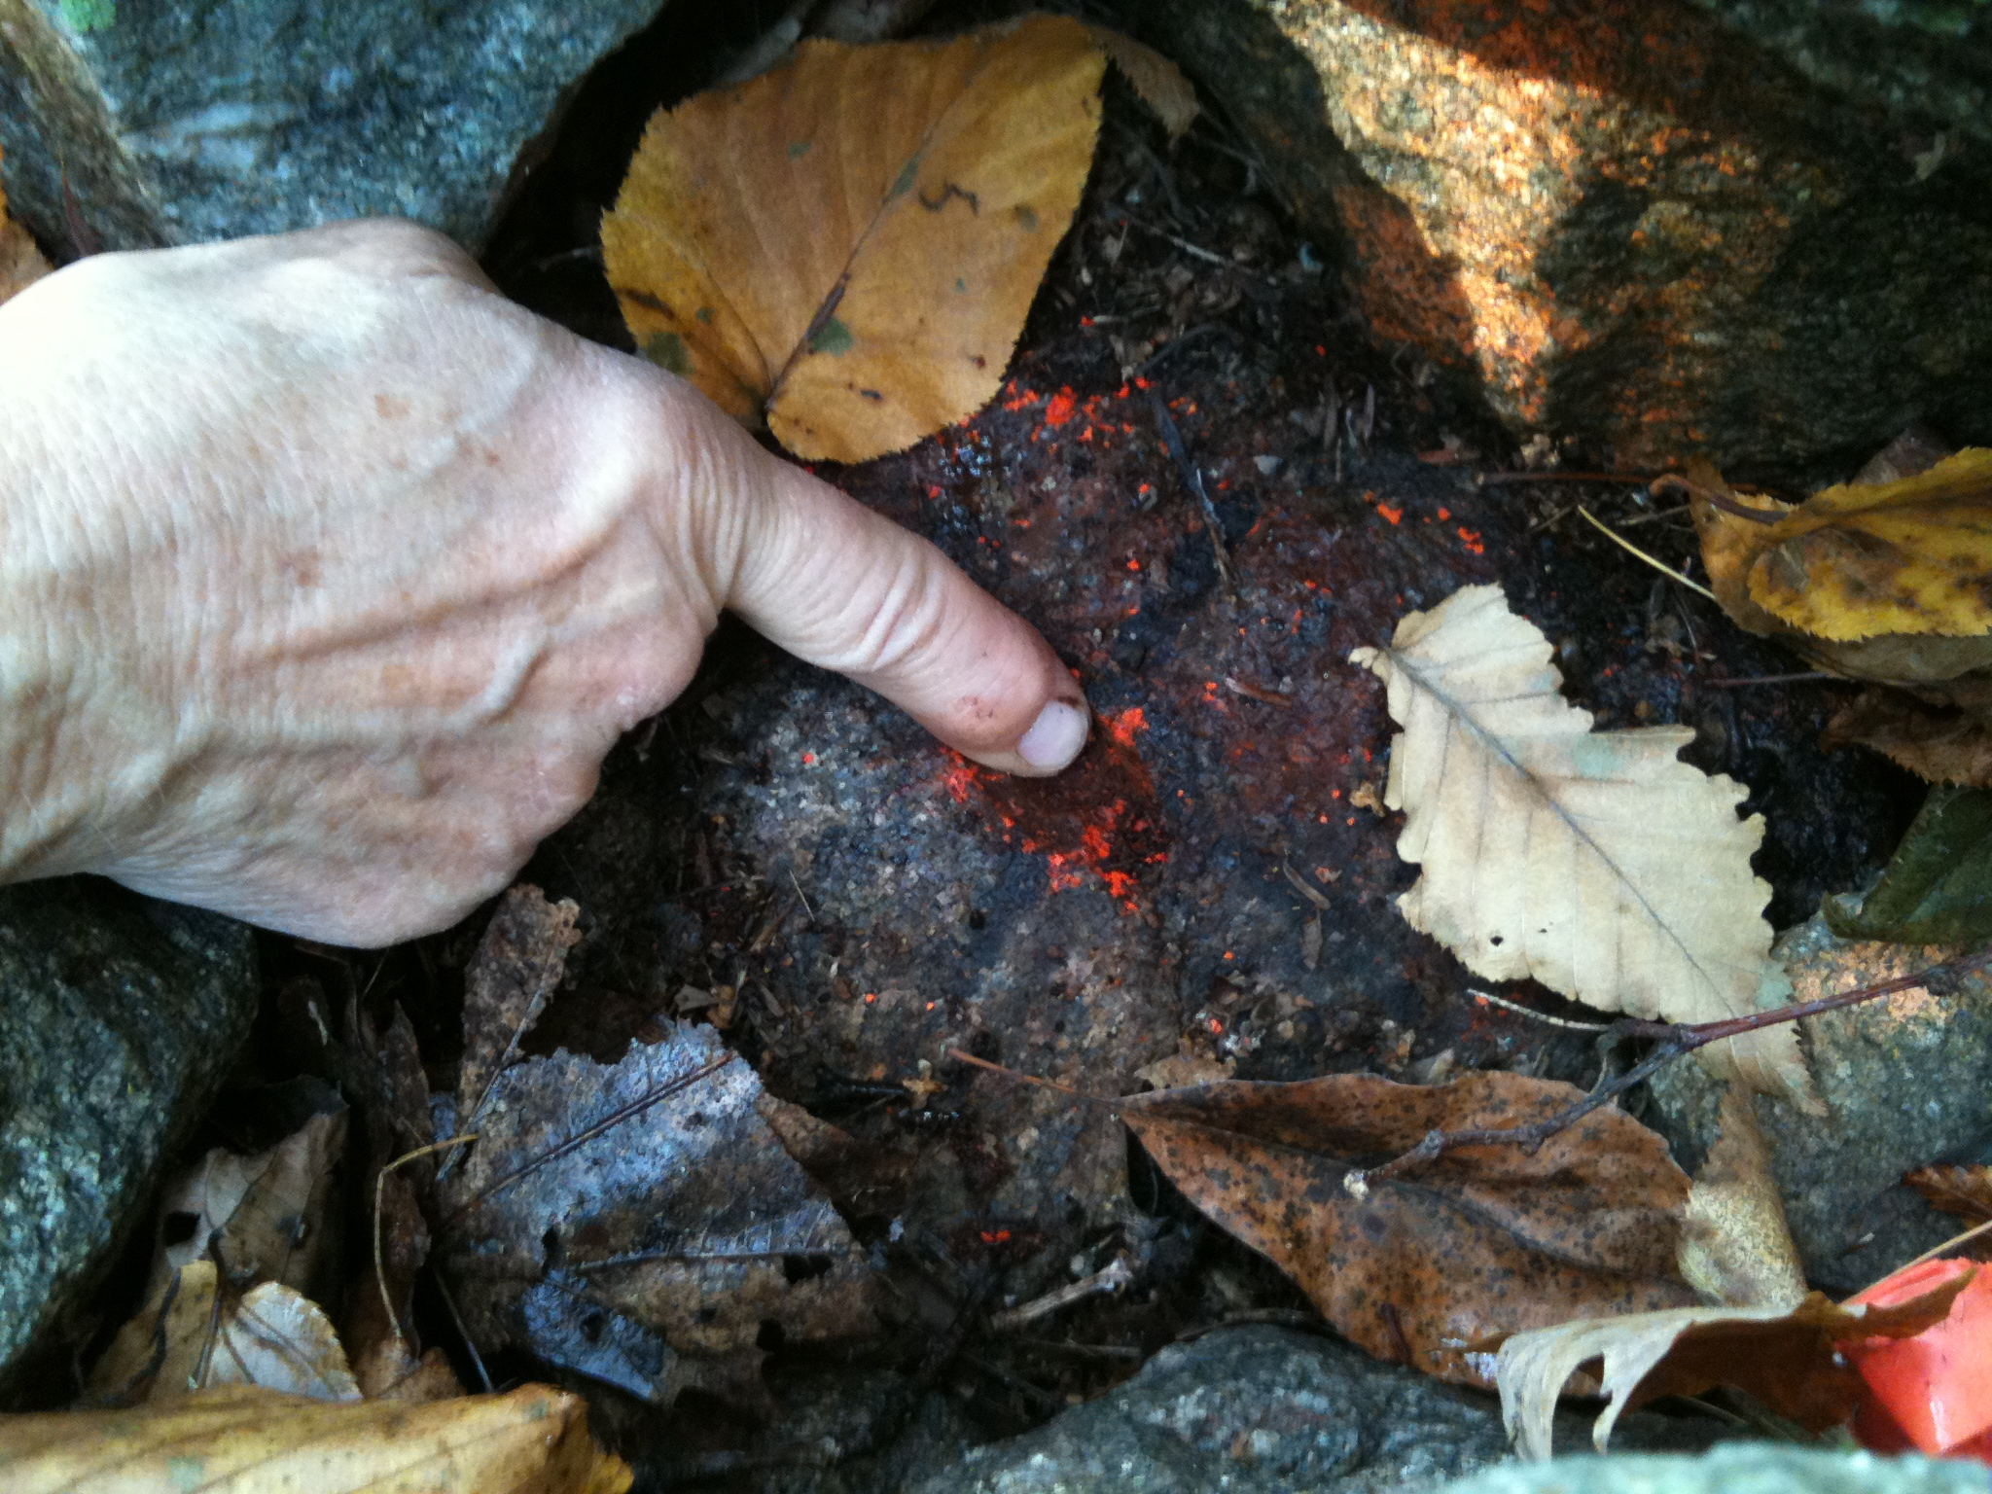
F. Drill hole (along western line)
(Photo, October monitoring 2012)

gps reading 6/19/2015
42.481972, -72.496909

