Friendship Trail Properties, Photos for Monitoring, part 2 (west and north sides)

(Letters designating corners match those on the Friendship Trail Properties Monitoring Map)

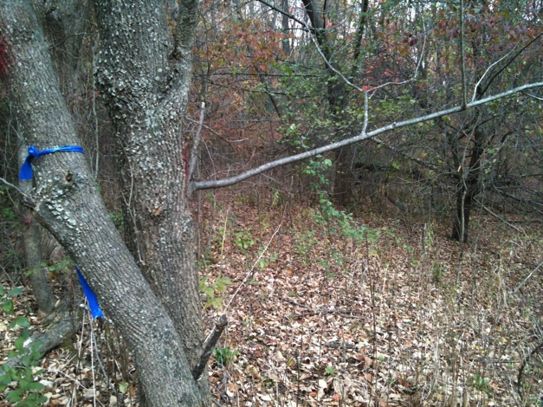E to F

Along west line.Two of the four old apple trees on the Woodard property just east of the west boundary.

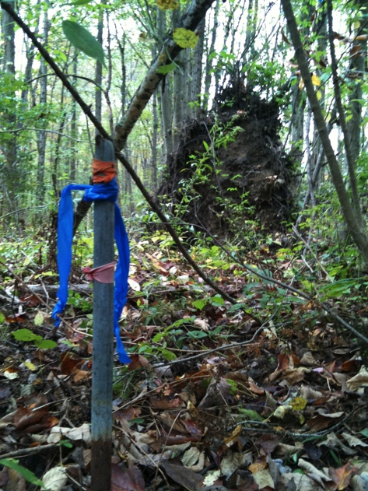

F. Woodard/Fair-Snyder/Carlin/D&M Field corner

Looking south, property line through tree root.

42.44979590, -72.50520956

October 5, 2010

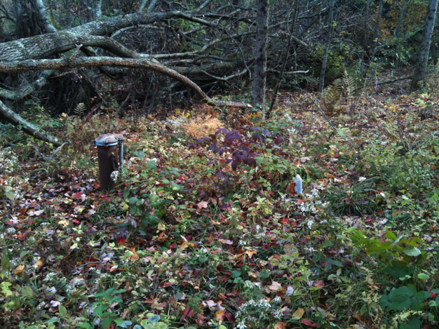F to G

On west line near Cider Mill Road is the well for the Carlin property. It is ... feet outside their property line. Photo shows both the well head and the tent stake (making the line) to the west.

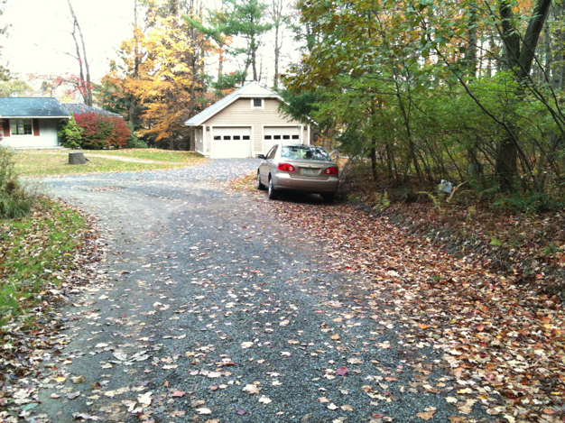

G. NW corner of David & Mary Field CR. Corner with Cider Mill Road and Karlin property. Orange tent peg is under the white paper to the right of the car.

Oct 24 2010

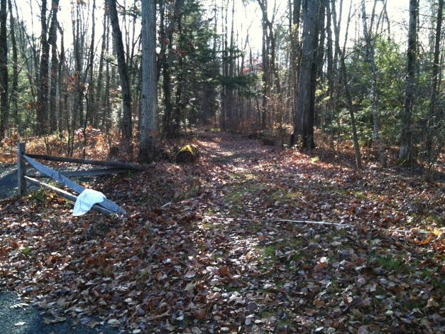

H. Culvert marking NE corner of David & Mary Field CR (border with Hagley-Obermeier).

White bag at edge of culvert (looking south, 11/14/2010)

42.45134303, -72.50707386 (9/21/2010)

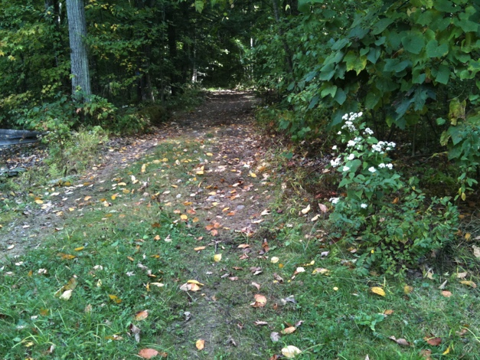

H. View of woods road from Cider Mill Rd looking south 9/17/2010

42.45165467, -72.50727293 (9/21/2010)

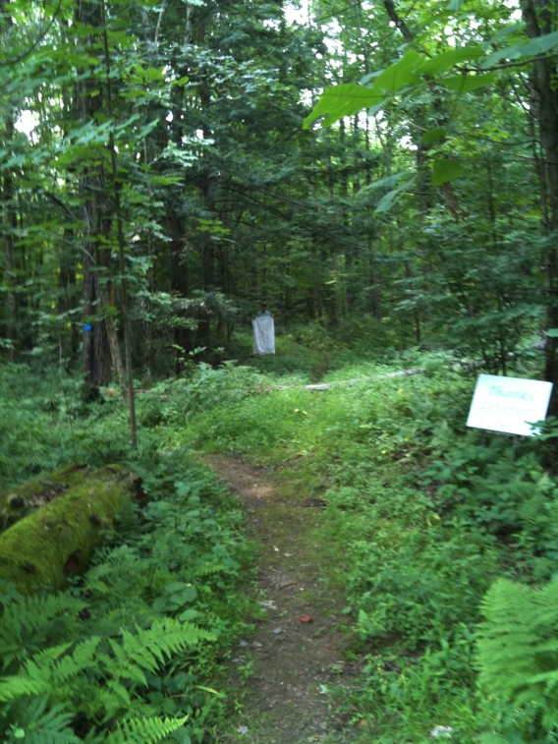

I. NW corner is to the left of the white rectangle (not the white sign which is much closer). Picture taken from the culvert at the edge of Cider Mill Road looking south. 8/6/2011

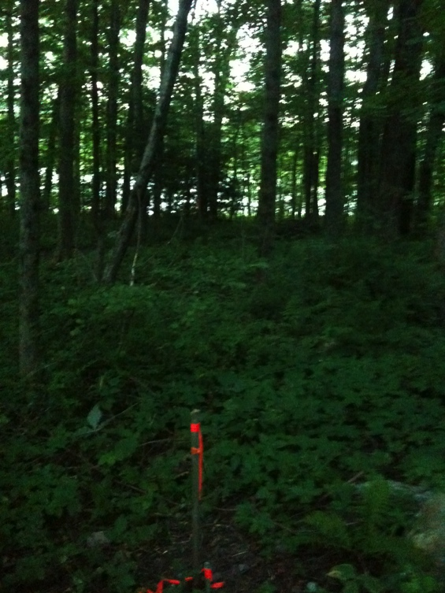

I. Iron Pin next to larger stake. Looking east to the pond along the line. Double-trunk red oak in the distance is on the line. The NE iron pin is behind that tree. 6/22/2011

42.45136256 -72.50700253

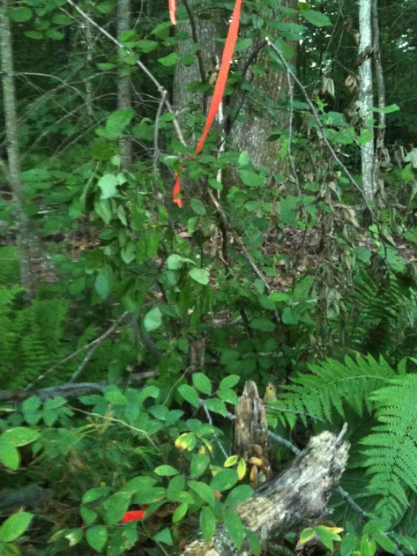

J. NE corner with iron pin in the rock in foreground. Looking west with the double tree that is on the line in the background. 7/22/2011

42.45154300 -72.50640000

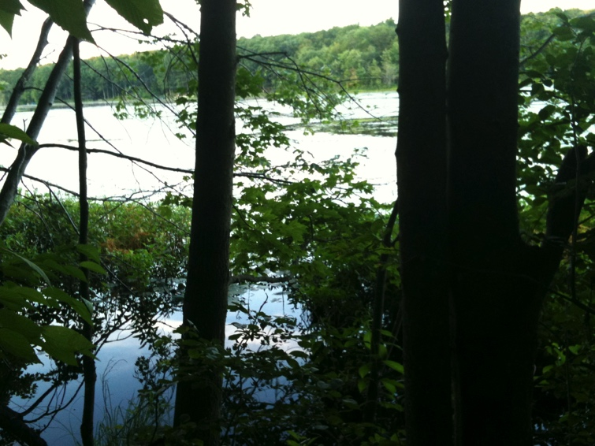

J. Looking NE Boat slip is just north of this corner. 7/22/2011

J to K

The line follows the shoreline. With considerable restraint, the many gorgeous photographs taken along the shoreline have not been included.

K to A.

The line follows the drainage up to the road. (The property to the east in also town-owned, but is not included in the Conservation Restriction.) Angle for line is about 165 degrees.