Friendship Trail Properties, photos for monitoring, part 1

(Letters designating corners match those on the Friendship Trail Properties Monitoring Map)

Note this set of photographs goes around the outside of all three properties taken together i.e. the internal lines between the 3 properties are ignored.

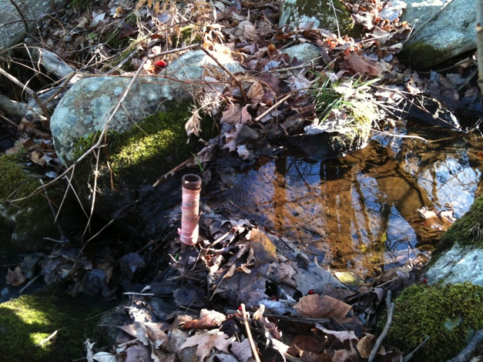

A. Corner of Road/David & Mary Field CR/David and Mary Field Conservation Area (given earlier to the town)

42.45027049. -72.50379209 (9/1/2010)

The iron pin is in the stream just upstream from the bog bridge crossing.

(11/14/2010)

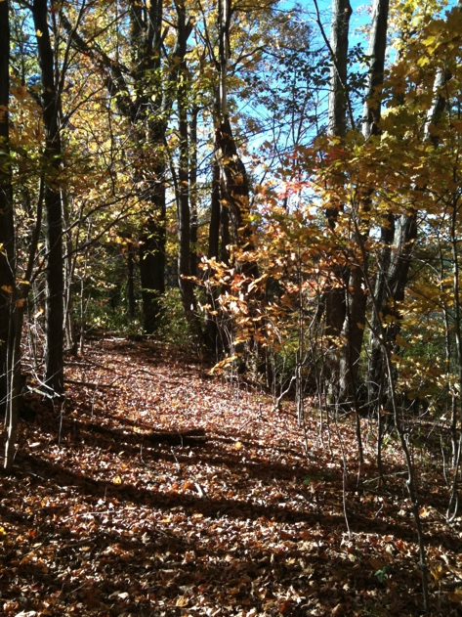

B. An old roadway

The old roadway is still very visible. (10/13/2010). It begins at the edge of Depot Road

42.45018130, -72.50414791 (10/28/2010)

For the first part of the old road, the angle is 312/132 degrees.

At 42.45041004, -72.50450204 (11/9/2010), the angle changes to 294/114 degrees

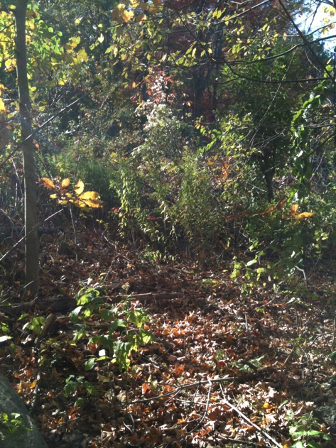

B to C. Following a ridge

It is much more difficult to follow the line once into the area cleared for a view. It is even more difficult to walk – a tangle of rose, blackberry and barberry. However, the birds – and presumably other creatures - love it. In October, this area hosted white-throated and white-crowned sparrows, and purple finch – as well as the usual pre-winter flocks. (10/13/2010,

looking west)

At the east end of the clearing 42.45044005, -72.50471394, the angle to the west is 272/92 deg.

The view area ends at 42.45040133, -72.50498828.

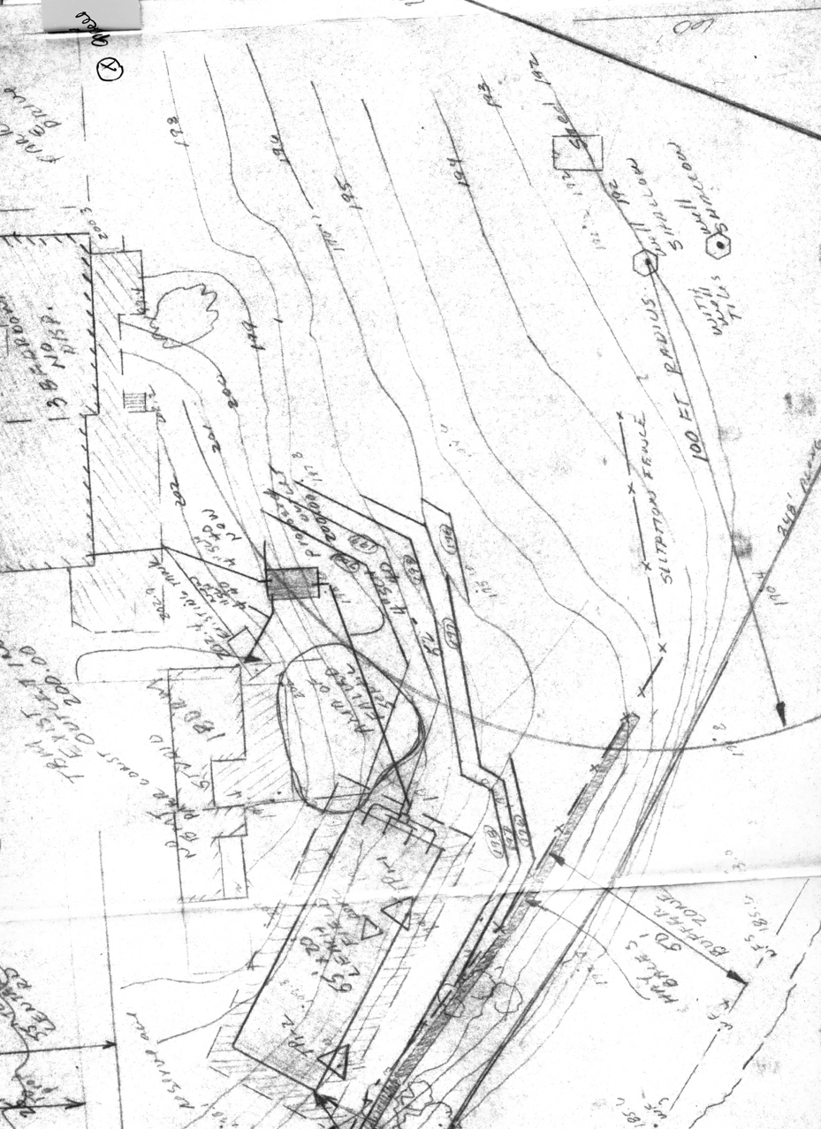

West of the view clearing, it is even more difficult to “follow the ridge”

Fortunately, the state contour map (seen in the Boundary Maps for both the Field and Woodard CRs) and the septic system map for the property show how the contours curve and it is, therefore, possible to follow the “ridge line” as it bends southwest.

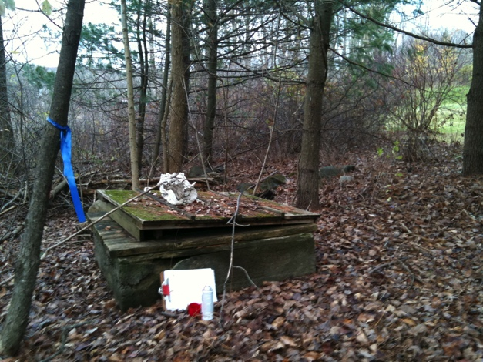

And there is another clue. The deed also says “. . .including a well though not on the property described. . . .“ While the well is no longer being used (a new well was drilled closer to the house), it is clearly visible and provides an anchor near the western end of the ridge line. The line from the view-clearing to the corner has a 268/88 degree angle

Picture taken 11/9/2010 looking west (268 deg) along line, brush in view-clearing visible beyond blue flag.

well: 42.45033528, -72.50509053 (11/9/2010)

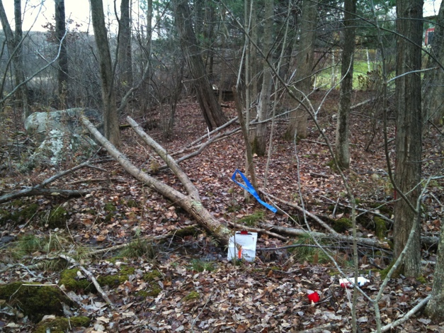

C Corner of north line and ditch (no IP)

There is a plastic tent stake serving as the marker

42.45032614, -72.50528181

October 31, 2010

Picture looking west to corner (clipboard behind orange tent state) 268 deg. The grey stone is on Field property/ The dark well cover is barely visible behind blue flag. (11/9/2010)

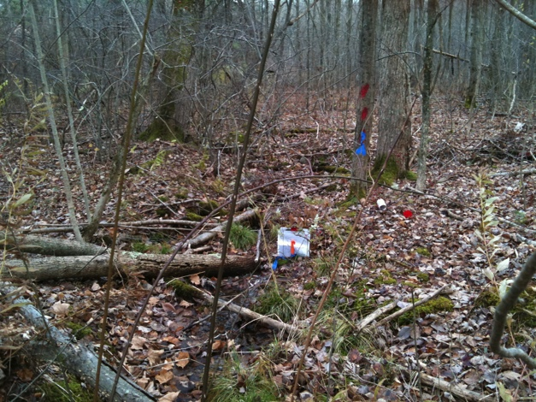

C. Second picture of the corner taken at the same time looking south along the west line. When following the ditch south to the road, the angle varies slightly but is mostly 8 degrees.

C to D.

The line begins at a ditch, thence running in the ditch in a southerly direction to the main highway. There is an iron pin placed by the Woodards in the ditch at the southern end (Depot Road).

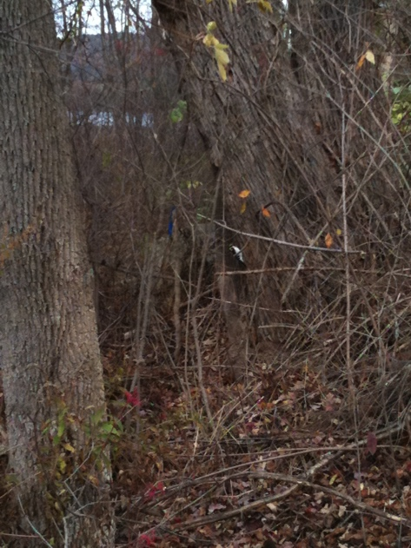

The ditch is clearly visible.

(The ditches were used to drain the Woodard hayfield – now wetland - created by a combination of raising the height of the Leverett Pond dam and improving Depot Road and changing the drainage.)

While the ditch varies slightly in direction, it is mostly 188/8 degrees.

To the right: Hairy Woodpecker (male) working on tree along the line. Leverett Pond (to the north) is visible in the background.

10/30/2010

D. Woodard/Bernard/Depot Road corner

Below: Iron pipe in the ditch at the SW corner of Bernard property.

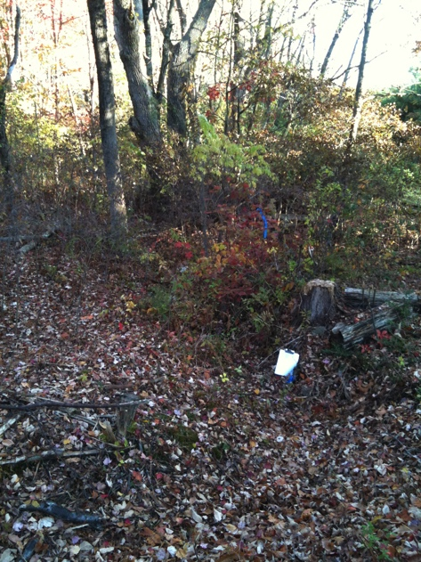42.45032136, -72.50528893

Both pictures show both the pipe and ditch. 10/14/2010

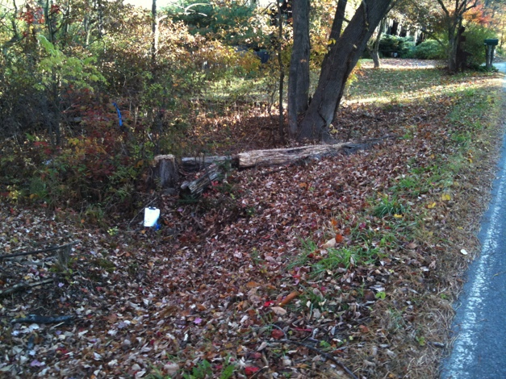

Looking west toward town Looking north toward pond

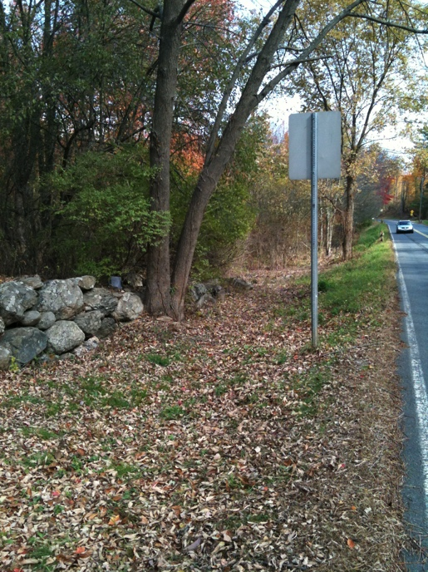

E. SW corner Woodard/Fair-Synder

Looking East from Depot Road.

Pipe is behind double-trunked tree

42.44919584, -72.50692441

October 17, 2010

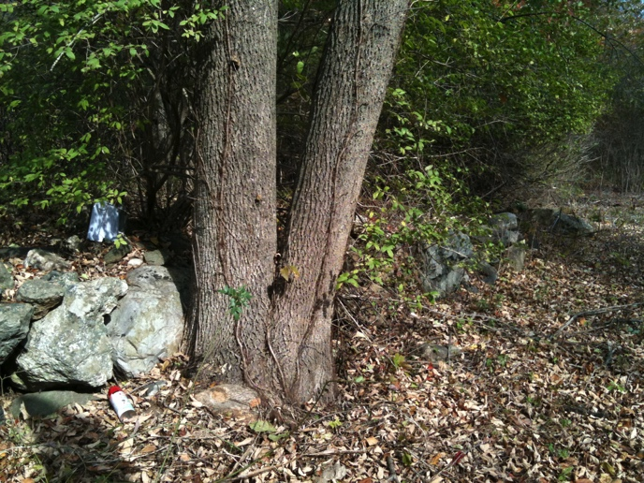

E. SW corner

Close-up of corner pipe in front of white paper (behind double tree).

October 17, 2010

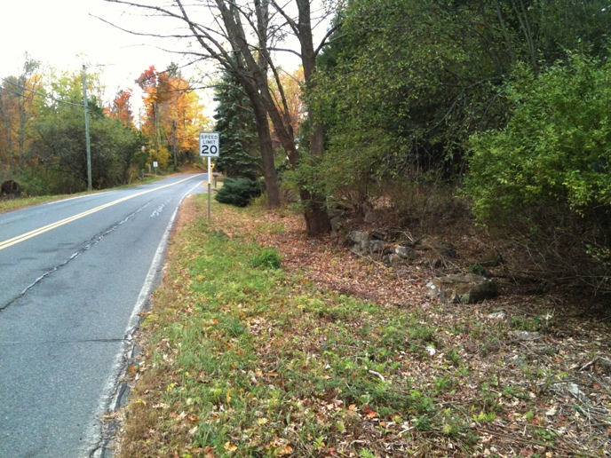

E. SW corner looking west

Note: there is another stake next to a rock near the end of the stone wall. It is not a corner stake.

October 17, 2010