ELM Photos for Monitoring, Part 1

(Corner letters correspond with those on the ELM Monitoring Map)

**Cushman Road Corners**

A. SE corner of property

corner of Cushman Road, ELM and Kuzmeski CR 1974 King survey (Franklin County Deeds, Plan Book 39, page 40) shows “SB“ (Stone Bound.) All we have found is a stone which might be the stone bound damaged by plowing. It is painted red.

42.43720536, -72.48601601

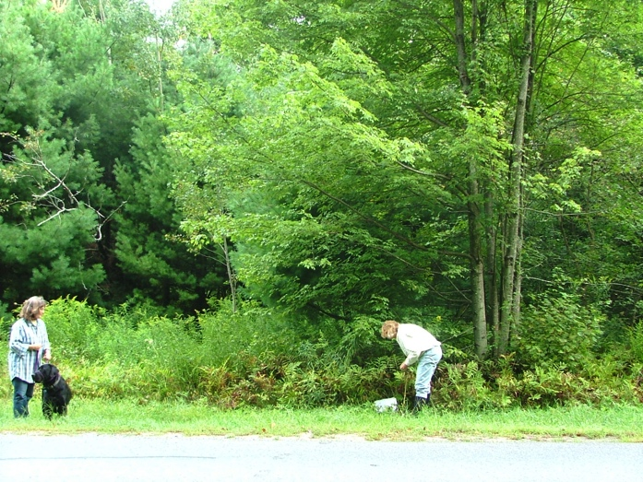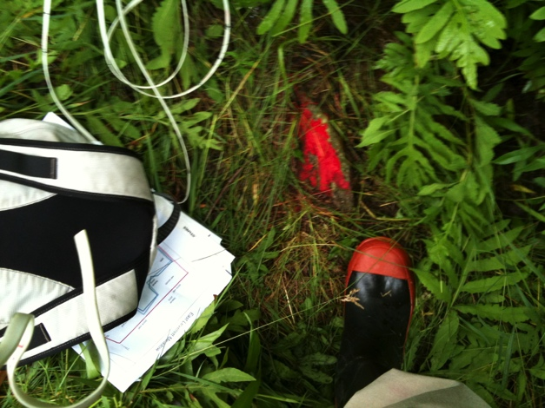

A. bending over stone, 9/1/2006 A. painted stone, 6/24/2011

B. SW corner of property

The line follows the road 200 feet to the corner with corner with Cushman Rd, ELM, and the Cramer property. The 1974 King survey shows IP which we have never found. Chet Cramer has planted a line of maples on his property. The eastern most appears to be at the corner. He also had an electric fence which matches the measurements/angle of the line to the stream so this tree could be taken as the corner. Both pictures taken 6/25/2011.

42.43706295, -72.48673.

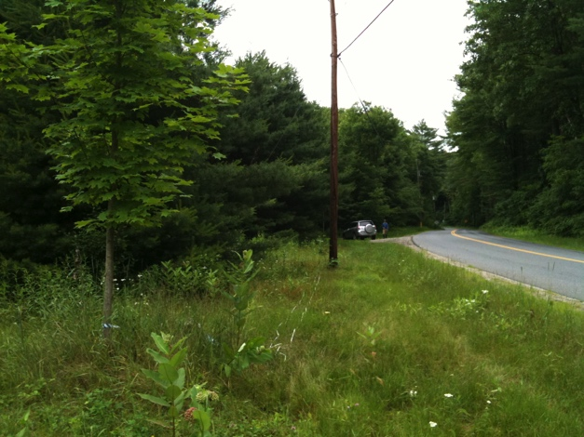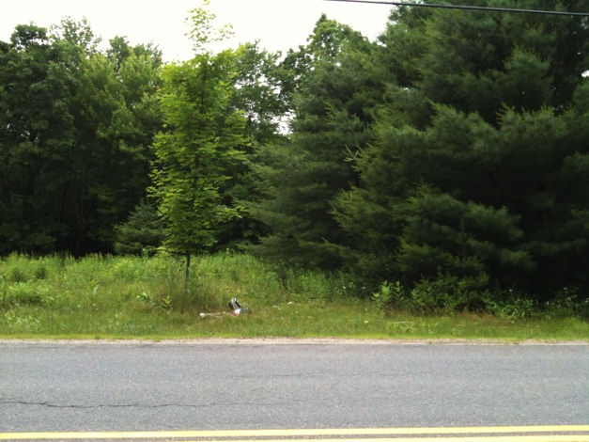

B. Maple tree on corner looking north B. Same tree looking east

**West Boundary Lines**

B to C. Cushman Road to Roaring Brook

The line between Cushman Road and the middle of Roaring Brook (285 feet, 344 degrees), runs along the edge of Chet Cramer’s property. He has previously had an electric fence along the first part of the line and so it is easy to follow. According to the 1974 King Survey, there never was a marker placed in the middle of the stream (no surprise). All 3 pictures taken 6/24/2011

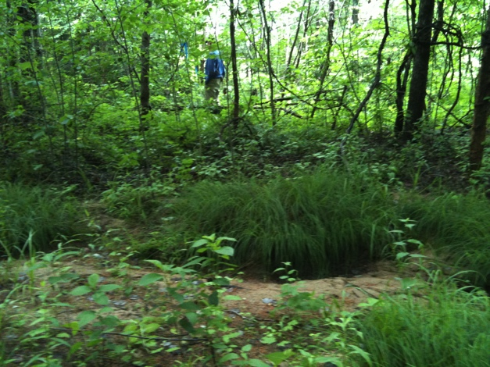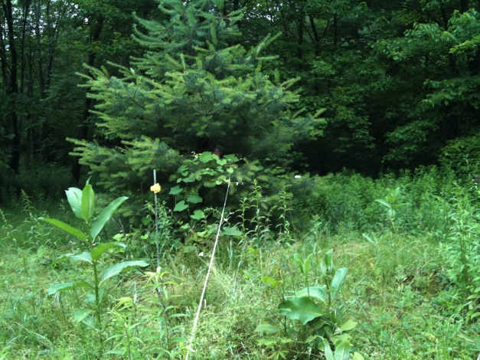

From corner maple (B) looking north On line, Bill Wilson standing by stream

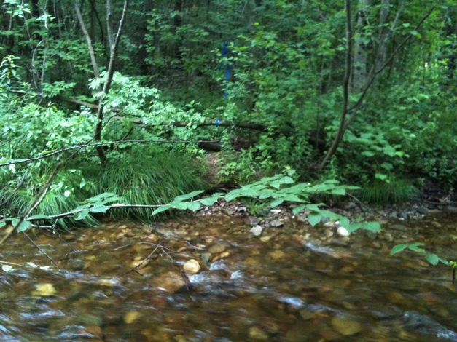

C. Looking south to line from the north side. If line were extended north beyond the middle of the stream it would be to the west of the large Shagbark Hickory, coming out almost exactly at the 2 bluebird boxes.

42.43790475 -72.48729232 (taken on

south side, not mid-stream)

C to D. Line down the middle of Roaring Brook to the ELM, Cramer, Sincuk/Jones corner

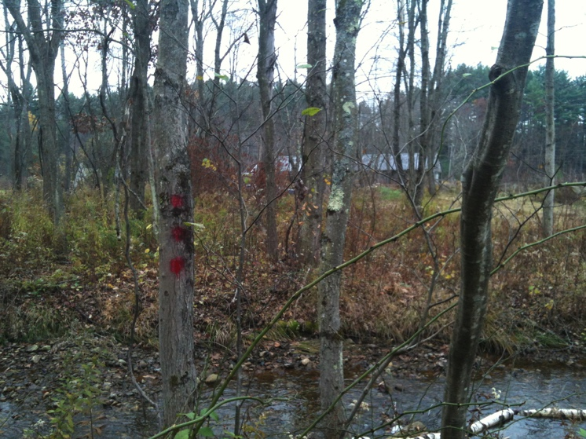

D. Triple-dot corner paint at SW corner of ELM. Corner with Cramer (across stream) and Sincuk-Jones (to the right) is in the middle of the stream. There is no pin.

October 27, 2012

D to E. West line to ELM, Sincuk/Jones, Adams corner. The boundary line follows the fence line (1326 feet, 404m, 166 deg).

E. The end of the line, marked by Sincuk/Jones fences and the Adams stone wall, is in a very wet area. The iron pin has been found in the past.

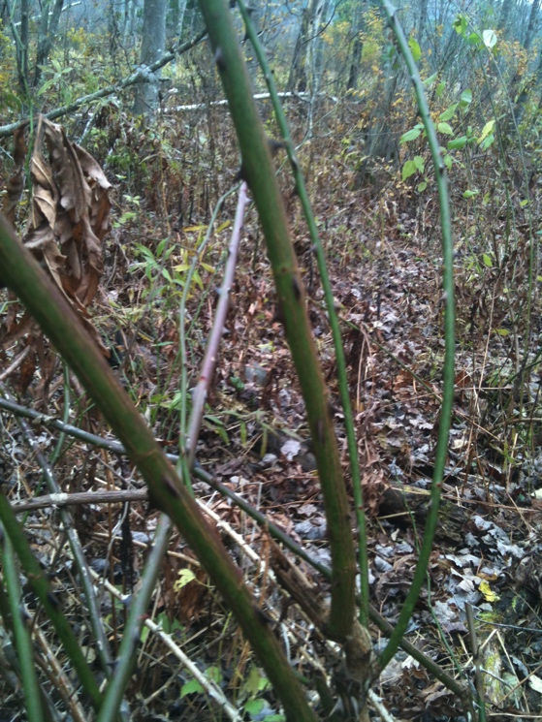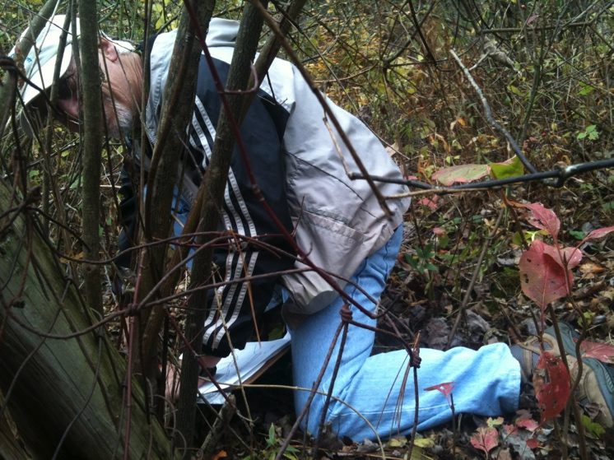

Why are both the photographer and Steve on hands and knees? See photograph to the right. (NW corner of ELM – no pin found.) October 27, 2012

**North Boundary Line**

E to F. North boundary is along Adams property and is marked with a stone wall (1305 ft, 398 m, 106 deg.). The corner of ELM/Adams/”the tavern” is marked by a pin in the stone wall (as noted in the 1974 King survey). The woods road leading from Shutesbury Road down to the meadow is just south (inside ELM land) at this point. Recently a breach was made in the stonewall for the Adams logging. Both pictures taken 6/23/2011

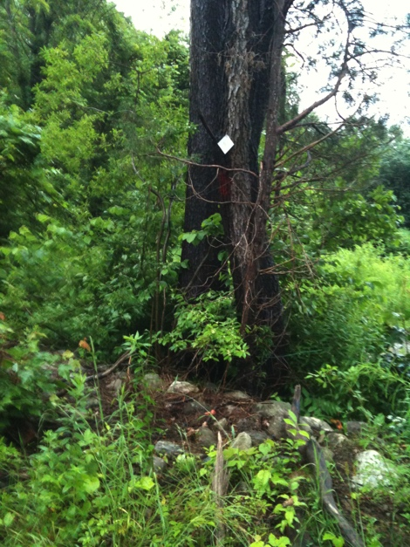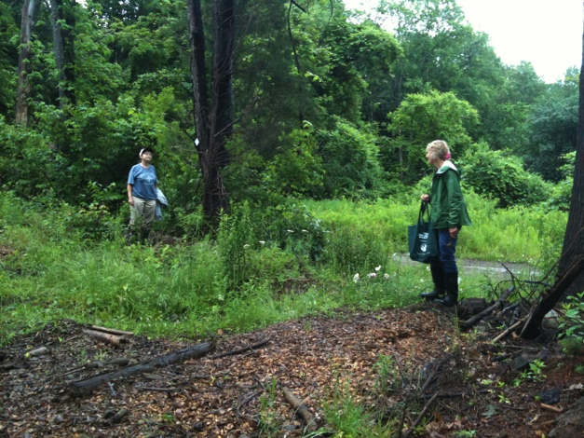

F (above) View from Adams land

F. (right) Stake in stone wall under tree with

white RGT tag. 42.43798597, -72.48624483