**East Leverett Meadow Photos for Monitoring, Part 2**

(Corner letters correspond with those on the ELM Monitoring Map)

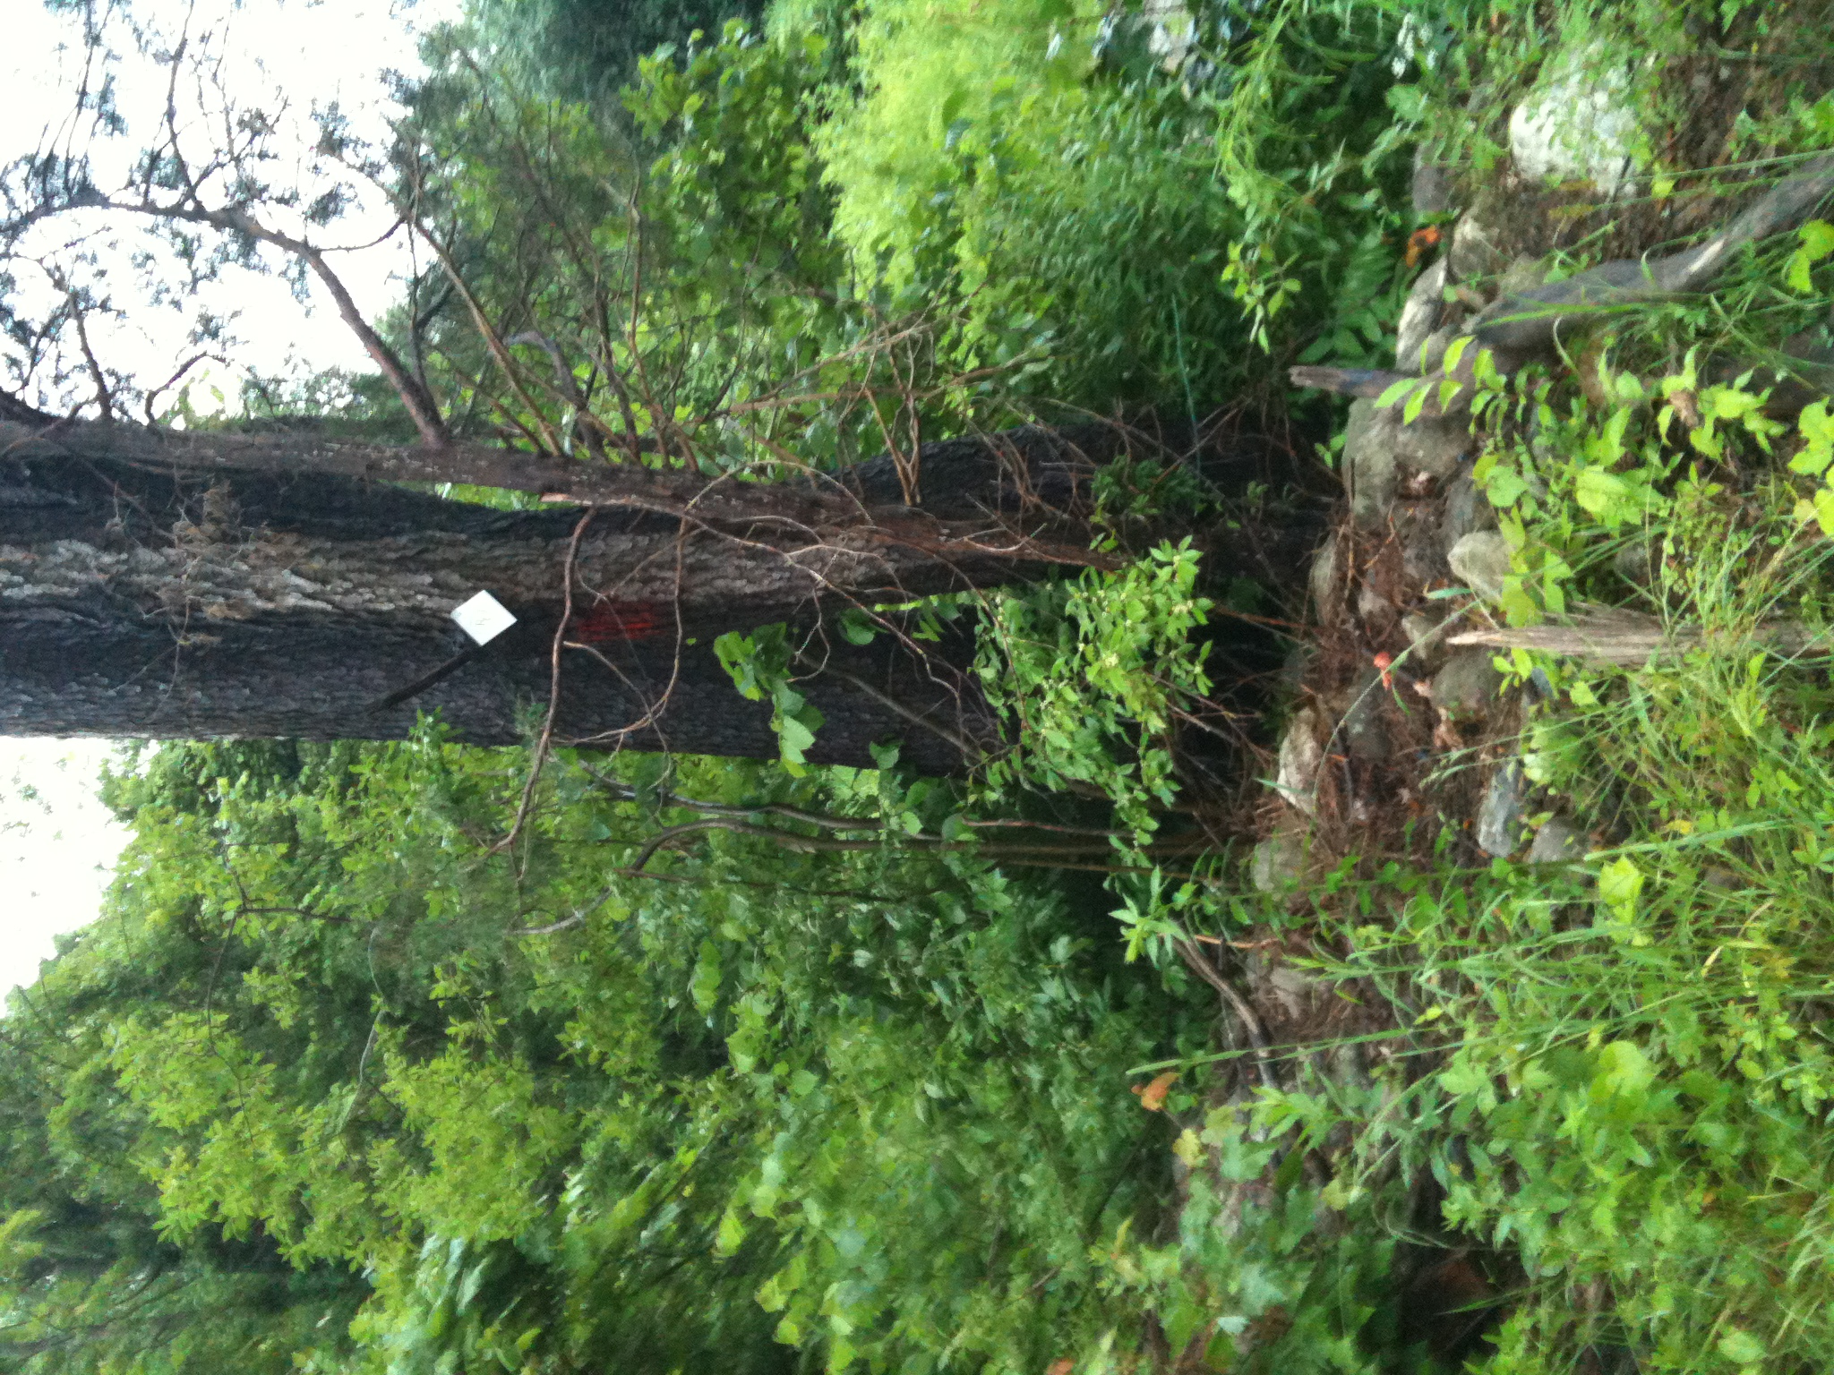**East Boundary Line**

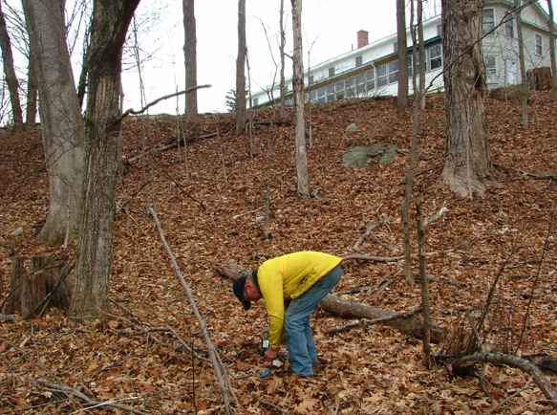F to G. From ELM/Adams/tavern stone wall to corner just below tavern (487 ft, 148 m, 174 deg.). Because this area used to be kept open as a picnic area for folks living at the tavern, it is a tangle of raspberry and bittersweet. Very difficult to walk through. The line does follow an old fence line, which means mostly fence posts about to fall down. (It is easier to find this and the next corner starting in the SE corner and walking north.) The 1974 King survey shows “IP in Fence Corner” and that it exactly where it is. Both pictures were taken 6/24/2011. 42.43948549, -72.48366849

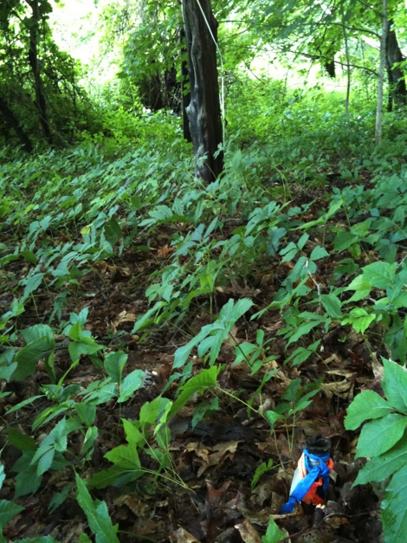G, Iron pin protected by poison ivy June 24, 2011 (left)

G. Same pin Dec 15, 2006 (right)

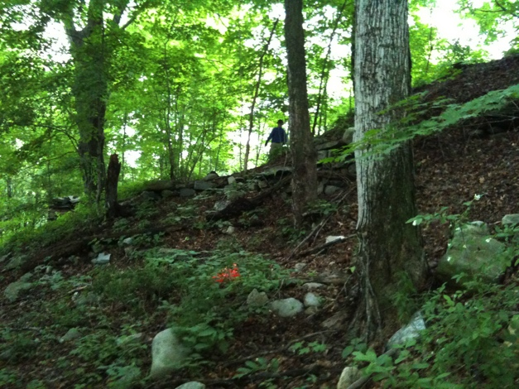

G. Looking along line north from IP. Note scars on left sides of trees from old wire fencing. (Orange object is trash, photographer is standing on pin.) June 24, 2011

H. West jog. The eastern boundary line then jogs west bordering the Truehart property to a Stone Bound well-buried in a stand of trees and shrubs (168 ft, 51 m, 262 deg). There is no old fence line or land use change – both sides have been mowed by the Trueharts. June 24, 2011 is the first time we have found this stone bound. And then thought we had mis-measured because there was no change in land use. 42.43948038, -72.48426737

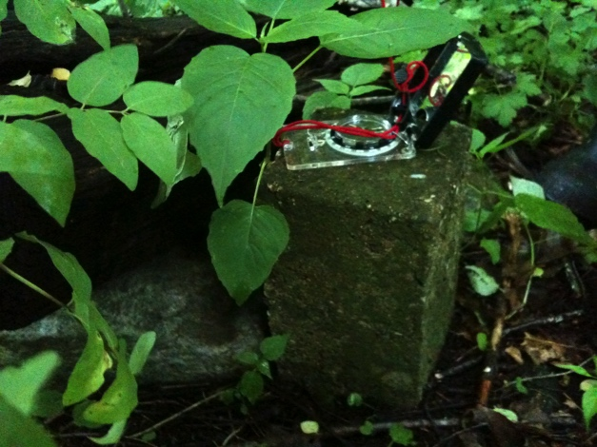H. Stone Bound (cement) shows on the 1974 King Survey. Another picture should be taken in the fall – one taken now would just show a wall of trees.

H to I. From the Stone Bound to the bent Iron to next iron pin (212 ft, 65m, 185 deg). This final section of the eastern boundary borders the Truehart property following an old fence line - sometimes fence, often just fence posts. The iron pin had been seen briefly years ago and was found by, literally, stumbling on it while measuring the distances. It is just north of the stand of aspen. 42.43892139, -72.48411843. Both pictures taken 6/24/2011.

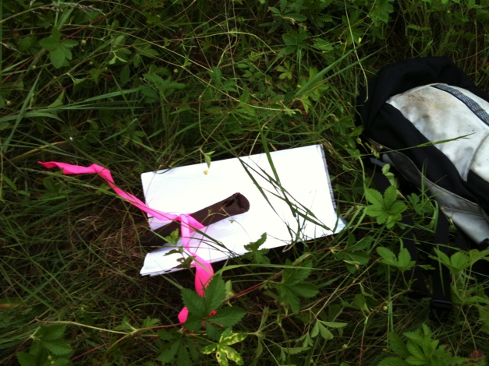

I. Iron Pin at ELM, Truehart,

Williams/Seaman corner. (mowing is hard on pins)

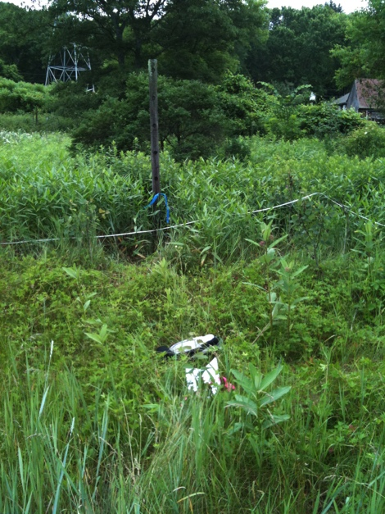

I. pin in front of backpack, looking to fence post and Truehart home.

Aspen is just to the right of the photograph.

I to J. Southern boundary along Williams/Seaman and the Kuzmeski Conservation Restriction. The line is a straight line (93 deg). It is 395 ft, 120 m along Williams/Seaman and 257 ft, 78 m along Kuzmeski CR. (Note, this is the only part of the 1974 King survey that is no help because the line was changed. For this section, use a subsequent survey done for Williams and Seaman in 1997 (Franklin County Deeds, Plan Book 101, page 44). The corner between Williams/Seaman and Kuzmeski is marked by an iron post and fence post. (Not needed for the ELM property, but important for monitoring the Kuzmeski CR.)

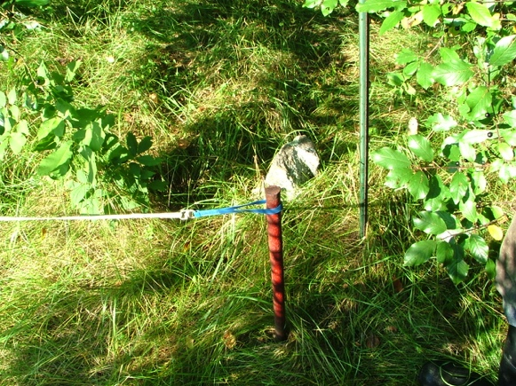J. IP at corner of ELM, Williams/Seaman, Kuzmeski CR. September 7, 2006

42.4367 -72.48556

The ELM/Kuzmeski CR is at the edge of the ELM mowed field and it is sometimes-mowed field closer to Roaring Brook. Both pictures taken Sept 10, 2006

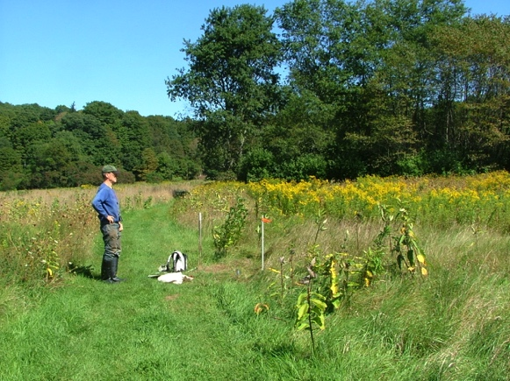

K. Looking east to white pipe marking ELM/Kuzmeski corner.

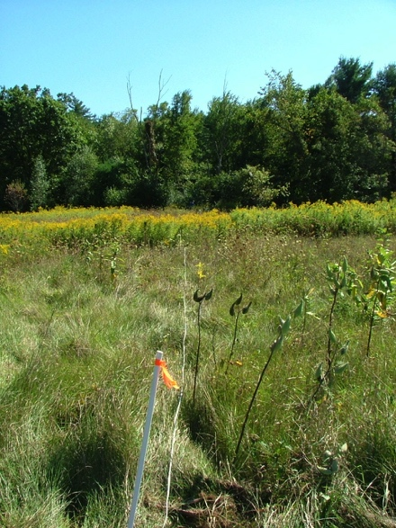

K. Looking south along the line from white pipe toward Roaring Brook.

42.43787 -72.48648

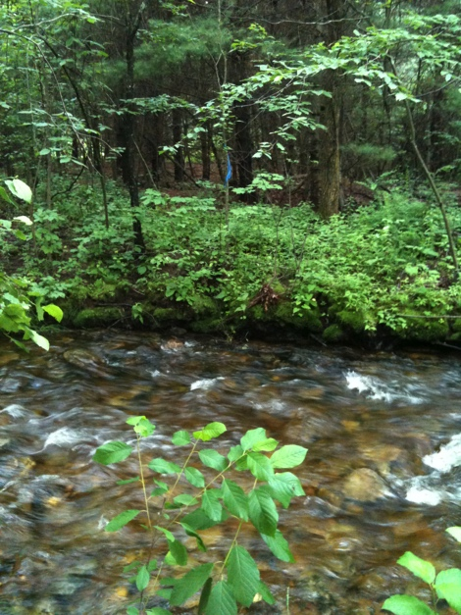K to A. East Boundary Line along Kuzmeski CR. The first section of the line (see above) goes through a field and then a line of trees (208 ft, 64 m, 184 deg). In the middle of the stream (no boundary marker), the angle changes (174 deg) and continues 334 ft, 102 m to Cushman Road and the painted stone (see A). It is this second section that is hard to follow because there is not land use change, in fact the trail into the meadow goes on to the CR. All 3 pictures taken 6/24/2011.

View from the north side of Roaring Brook

looking south to the flag/line. The Americorps Bridge is out of view to the right (downstream).

42.43798597, -72.48624483

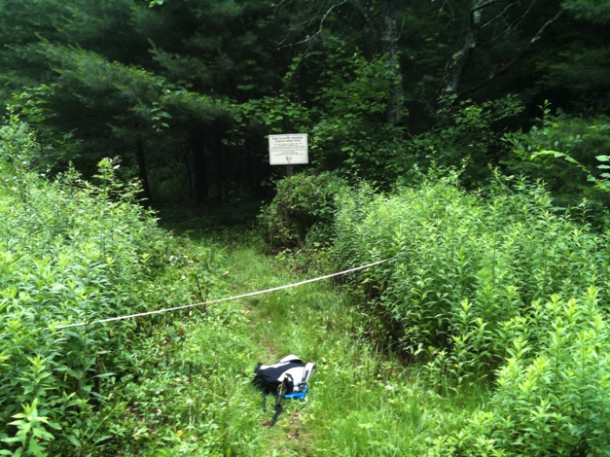

ELM/Kuzmeski line (white tape) as it crosses the trail just east of the large ELM sign.

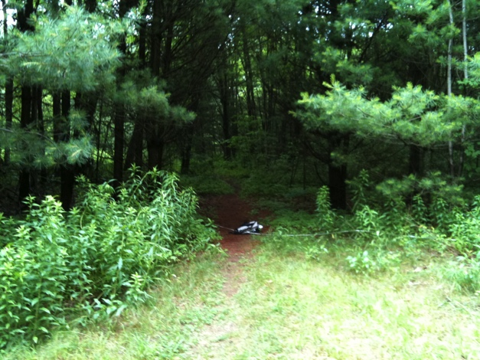

ELM/Kuzmeski line (white tape and backpack) as it crosses the trail just north of the parking area.

42.43745741, -72.48626025

Thus endeth the tour of the East Leverett Meadow Boundaries. Special thanks to Bill Wilson, Steve Weiss, Sheila Seaman, and Gwyn Mitchell for their on-going help with this property.