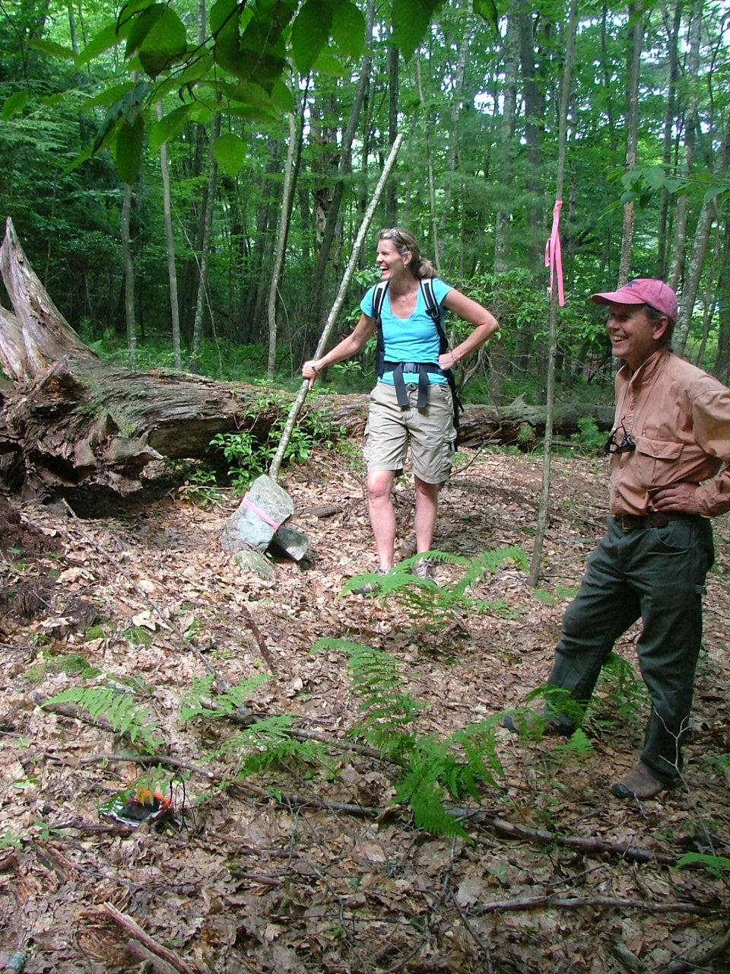

F. NE corner Looking from southeast to

NE Corner with large trees on

either side of stone monument

July 11, 2009 digital picture #11

42.50124, -72.46207

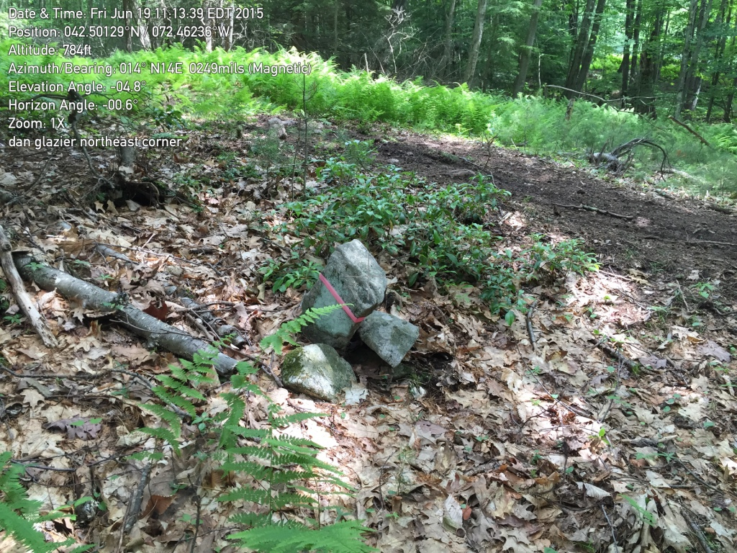

F. NE Corner, stone monument

Photo taken in June 2015. ATV trail is on private property next door.

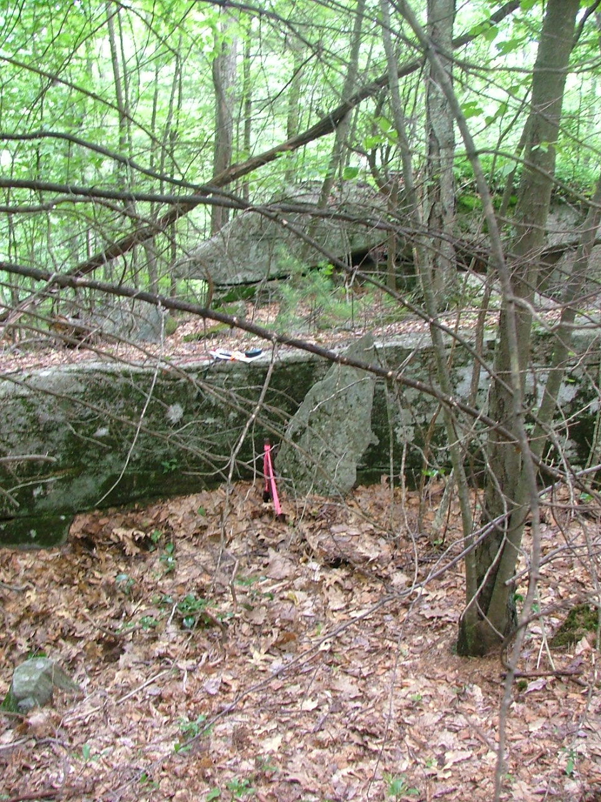

West of F. Stone monument against cliffs

along north line, looking south

(Monument shown in 1970 survey)

42.50091, -72.46394

July 11, 2009, digital picture #15

Looking toward property from neighbors' land to the north

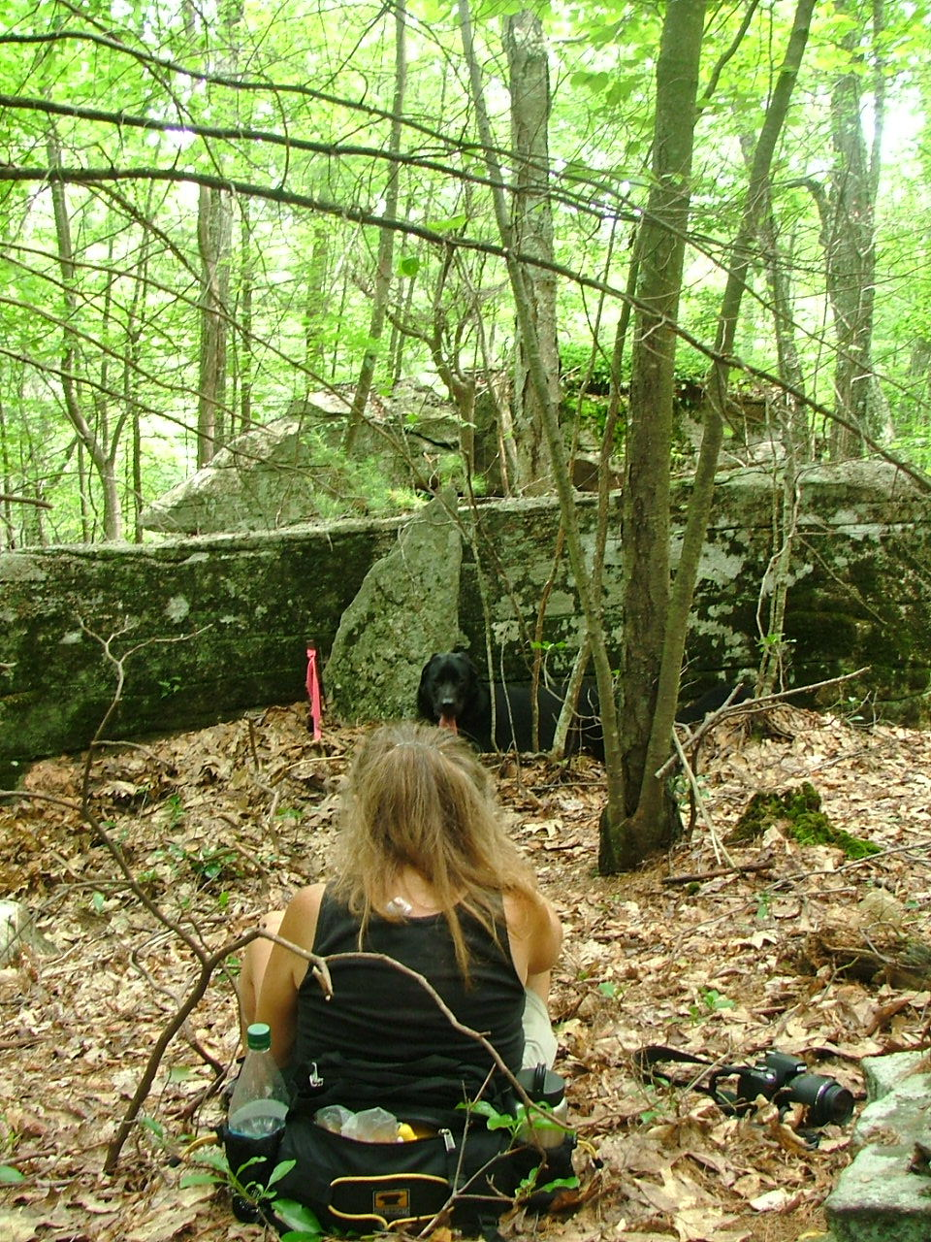

Same stone monument

Sight-line: Eva, Moby, monument,

crack between rocks (to left of sapling)

July 20, 2009, digital picture #07

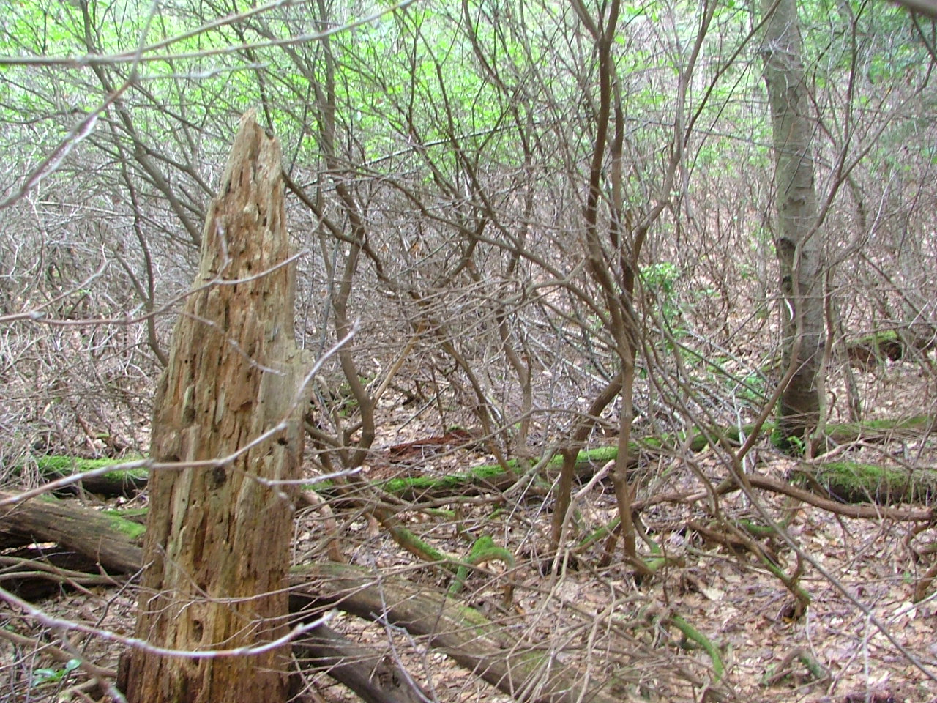

West of F. Hmmm, where is that line?

Laurel thicket along north line

42.50061, -72.46674

July 11, 2009, digital picture #17

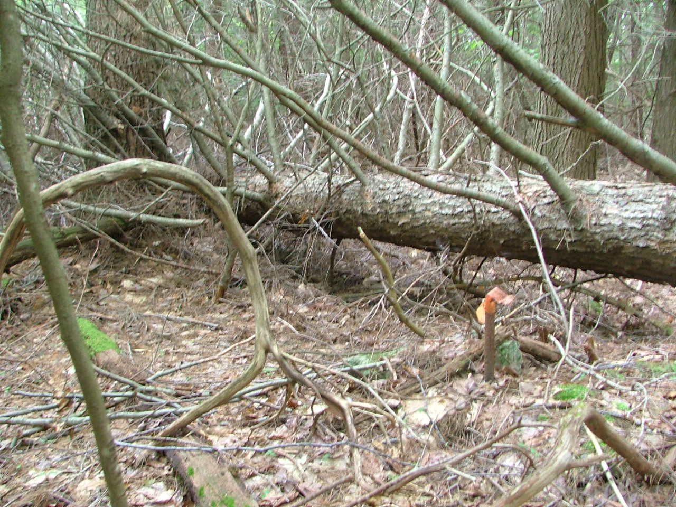

There it is!

(the pipe is on the east side of the log)

July 11, 2009, digital picture #18

Note June 2015: Found what appears to be the right tree, and lots of tape, but not the pipe.

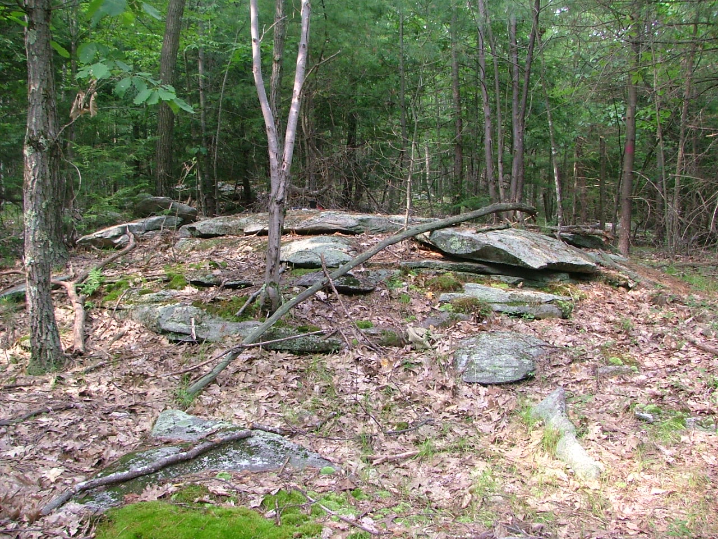

West of F. Just south of north line

painted maroon blazes on tree

(from planned M-M Trail not allowed by owners)

42.49995, -72.46951

July 11, 2009, digital picture #19

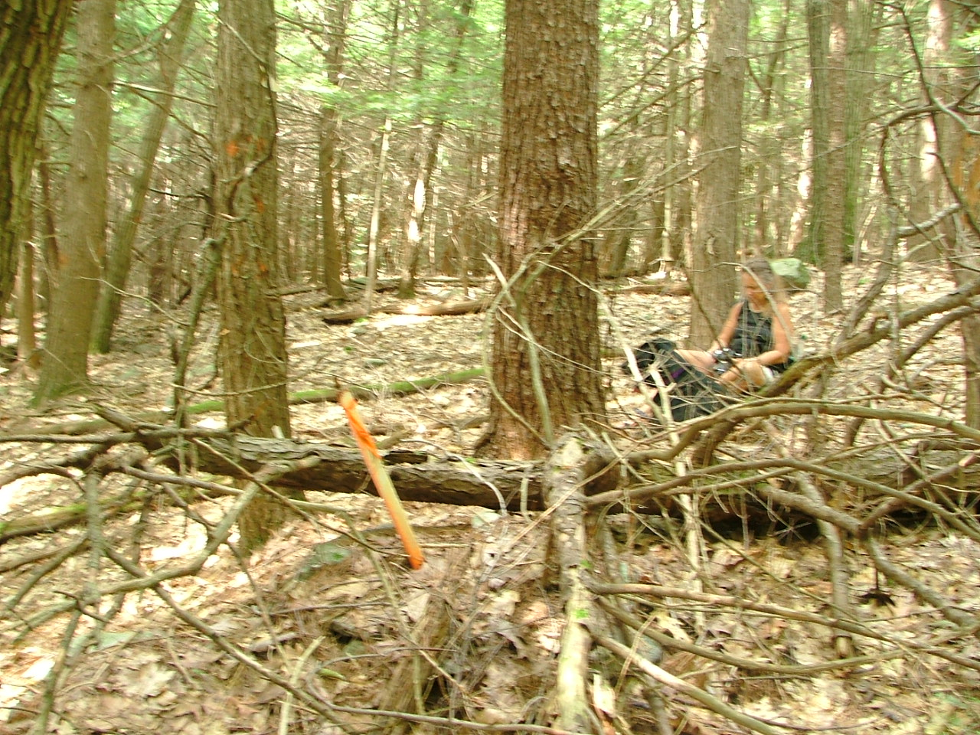

West of F. White stake, from here to west are

blazed trees, looking west along line

Marks change of ownership to north

42.50018, -72.47025

July 20, 2009, digital picture #08

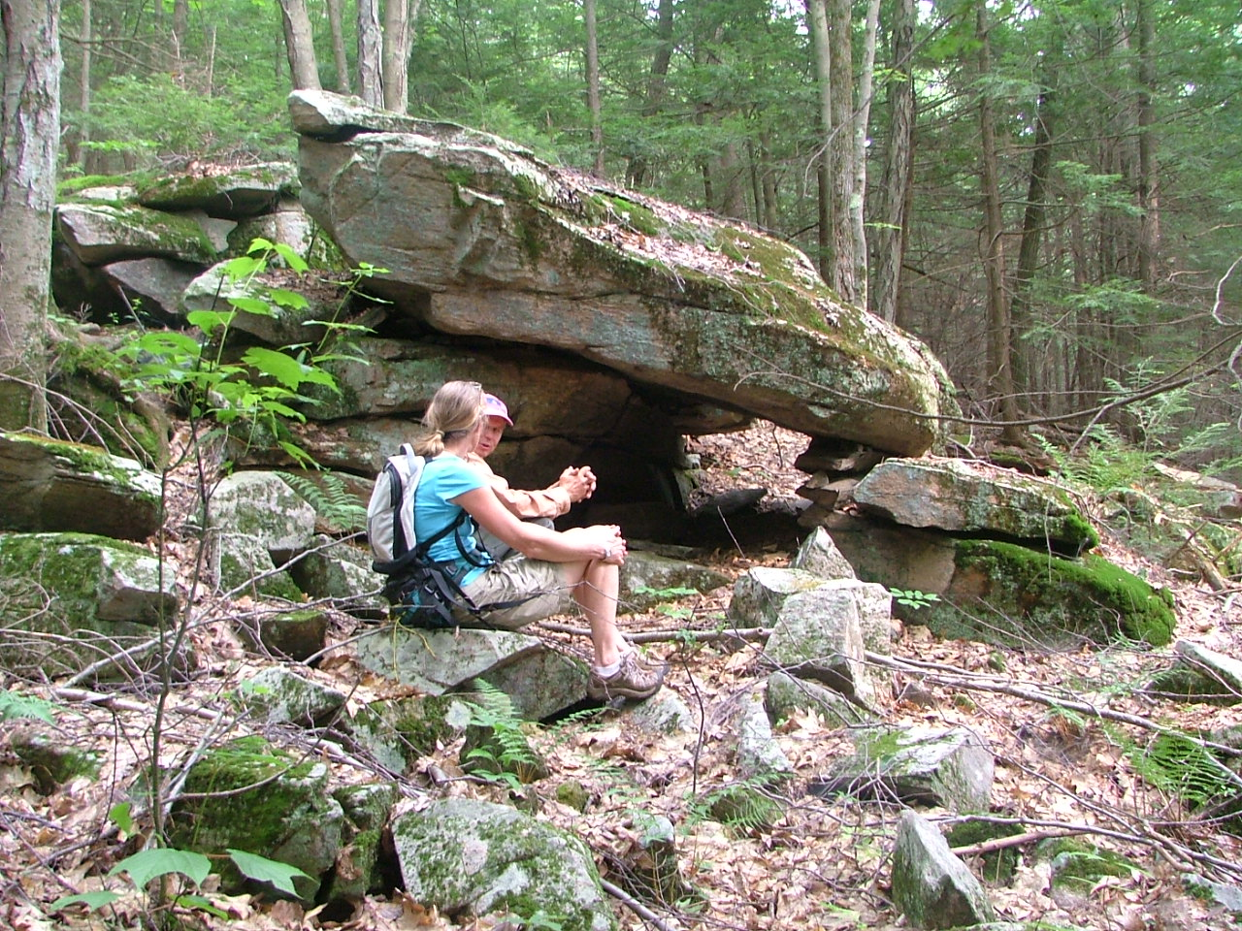

West of F. (on new trail) Stone formation

This rock is very close to north line

and just east/below cliff/jumble of rock along

line (3rd ridge of rocks if coming from east)

42.49954, -72.47129

July 11, 2009, digital picture #22

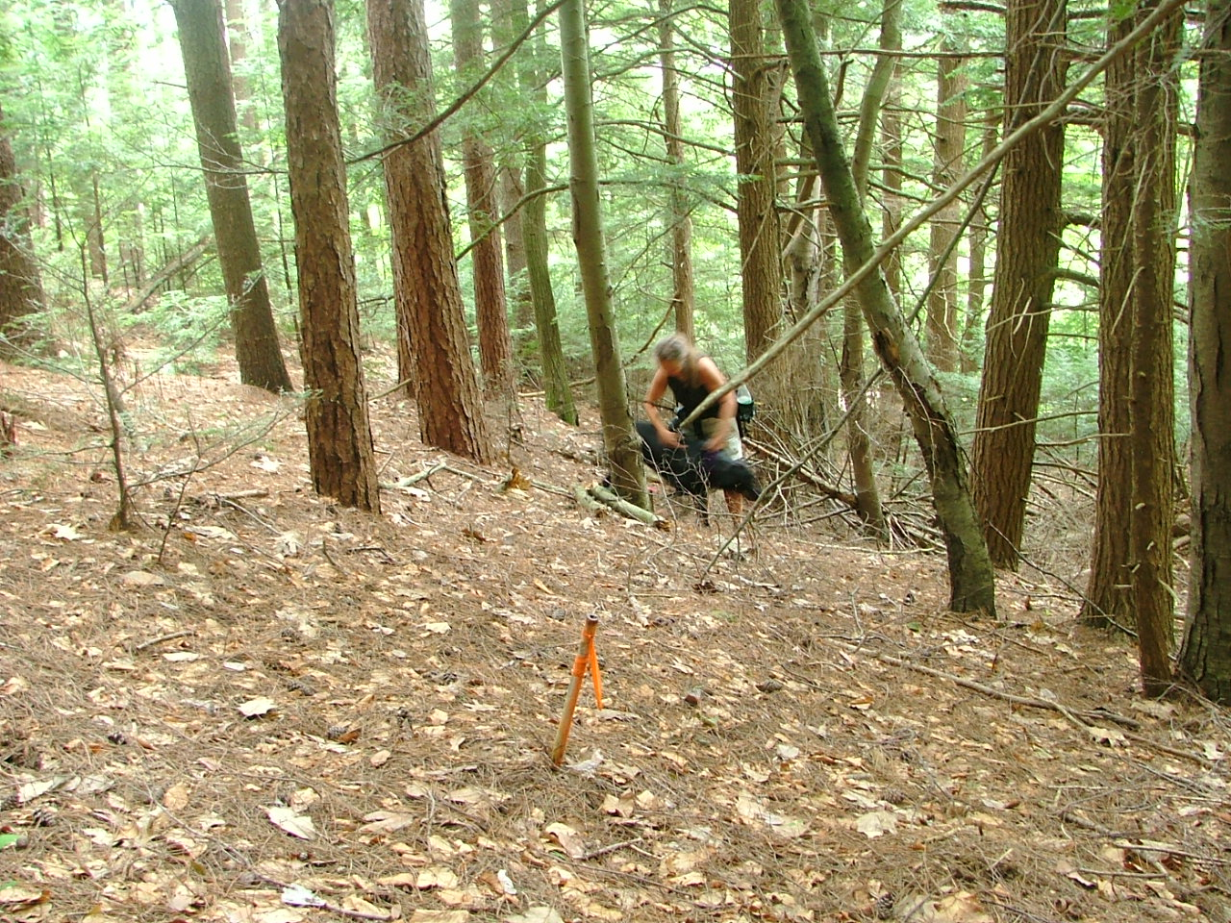

F. Pipe along line just west of stone structure

looking west toward power line

July 20, 2009, digital picture #09

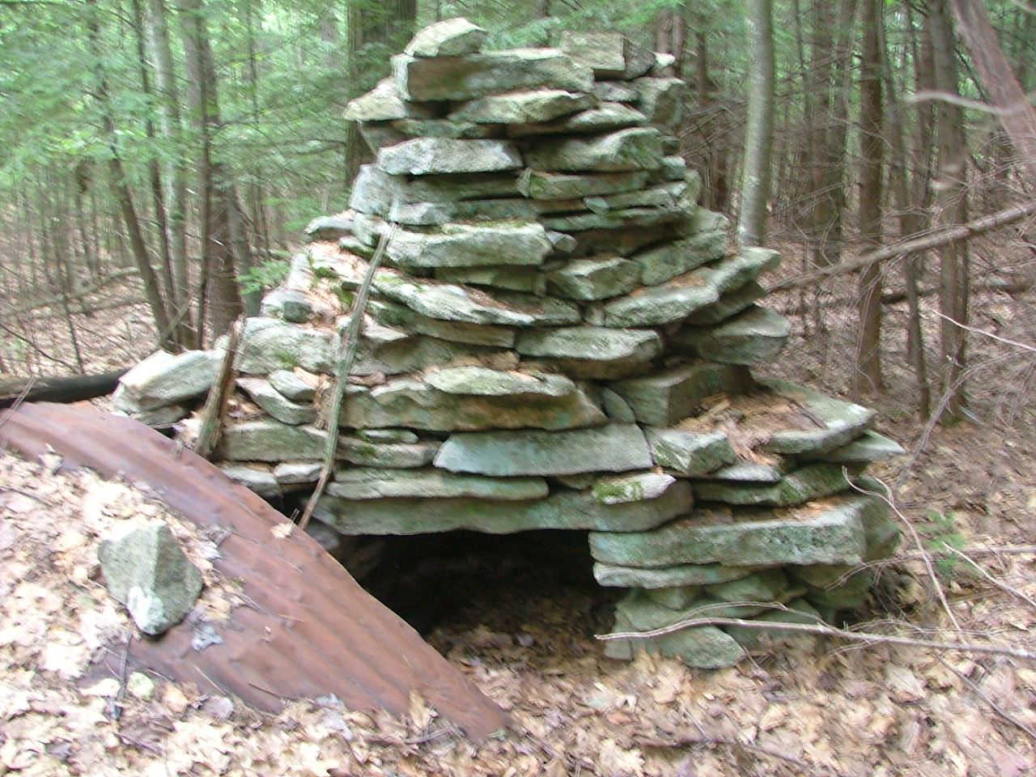

Stone Chimney (south of line and

south of stone structure)

initially built by Dan Bennett

(added to by others)

42.49921, -72.47195

July 11, 2009, digital picture #24