Dan Glazier Forest Photographs for Monitoring

Note that Alphabet matches alphabetical code on Monitoring Map

July 11, 2009: Thad Danielson, Julie Shively, Jean Bergstrom, Mary Alice Wilson, walked the boundary as well as to stone places that Thad showed us.

July 20, 2009: Eva Gibavic and Mary Alice Wilson walked the land to complete gps and photography.

June 2015: During the month, Angelo Teachout (UMass grad student doing practicum with RGT), Julie Shively, Rocky Adriance, Bill and Mary Alice Wilson spent time on the property. At first we were trying to find the trail marked by student Keith DiNardo years earlier. We did find parts of it, but soon changed our focus to (a) re-marking the boundaries so that the trail workers would know where they were and (b) designing an interesting trail. Boundaries were painted with orange paint and RGT metal markers were put up when there was a iron post or stone/concrete bound. (These markers assured us we were in the right place.) Pink ribbons were added to the faded ribbons on the many iron pins and ribbon was put up occasionally when the boundary was confusing. There are so many iron posts on the south side, we put an RGT sign up at about every two ips. The proposed trail is marked with blue tape/ribbon awaiting suggestions and a work party later in the summer.

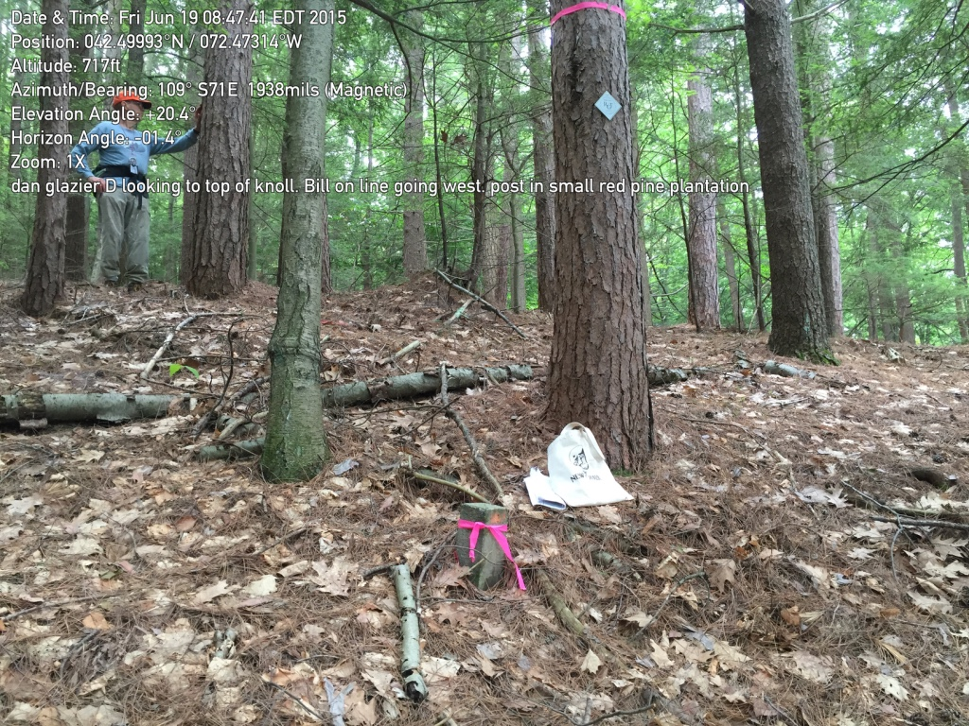

A. NW corner

cement post placed by NE Utility Co.

looking south along line

If walking from C, go up and over small knoll. You will be in red pine stand. Pin is part way down slope.

42.49987, -72.47332

July 23, 2015

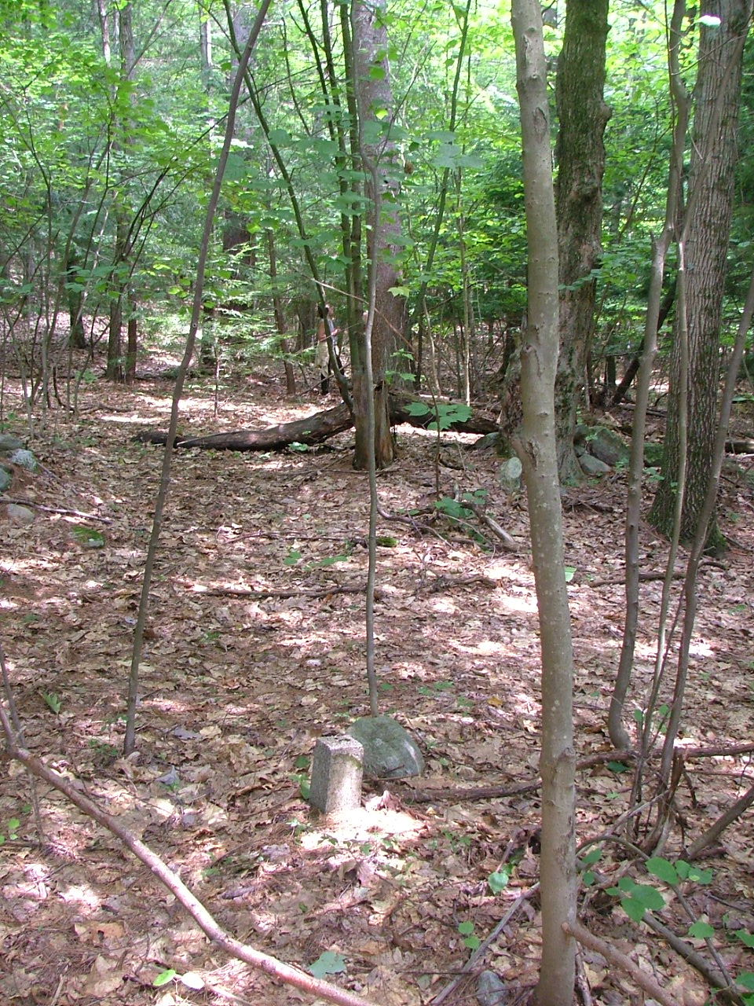

B. West line, corner at “notch”

cement post placed by NE Utility Co

(Notch where power lines turn corner,widened in preparation for nuclear power plant once planed in Montague.)

Stone wall nearby runs somewhat parallel to line

looking north

42.49800, -72.47362

July 11, 2009, digital picture #02

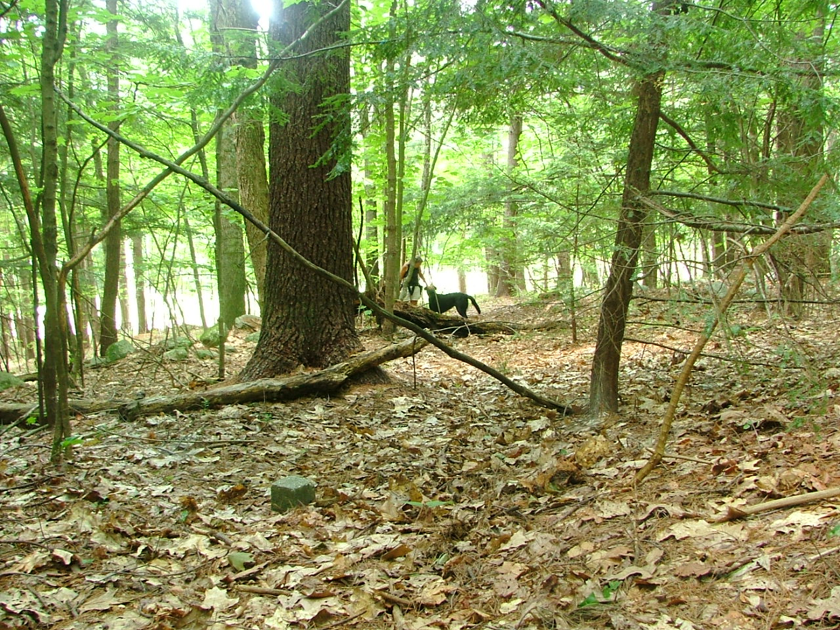

C. inside of “notch”

again, cement post

looking west to west line

Eva Gibavic and Moby at post on east line

(50 feet to east)

42.49810, -72. 47354

July 20, 2009, digital picture #02

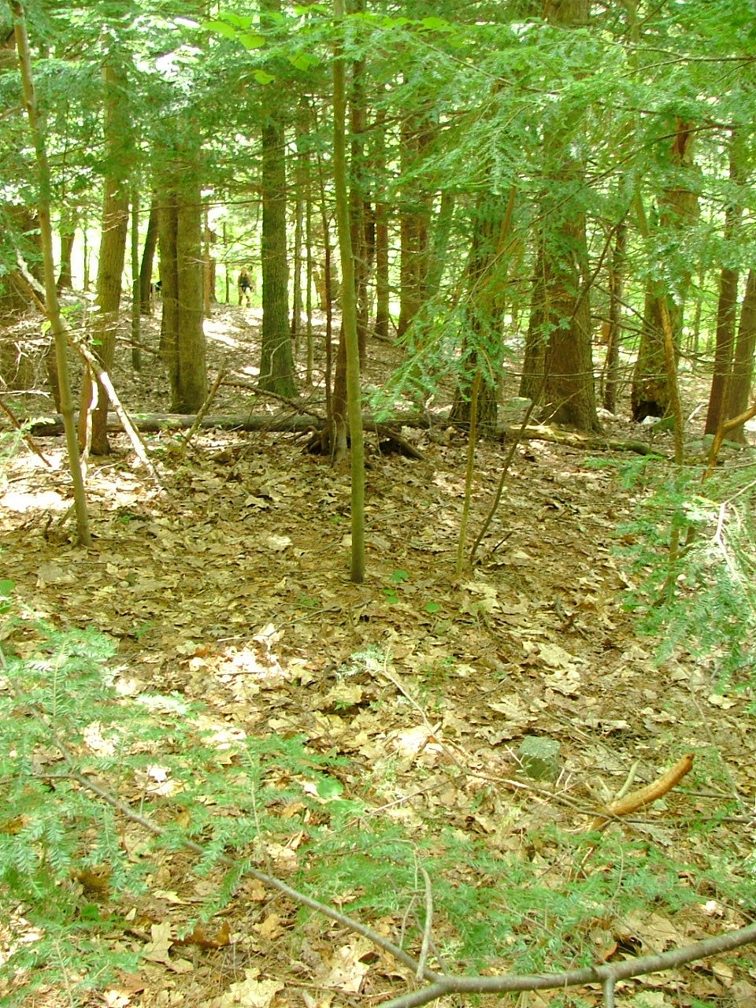

C. inside of “notch”

same post as above.

This time looking south to sw corner

Eva and Moby at SW post (105 feet)

July 20, 2009, digital picture #03

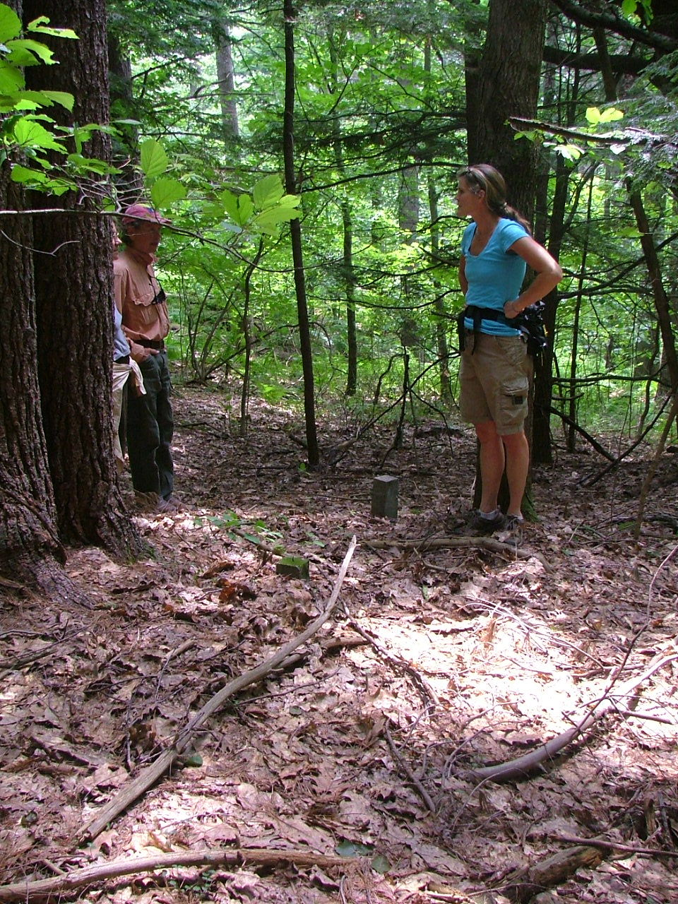

D. SW corner

again cement post(s)

42.49.758, -72.47322

looking south. Note that there are two cement posts

(one by Jean Bergstrom’s feet the other near front tree)

July 11, 2009, digital picture #03

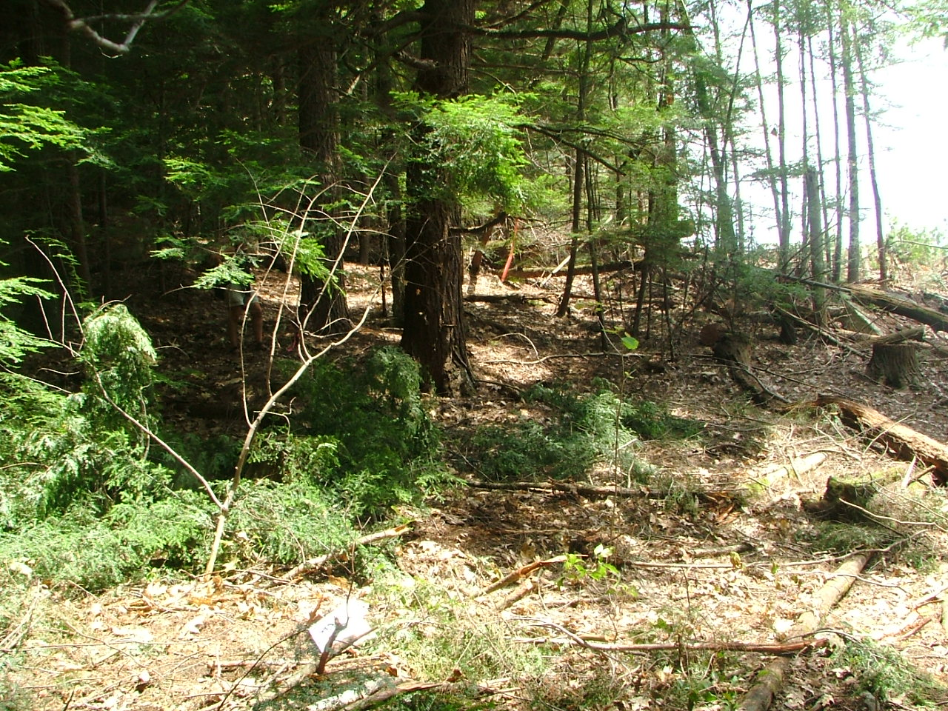

East of D. Along south line

at west edge of logging on land to south

looking east along line

42.49772, -72.47099

July 20, 2009, digital picture #04

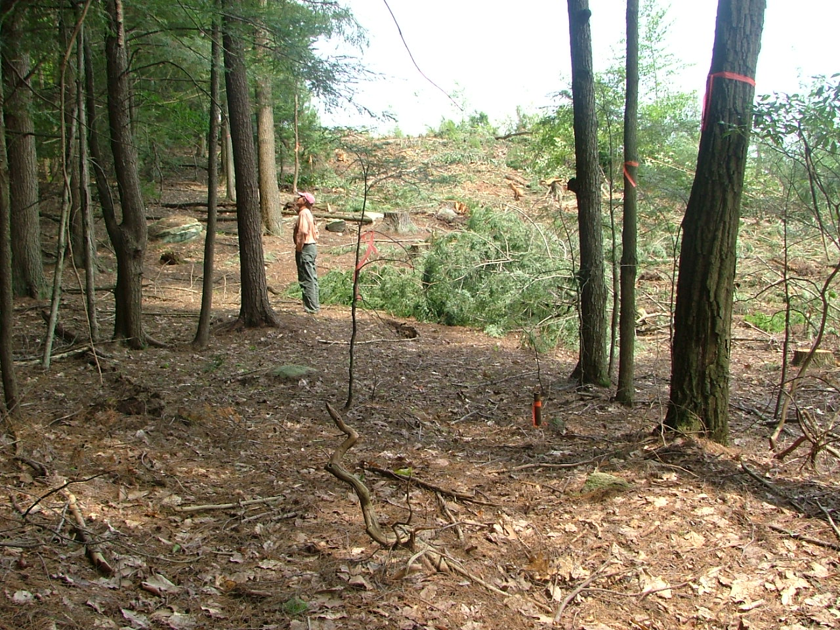

East of D. Along south line looking east along line

Logging on land to south

This line well-marked by iron pipes, and, as of 2015 orange paint, and occasional (at approximately every other iron pip) RGT metal boundary signs. (Clear cut growing up but pipes still visible.

July 11, 2009, digital picture #04

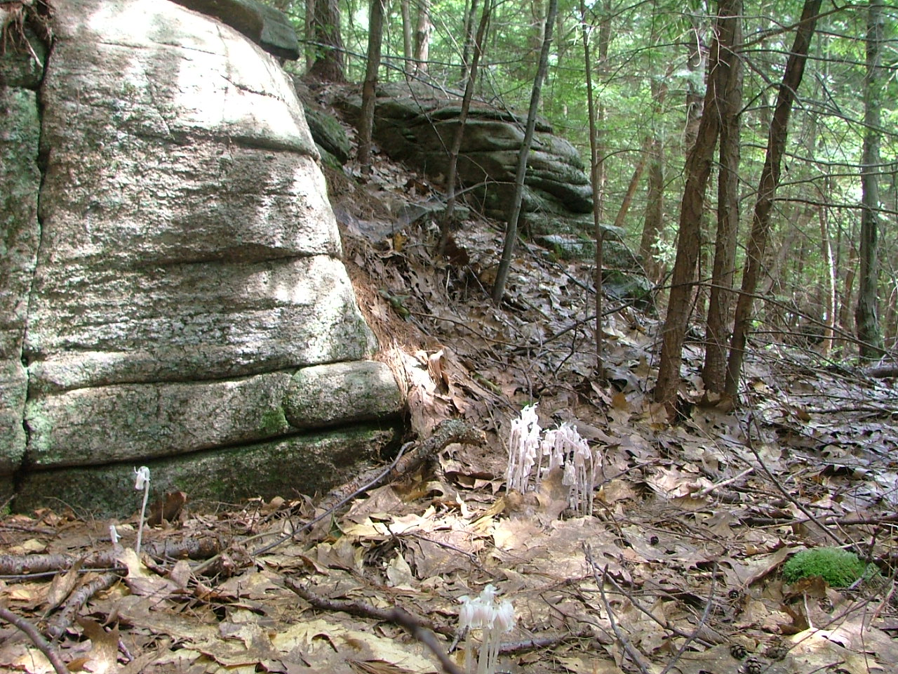

East of D. Cliffs (with Indian Pipe)

north of south boundary

42.49872, -72.47119

July 11, 2009, digital picture #05

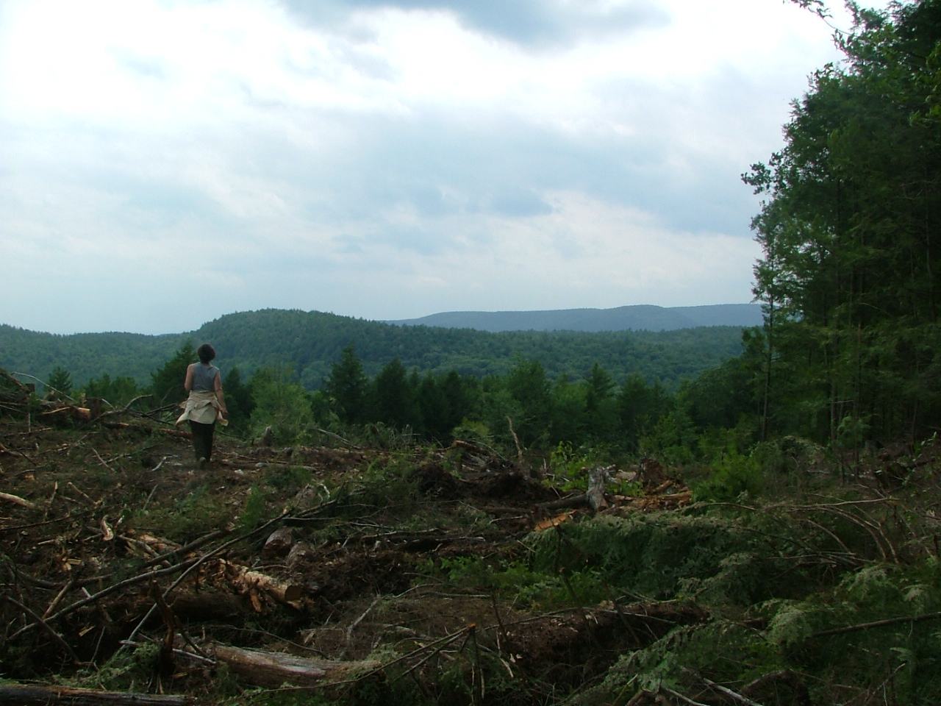

East of D. View west over logged land

from high point on south line

Rattlesnake Gutter cliffs

just beside Julie Shively

Mt Tom barely visible beyond.

Mt Toby to the right

43.49809., -72.46905

July 11, 2009, digital picture #08

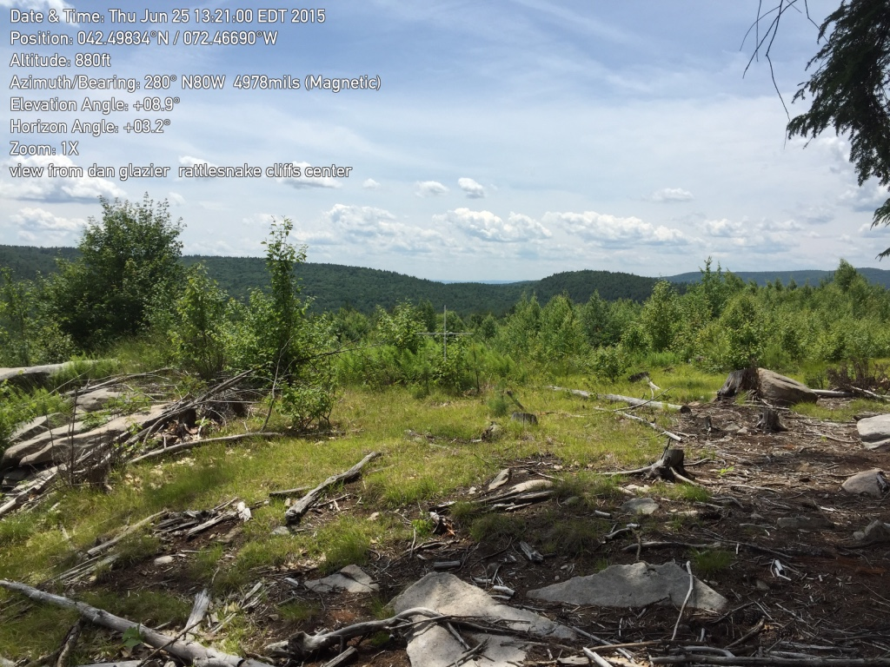

East of D. approximately the same location. As new growth takes over, the view is disappearing.

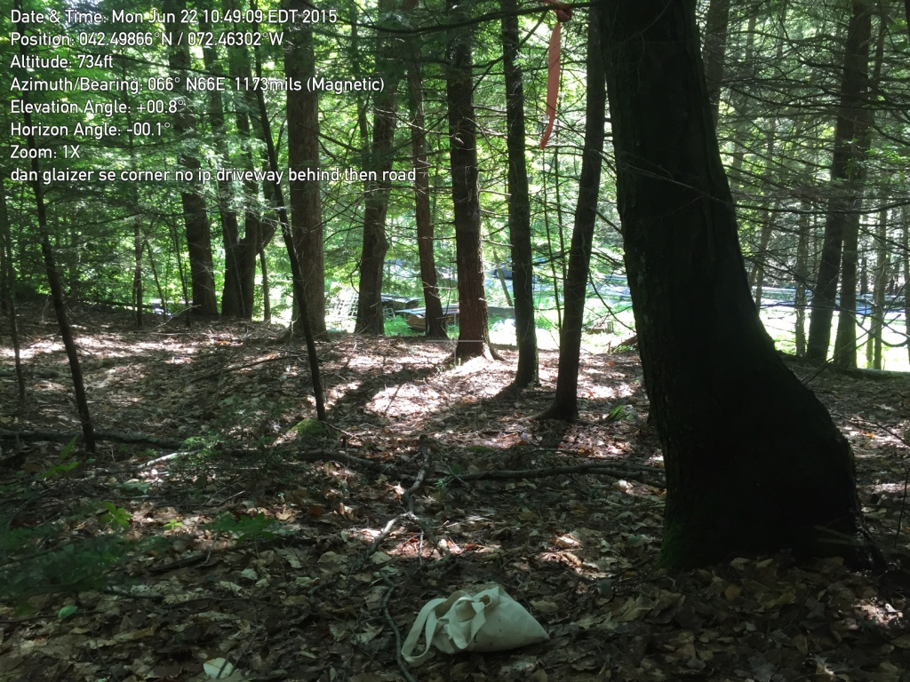E. SE corner. This is the only place on the property that does not have a pin or stone/cement bound. White bag where pin should be.

There is a driveway just downhill and the North Leverett Road just beyond that.

Note: line from E to F goes just behind the neighbor's brush pile and crosses woods road.

(Road is also crossed on the south line to E.)