Cheyette Photos for Monitoring, Part 2 (west and north)

(Corner letters correspond with those on the Cheyette Monitoring Map)

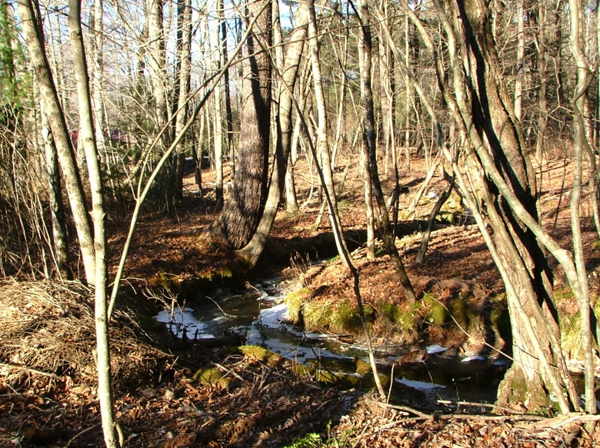

North of D. January 29, 2007

Looking north along west line (9 deg)

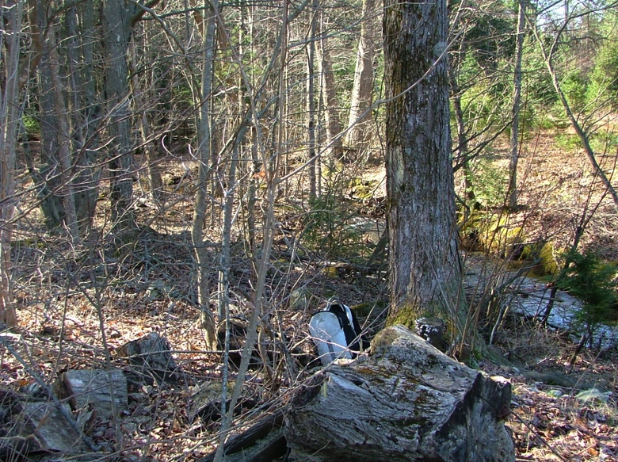

E. April 20, 2007

Looking south (189 degrees) along west line from northwest corner.

Iron pipe in front of gray backpack

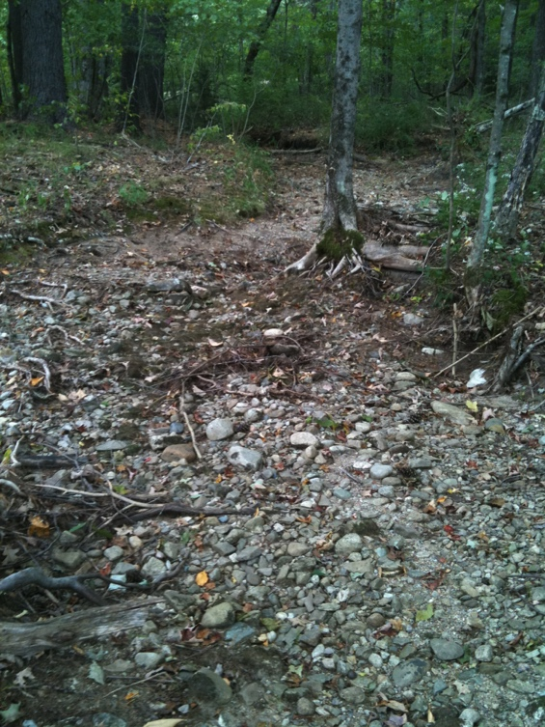

North of E. September 14, 2010

Standing in Mountain Brook (dry) looking north. Picture taken from W line very near NW corner. Very dry summer - stream has been dry since early August.

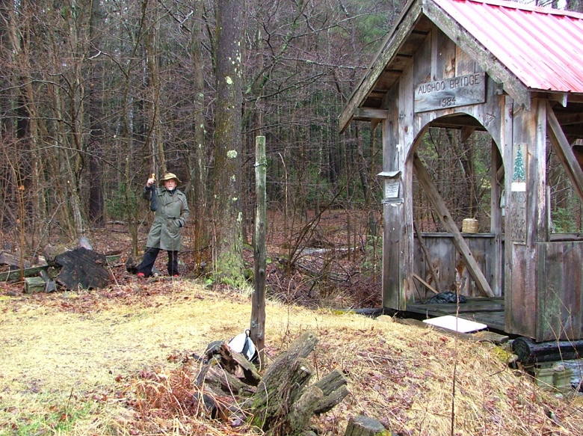E. April 17, 2007

Looking east, owner (Frederick Cheyette) standing at the northwest corner post.

(Covered walking bridge part of King Christmas Tree Farm).

Cheyette CR behind Mr. Cheyette.

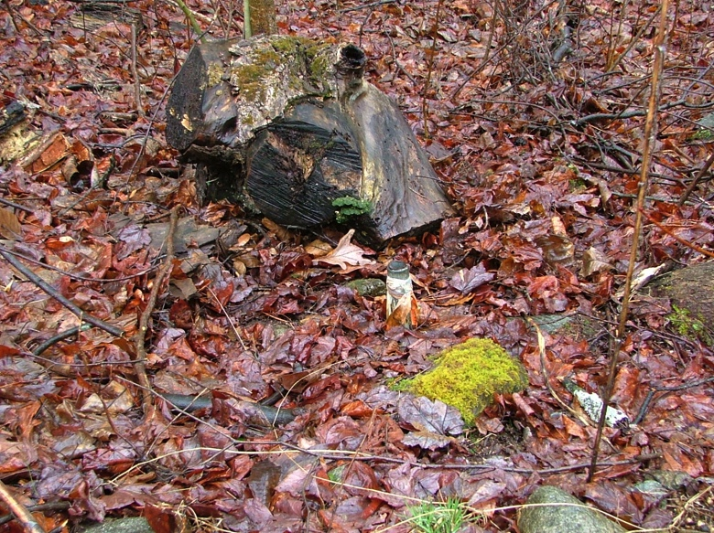

E. April 17, 2007

Northwest corner post (white tape)

4 17 07

42.44453, -72.48926

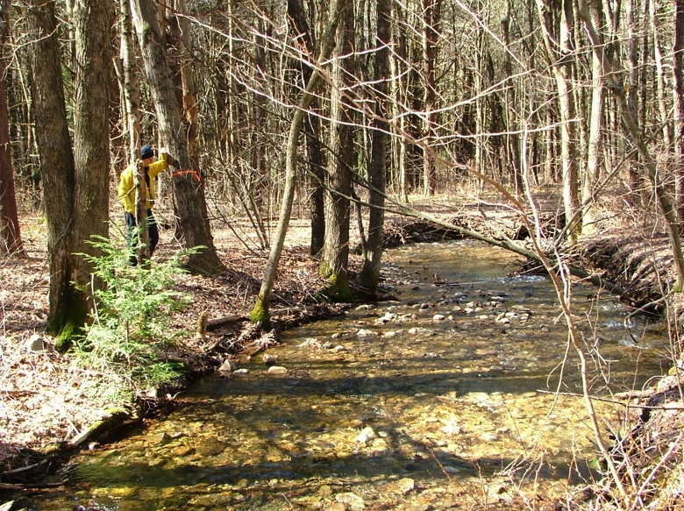

North of E. April 20, 2007

Angled corner on north line (iron pipe not found, tree marked with tape). Yellow jacket next to tree.

Looking downstream along Mountain Brook from north side of the stream

4 17 07

**Note from 2014**. There is an iron pipe north of the road separating King/Evans that is not on the survey but surely should be also the corner with Cheyette. Calls into question the location of F.

42.44450, -72.48771

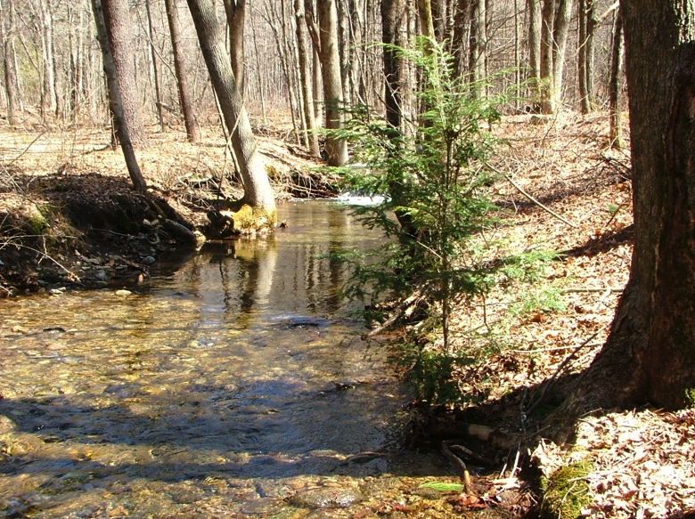

North of E. April 20, 2007

View from the same angled corner on north line, view upstream from the south side of Mountain Brook.

(Dirt road into Christmas Tree Farm on north side of stream)

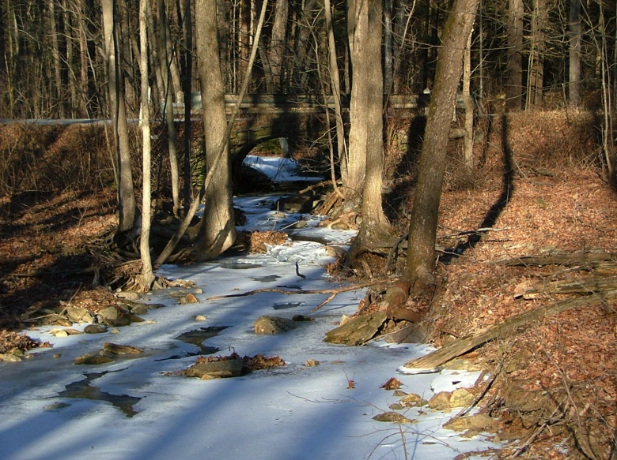

G. January 29, 2007

Looking northeast along Mountain Brook

to Shutesbury Road.

NE corner of property just north of

culvert.

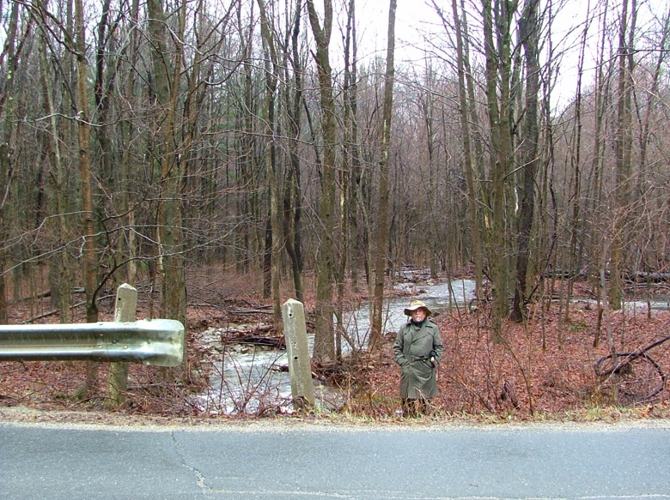

G. April 17, 2007

Same stream looking southwest

Owner (Frederick Cheyette) is standing at the northeast corner pipe by Shutesbury Road.

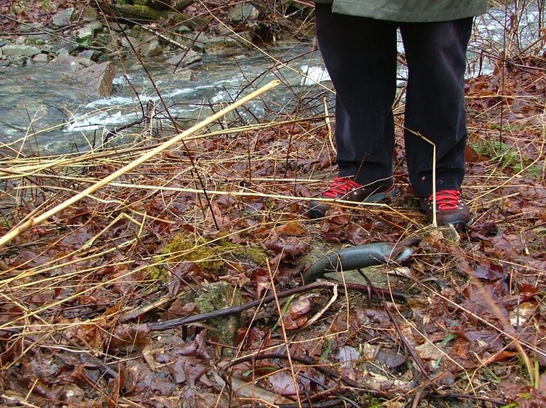

G. April 17, 2007

Northeast corner (bent pipe)

42.44555, -72.48656

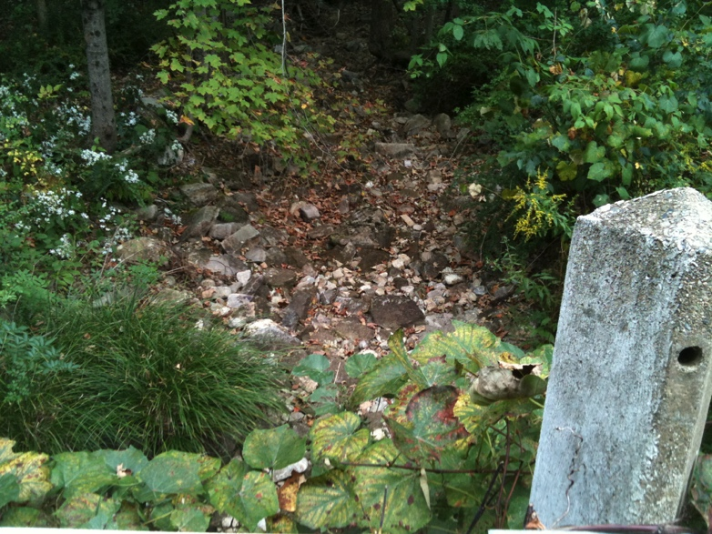

G. September 14, 2010

Standing on bridge at NE corner looking west along Mountain Brook (dry since early August)

Note: Property line follows Shutesbury Road back to the southeast corner. (A.)