Cheyette Conservation Restriction: Boundary Pictures (updated first 9/14/2010 after placing of new Building Envelope stakes. Point A new photographs 2015) Capital letter matches monitoring map.

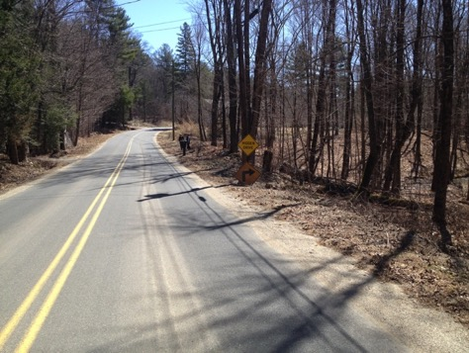

A. 3 views of CR from road.

Property and CR goes from culvert

to just beyond yellow road signs (where

CR ends and building envelope begins.

Three photos with monitors standing

at point A 4 12 2015

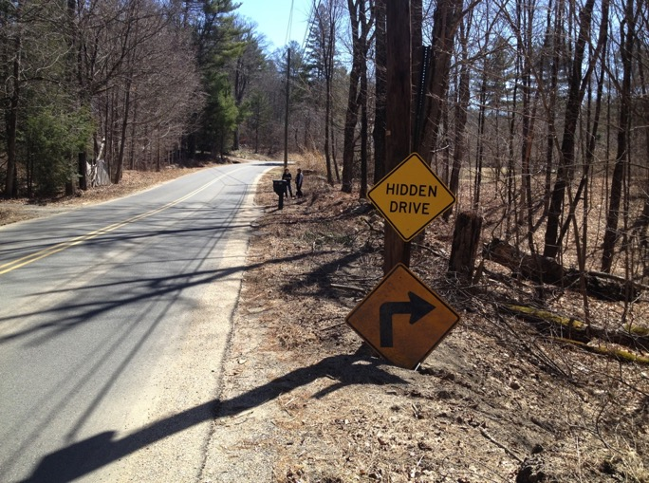

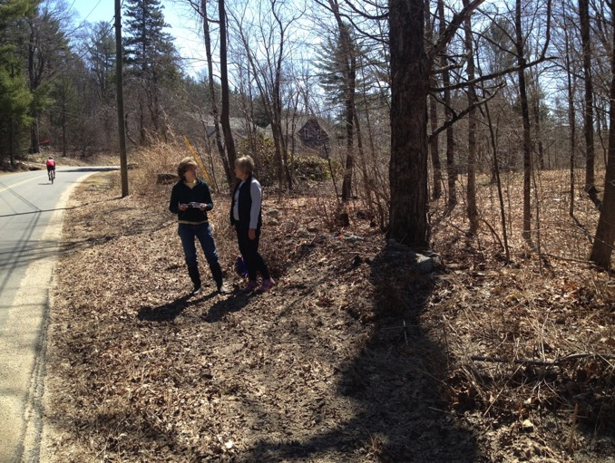

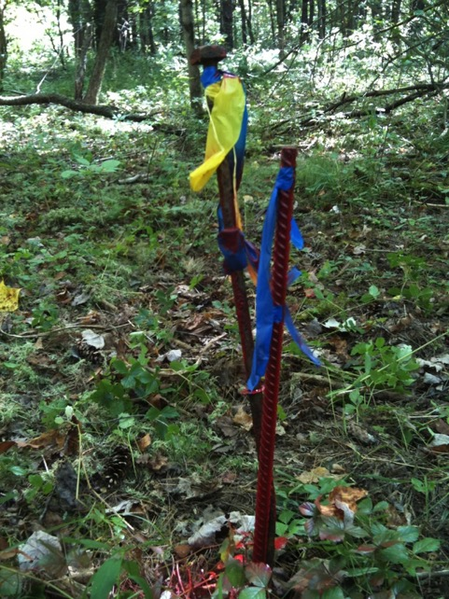

B, September 14, 2010

New rebar marking NW corner of building

envelope (inside corner of CR).

42.44473, -72.48666

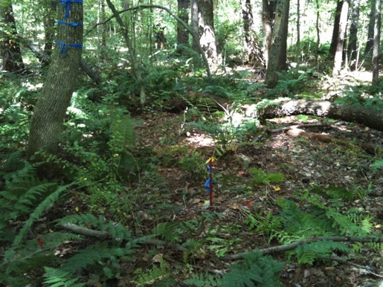

C. September 14, 2010

New rebar at SW corner of building

envelope (along property line with

Crafts/Snowden) looking north along

line dividing CR (to left/west) and

building envelope (to right/east)

42.44404,-72.48651

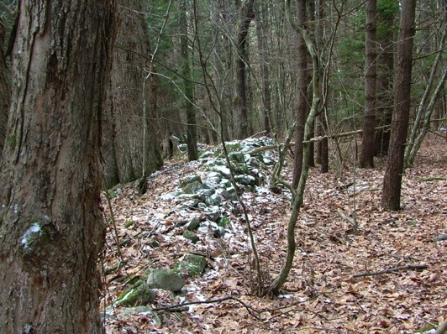

west of C. January 28, 2007

Stone wall marking section

of south line (with Crafts/Snowdon).

Looking west (276 deg).

1/28/07 001

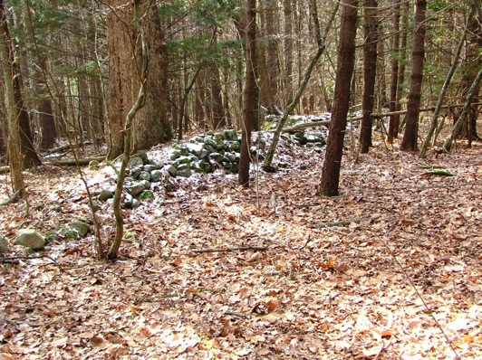

west of C. January 28, 2007

Second view of stone wall, taken

from Cheyette CR, looking

southwest

1 29 07 003

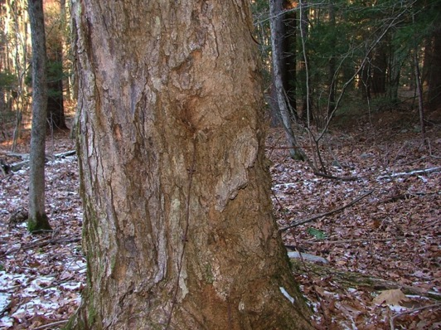

west of C. January 29, 2007

South line is marked by barbed wire

well-embedded into the trees.

1 29 07 027

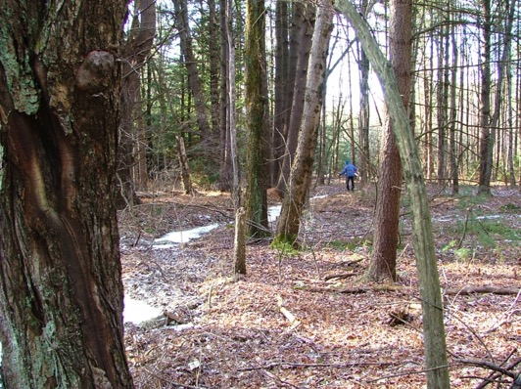

West of C. January 29, 2007

South line (line of barbed wire fence)

somewhat follows stream.

(Opening for Christmas tree farm on

town-owned Conservation Land visible

at a distance.)

1 29 07 011

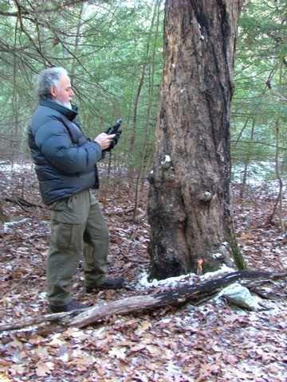

D. January 28, 2007

Corner of Cheyette, Crafts, and Leverett (King)

land. King Christmas tree farm just beyond tree.

Stake embedded in tree root.

42.44385, -72 48913

1 28 07 006

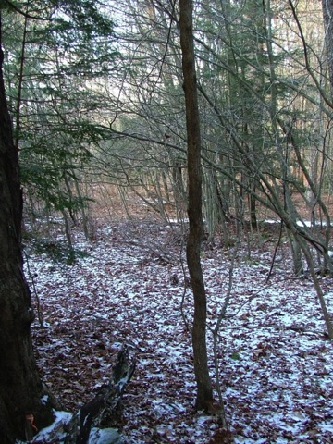

North of D, January 28, 2007

Looking north along west line to next corner

with the Christmas tree farm. (9 deg)

1 29 07 007