17. West side stone bound;  Second bound on jog to west.  42.49208, -72.50531  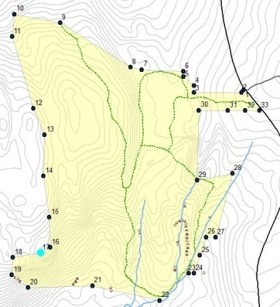  Photo facing N 23 degrees (magnetic)  August 17, 2014 | 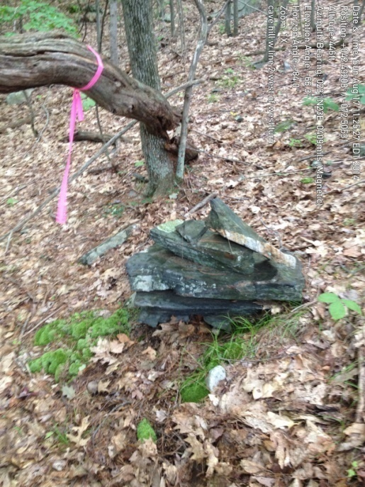
18. W side; NW corner of west jog;  Pin hidden somewhat; at base of ledge to west (ahead in picture) and huge boulder behind.  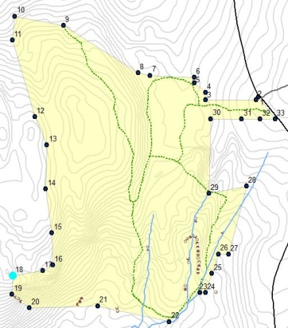  42.49155, -72.50602  Photo facing W 299 degrees (magnetic)  August 17, 2014 | 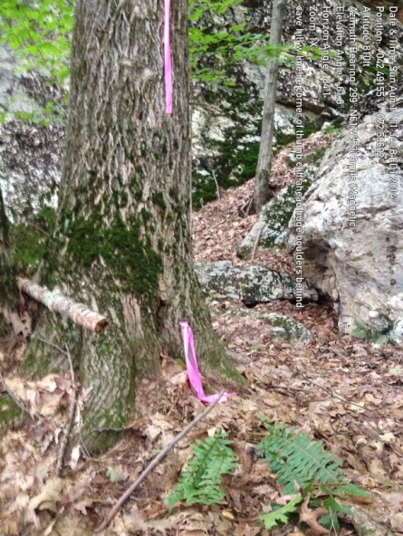
19. W side bound; SW corner of west jog; bound is the highest point of a short southeast/northwest stone row that is the boundary line.  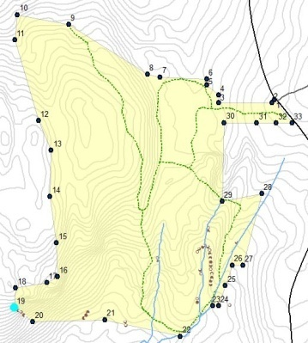  42.49132, -72.50598  Photo facing NW 230 degrees (magnetic)  August 25, 2014 | 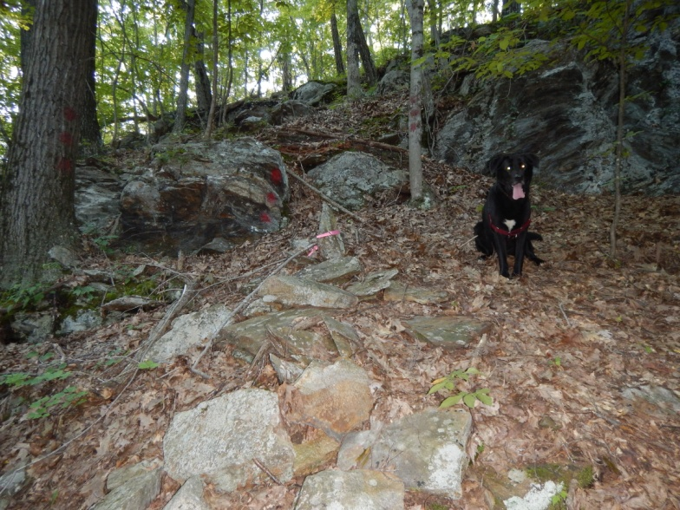
20. S side bound; at bottom of hill/ledge.  42.49085, -72.50542  Photo facing NW 327 degrees (magnetic)  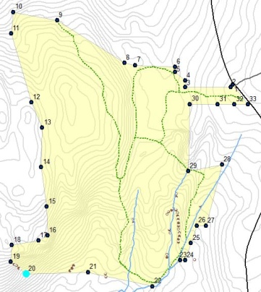  August 17, 2014 | 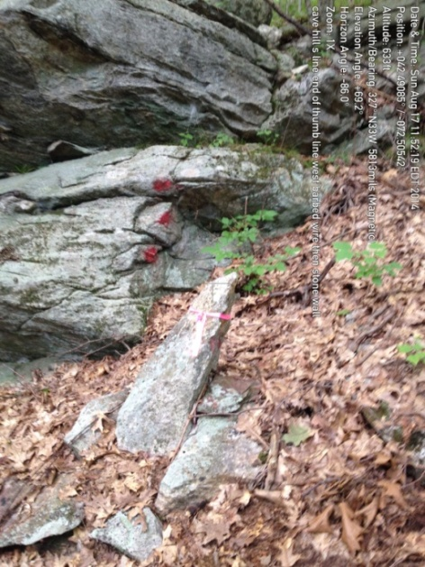
21. S side stake and stones;  midway on south line under fallen tree.  42.49079, -72.50290  Photo facing S 247 degrees (magnetic)  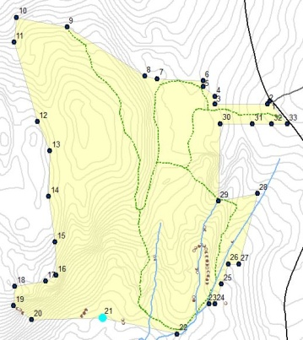  August 17, 2014 | 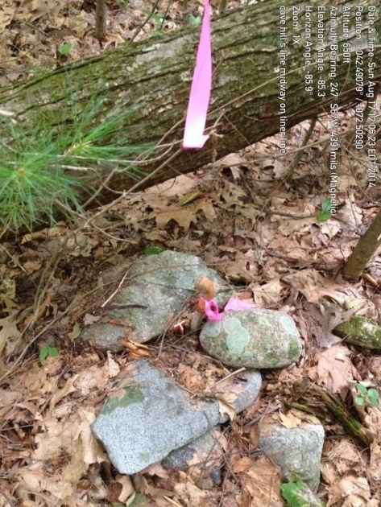
22. SE corner, pin on edge of stream  42 29' 26", -72 30' 1.0"  Photo facing SSE 155 degrees (true)  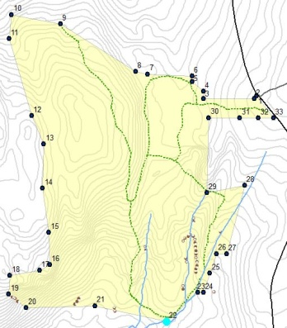  December 29, 2013 | 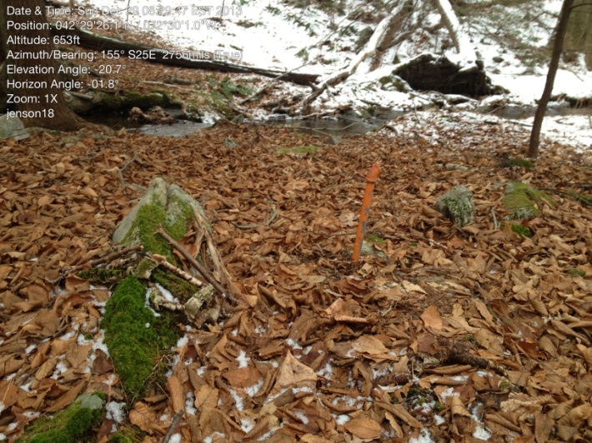
23. SE area, pin, line jogs eastward from here 55 feet to pin 24.  42 29' 28.7", -72 29' 57.4"  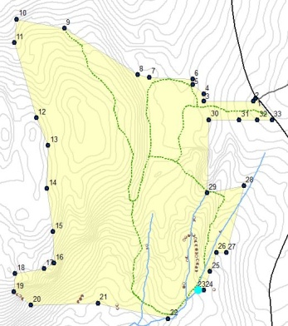  Photo facing NW 303 degrees (true), taken from Cowls land looking at CHCA.  December 29, 2013 | 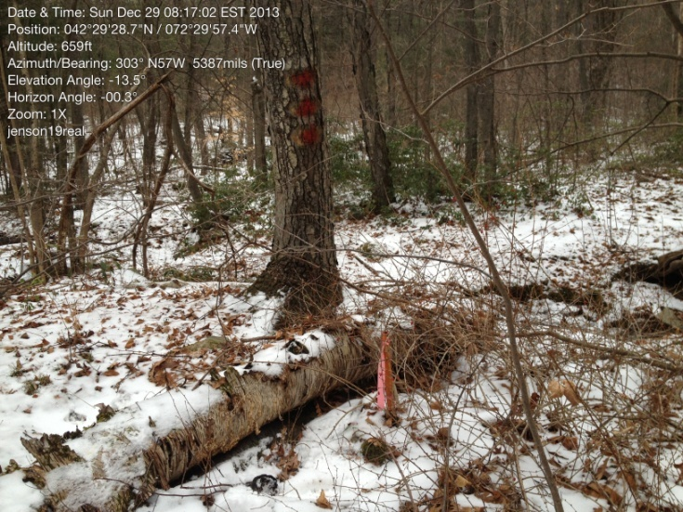
24. SE area, pin, line jogs north eastward from here.  42 29' 28.8", -72 29' 56.8"  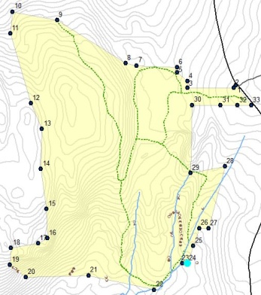  Photo facing E 90 degrees (true), taken from CHCA looking at Cowls land.  December 29, 2013 | 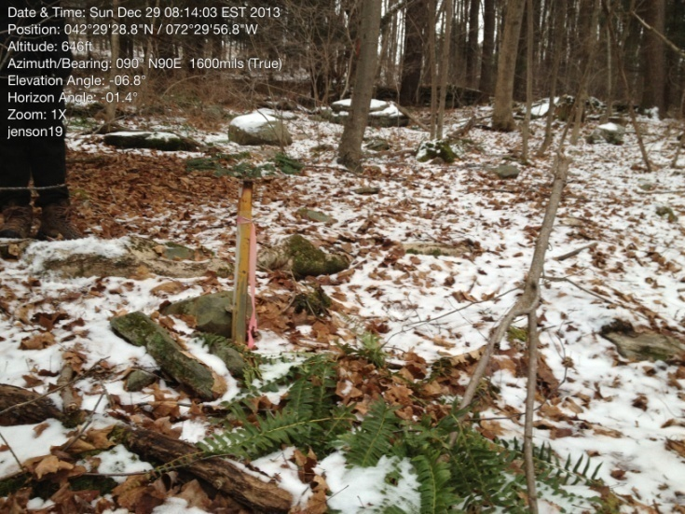
25. E side, stake and stones, on east side of brook.  42 29' 31.4", -72 29' 54.2"  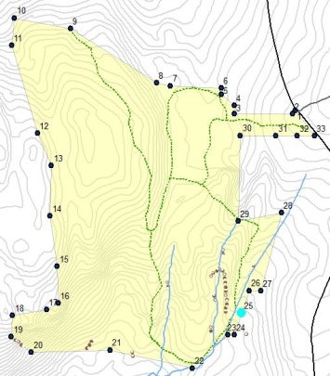  Photo facing NNW 337 degrees (true), taken from Cowls land looking at CHCA.  December 29, 2013 | 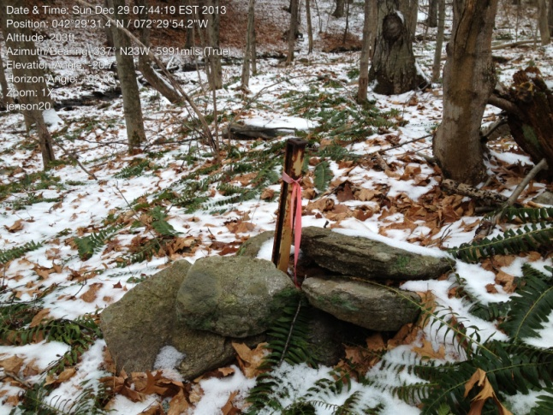
26. E side, stake and stones; boundary takes a jog east from here to 27.  42.49229, -72.49844  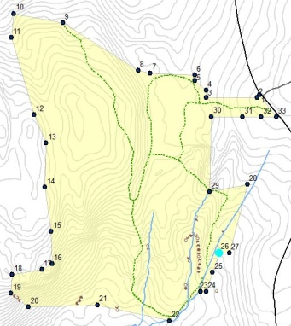  Photo facing NNE 30 degrees (magnetic)  August 17, 2014 | 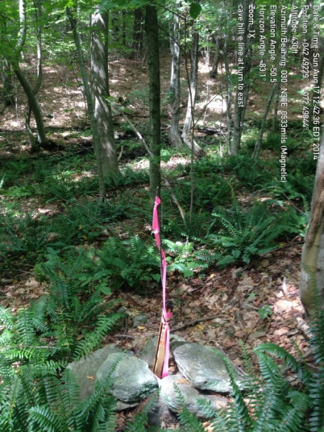
27. E side, stake and stones; boundary takes a jog NNE from here to 28, along Cowls boundary.  42.49233, -72.49828  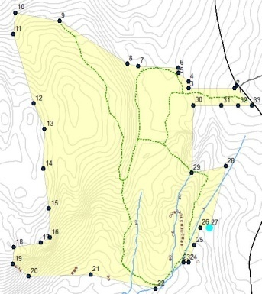  Photo facing NNE 35 degrees (magnetic)  August 17, 2014 | 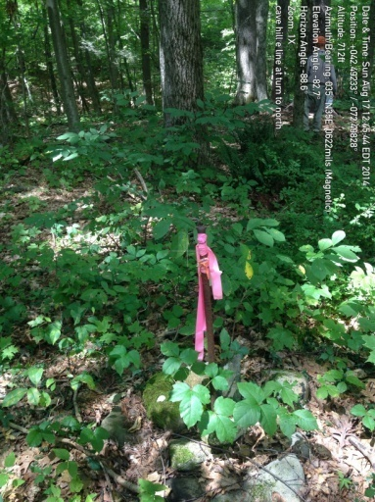
28. E side, pin, SE corner of Matsuda; boundary takes a jog west from here to 29.  42.49420, -72.49782  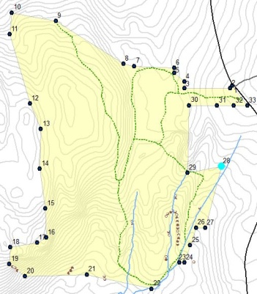  Photo facing W 256 degrees (magnetic)  August 17, 2014 | 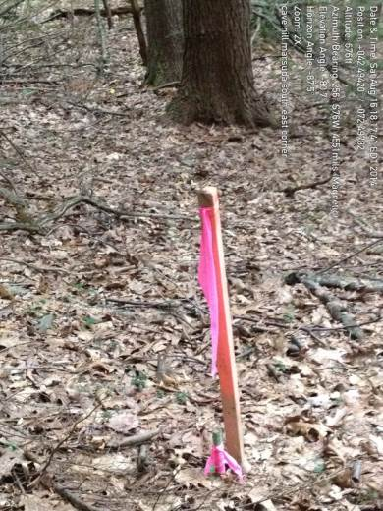
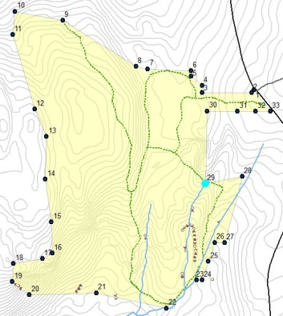  29. E side, stake and stones; Matsuda southwest bound; bound is southwest of trail; permission granted for trail to cross Matsuda land.  42.49229, -72.49844  Photo facing W 270 degrees (true)  August 25, 2014 | 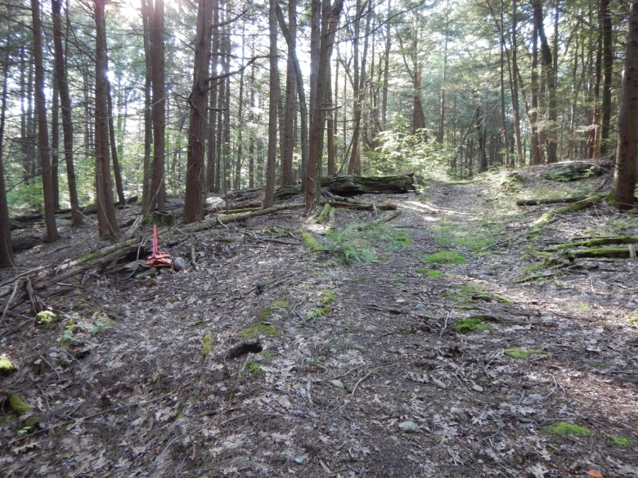
30. E side pin; NW corner of Matsuda land; pin in midst of mountain laurel tangle; boundary turns east from here.  42.49597, -72.49898  Photo facing S 212 degrees (magnetic)  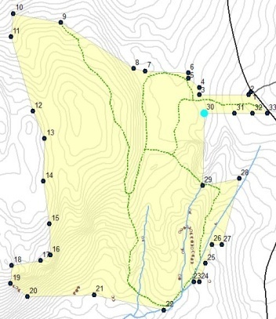  August 17, 2014 | 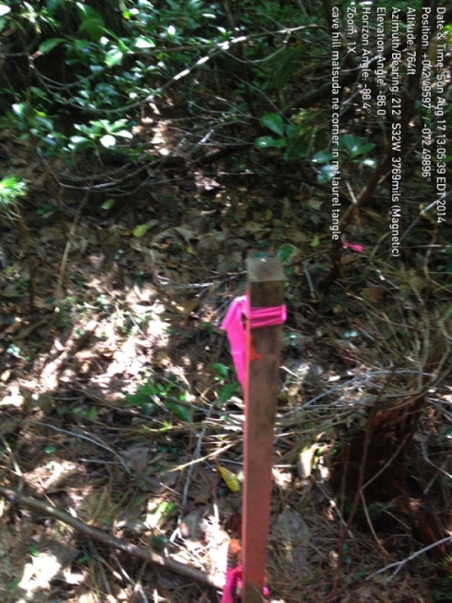
31. E side, pin on Matsuda north line, 3rd west from road.  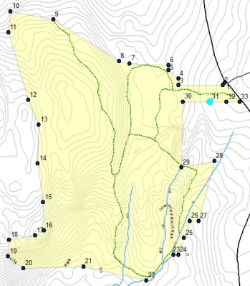  42.49600, -72.49794  Photo facing W 265 degrees (true)  August 25, 2014 | 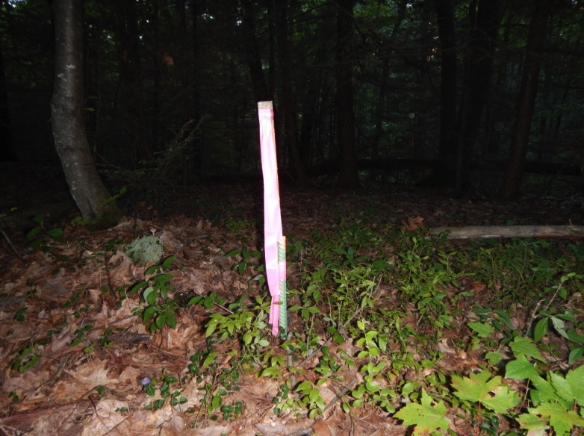
32. E side, pin on Matsuda north line, 2nd west from road.  42.49604, -72 49803"  Photo facing S 180 degrees (true)  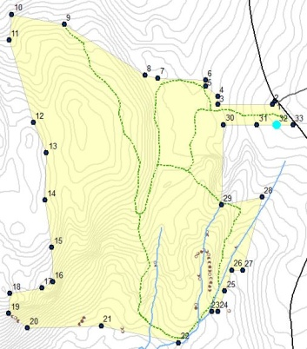  August 25, 2014 | 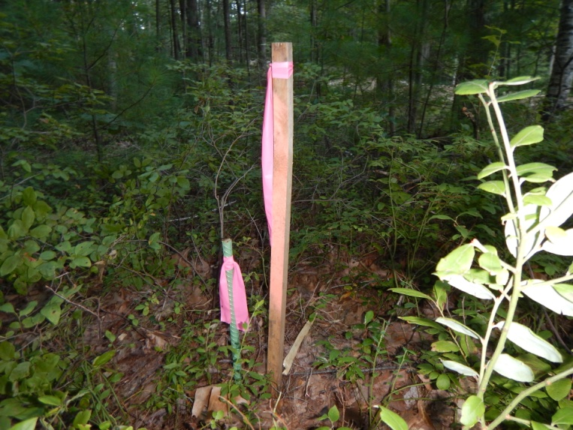
33. E side, pin at Matsuda north line at Cave Hill Road.  42.49615, -72.49666  Photo facing E 66 degrees (magnetic)  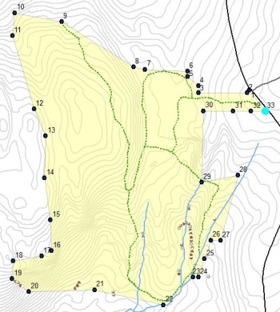  August 17, 2014 | 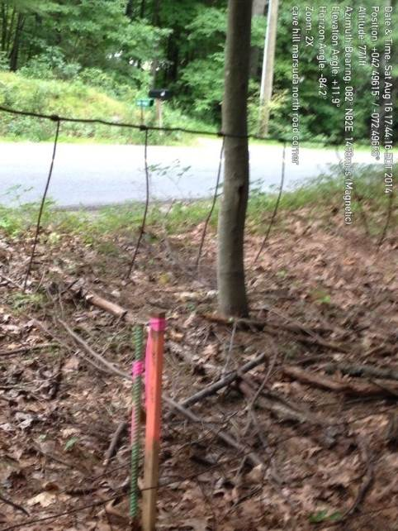

16. West side stone bound and pin;  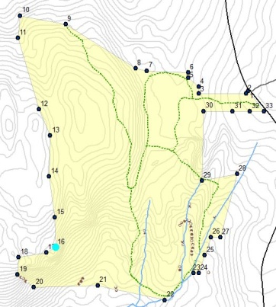  Bound is downhill on side of ledge; beginning of jog to west.  42 29' 31.1", -72 30' 16.7"  Photo facing S 138 degrees (true)  December 29, 2013 | 