# Cave Hill Photos for Monitoring, Part 1 (north and part of west)

(Corner numbers match numbers on Cave Hill Monitoring Map)

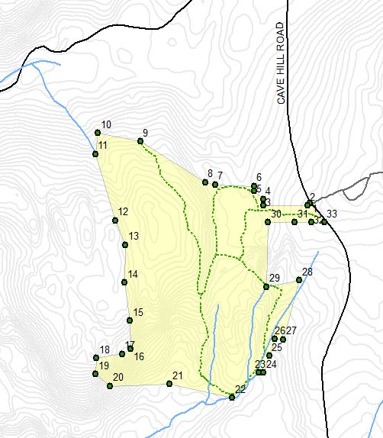

Note: In the following boundary-line photographs, the location on the accompanying map is shown in light blue. Photographs/numbers begin on Cave Hill Road at the Baillargeon corner and go counter-clockwise around the property, coming back to Cave Hill at the corner with Matsuda. A map with the abutting properties is with the Abutter Deeds in Appendix I; the map is in Part 1

|  |  |
| --- | --- |
| 1. NE area, pin at corner of Cave Hill Road  Boundary with Baillargeon closest to road  42.49672, -72.49754  CHCA1.JPGPhoto facing N 4 degrees (magnetic)  August 16, 2014 | CH1.JPG |
| 2. NE aea, pin boundary with Baillargeon; 2nd from the road going west  42.49662, -72.49776  Photo facing NW 313 degrees (magnetic)  CHCA2.JPGAugust 16, 2014 | CH2.JPG |
| 3. NE area, pin on boundary with Baillargeon; 3rd from road, right angle junction  42.49672, -72.49754  Photo facing S 182 degrees (magnetic)  CHCA3.JPGAugust 16, 2014 | CH3.JPG |
| 4. NE area, stake and stones on boundary with Baillargeon; 4th from road, north of Pin 3; along old trail  42.49672, -72.49754  CHCA4.JPGPhoto facing S 182 degrees (magnetic)  August 16, 2014 | CH4.JPG |
| 5. NE area, pin on boundary with Baillargeon; 5th from road, right angle junction  42.49672, -72.50006  Photo facing E 83 degrees (magnetic)  CHCA5.JPGAugust 16, 2014 | CH5.JPG |
| 6. NE area, pin on boundary with Baillargeon; 6th from road, right angle junction; northwest pin abutting Baillargeon  CHCA6.JPG42.49726, -72.49994  Photo facing N 4 degrees (magnetic)  August 16, 2014 | CH6.JPG |
| CHCA7.JPG7. North line, approximate location of unmarked point; junction point of Suzanne Webber (southwest corner) and James Hicks/Anna Botta (southeast corner)  42 29' 49.6", -72 30' 4.9"  Photo facing N 357 degrees (true)  December 28, 2013 | IMG_1520.JPG |
| 8. North line, mid property stone bound, 3rd from west  42.49696, -72.50200  CHCA8.JPGPhoto facing NW 341 degrees (magnetic)  August 17, 2014 | CH7.JPG |
| 9. North line stone bound, 2nd from west  42.49834, -72.50457  Photo facing NE 44 degrees (magnetic)  August 17, 2014  CHCA9.JPGThis bound is near and can be confused with stone bound and pin placed by Dale Merritt, marking the boundary between James Hicks/Anna Botta and Leighton LaClaire (see photograph). | CH9.1.JPGCH9.JPG  Left: Stone bound 9  Above: Hicks/Botta and LaClaire bound and pin placed by Dale Merritt, appears within CHCA, not on survey. |
| 10. NW Corner stone bound  42.49856, -72.50604  Photo facing SW 233 degrees (magnetic)  CHCA10.JPGAugust 17, 2014  Bill Wilson is standing to southwest, near a tree with barbed wire. | CH10.JPG |
| 11. West side stone bound, near brook and spring  42.49778, -72.506639  Photo facing E 86 degrees (magnetic)  CHCA11.JPGAugust 17, 2014 | CH11.JPG |
| 12. West side stone bound;  fading paint on opposite side of bound.  42.49581, -72.50538  Photo facing N 23 degrees (magnetic)  CH12.JPGAugust 17, 2014 | CH12.JPG |
| 13. West side stone bound  42.49556, -72.50502  CHCA13.JPGPhoto facing N 7 degrees (magnetic)  August 17, 2014 | CH13.JPG |
| 14. West side stone bound  42 29' 38.2", -72 30' 17.1"  Photo facing S 138 degrees (true)  CH14.JPGDecember 29, 2013 | IMG_1542.JPG |
| 15. West side: no pin; slight variation in direction between 16 and 14.  42 29' 35.3", -72 30' 17.6"  CH15.JPGPhoto facing NW 340 degrees (true)  August 25, 2014 | DSCN0239.JPG |
| 16. West side stone bound and pin;  CH16.JPGBound is downhill on side of ledge; beginning of jog to west.  42 29' 31.1", -72 30' 16.7"  Photo facing S 138 degrees (true)  December 29, 2013 | IMG_1541.JPG |