Brief History of RGT's role in the Leverett Trails Committee

In the month between the June and July 2010 meetings of the Board, RGT representatives were invited to meet with the Selectboard and the ConCom. The Selectboard asked RGT and ConCom to work together to prepare a Trails Proposal to MA DCR. The minutes of the July 14th Board meeting report that "Dave Powicki will chair the group and that RGT will be represented by Eva, Julie Shively, and Mary Alice."

At the next meeting, September 15th, the Board reviewed the draft Trails Proposal which was to be co-sponsored by ConCom and RGT with the funding going to the town. Near the end of the narrative, the partnership is described:

*This project represents the first formal partnership between the LCC and RGT. Both groups have been separately active in preserving land in town for decades. We see this as an opportunity for the two groups to work together, with a common set of goals for linking preservation with the recreational use of our combined properties. It has been the objective of both groups to use this project as a framework for future trail construction/rehabilitation projects in other areas of town, including Rattlesnake Gutter, Leverett Pond, and Brushy Mountain.*

(Note that this was before the Brushy Mountain CR/trails problem.)

The proposal was submitted by the November 1, 2010 deadline

In fact, long before we heard from DCR, the group that had been meeting to create the proposal had agreed to form a committee and get started on refurbishing and creating a network of trails. By late April, the committee produced a handout for town meeting at the end of this brief history (attached at end of this history).

The proposal was accepted in the summer of 2011 and the real work began. There are a series of reports on the RGT website (go to Trails, then Reports and Resources). There is also a print copy of all reports up through May 2015. And additional copies in files dropbox and google docs that will be available as backups to the website. The list of maps on the website (go to Trails, then Trail Maps) probably tells the story better than the reports.

From the beginning of the Leverett Trails Committee, the committee has been co-chaired by representatives from ConCom and RGT who have shared agenda planning and an email distribution list (110 folks in June 2015). While members of both boards have been involved, all the meetings and all of the work days have involved additional members of the community.

There were no costs to RGT (well, except trail-workers time) until the winter of 2012 when the Leverett Trails Committee began holding spring exhibits at the library that had not been included in the DCR proposal. Costs included foam backing for photographs so all could be hung in the same way in 2012 and 2013, poster board for the 2014 nature collages, and the poster board and printing of poems and maps for the 2015 Roses are red....." exhibit.

The initial poetry box project (workshops and materials) was paid by a grant from the Arts Council. (A copy of the letter of support from RGT and ConCom for this proposal is included at the end of this history.) The buses to take LES students to the trails to write poems was paid from the DCR grant - as was the videography work to prepare the East Leverett Mill video with John and Georgana Foster.

Beginning in 2012, RGT began assuming some trail costs that related directly to our properties (or potential properties), for example, the cost of stakes to mark the Ed Field Trail, or the greater cost of replacing broken bog bridges on the Roaring Brook Conservation Area so that a second access could be opened to the new Donald H. Bates Sanctuary. (The original bridges boards had been installed by the Appalachian Mountain Club when this trail was the M-M/white dot trail. Once the trail was moved - and renamed, AMC stopped maintaining it.) It is now named the Roaring Brook Trail.

Over the period of the grant, LTC has developed an inexpensive trail signage system: a simple sign-board with a slight overhang nailed to a tree or stake carrying a laminated map/information. This system allowed changes in maps or information as each trail network was enlarged or better information was needed. ConCom and RGT have shared the cost of the wood and the construction tasks. RGT has paid for most of the laminating. RGT has paid for paint on trails on its land; ConCom has paid for plastic tags on trails on their land. In recent years, the annual budget review has included Programs as a general category which has been divided into 3 parts: Community, LES, and LTC.

LTC meetings focus on issues of trail maintenance, ways to design trails that link already existing networks, and ways to reach out to the rest of the community. Unfortunately, there is no easy way to evaluate the value of the trail work/costs either to the community or to RGT except to look at the cars parked at trail heads and to talk with folks when you meet them on the trails or at exhibits or other events. The issue of how to evaluate the impact is perhaps best addressed by the report on LTC done by the state project Mass in Motion. (Copy attached.)

Mary Alice, June 6, 2015

(hand out at town meeting)

The Leverett Trails Committee (LTC): Report and Invitation, April 30, 2011

Last summer, the Leverett Select Board asked the Conservation Commission and the Rattlesnake Gutter Trust to work together to prepare a proposal for a grant from the Recreational Trails Grant Program administered by the Massachusetts Department of Conservation & Recreation. We focused the proposal on East Leverett where there is already a network of properties protected by the town and the Rattlesnake Gutter Trust (RGT).

While we were working on the proposal, we agreed that our real, long-range goal was to have self-sustaining committee whose goal would be to develop a network of well-maintained, marked, and described trails throughout Leverett. And so, on Tuesday evening, April 26th, twelve folks met to form the Leverett Trails Committee. Josh Surette, Mary Alice Wilson and Tim Silva, an AmeriCorps/MassLIFT volunteer serving with the Kestrel Land Trust, helped to lead us in a two-part agenda:

1. We discussed plans, tools needed and objectives for our first Trail Work Day, Saturday, May 14, noon-4 at the 4-H Forest. Contact Josh Surette (see bottom on the page) for more information.

2. We broadly outlined our goals as a committee. (While this is not the finished list, it will give you an idea of where we are heading.)

a. To have lots of folks using the trails all over Leverett – which means having different kinds of trails to meet different interests and abilities.

b. To develop standards for trail building, maintenance, signage, and information that will create sustainable, easily maintained trails that will provide users with an enjoyable experience. With these standards/guidelines, trail stewards will be able to do maintenance at their own convenience, saving Trail Work Days for major projects. There are excellent standards/practices already developed and used by other groups that we can adapt for our needs.

c. To make the trails inviting (maps and trail guides on the web and in print) with different folks preparing materials (children, poets, older residents), and regular invitations to visit – for example Trail Walks as part of Harvest Festival.

d. To work with private landowners to create a truly town-wide network of trails over public and private lands. To this end, the committee felt that by focusing our early efforts on lands owned by the town, RGT, the state, and/or other land trusts, we could develop, implement and refine our standards and techniques on these lands – specifically the 4-H Forest and associated East Leverett properties first of all- and then use these properties to show private landowners what we can do.

e. To create a committee which includes both ConCom and RGT representatives, but is made up primarily of members of the community with a special interest in the trail network. We hope to expand the committee to include a variety of geographic areas, interests, and skills. We also hope to build a wider list of individuals and groups (not interested in being part of the Trails Committee and perhaps not all based in Leverett) that we can call on for help with specific projects and workdays.

f. To make participation in the Trails Committee and the events & workshops it sponsors fun and rewarding for all involved.

Do join us if you can on Saturday, May 14, from 12:00 PM - 4:00 PM at the 4-H Forest to help build a new trail. If you can’t be there that day, let us know you want to be put on the mailing list for the next LTC meeting or event.

Contact either : Josh Surette, Conservation Agent, 548-1022 or [concom@leverett.ma.us](mailto:concom@leverett.ma.us)

or: Mary Alice Wilson, RGT Board member, 548-9078, [mwilson@umassk12.net](mailto:mwilson@umassk12.net)

October 12, 2011

Janine Roberts

PO Box 277

Leverett, MA 01054

Dear Janine,

We are writing in support of your proposal,***Leverett Trails: Poems, Paper, and Scroll Boxes*,** to the Leverett Cultural Council.

When the Rattlesnake Gutter Trust and the Leverett Conservation Commission began discussing our goals for a network of trails in Leverett, we realized that our initial focus had to be on the physical condition of the trails. However, from the beginning, our long-range goal was to have the residents of Leverett using the trail, enjoying the natural world, and actively engaged in helping protect the diverse natural habitats in our town.

We began by applying for a grant from the Massachusetts Department of Conservation and Recreation to develop a trail system in the East Leverett area. Even before we received the funding in August, we had realized that our greatest resource was members of the community – we decided that our two organizations should co-sponsor a committee. The Leveret Trails Committee (LTC) began meeting in late April.

LTC has organized the two Work Days, but even more important, they have opened up entirely new ways of engaging the community with the trails. As you know, a photo contest for children and adults is being launched this week. The poetry workshops for both the Leverett Elementary School students and adults, takes the project to a new level. Like the photographer, the poet slows down, reflects, observes, considers alternatives. The poet has to articulate that experience. What an opportunity.

As this project goes forward, the Rattlesnake Gutter Trust will be able to provide space on its new website (rattlesnakeguttertrust.org) for information about the program – and space for some poems if that would be useful. If appropriate, we can also include information about the community workshop(s) at the library in our mailings. We have already funded this year’s Frances King Memorial Program at LES: Heidi Stemple will present a program in the spring on making books and will work with the librarian, Susan Wells, to integrate the needs of this project into her workshops.

Yours very truly,

Mary Alice Wilson David Powicki

Co-chair, Rattlesnake Gutter Trust Chair, Leverett Conservation Commission

Excerpt from:

From Plan to Project: Franklin County, MA

Report on Health Elements in Franklin County Plans, and Case Study Write-ups of Successful Projects that Promote an Increase in Physical Activity within Communities

Prepared by:

Franklin Regional Council of Governments 12 Olive Street Greenfield, MA 01301 Telephone: (413)774-3167 Fax: (413) 774-3169 www.frcog.org

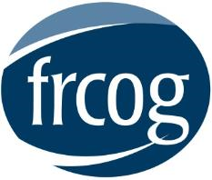

(beginning on page 7)

Leverett Trails Committee, Leverett

The 2010 update to the Leverett Open Space and Recreation Plan (OSRP) demonstrated strong support for preserving Leverett’s rural character, while also providing outdoor recreation opportunities. Respondents to the OSRP public survey identified walking, observing nature, and hiking as their most preferred recreational activities. In 2010 the Leverett Select Board asked the Conservation Commission and the Rattlesnake Gutter Trust (RGT) to work together on an application for the Recreational Trails Grant Program, administered through the Massachusetts Department of Conservation and Recreation (DCR). The two groups focused the application on trail development in East Leverett, where there was already a cluster of properties protected by the town and the RGT.

While working on the grant application, members of the two groups realized that there was a longer- term need for a self-sustaining committee that would work to develop a network of well-maintained, marked, and documented trails throughout Leverett. The Leverett Trails Committee was formed to meet this need, and held its first meeting in April 2011. It has met once every three months since. The Committee is made up of members of the Conservation Commission and the Rattlesnake Gutter Trust, as well as members of the community with an interest in the trail network in town.

The committee established goals to guide their work, including creating trails in town for a variety of users with different interests and skills; making the trails inviting through maps, guides, and events; developing standards for trail building, maintenance, signage, and information to allow for an enjoyable experience and easy long-term maintenance; creating a town-wide trail network by first focusing efforts on lands owned by the town, RGT, the state, and/or other land trusts, and then approaching private landowners; and finally, making participation in the committee fun and rewarding.

The Town was awarded the Recreational Trails grant of $10,550 for trail building in East Leverett. Volunteers built the bridges, designed and cleared the trails, and the Leverett Highway Department supplied gravel for parking areas and bridge cribbing. The grant also covered the cost ($300) for a videographer to develop an oral history of the mills in East Leverett. Leverett Historical Society volunteers donated space and expertise for the project, and Amherst Media provided video resources in return for showing the completed work on the Amherst cable station. Annotated maps of the mill area will be available on the RGT website.

Another project initiated through the grant, but which took on a life of its own, is the construction of a series of poetry boxes on the trails. The construction of eight poetry boxes and accompanying benches was a volunteer effort. These wooden, waterproof boxes are placed along trails throughout town, with extra paper and pencils for those who are inspired to write while on the trail. The grant provided funding to transport Leverett Elementary students to the trails, but the idea to focus the students’ visit on poetry grew out of Leverett Trail Committee discussions on how to encourage the community to reflect on the natural world. Two Pizza and Poetry workshops were planned and paid for through a Leverett Arts Council grant of $900. Three local businesses provided food for the events.

Since these initial projects, the Leverett Trails Committee has worked to design and clear a new trail at the Bill Rivers Conservation Area, which is located adjacent to the Leverett Library and Leverett Elementary School. The committee received $3,500 in Community Preservation Act (CPA) funding from Town Meeting to rebuild trail bridges. The trail should be completed in fall 2013. The committee also facilitated a photography exhibit and contest at the Leverett Library with the help of volunteers in the spring of 2012. The community was encouraged to enter photographs taken along the trails, with prizes donated from three local businesses. The exhibit was so popular that it was done again the following year.

There are several indications that there has been an increase in use of the trails in town, and an increase in physical activity. Prior to the formation of the committee and the Trails grant work, trailhead parking areas either did not exist, or were rarely used. These are now well worn, which does not even account for residents who walk to the trailheads. Participation in numerous trail workdays has ranged from 8 to 20, and trail walks have had between 6 and 30 participants.

Despite the success over the last few years, the committee identified several challenges they have encountered or anticipate encountering. Keeping people informed and involving new people in the projects was addressed through using as many forms of communication as possible, through websites, email lists, signage at trail heads, fliers posted around town, the town newsletter, events held on the trails, and word of mouth. The challenge of finding the time to accomplish the larger tasks of trail building, and the many smaller associated tasks, was addressed through being as efficient as possible. This could be anything from doing a lot of pre-workday preparation, to not scheduling trail events on top of other town events, to involving skilled volunteers who can do some of the work on their own time. Finally, keeping the initial enthusiasm going has not yet been a problem, but will likely be a challenge in the future. This goes back to keeping with the original committee goals of making the trails inviting for everyone, and making participation in the committee and trail events fun and rewarding.

Next steps for the committee are to maintain the existing trails, create more trails and linkages between trails, encourage more projects related to the trails, and to not lose sight of the original goals set out by the committee when it formed. The Leverett Trails Committee advice to other towns interested in a similar pursuit? “Trail building is about community building. It takes time, hard work, and patience. And it’s fun. Enjoy it.”

(Photographs, next page)

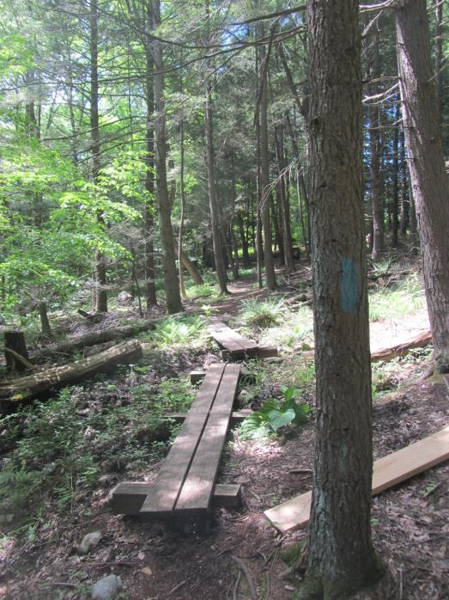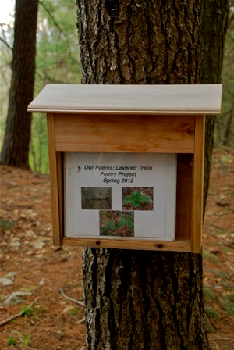

Photos: Bill Rivers Conservation Area trail, July 2013 (left); Poetry box, photo credited to Mary Barnett (right).