Bates Photos for Monitoring, Part 2 (west and south sides)

(Corner letters correspond with those on the Bates Monitoring Map)

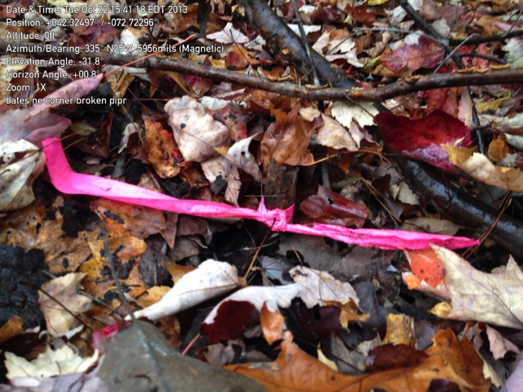

K. SW Bates corner

IP found (thanks to metal detector) in pond behind discontinued road and trees.

42.439187 -72.477937

October 22, 2013

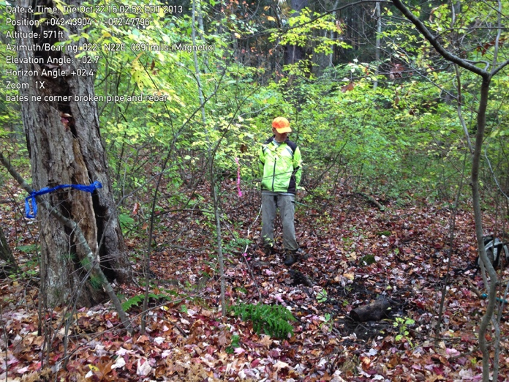

K. Same broken/rusted post.

rebar added next to ip

(pond dry after almost a month without rain)

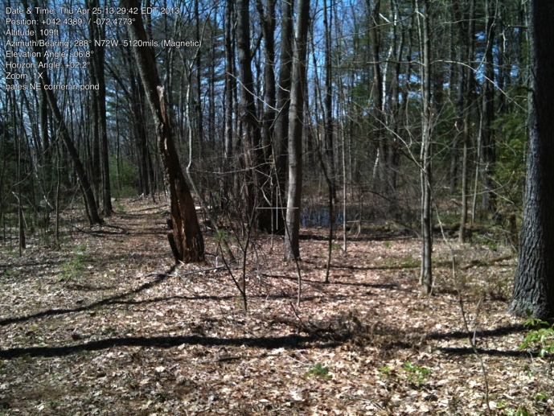

View of pond with SW IP (K.)

taken from Connelley/discontinued

road (line) looking south

April 25, 2013

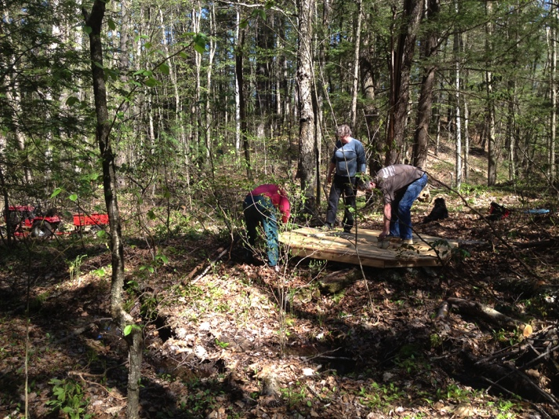

Bates well. (Deed gives water to the Stetson homestead across

Shutesbury Road.)

On May 4 Mary Barnett led a team

of assistants assembling her well

cover. Condition of the well (and

cover) should be checked annually.

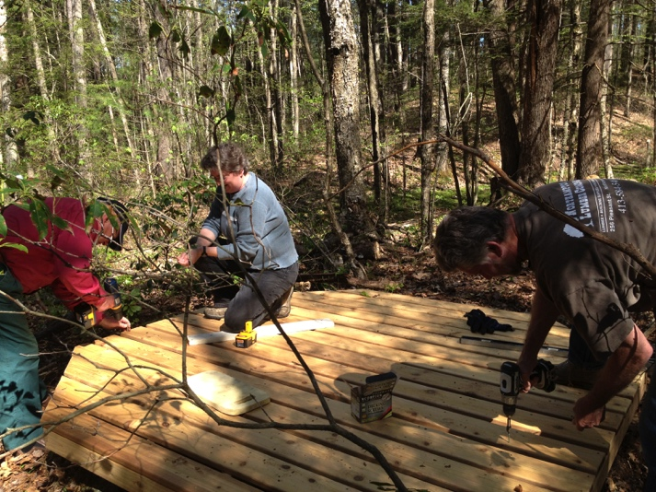

Close-up of well cover with George Lockwood, Mary Barnett, and Chug Holmes

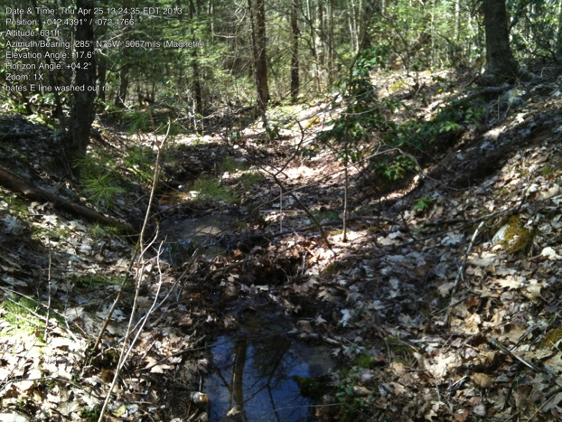

The eastern line follows the original discontinued county road. Each map has a different name for the road, it is the extension of the Connelly driveway.

There is a easier-to-walk trail to the just east of this section of the road.

North junction of old and easy road:

42.438944, -72.477078

April 25, 2013

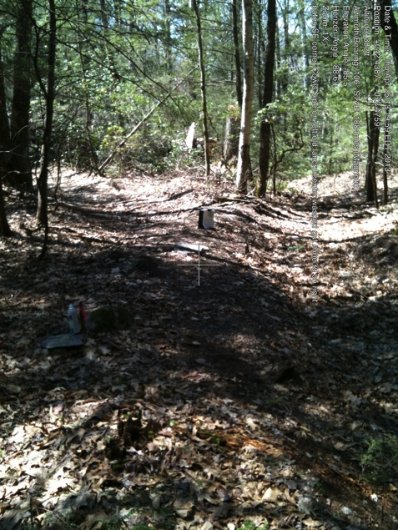L Bates south line.

Junction of discontinued (Connelly) Road and January Hills/Old Lancaster Turnpike (not maintained, but not legally discontinued).

IP is on Cowls land. This IP used to be in what is now the middle of the berm. Looking east.

42.43881050 -72.47604473

April 25, 2013

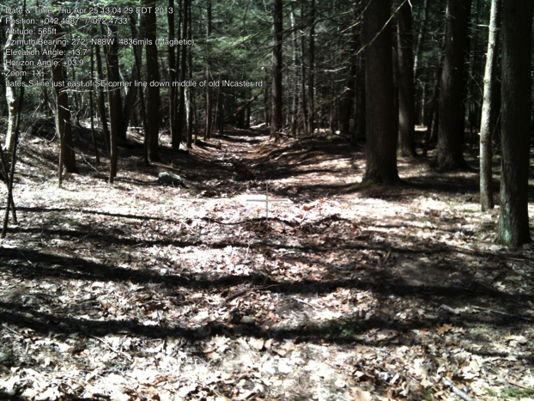

This section of the line follows the almost-straight Old Lancaster Turnpike (also called Old January Hills Road)

This photo looks from near the SE corner

April 25, 2013

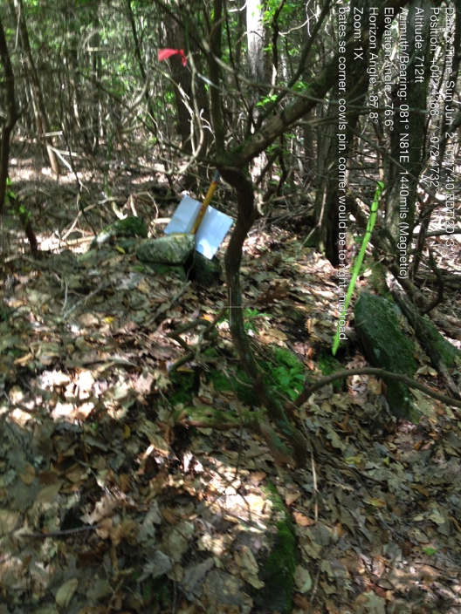

11. SE Bates corner iron pin.

Pin is on Cowls land, corner but technically is in the middle of the road

42.43895700 -72.47318200

June 2, 2013

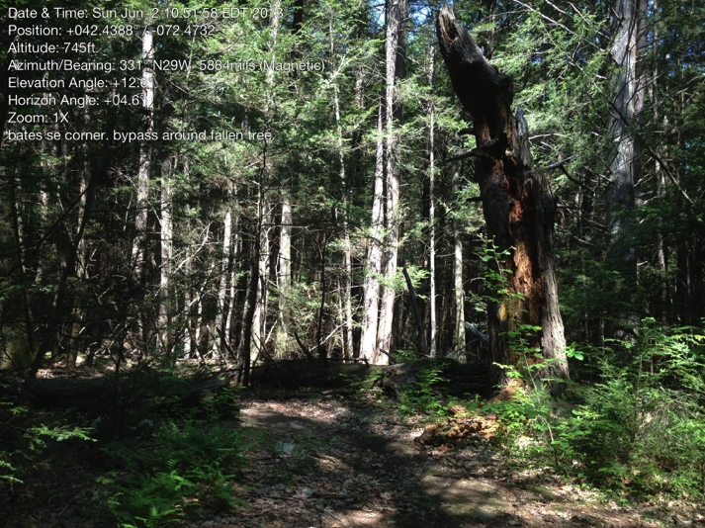

Same SE corner (M.)

Looking east on Old LancasterTurnpike, pin is to the left, line goes down the middle of this county road which is not maintained.

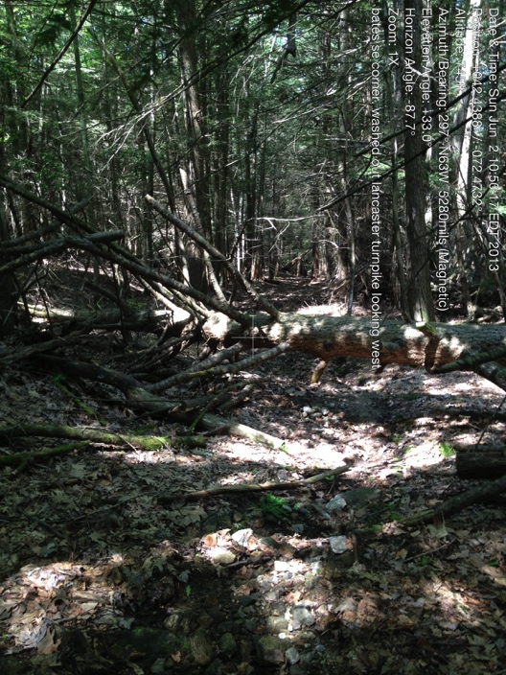

Same SE corner (M.), slightly farther east, Cowls property to left/south. Bates property to right/north.

Note. The eastern line follows almost exactly the old M-M Trail (now called the Roaring Brook Trail). The yellow painted blazes of MacConnell to the east and the old barbed wire fences and the white dots of the trail (and now the blue paint of the Bates line) on the west side decorate the line of trees.