Bates Photographs for Monitoring, Part I (north and east sides)

(Corner letters correspond with those on the Bates Monitoring Map)

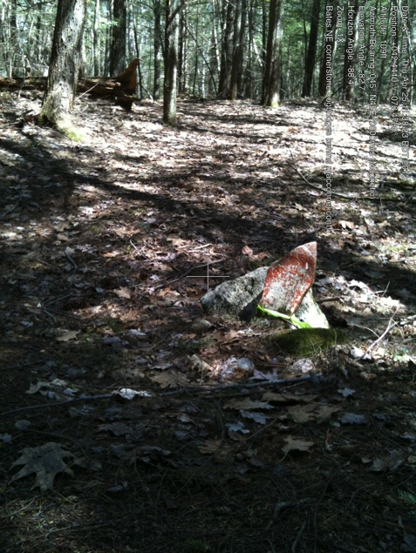

A. NE Bates corner, triangular stones. Stone is just north of small stream crossing (called Bates-Campbell Stream) in baseline photographs.

42.44070916 -72.47291953

April 25, 2013

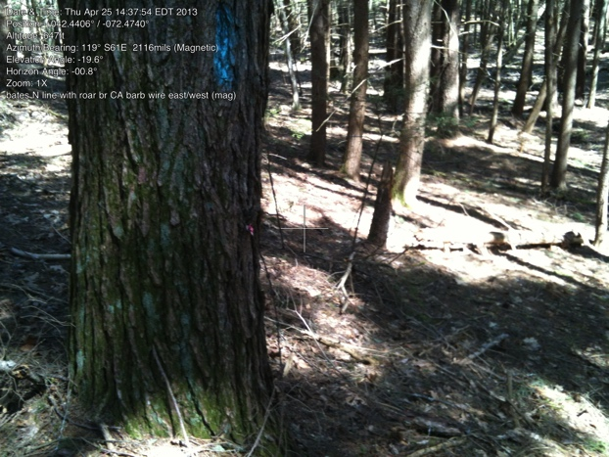

North line along the boundary with Roaring Brook Conservation Area.

Line is marked with barbed wire deeply imbedded in the trees.

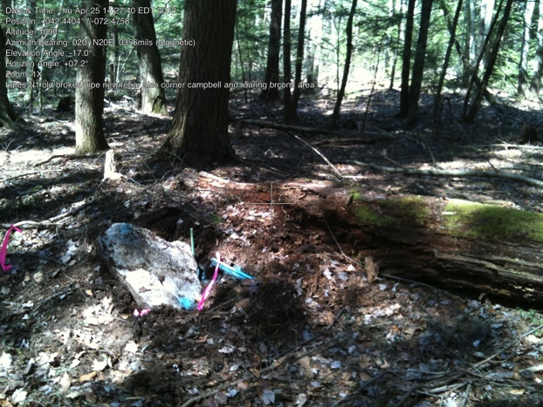

B. Bates Corner with Roaring Brook Conservation Area and Campbell property (6 acre piece). in 1973 survey“old pipe” and “white oak” are mentioned.

White Oak has fallen; old pipe broken

(probably by falling tree). Rebar added.

42.44052770 -72.47510109

April 25, 2013

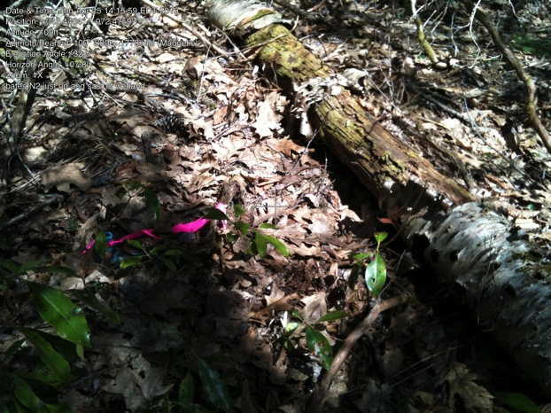

C. Bates Corner

Corner is just at eastern edge of wetland.

42.44053734 -72.47575203

April 25, 2013

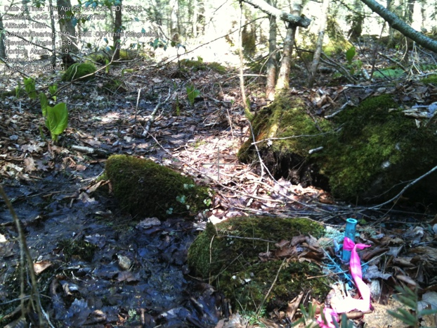

C. Bates Corner

This pin is often almost covered by water.

42.44034187 -72.47614757

April 25, 2013

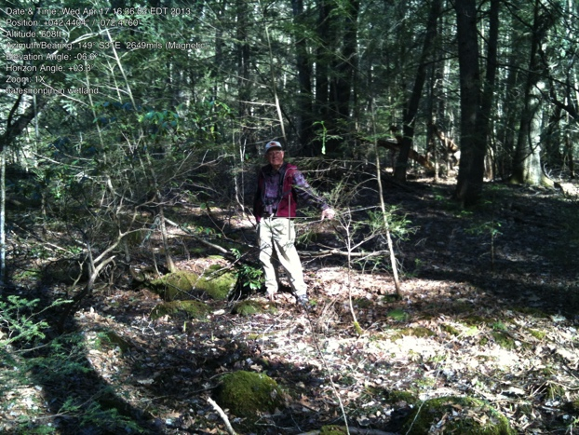

D. Bates Corner

Harvey Allen standing in the area of the pin. Photo taken the day Bill and Nancy Bates walked the land with us. (April 17, 2013)

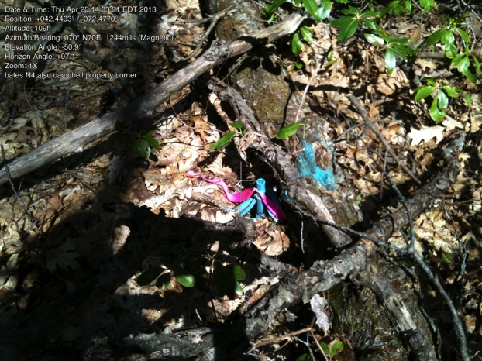

E. Bates Corner

IP almost under fallen log.

This is also the corner for the two Cambell properties (formerly Nathaniel Smith to the east).

42.44037733 -72.47680119

April 25, 2013

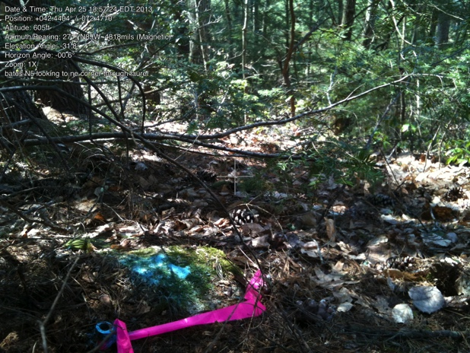

F. Bates Corner

On knoll, the next (NW) pin in downhill in the laurel.

42.44027037 -72.47709724

April 25, 2013

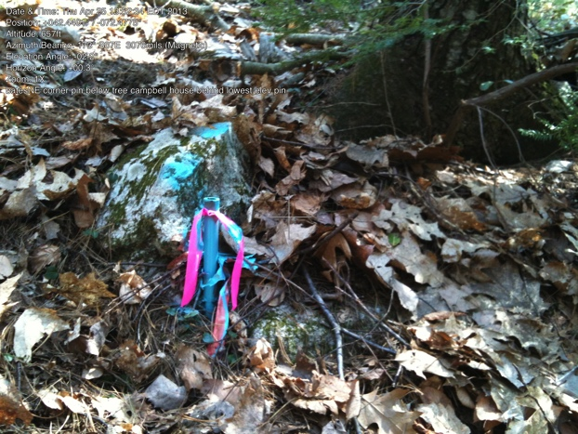

G. NWBates Corner

This is most northerly and the farthest downhill of the zig-zag north line.

It is on the downhill side of a large tree.

42.44036643 -72.47733998

April 25, 2013

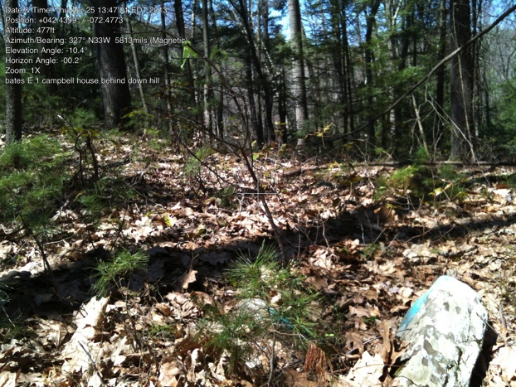

H. Bates Corner

Looking north over NW corner,

(Stick is coming from short iron pipe.)

42.44007859 -72.47751407

April 25, 2013

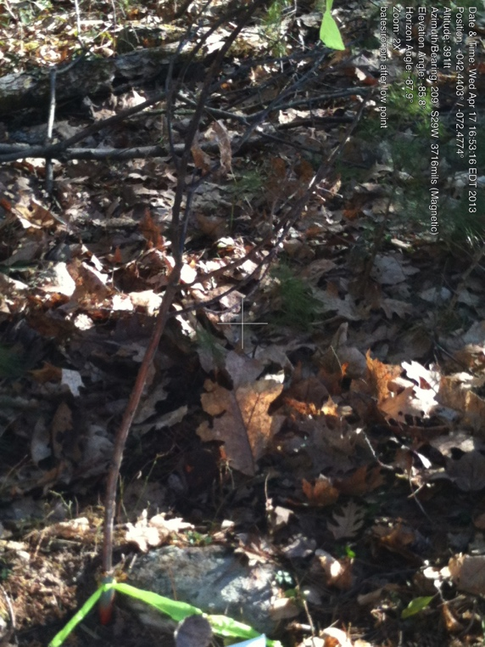

H. Same H. corner

Photo shows short pipe with stick coming out of it.

Note, the other iron pin (I.) and drill hole (J.) have not been found, but it is a straight line marked by a casual stone wall and probably Virginia rail fence stones to the iron pin in the pond at the SW corner.