Adams Conservation Area *(final name to be selected by Paul Adams)*

Boundary Photographs

*(remove this italics section when rest of photos added)*

*Note: The initial work on the boundary map and the boundary photographs was done by Angelo Teachout, as part of his Sustainability Science Master's Practicum, and Mary Alice Wilson*

*This work was done before the survey of the easterly Adams house lots was done and, therefore, before neighbors were informed.*

*Work was done only on the western line from the northwest corner to the area where the access road enters the property (map corners H, G and almost to F).*

*No work was done on:*

*land abutting Sincuk/Johnson (map corners F, E, C, and D)*

*land abutting Crafts/Snowdon (map corners I, J)*

*land abutting the Adams house lots which have not yet been surveyed (map corners A and K)*

Note on sources of boundary information

1. Deed from Barbara, Stetson, and son Paul Adams to the town creating what is now called the Adams Family Conservation Area (Book 1833, p. 206 and Plan Book 55, p. 99). While this is needed only for the western line of the Adams property, having the description and survey is very helpful. An annotated copy (letters to match monitoring map) appears in this folder.

2. Deed from Barbara Adams to Paul Adams for the Adams property (Book 2133, page 195.) The property description is confusing because it includes the land already given the town - but says at the end that it is excluded from the deed.) An annotated copy (letters to match monitoring map) appears in this folder. There is no survey, but Paul was careful to mark the boundary with red paint (and corners with triple dots).

Special thanks to Angelo Teachout, for his help in the project while completing his practicum in Sustainability Science, UMass.

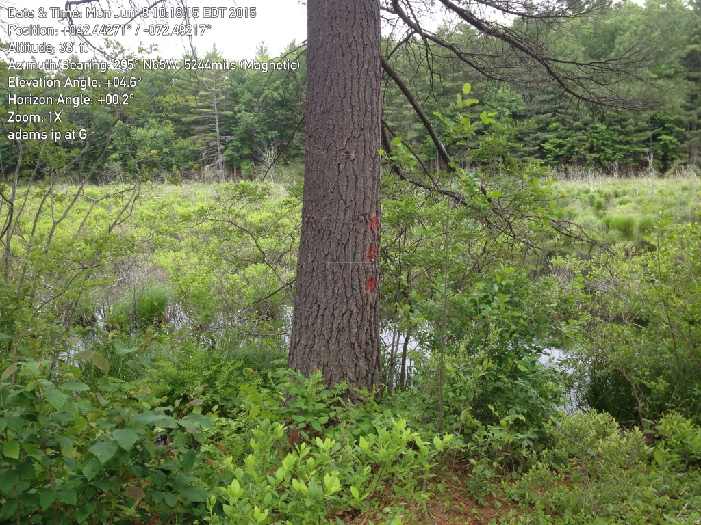

G. Corner south of SW corner

42. 442608, -72. 492227

Just west of the present bench/view on the East Leverett Trail Network

Triple paint on tree. In theory the iron pin is easterly of the 10" diameter pine (size in 1996 diameter at breast height) so it might well be covered by base of the pine. IP not found.

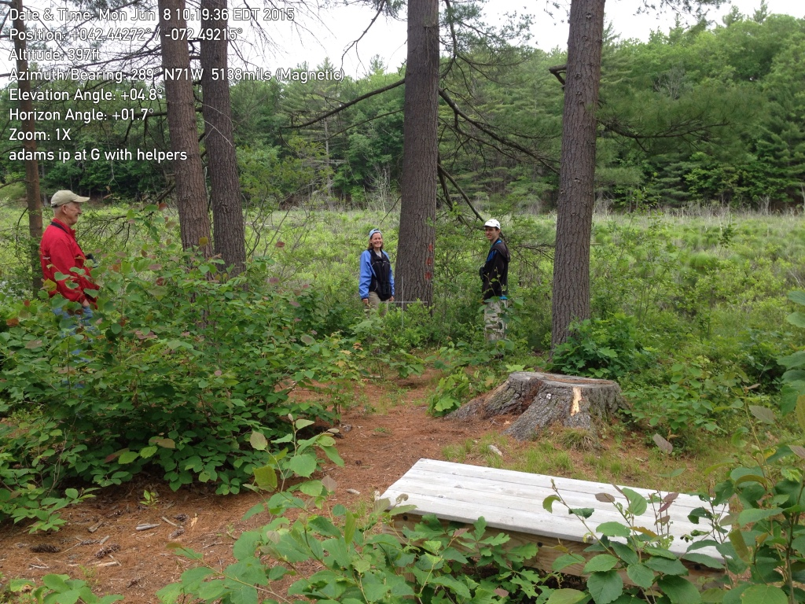G. same corner with Doolittle Brook beaver swamp behind.

photos 6/8/2015

gps 6/4/2015

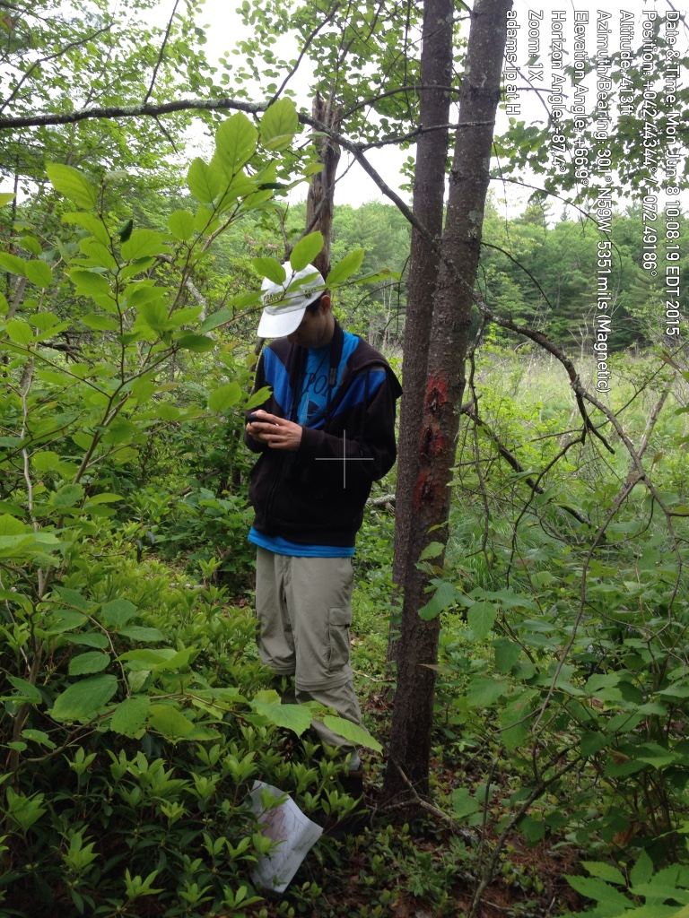

H. Southwest Corner

42.443395, -72.491852

triple painted tree. Short iron pin painted red in front of white paper. Angelo Teachout taking gps reading. Looking west into the Doolittel Brook beaver swamp

photo and gps 6/8/2015